**Logo Brief – LuvYoga**

|  |  |
| --- | --- |
| Client: | Siva Rajah |
| Contact address: | 80 Underwood Road, High Wycombe, Buckinghamshire, HP13 6YA. |
| Email: | [sivatrajah@gmail.com](mailto:sivatrajah@gmail.com) |
| Telephone: | 07932 038202 |
|  |  |
| **Business Description:**  Siva is a massage therapist and teacher of yoga, and anatomy and physiology, operating as a self-employed sole trader. Her massage speciality is traditional Thai massage though she also offers deep tissue and sports massage. Siva has been operating for 15 years and primarily works in the ‘high-end’ part of the market, combining her work at the esteemed Chelsea Triyoga Studio with home-based/mobile treatments of clients in London, Buckinghamshire and Berkshire.  Siva also runs local yoga classes in Buckinghamshire and this is the side of the business which she wishes to expand through an enhanced marketing program. The ‘LuvYoga’ name has been chosen around which to build her yoga brand and a website presence, ‘www.luvyoga.com’ will be developed alongside traditional off-line marketing materials such as vehicle stickers and promotional leaflets, apparel etc. | |
| **Project Objective:**  To design a size-scalable logo for the ‘LuvYoga’ brand which can be used across a variety of online and print marketing mediums. It should therefore be able to be expressed both with and without a ‘.com’ suffix. | |
| **Brand Values:**  LuvYoga emphasizes heart over the mind and body. It is about developing inner strength, will power, and fearlessness, rather than mastery of the picture perfect yoga pose. The central idea is to develop an ability to feel good on the inside, through a journey of transformation. This brings the body into alignment with what is felt and experienced. This can be expressed through flowing yet controlled movement and the idea of energy, vibration, breath and ideas circulated through every cell of our being. A possible strapline might be: “Be True to your Heart”.  Values   * Willpower and inner strength * Positivity and transformation * Heart over Mind and body * Strength, movement, fluidity | |

|  |
| --- |
| **Design Principles:**  **DO:**   * Simple and legible from distance * Make the name ‘LuvYoga’ dominant in the design. Graphical elements should sit within, between or sprout from the lettering. * Include a heart-shaped icon which symbolises the ‘luv’ in LuvYoga. However, be careful to ensure the logo appears gender neutral and is not overly feminised. The client has suggested the possibility that the ‘v’ in Luv could form the base of a heart graphic. * The client envisages the logo being used in conjunction with or having a relationship to mandala artwork – Manadalas are geometric patterns of Indian origin which represent the universe (see example sheet). It maybe that the design of the logo incorporates a visual cue from mandalas or it may be that it is able to sit on top of Mandala patterning, for example on a website header graphic. Feel free to experiment bearing in mind the need for simplicity in logo design. * Experiment with text – for example, luvYoga, Luvyoga, LuvYoga, LuvYOGA etc. * Incorporate a sense of flowing energy or circulation in the logo. * Strong logos often use a limited rather than full colour pallet. The client is therefore open to mono, two or a maximum of three colours but not four. * Where appropriate, bright, vivid colours are preferred with the client favouring purples, green and oranges hues.   **DON’T:**   * The client does not want a logo treatment that adheres to the discreet ‘picture with title underneath’ model (see example sheet). * Use traditional standard iconography for yoga such as lotus flowers, or standing and stretching poses, as these images have become a stereo-typed commodity (see example sheet). * Use a coloured background. The logo should be able to sit on white or be dropped over another graphic. |

**Sample Sheet**

**AVOID**

The following samples are included to illustrate examples of Yoga logo types which the client would like to avoid.

**X -** Illustrated classic yoga poses. They are clichéd, static and don’t feel ‘real’

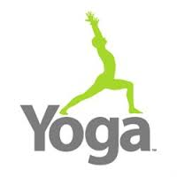

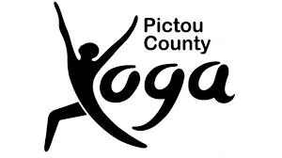

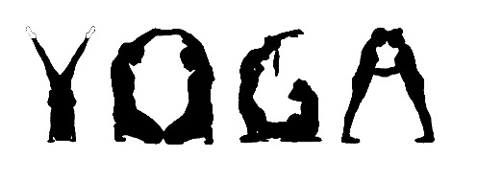

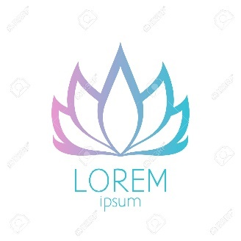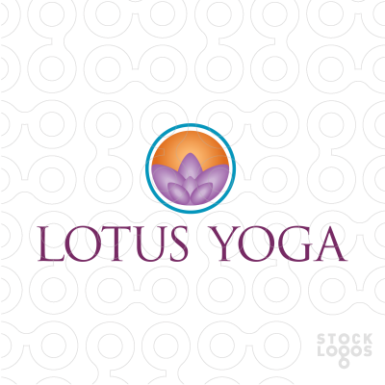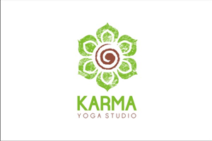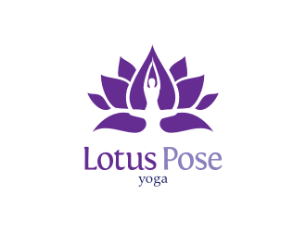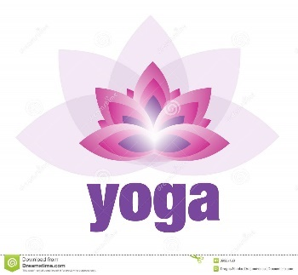

X – Heavy use of Lotus flower graphics are all too typical which makes it hard to differentiate the business. These logos also illustrate the ‘picture above name’ type of logo where the picture has a weak visual relationship with the brand even if thematically relevant.

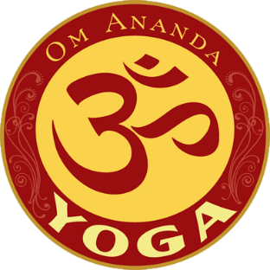

**X -** No use of the ‘OM’ symbol

**Sample Sheet**

**Good Use of graphics**

The following samples are included to illustrate good examples of Yoga logo types which match the client’s view that any graphics should be implicitly part of the name text.

Graphics have a clear and active visual relationship with the brand name

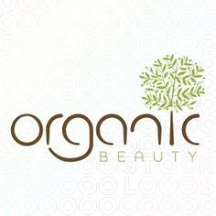

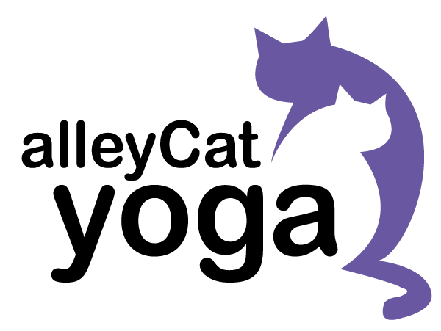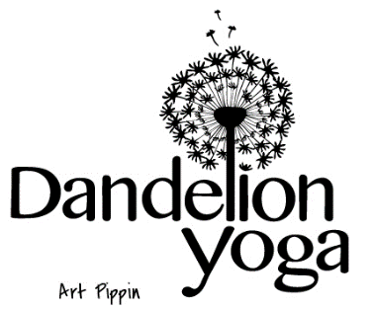

#

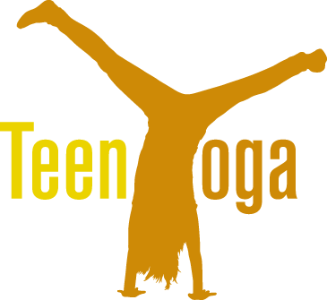

Though this logo features a yoga pose it works for 3 reasons: a) the image is integral to the word text, b) the stance is not perfect so feels real, c) the trailing hair communicates a sense of teenage fun which matches the brand proposition

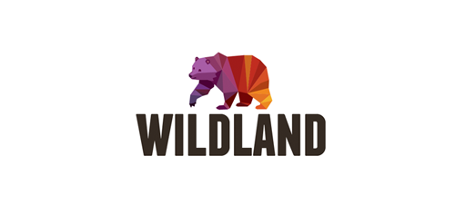

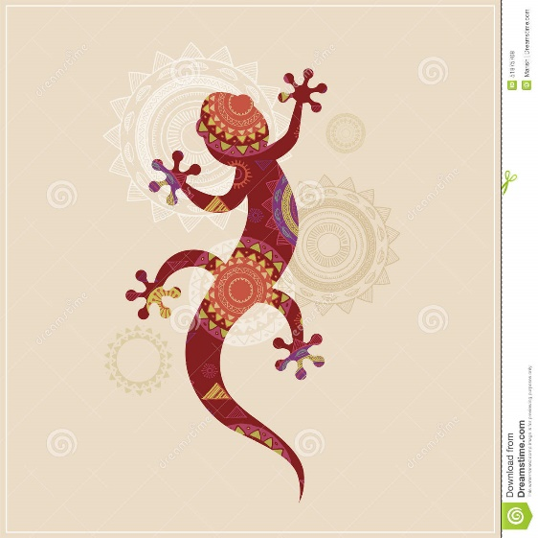

These logos are interesting, because they incorporate ethnic patterning inside the dominant image. Possibly, the heart element might use a device like this?

**Mandala Patterning**

The logo design should fit well within an ethnic visual setting such as for example mandala inspired backgrounds. Common features of mandalas include circles and spirals, fine etching, and tear-drop shapes. Given the complexity of these patterns it is likely the logo itself will take only light inspiration from this aesthetic or just use lettering with a slightly ‘ethnic feel’.

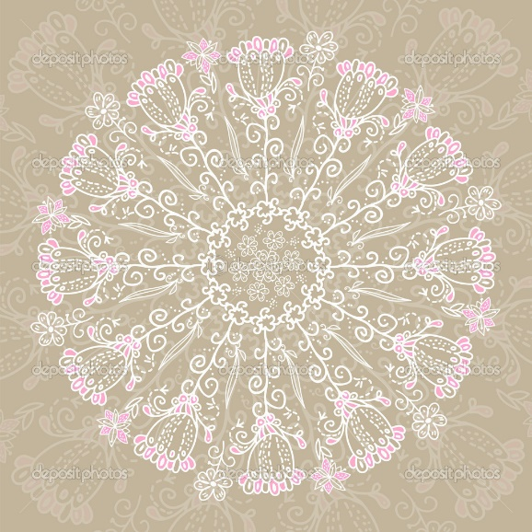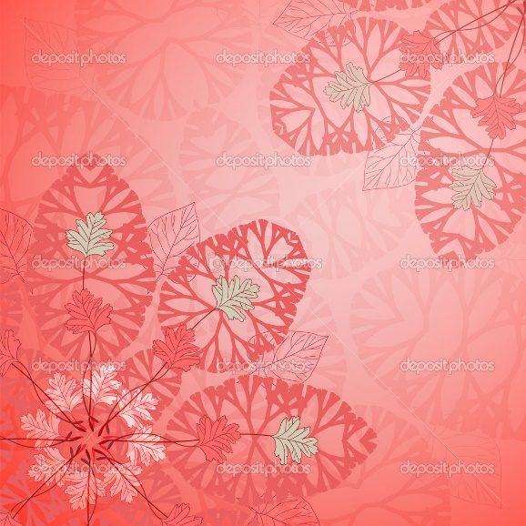

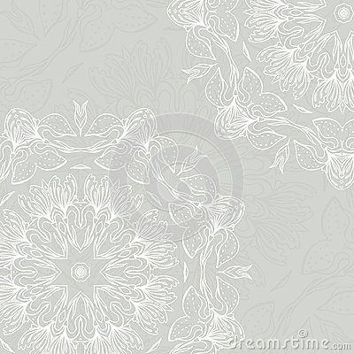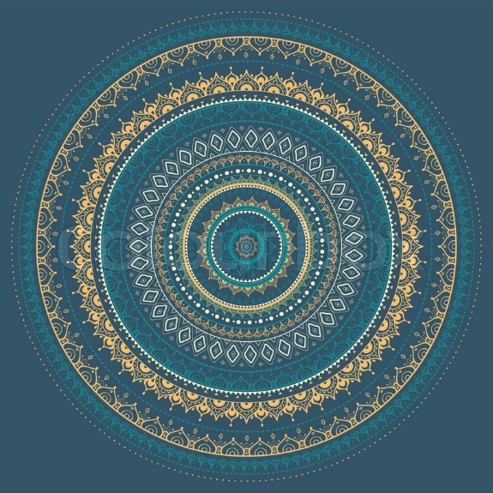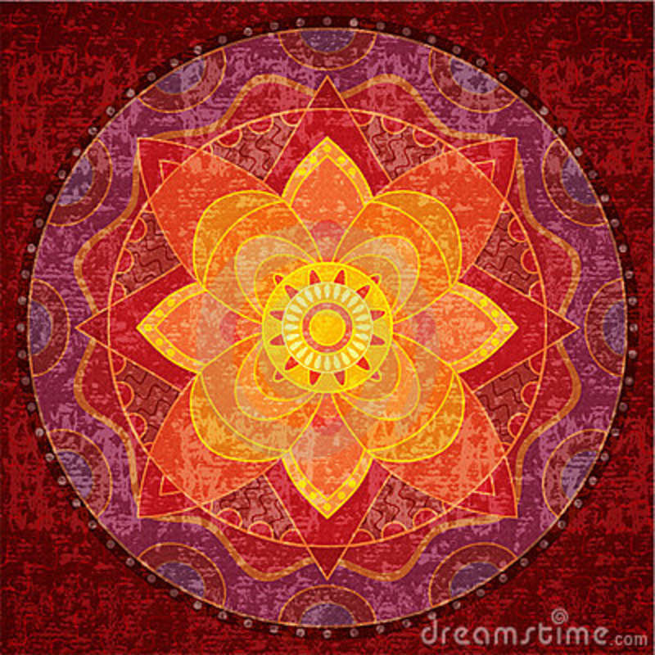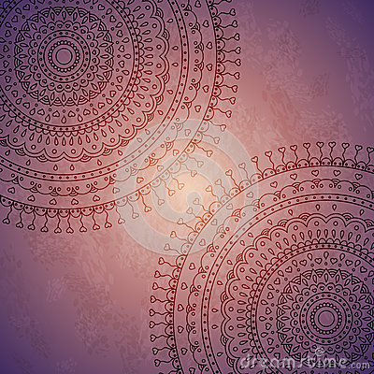

**Henna Designs**

Another possible background setting for the logo could be traditional henna designs. Whether an aspect of this visual reference could be feasibly incorporated in a legible logo is open to question.

