[](https://www.google.co.uk/url?sa=i&rct=j&q=&esrc=s&source=images&cd=&ved=0ahUKEwiy_enY6ubLAhUFCBoKHak5D2cQjRwIBw&url=https://www.pinterest.com/priscill/africa-our-love/&bvm=bv.117868183,d.d2s&psig=AFQjCNE1kdBHd-_ljKGmP1_npXWjUYoB3g&ust=1459373080339939)

[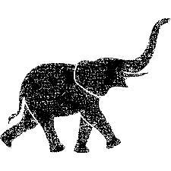](https://www.google.co.uk/imgres?imgurl=http://shirta.de/media/catalog/product/cache/1/small_image/295x295/9df78eab33525d08d6e5fb8d27136e95/e/i/ein-grosser-elefant-mit-einem-ruessel-d76319369.png&imgrefurl=http://shirta.de/catalogsearch/result/index/?p%3D2%26q%3Dprag&h=295&w=295&tbnid=RYMQu9KIEWyX3M:&docid=H4ZB7mze5DvXjM&ei=Yu_6VoyZJIata-TJjegH&tbm=isch&ved=0ahUKEwiM0ui55-bLAhWG1hoKHeRkA304ZBAzCBYoEzAT)