**PROCESSING CUSTOMIZED ORDERS**

If clients order services that are NOT listed on the STANDARD ADDITIONAL SERVICES on their account (see screenshot), you must follow the steps below:

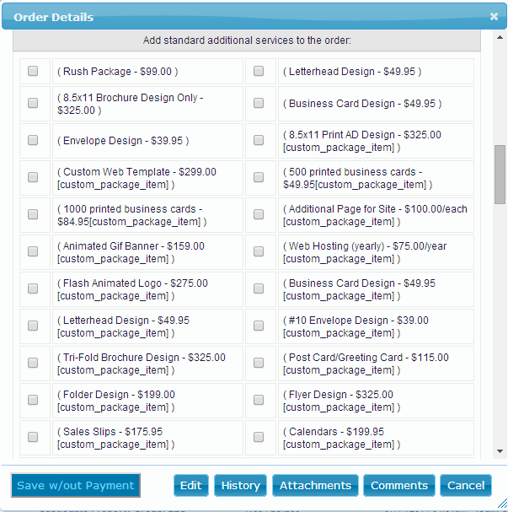

1. Go to the admin/user panel.
2. Pull up the client’s account on the ORDER tab by clicking the company name.
3. On their account, you can find the “+ Add Custom Service” link (below the additional services list). Click this link.
4. Fill out the form. (see screenshot) You may add discount, etc. and click on “CALCULATE TOTAL” to show the total cost.

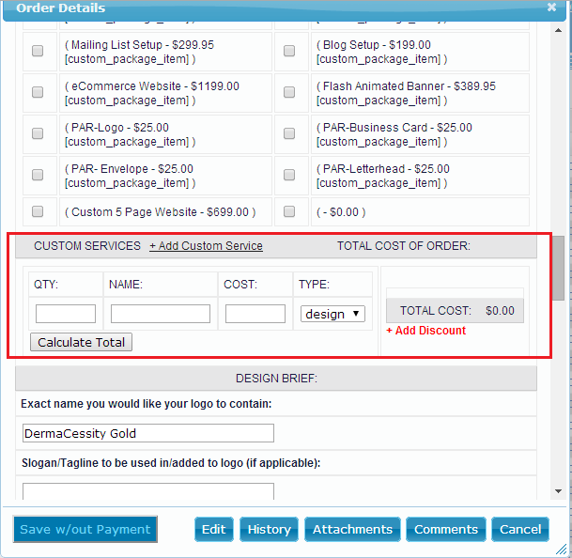

1. Process the payment by selecting an existing card o adding a new one, then, click on “SAVE ORDER AND MAKE PAYMENT”.

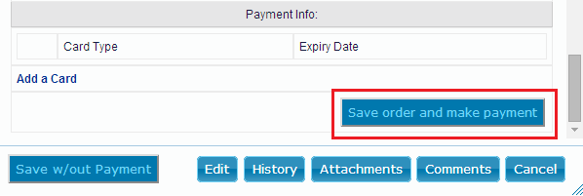

1. 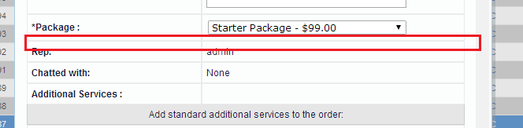Once the payment is processed, you can close the account and pull it out again. This time you will see that the new customized order is added on the client’s orders.
2. Add notes on the COMMENT tab. Make sure that you document all the important details of the customized order. Do not forget to add your name below the notes for reference before saving the comment.

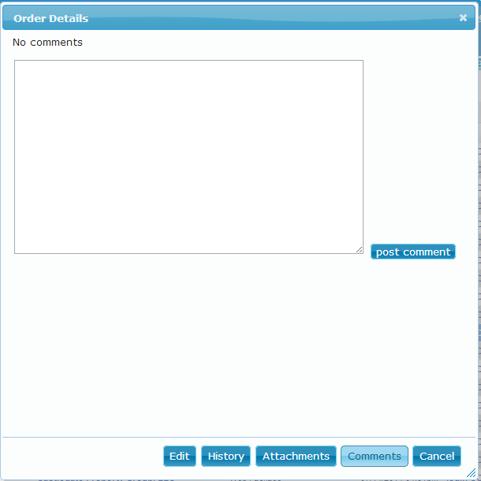

1. Escalate the order details on MANAGER JOBS-ADD JOBS and on Basecamp LOGOLOFT PENDING works.
2. Update the client’s Highrise case notes.
3. Post the recording on the Basecamp Logoloft sales recording link.