[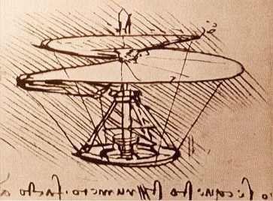](https://upload.wikimedia.org/wikipedia/commons/3/37/Leonardo_da_Vinci_helicopter.jpg)