**GUY BONGONGO** Ministries

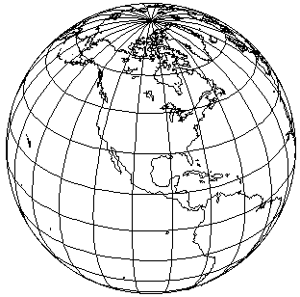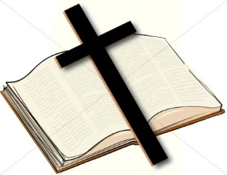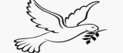

Dear Design,

Could you put the globe as the background, put the bible and the cross in the globe and add the dove in the centre of the cross. Then, write the logo name around the globe. Many thanks.