C:\Users\Daddy\AppData\Local\Microsoft\Windows\Temporary Internet Files\Content.IE5\KJJW43A6\Pawprint[1].pngC:\Users\Daddy\AppData\Local\Microsoft\Windows\Temporary Internet Files\Content.IE5\KJJW43A6\Pawprint[1].png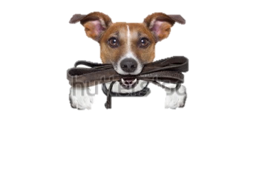C:\Users\Daddy\AppData\Local\Microsoft\Windows\Temporary Internet Files\Content.IE5\KJJW43A6\Pawprint[1].png

**Paws Outdoors Knutsford**

Dog walking & pet care services