Traveler’s diary
Class
&
Collaboration Diagrams

Group 5
CSE B(2)
Student no.
1005101
1005102
1005103
1005104
1005119

Sub-systems

- User profile system
- Agency profile system
- Board controlling system
- Information update system

User profile system
Use-cases
- Log in/sign up
- Review
- Search

Login/Signup
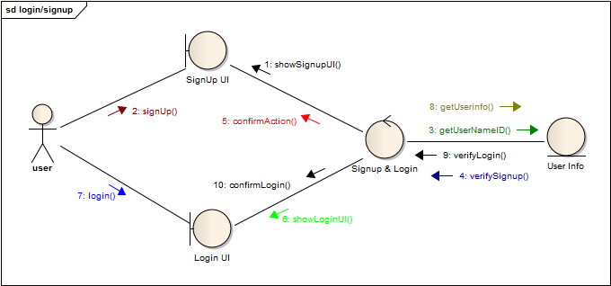

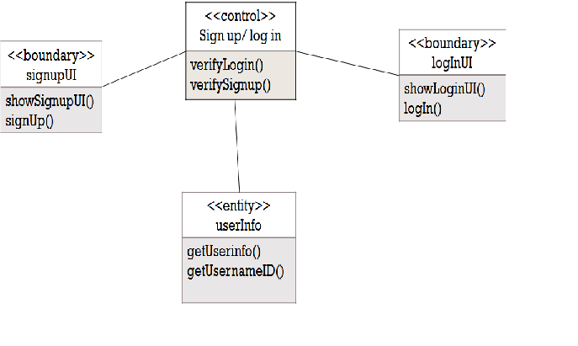

SEARCHING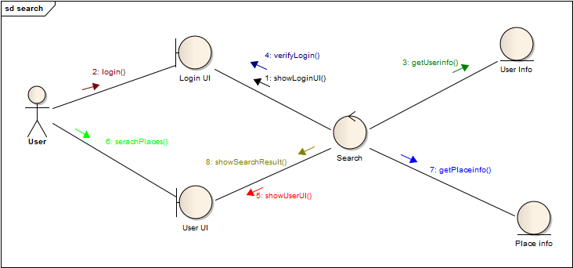

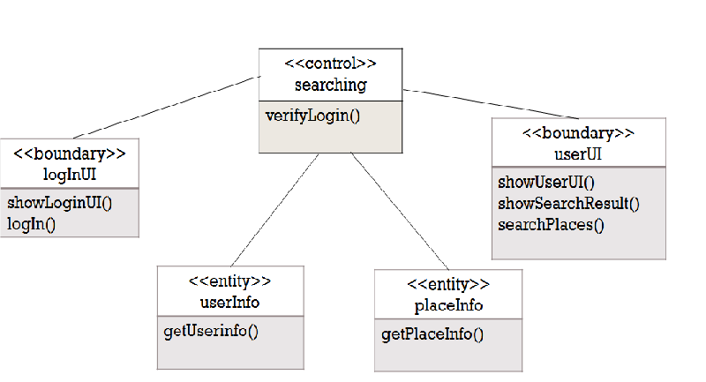
REVIEW
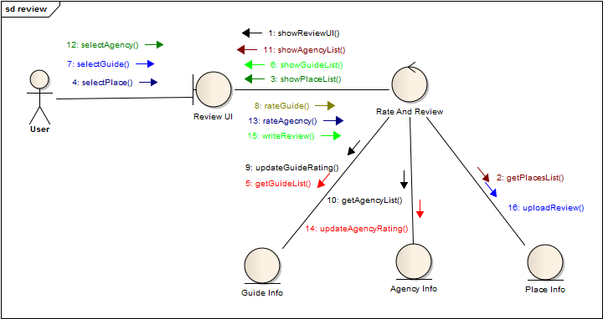

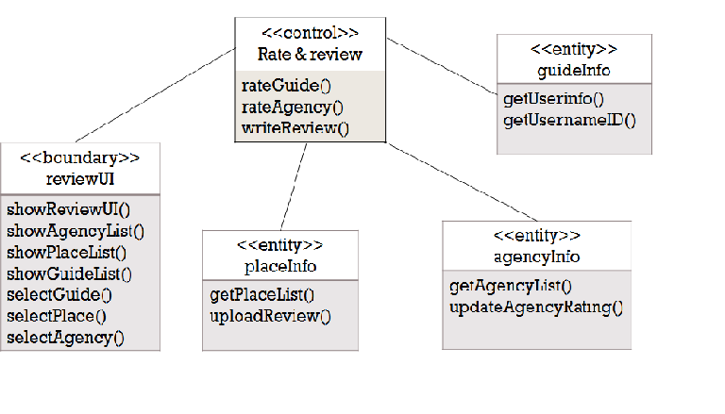
Agency profile system

Use case
- Membership renewal
- Promotional activity

RENEWAL REQUEST
2
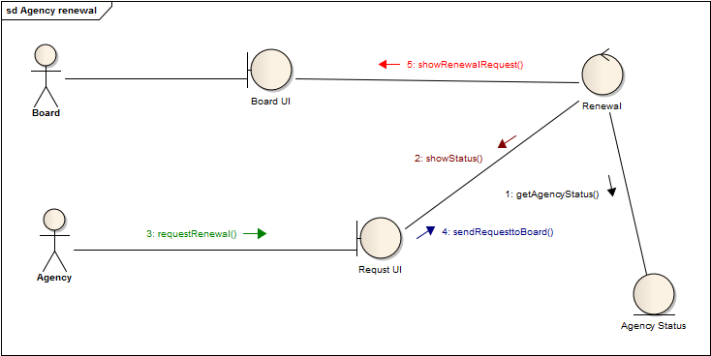

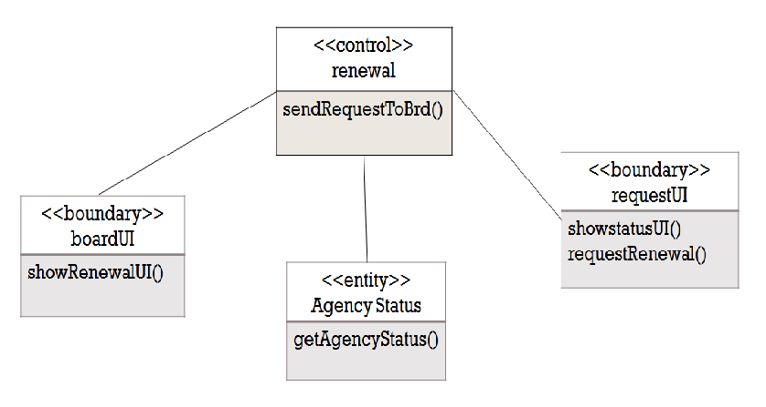
PROMTIONAL ACTIVITY
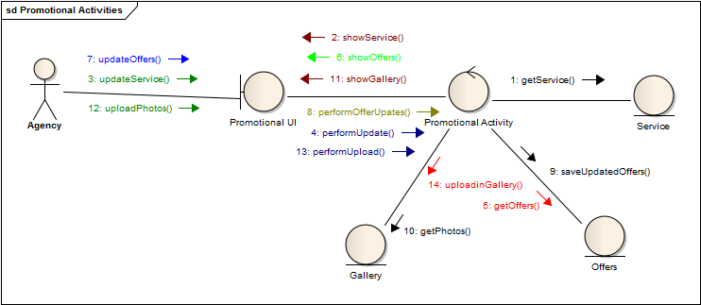

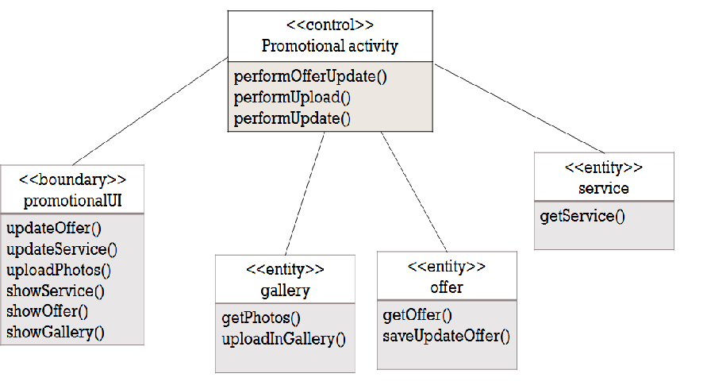
Board controlling system

Use case
- Agency management
- User management

AGENCY MANAGEMENT
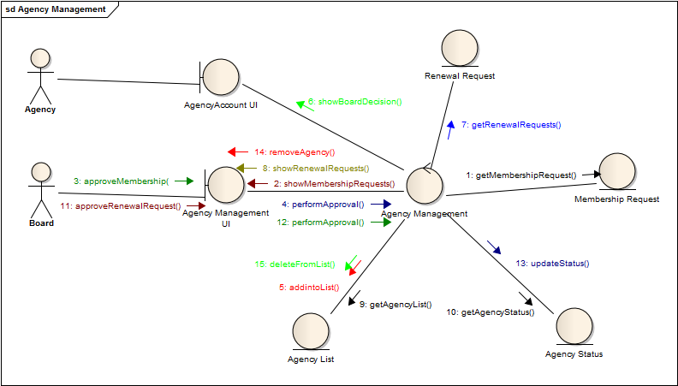

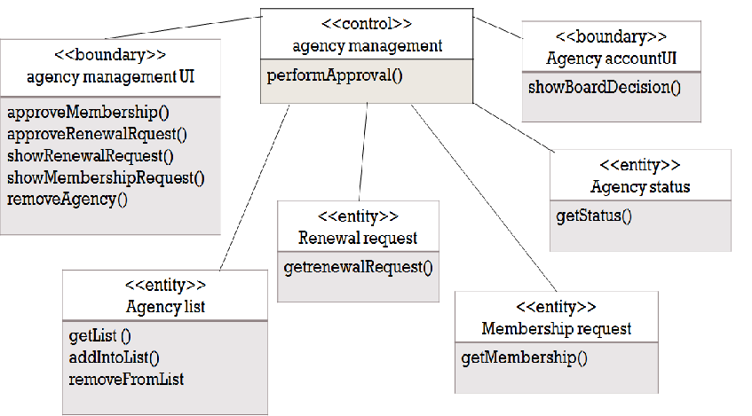
USER MANAGEMENT
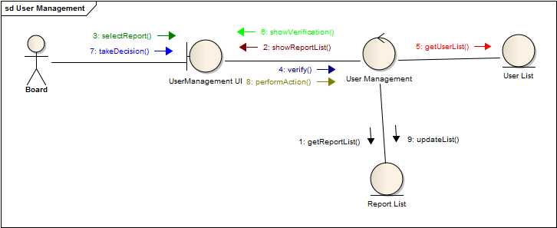

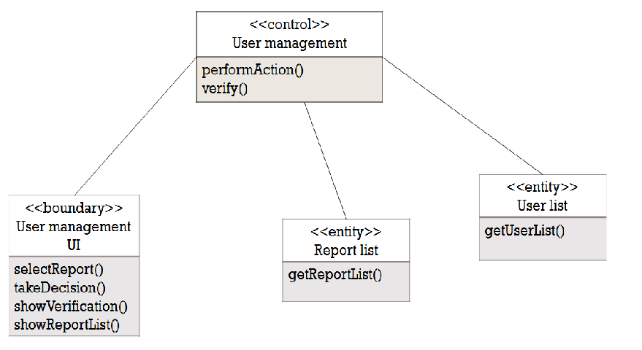
INFORMATION UPDATE
