[Google Apps](https://www.researchgate.net/publication/279197961_Numeric_Rating_of_Apps_on_Google_Play_Store_by_Sentiment_Analysis_on_User_Reviews?enrichId=rgreq-87b9c4d2977603dfc78a78824fb49318-XXX&enrichSource=Y292ZXJQYWdlOzI3OTE5Nzk2MTtBUzoyNDQ5NzExOTQyODYwODFAMTQzNTQxNzA5MzAwNQ%3D%3D&el=1_x_3&_esc=publicationCoverPdf) Ratings

**Conference Paper** · April 2021

Google Apps Ratings

Md. Rifat Mahmud Rakib

Kamrul Kader Mehadi Khan

Anupom Paul Ornob

Zibran Ahmed Eshan

Shafkhat Md. Sabid Alam

*Department of B.Sc in CSE*

*Daffodil International University*

*Daffodil Smart City, Ashulia Bangladesh*

*Abstract*—*Google play store is engulfed with a few thousands of new applications regularly with a progressively huge number of designers working freely or on the other hand in a group to make them successful, with the enormous challenge from everywhere throughout the globe. Since most Play Store applications are free, the income model is very obscure and inaccessible regarding how the in-application buys, adverts and memberships add to the achievement of an application. In this way, an application's prosperity is normally dictated by the quantity of installation of the application and the client appraisals that it has gotten over its lifetime instead of the income is created. Application (App) ratings are feedback provided voluntarily by users and function important evaluation criteria for apps. However, these ratings can often be biased due to insufficient or missing votes. Additionally, significant differences are observed between numeric ratings and user reviews. This Study aims to predict the ratings of Google Play Store apps using machine learning Algorithms. I have tried to perform Data Analysis and prediction into the Google Play store application dataset that I have collected from Kaggle. Using Machine Learning Algorithms, I have tried to discover the relationships among various attributes present in my dataset such as which application is free or paid, about the user reviews, rating of the application*

*Keywords*—Google Play Store Apps, Ratings Prediction, Exploratory Data Analysis, Machine Learning.

I. INTRODUCTION

T

HERS are all opinions are always important for us during any decision making process. Before the wide spread of the World Wide Web, we used to ask our friends or help internet about anything we were going to use. But now a days we need to ask someone for the suggestions. All the reviews and recommendations are available on online review sites and blogs. To be more specific, the users of devices with Android IOS generally choose their required apps from the Google Play Store. Generally, it is seen that people makes the decision for any app on the basis of the numeric rating of that. The rating is the average of all the ratings given by other users by stars. Moreover, the users have to include a comment as well. It is observed that ambiguity lies between the star rating and the comments of the users. It creates confusion to the new user who is going to download and use the app. Here another problem evolves, people always go for a summary rather than an elaborative statement. So, this problem rises with ambiguity of reviews and the biasness of users to summarized option.

The problem described above has two sub-problems. Firstly, the ambiguity. This can be easily removed by using anyone of the two review types, star rating and comment. Another subproblem is the biasness to the summarized rating of the users. Earlier most of the approaches were only to find out the polarity of the comments bound within negative, neutral and positive. Moreover, once the problem was treated with the help of opinion mining with support vector machine. As a part of the same approach later it was shown with the well-known Naive-Bayes model. All of the earlier approaches were only to extract a rating from the comments leaving the star rating part aside.

Extracting sentiment expressions was done earlier from formal corpus. Generally, the user reviews are not written following the formal rules. So, the exact sentiment expression can’t be extracted from the user reviews with some predefined patterns. In a word, the writing style of the user reviews can’t be easily parsed with various parsers and parts-of-speech taggers. These tools are typically made on the basis of standard spelling and grammar.

Here, the solution to the problem is proposed using sentiment analysis on the user reviews and considering the starred rating. Sentiment analysis will be conducted on the reviews of the users and a apps rating will be generated from the polarity of the content of the reviews.

# LITERATURE SURVEY

There has been a constant growth in the public and private information stored within the internet. This includes textual data expressing people's opinions on review sites, forums, blogs, and other social media platforms. Review based prediction systems allow this unstructured information to be automatically transformed into structured data reflecting public opinion. These structured data can be used subsequently as a measure of users' sentiments about specific applications, products, services, and brands. They can hence provide important information for product and services refinement. This kind of sentiment analysis was conducted in the following studies.

* Kumari and other researchers used the Naïve Bayes (NB) classifier to classify opinions as positive, negative, or neutral.
* Wang and others argued that a rating is not entirely determined by a review content. For example, a user may well intend to give a positive review by employing positive words, and yet issue a comparatively lower rating.
* Dave and others proposed a method for extracting the polarity in user reviews of products, expressed as poor, mixed, or good. The classifier used was Naïve Bayes (NB).
* According to Pang et al although machine learning approaches perform far better for traditional topicbased categorization, they're less successful for sentiment analysis.
* Information-extraction technologies have also been explored to identify and organize opinions contained

in text. For example, some authors proposed a scheme for annotating a low-level representation of opinions within a text. Additionally, they described an opinion-oriented “scenario template” that summarizes the opinions expressed in a document. This approach is helpful for tasks that involve posing question from multiple perspectives.

* Other authors suggested adopting a statistical analysis based on a spin model, to extract the semantic orientations of words. Mean field approximations were used to compute the approximate probability in the spin model. Semantic orientations are then evaluated as desirable or undesirable. A smaller number of seed words for the proposed model produce highly accurate semantic orientations based on the English lexicon.
* Various sentiment analysis methods have been performed to summarize the ensembles of comments and reviews. These methods use mathematical and statistical methods (especially involving Gaussian distributions) to overcome the problems encountered in sentiment analysis. Although these authors proposed a model, it was not implemented.
* A recent study investigated the application of a machine learning algorithm to a dataset covering, for example, the app category, the numbers of reviews and downloads, the size, type, and Android version of an app, and the content rating, to predict a Google app ranking. Decision trees, linear regression, logistic regression, support-vector machine, NB classifiers, kmeans clustering, k-nearest neighbors, and artificial neural networks were studied for that purpose.
* App ratings have been predicted based on the features provided for app. Experiments were performed on the BlackBerry World and Samsung Android stores to collect the raw features provided for the apps, including their price, rank of downloads, ratings, and textual descriptions. The features were then encoded into a numerical vector to be used in case-based reasoning and to predict the app rating.
* In contrast to the above-cited studies, other authors [20] investigated the nature of sentiments expressed in Google app reviews. Their study measured opinions and sentiments represented in user reviews through a variety 4 | UMER et al. of emojis expressing, for example, negativity, positivity, anger, or excitement. It evaluated whether those sentiments are informative for the purpose of app development and refinement.

However, the above studies are unsatisfactory in various respects and are unsuitable for predicting numeric ratings of Google apps. First, text-mining techniques are ineffective when applied to app reviews, as it has Unicode supported language with a limited number of words. Second, those studies are based either on rating predictions made using inherent app features or on external features (eg, price, bug report, etc.). None of those studies investigated the possible discrepancies between users' numeric ratings and reviews. To our knowledge, this study is the first to investigate such discrepancies and to base numeric-rating predictions for Google apps.

# EXPLORATORY DATA ANALYSIS

*Free vs Paid*

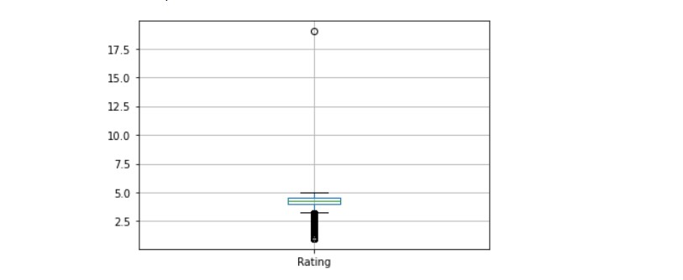

**Fig -1**: Rating

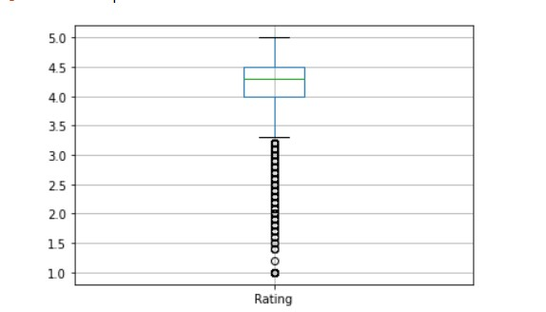

**Fig -2**: Rating

|  |  |
| --- | --- |
| **Fig -3**: | used like as ”Pathetic”, ”stupid” and ”weird”. Because of this the probabilistic outcome of the review was 0*.*135. Finally the user starred rating was normalised to 0*.*8. Averaging the two |

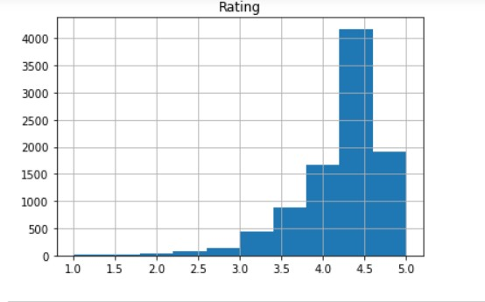 IV. EXTRACTING RATING FROM USER REVIEW

H

ere it is seen that there lies a vast difference between the starred rating and the review written by the user. As we see the review is written in an informal way, we used the online NLP tools stated in one of the earlier sections to find out the root words, consistency/inconsistency networks. After that we used our proposed probabilistic model on the generated network to find out the polarity of the review. In the mentioned review there are some negative informal words

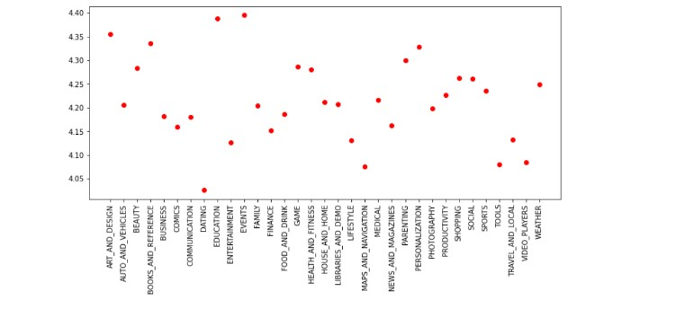numeric values we generate the final rating 0*.*4675 which is of a below average standard.

We focus only on the mentioned review we can conclude that the particular user is not happy with the app but if we focus only on the starred rating other users may be deceived from the actual sentiment of the user. However, the combined rating minimizes the degree of difference between the two different ratings posted by the user.

|  |  |  |  |
| --- | --- | --- | --- |
| **Fig -4**: Ratings |  | V. | FUTURE WORKS |

T

|  |  |  |
| --- | --- | --- |
| **Fig -7**: Category wise reviews | [2] | J. Jong, “Predicting Rating with Sentiment Analysis,” pp. 1–  5, 2011. [Online]. Available: http://cs229.stanford.edu/proj2011/JongPredictingRatingwithSentime ntAnalysis.pdf |

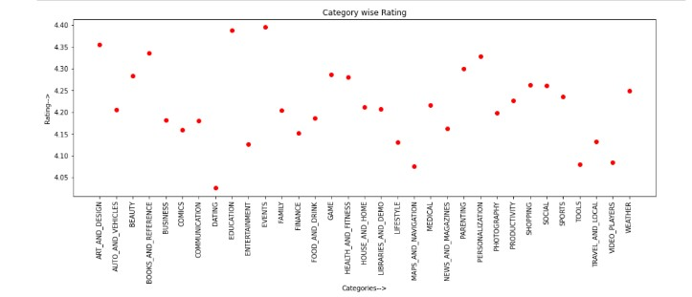HE whole proposal for the desired result is given on the theoretical and practical works done before. This procedure is not implemented on a noteworthy number of data so the efficiency can’t be measured now due to lack of time and resources. A study can be done on the theoretical results of the procedure which will be done on a sound amount of user reviews. Furthermore, the procedure can be modified or changed with other efficient algorithm to get the desired

result.

|  |  |  |  |
| --- | --- | --- | --- |
| **Fig -5**: Category wise rating |  | VI. | CONCLUSION |

I

|  |  |
| --- | --- |
| **Fig -6**: Category wise pricing | the informal reviews and blogs. According to the authors of the approach we followed it is efficient for the diverse sentiment expressions of definite domains. As the user reviews of apps vary from category to category, the proposed procedure is efficient from that point of view. |

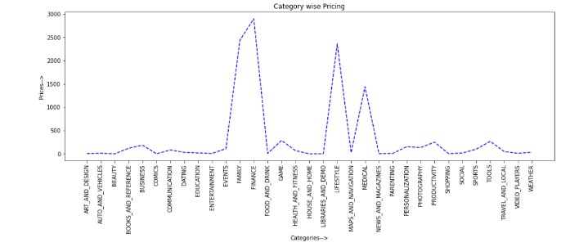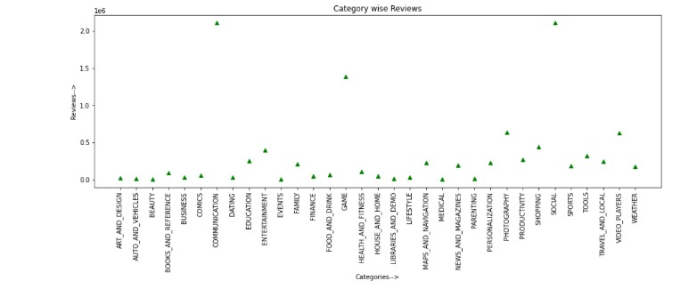N this paper, a procedure to get unified user rating from the written reviews and starred rating is described based on another optimization-based approach for extracting diverse sentiment expressions. To the best of my knowledge, this procedure of unifying rating has not been considered for studies earlier. Earlier it was limited to extracting polarity only.

Mostly the area of formal writings are taken under considerations. Recently a number of works has been done for

REFERENCES

[1] A. Maas, R. Daly, P. Pham, and D. Huang, “Learning word vectors for sentiment analysis,” *Proceedings of the 49th Annual Meeting of the Association for Computational Linguistics: Human Language Technologies*, vol. 1, 2011. [Online]. Available: http://dl.acm.org/citation.cfm?id=2002491

1. L. Chen, W. Wang, M. Nagarajan, S. Wang, and A. Sheth, “Extracting Diverse Sentiment Expressions with Target-Dependent Polarity from Twitter.” *ICWSM*, vol. 2, no. 3, pp. 50–57, 2012.

[View publication stats](https://www.researchgate.net/publication/279197961)

1. K. Dave, S. Lawrence, and D. Pennock, “Mining the peanut gallery: Opinion extraction and semantic classification of product reviews,” *Proceedings of the 12th international conference on World Wide Web*, pp. 519–528, 2003. [Online]. Available:

http://dl.acm.org/citation.cfm?id=775226

1. M. Hu and B. Liu, “Mining and summarizing customer reviews,” *Proceedings of the tenth ACM SIGKDD international conference on*

*Knowledge discovery and data mining*, pp. 168–177, 2004. [Online].

Available: http://dl.acm.org/citation.cfm?id=1014073

1. ——, “Mining opinion features in customer reviews,” *AAAI*, pp. 755– 760, 2004. [Online]. Available: http://www.aaai.org/Papers/AAAI/2004/AAAI04-119.pdf
2. L. Ku, T. Wu, L. Lee, and H. Chen, “Construction of an evaluation corpus for opinion extraction,” *Proc. of the Fifth NTCIR Wksp. on Evaluation of Information Access Technologies: Information*
3. *Retrieval, Question Answering, and Cross-Lingual Information Access*, pp. 513–520, 2005.

[Online]. Available: http://nlg.csie.ntu.edu.tw/conference papers/ntcir2005a.pdf

1. B. Pang, L. Lee, and S. Vaithyanathan, “Thumbs up?: sentiment classification using machine learning techniques,” *Proceedings of the ACL-02 conference on Empirical methods in natural language processing*, vol. 10, pp. 79–86, 2002. [Online]. Available: http://dl.acm.org/citation.cfm?id=1118704
2. C. Cardie, J. Wiebe, T. Wilson, and D. Litman, “Combining Low-Level and Summary Representations of Opinions for Multi-Perspective Question Answering.” *New directions in question answering*, pp. 20–

27, 2003. [Online]. Available:

http://www.aaai.org/Papers/Symposia/Spring/2003/SS03-07/SS03-

07-004.pdf

1. H. Takamura, T. Inui, and M. Okumura, “Extracting semantic orientations of words using spin model,” *Proceedings of the 43rd Annual Meeting on Association for Computational Linguistics. Association for Computational Linguistics*, no. June, pp. 133–140, 2005. [Online]. Available: http://dl.acm.org/citation.cfm?id=1219857
2. A. Popescu and O. Etzioni, “Extracting product features and opinions from reviews,” *Natural language processing and text mining*, no. April, pp. 19–38, 2007. [Online]. Available: http://link.springer.com/chapter/10.1007/978-1-84628-754-1 2
3. A. Buche, D. Chandak, and A. Zadgaonkar, “Opinion Mining and Analysis: A survey,” *International Journal on Natural Language Computing*, vol. 2, no. 3, pp. 39–48, 2013. [Online]. Available:

http://arxiv.org/abs/1307.3336

1. B. Liu, “Sentiment analysis and subjectivity,” *Handbook of natural language processing*, vol. 2, p. 568, 2010.

[Online]. Available: http://people.sabanciuniv.edu/berrin/proj102/1BLiu-Sentiment

Analysis and Subjectivity-NLPHandbook-2010.pdf