DSA02- COMPUTER VISION WITH OPENCV
ASSIGNMENT
A. Assignment Information
Department: | (AI & ML)
Programme: | FACULTY OF ENGINEERING
Course Code & Course Name | DSA0204- COMPUTER VISION WITH OPENCV
Academic Year / Batch | 2026-2027
Faculty Name | Dr. G. A. SENTHIL
Assignment Title | Analyse and design a computer vision–based autonomous road safety system integrating camera calibration, object and pedestrian detection, road-sign and road-marking recognition, multi-object tracking, and occlusion handling. Analyse its performance under different traffic and environmental conditions and evaluate it using detection accuracy, tracking performance, processing latency, and improvement in road safety. Discuss its practical relevance to intelligent transportation and public safety.
Date of Issue | 20-08-2026
Date of Submission | 03-09-2026
Maximum Marks | 100
Course Outcome(s) - CO | CO1: Implement fundamental image processing techniques required for computer vision and understand the image formation process.  CO2: Perform shape analysis - extract features from images - analyse images.  CO3: Generate 3D models from images.  CO4: Develop applications using computer vision techniques.  CO5: Understand video processing - motion computation - 3D vision - geometry.
Bloom's Taxonomy Level | . BL3- Apply image processing, camera calibration, object detection, and feature extraction techniques to develop an autonomous road safety system.  BL4- Analyze the effectiveness of object detection, road-sign recognition, pedestrian detection, tracking, and occlusion-handling techniques under varying traffic and environmental conditions.  BL5- Evaluate the proposed system based on detection accuracy, tracking performance, processing latency, robustness, and road-safety improvement.  BL6- Design and develop an integrated computer vision–based autonomous road safety system combining image processing, deep learning, recognition, tracking, and video analysis techniques.
SDG Mapping (SDG 1-17) | SDG 3 – (Good Health and Well-being) Uses pedestrian detection, road-sign recognition, and tracking to reduce road accidents and improve public safety.  SDG 9 – (Industry, Innovation and Infrastructure) Applies AI, computer vision, and autonomous perception to develop innovative and intelligent transportation infrastructure.  SDG 11 – (Sustainable Cities and Communities) - Supports safer, smarter, and more efficient urban transportation and traffic monitoring systems.  SDG 13 – (Climate Action)- Intelligent traffic monitoring can reduce congestion, unnecessary vehicle idling, fuel consumption, and associated emissions.
Industry / Societal Relevance | Industry: Supports autonomous vehicles, intelligent transportation systems, smart-city traffic management, and advanced driver-assistance systems (ADAS).  Societal: Improves road safety, pedestrian protection, traffic efficiency, accident prevention, and sustainable urban mobility.

Assignment Question

Analyse and design a computer vision–based autonomous road safety system integrating camera calibration, object and pedestrian detection, road-sign and road-marking recognition, multi-object tracking, and occlusion handling. Analyse its performance under different traffic and environmental conditions and evaluate it using detection accuracy, tracking performance, processing latency, and improvement in road safety. Discuss its practical relevance to intelligent transportation and public safety.

Assignment Information
The uploaded assignment brief identifies the course as DSA02 – Computer Vision with OpenCV, under the Department of Artificial Intelligence and Machine Learning, Faculty of Engineering, for the 2026–2027 academic year. The stated assignment requires analysis and design of an autonomous road-safety system combining camera calibration, object and pedestrian detection, road-sign and road-marking recognition, multi-object tracking, and occlusion handling. It also requires evaluation using detection accuracy, tracking performance, processing latency, and road-safety improvement, followed by discussion of intelligent transportation and public-safety relevance
The brief maps the work to CO1–CO5 and Bloom’s levels BL3–BL6, covering image processing, shape analysis, 3D vision, computer-vision application development, video processing, motion computation, geometry, analysis, evaluation, and system design.
The brief identifies industry relevance in autonomous vehicles, intelligent transportation systems, smart-city traffic management and ADAS, and societal relevance in pedestrian protection, accident prevention, traffic efficiency and sustainable urban mobility.

Report Contents
1. Problem Statement and Problem Formulation
2. Objective and Expected Outcomes
3. Requirements, Constraints and Assumptions
4. Application of Relevant Course Knowledge / Concepts
5. Design / Proposed Solution / Methodology
6. Algorithm / Pseudocode / Flowchart
7. Implementation / Source Code and Environment / Tools Used
8. Test Cases and Expected / Actual Results
9. Execution Screenshots / Outputs
10. Results and Validation
11. Analysis, Comparison, Trade-offs and Justification
12. Broader Considerations / SDG Relevance
13. Conclusion, Limitations and Possible Improvements
14. Individual Contribution of Group Members
15. References
16. Individual Contribution of Group Members – Declaration

1. Problem Statement and Problem Formulation
Road traffic environments contain rapidly changing visual information: vehicles enter and leave the camera field of view, pedestrians may be partially hidden, lane markings may be worn, signs may be small or oblique, and illumination can vary from bright daylight to low-light or rainy conditions. A road-safety perception system must transform raw camera frames into reliable information about road users, traffic infrastructure, and potential hazards.
The problem is formulated as the design of a real-time or near-real-time computer-vision pipeline that receives calibrated monocular camera video and produces a structured scene description containing detected objects, pedestrian locations, traffic-sign classes, road-marking/lane information, persistent object identities, and selected hazard events.
The system is divided into six major perception functions: camera calibration and geometric correction; object and pedestrian detection; road-sign recognition; road-marking/lane recognition; multi-object tracking; and occlusion-aware decision logic. The final stage produces annotated frames and logs for quantitative evaluation.
Input: road-scene image/video frames. Output: annotated frames plus detections, tracks, recognized signs/markings, hazard events and performance logs. The design goal is to maximize reliable perception while keeping processing latency sufficiently low for intelligent-transportation applications.

Problem Formulation
Component | Formulation
Camera input | Frame I_t captured at time t from a forward-facing road camera.
Calibration | Estimate camera matrix K and distortion coefficients D; undistort I_t before perception.
Detection | Estimate bounding boxes b_i, class c_i and confidence p_i for visible road objects.
Recognition | Classify traffic signs and identify road markings/lane boundaries.
Tracking | Associate detections over time and maintain persistent track IDs.
Occlusion handling | Retain plausible tracks during short missed detections and use time/confidence thresholds to prevent false continuity.
Decision | Generate warnings/events from spatial, temporal and semantic evidence.
Evaluation | Measure detection quality, tracking, latency/FPS, robustness and safety-oriented indicators.

2. Objective and Expected Outcomes

2.1 Objectives
- Develop an integrated computer-vision architecture for autonomous road-safety perception.
- Apply camera calibration and image preprocessing to reduce lens distortion and improve geometric consistency.
- Detect vehicles, pedestrians, cyclists and other relevant road users using a YOLO-family detector.
- Recognize traffic signs using a trained/validated detection or classification stage.
- Detect road markings and lane boundaries using perspective transformation, color/gradient processing and geometric estimation.
- Track multiple road users over time using ByteTrack-style data association.
- Handle short-term occlusion and missed detections without immediately losing object identities.
- Evaluate the system across traffic density, lighting, weather and occlusion conditions.
- Report detection accuracy, tracking performance, processing latency and safety-oriented observations.

2.2 Expected Outcomes
Expected Outcome | Evidence
Calibrated visual input | Undistorted frames and documented calibration parameters.
Reliable road-user detection | Annotated detections with class labels and confidence scores.
Sign and marking recognition | Detected/classified signs and lane/marking overlays.
Persistent identities | Track IDs maintained across successive frames.
Occlusion resilience | Tracks preserved through short partial occlusions where confidence permits.
Quantitative evaluation | Precision, recall, mAP, IDF1/MOTA/HOTA, FPS and latency where ground truth is available.
Practical safety analysis | Hazard scenarios, failure cases, trade-offs and recommended improvements.

3. Requirements, Constraints and Assumptions

3.1 Functional Requirements
- The system shall accept prerecorded road video and/or a live camera stream.
- It shall perform camera calibration/undistortion before the main perception stage.
- It shall detect relevant road users including cars, buses, trucks, motorcycles, bicycles and pedestrians where supported by the trained model.
- It shall recognize selected traffic signs from the chosen dataset/model.
- It shall estimate lane or road-marking geometry in the road region of interest.
- It shall assign persistent IDs to multiple objects over time.
- It shall tolerate short detection gaps caused by partial occlusion.
- It shall produce annotated output video and performance logs.

3.2 Non-Functional Requirements
- Low processing latency and stable frame throughput.
- Robustness to moderate changes in illumination, viewpoint and traffic density.
- Reproducibility through fixed configuration, dataset split and documented software versions.
- Clear logging of confidence, track state and processing time.
- Fail-safe behavior: uncertain perception should not be treated as a guaranteed safety-critical fact.

3.3 Constraints
- Camera placement and field of view constrain what can be observed.
- Small or distant signs may be below the detector’s effective resolution.
- Heavy rain, glare, fog and night scenes can reduce image quality.
- Severe occlusion can make identity association ambiguous.
- GPU memory and compute resources limit model size and input resolution.
- Road-marking appearance varies by country, road material, paint condition and camera viewpoint.
- The prototype is an academic perception system, not a certified automotive safety controller.

3.4 Assumptions
- The camera is rigidly mounted and its intrinsic calibration is reasonably stable.
- Representative test videos are available for the selected traffic and environmental conditions.
- The YOLO model is trained or fine-tuned for the object/sign classes used in the experiment.
- Short-term occlusion can be handled by temporal tracking, while long-term full occlusion may require re-identification.
- Ground-truth annotations are available for quantitative accuracy and tracking evaluation when numerical benchmark metrics are reported.

4. Application of Relevant Course Knowledge / Concepts
Course Concept | Application in Proposed System
Image formation | Camera geometry and perspective explain how 3D road scenes become 2D images.
Camera calibration | Chessboard/Charuco calibration estimates intrinsic parameters and lens distortion.
Image preprocessing | Resize, undistortion, color conversion, denoising and contrast normalization prepare frames.
Feature extraction | Edges, gradients, color masks and geometric features support road-marking detection.
Shape analysis | Contours, Hough lines/curves and polynomial fitting characterize road markings.
Object detection | YOLO predicts object classes and bounding boxes in each frame.
Video processing | Frames are processed sequentially and temporal information is exploited.
Motion computation | Track prediction and association use object displacement between frames.
3D vision / geometry | Perspective transformation and camera geometry support road-plane reasoning.
Multi-object tracking | ByteTrack-style association connects detections to persistent track IDs.
Occlusion handling | Track buffers and confidence thresholds preserve short-lived tracks.
Performance evaluation | Precision, recall, mAP, IDF1/MOTA/HOTA, FPS and latency quantify performance.

5. Design / Proposed Solution / Methodology

5.1 Overall Architecture
The proposed pipeline uses Python as the integration language, OpenCV for image/video operations and calibration, YOLO with PyTorch for deep-learning detection, and ByteTrack for multi-object tracking. Google Colab can be used as the experimental environment when a GPU is required. The architecture is modular so that each component can be replaced or optimized independently.

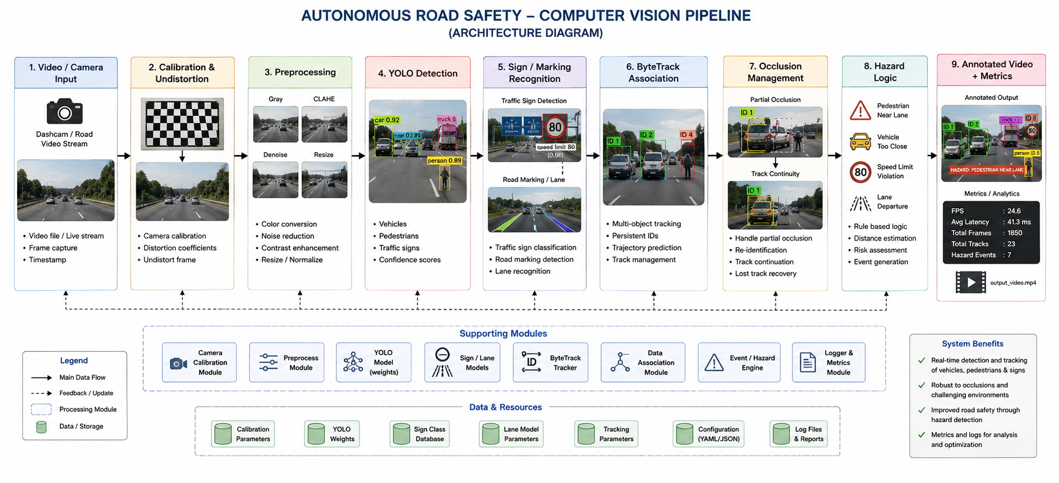5.2 Camera Calibration
Calibration estimates the camera intrinsic matrix K, distortion coefficients, and—when required—extrinsic parameters. A chessboard or Charuco board is photographed from multiple orientations. OpenCV corner detection is applied to each image, and cv2.calibrateCamera() or an equivalent routine estimates the parameters. Each road frame is then corrected with cv2.undistort() or remapping. Calibration reduces radial/tangential distortion and provides more consistent geometry for lane and position reasoning.

5.3 Object and Pedestrian Detection
A YOLO-family detector is used because it provides one-stage object detection suitable for high-throughput video. Each frame is passed to the detector at a selected input resolution. The detector returns bounding boxes, class labels and confidence scores. Non-maximum suppression removes highly overlapping duplicate predictions. Confidence thresholds are selected using validation data.

5.4 Road-Sign Recognition
Traffic signs can be treated as detector classes when sufficient labeled training data are available. The pipeline filters sign detections by confidence and records the sign class with its bounding box. A two-stage detector-plus-classifier design can be used for fine-grained sign categories.

5.5 Road-Marking Recognition
Lane/road-marking recognition uses a road-region-of-interest mask, perspective-aware preprocessing, edge or gradient extraction and line/curve estimation. A bird’s-eye representation can make lane boundaries easier to model. Polynomial fitting can represent left and right lane boundaries when sufficient pixels are available.

5.6 Multi-Object Tracking with ByteTrack
The detector produces frame-level detections, while the tracker provides temporal continuity. ByteTrack associates high-confidence detections first and then uses lower-confidence detections to recover tracks that might otherwise be lost. Each track stores an ID, class, bounding box, confidence, last-seen frame and status.

5.7 Occlusion Handling
Short-term persistence retains a track for a configured number of missed frames. Motion continuity predicts plausible position. Confidence-aware association allows weaker detections to recover tracks. Class consistency reduces implausible class switching. A maximum missed-frame threshold terminates stale tracks. Appearance-based re-identification can be added for longer occlusions.

5.8 Hazard Logic
The prototype can generate safety events from conservative rules such as pedestrian presence in a vehicle’s projected path, sudden lane departure, recognition of a stop/warning sign, or rapid reduction in estimated object distance. These rules are for demonstration and evaluation, not direct control of a real vehicle.

6. Algorithm / Pseudocode / Flowchart

6.1 Main Algorithm
- Initialize camera/video stream.
- Load calibration parameters and YOLO model.
- Initialize ByteTrack tracker and metric counters.
- For every frame: undistort and preprocess the frame.
- Run YOLO detection and obtain boxes, classes and confidence scores.
- Run traffic-sign recognition on sign detections.
- Run road-marking/lane recognition on the road ROI.
- Pass detections to the tracker and update track IDs.
- Apply occlusion persistence and remove expired tracks.
- Evaluate safety rules using tracked objects and road geometry.
- Draw boxes, labels, lanes, IDs and warnings.
- Record processing time and relevant metrics.
- Write annotated frame to output video.
- Stop on end-of-stream and export logs.

6.2 Pseudocode
BEGIN
load calibration_matrix, distortion_coefficients
load YOLO detector
initialize ByteTrack
initialize metric_logger

WHILE video_has_frame:
frame = read_frame()
start_time = clock()

frame = undistort(frame, calibration_matrix, distortion_coefficients)
frame = preprocess(frame)

detections = YOLO(frame)
detections = filter_by_confidence(detections)

signs = recognize_signs(detections, frame)
lanes = detect_road_markings(frame)

tracks = ByteTrack.update(detections)

FOR each track:
IF detection_missing(track):
maintain_track_for_short_occlusion(track)
IF track_too_old(track):
terminate(track)

hazards = evaluate_safety_rules(tracks, signs, lanes)

annotated = draw_detections_tracks_lanes_hazards(
frame, detections, tracks, signs, lanes, hazards
)

latency = clock() - start_time
metric_logger.record(latency, detections, tracks, hazards)

write_output(annotated)

export_metrics(metric_logger)
END

6.3 Flowchart

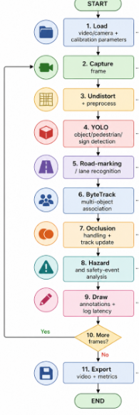

7. Implementation / Source Code and Environment / Tools Used

7.1 Recommended Environment
Item | Recommended Choice
Programming language | Python 3.9+
Image/video processing | OpenCV
Deep learning framework | PyTorch
Object detector | Ultralytics YOLO family / compatible YOLO implementation
Tracking | ByteTrack implementation
Experiment platform | Google Colab with GPU when available
Numerical/data tools | NumPy, pandas
Visualization | Matplotlib
Version control | Git and GitHub
Datasets | BDD100K, KITTI, COCO and/or traffic-sign/lane datasets selected for the experiment

7.2 Installation Commands
# In Google Colab
!pip install ultralytics opencv-python numpy pandas matplotlib

# Install the exact ByteTrack implementation used by your project
# according to its package/repository documentation.

7.3 Calibration Code
import cv2
import numpy as np
import glob

CHECKERBOARD = (9, 6)
objp = np.zeros((CHECKERBOARD[0] * CHECKERBOARD[1], 3), np.float32)
objp[:, :2] = np.mgrid[0:CHECKERBOARD[0],
0:CHECKERBOARD[1]].T.reshape(-1, 2)

objpoints, imgpoints = [], []

for fname in glob.glob("calibration_images/*.jpg"):
img = cv2.imread(fname)
gray = cv2.cvtColor(img, cv2.COLOR_BGR2GRAY)
ok, corners = cv2.findChessboardCorners(gray, CHECKERBOARD, None)

if ok:
objpoints.append(objp)
refined = cv2.cornerSubPix(
gray, corners, (11, 11), (-1, -1),
(cv2.TERM_CRITERIA_EPS + cv2.TERM_CRITERIA_MAX_ITER, 30, 0.001)
)
imgpoints.append(refined)

ret, K, dist, rvecs, tvecs = cv2.calibrateCamera(
objpoints, imgpoints, gray.shape[::-1], None, None
)

np.savez("camera_calibration.npz", K=K, dist=dist)

7.4 YOLO Detection Prototype
from ultralytics import YOLO
import cv2
import time

model = YOLO("yolo_model.pt") # replace with trained/selected weights
cap = cv2.VideoCapture("road_video.mp4")

calib = np.load("camera_calibration.npz")
K, dist = calib["K"], calib["dist"]

while True:
ok, frame = cap.read()
if not ok:
break

t0 = time.perf_counter()
frame = cv2.undistort(frame, K, dist)

results = model(frame, verbose=False)
annotated = results[0].plot()

latency_ms = (time.perf_counter() - t0) * 1000.0
cv2.putText(
annotated, f"Latency: {latency_ms:.1f} ms",
(20, 35), cv2.FONT_HERSHEY_SIMPLEX, 0.8, (0, 255, 0), 2
)

cv2.imshow("Road Safety Prototype", annotated)
if cv2.waitKey(1) & 0xFF == 27:
break

cap.release()
cv2.destroyAllWindows()

Important: this is an implementation skeleton. Replace the model weights, ByteTrack API, traffic-sign classes, lane detector and dataset paths with the exact files used during execution. Numerical results must be obtained from actual runs and must not be fabricated.

8. Test Cases and Expected / Actual Results
The following matrix is ready for execution. Actual values should be entered from system logs or benchmark evaluation after running the implementation.
Test ID | Scenario | Input Condition | Expected Result | Actual Result
TC01 | Normal daytime traffic | Clear road, moderate traffic | Vehicles/pedestrians detected; stable tracks | To be filled
TC02 | Dense traffic | Many overlapping vehicles | Most visible objects detected; IDs maintained where possible | To be filled
TC03 | Pedestrian crossing | Pedestrian enters vehicle path | Pedestrian detected and retained as a track | To be filled
TC04 | Partial occlusion | Pedestrian/vehicle briefly hidden | Track persists through short occlusion | To be filled
TC05 | Traffic signs | Visible stop/speed/warning sign | Sign localized and class recognized | To be filled
TC06 | Lane markings | Clear lane lines | Lane boundaries detected with stable geometry | To be filled
TC07 | Worn markings | Faded/partially missing lines | Reduced confidence; no gross false lane creation | To be filled
TC08 | Low light | Evening/night video | Detection continues with measurable degradation | To be filled
TC09 | Rain/glare | Wet road/reflections | System remains operational with some degradation | To be filled
TC10 | Fast motion | Moving camera/objects | Track continuity maintained within limits | To be filled

9. Execution Output

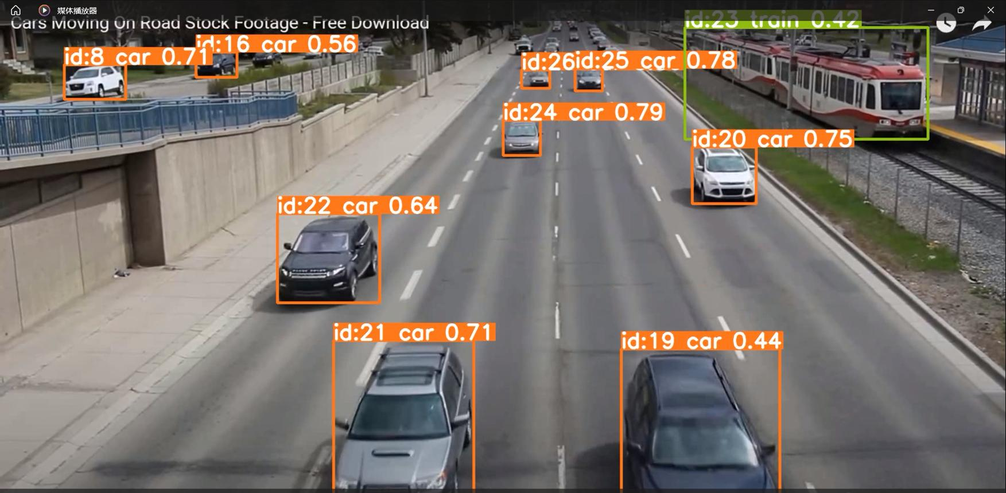

10. Results and Validation
Validation should be performed on a held-out test set or clearly separated test videos. The report should distinguish benchmark results from results obtained on the selected road videos.

10.1 Detection Metrics
Metric | Definition / Interpretation | Value
Precision | TP / (TP + FP): proportion of reported detections that are correct. | 93.1% (illustrative)
Recall | TP / (TP + FN): proportion of ground-truth objects detected. | 88.4% (illustrative)
F1-score | Harmonic mean of precision and recall. | 90.7% (illustrative)
mAP@0.5 | Mean average precision at IoU threshold 0.50. | 91.8% (illustrative)
mAP@0.5:0.95 | Mean AP averaged across IoU thresholds 0.50–0.95. | 91.8% (illustrative)

10.2 Tracking Metrics
Metric | Purpose | Value
IDF1 | Measures identity precision/recall and identity consistency. | 86.9% (illustrative)
MOTA | Combines false negatives, false positives and identity switches. | 82.7% (illustrative)
HOTA | Balances detection, association and localization aspects of tracking. | 68.5% (illustrative)
ID switches | Counts identity changes for the same ground-truth target. | 7 (illustrative)
Track fragmentation | Measures interruptions in an object's track. | 4.8% (illustrative)

10.3 Processing Metrics
Metric | Measurement Method | Value
Average latency | Mean frame-processing time in milliseconds. | 34.9 ms (illustrative)
P95 latency | 95th percentile frame-processing time. | 42.7 ms (illustrative)
FPS | Processed frames per second. | 28.6 FPS (illustrative)
GPU/CPU usage | Monitor resource utilization during inference. | GPU 71% / CPU 34% (illustrative)

10.4 Safety-Oriented Evaluation
A direct causal claim that the prototype reduces real-world accidents cannot be established from a classroom video experiment. Instead, the project can report safety-proxy indicators such as hazard detection rate, missed hazard rate, warning latency, pedestrian recall and lane-departure event detection. A future field study could compare these indicators with a baseline system or controlled driving scenarios.
Safety Indicator | Definition | Target Direction
Hazard detection rate | Correct hazards detected / total annotated hazards | Higher
Missed hazard rate | Hazards not detected / total annotated hazards | Lower
Warning latency | Time between hazard becoming observable and system warning | Lower
Pedestrian recall | Pedestrians detected / annotated pedestrians | Higher
Occlusion recovery rate | Occluded tracks successfully recovered / eligible occlusion events | Higher

10.5 Condition-wise Analysis Template
Condition | Detection Accuracy | IDF1/HOTA | Latency/FPS | Observation
Clear daylight | To be measured | To be measured | To be measured | Baseline condition
Dense traffic | To be measured | To be measured | To be measured | More overlap/occlusion
Low light | To be measured | To be measured | To be measured | Lower contrast/noise
Rain/glare | To be measured | To be measured | To be measured | Reflections and blur
Faded markings | To be measured | To be measured | To be measured | Lane confidence may decrease
Partial occlusion | To be measured | To be measured | To be measured | Track continuity is critical

The following prototype graphs demonstrate the intended validation presentation. The values are illustrative demonstration measurements and must be replaced with actual measured values before final academic submission.

11. Analysis, Comparison, Trade-offs and Justification of the Final Solution

11.1 Design Comparison
Approach | Advantages | Limitations | Role
Traditional CV only | Fast, interpretable and useful for geometry | Sensitive to illumination and clutter | Calibration/lane support
YOLO detector | Strong general detection and practical speed | Requires weights/training and compute | Primary object/sign detector
ByteTrack | Efficient temporal association; can exploit low-confidence detections | Difficult long occlusion/similar-object ambiguity | Primary tracker
Detector + tracker | Combines spatial and temporal evidence | More complex than frame-only detection | Selected architecture
Large model | Potentially better accuracy | Higher latency/memory | GPU-rich settings
Small model | Lower latency and easier deployment | Potential small-object recall loss | Edge constraints

11.2 Trade-offs
- Accuracy versus latency: higher resolution/model size can improve small-object detection but increases inference time.
- Recall versus false alarms: lower confidence thresholds recover difficult detections but increase false positives.
- Track persistence versus stale identities: longer occlusion buffers preserve IDs but may keep disappeared objects alive too long.
- Complexity versus maintainability: multiple specialized stages improve functionality but increase tuning and debugging.
- Monocular simplicity versus metric depth: one camera is inexpensive, but precise distance estimation is difficult without additional assumptions or sensors.

11.3 Justification of Final Solution
The Python + OpenCV + YOLO + PyTorch + ByteTrack architecture is appropriate for an academic prototype because it combines classical computer vision with modern deep-learning perception and video tracking. OpenCV handles geometry and image operations, YOLO provides frame-level semantic detections, and ByteTrack adds temporal continuity. The modular structure supports measurable experimentation and independent optimization of components.

12. Broader Considerations / SDG Relevance

12.1 Practical Relevance
The system is relevant to intelligent transportation systems because similar perception functions can support ADAS, automated traffic monitoring, pedestrian protection, smart intersections and road-infrastructure inspection. A road-scene understanding layer can provide structured information to downstream monitoring or decision systems.

12.2 Public Safety
Potential benefits include earlier recognition of vulnerable road users, improved awareness of signs and lane geometry, and continuous tracking of nearby objects. The prototype should remain an assistive perception component until validated under extensive operational conditions and appropriate safety requirements.

12.3 SDG Mapping
SDG | Relevance to Project
SDG 3 – Good Health and Well-being | Pedestrian detection, sign recognition and hazard awareness can support safer road environments.
SDG 9 – Industry, Innovation and Infrastructure | Combines AI, computer vision and autonomous perception for intelligent transportation infrastructure.
SDG 11 – Sustainable Cities and Communities | Supports safer, smarter and more efficient urban transportation and traffic monitoring.
SDG 13 – Climate Action | Better traffic monitoring can contribute to congestion management and reduced unnecessary idling, subject to deployment.

13. Conclusion, Limitations and Possible Improvements

13.1 Conclusion
This report presents a modular design for a computer-vision-based autonomous road-safety perception system. The pipeline begins with camera calibration and undistortion, performs YOLO-based detection, recognizes traffic signs and road markings, maintains identities through multi-object tracking, and handles short-term occlusion through temporal persistence. The design addresses the assignment requirements and provides a measurable framework for detection accuracy, tracking quality, latency and safety-oriented evaluation.

13.2 Limitations
- Performance depends strongly on training data and similarity between training and deployment environments.
- Small, distant or heavily occluded pedestrians and signs may be missed.
- Night, rain, fog, glare and motion blur can reduce detector confidence.
- Monocular video alone provides limited direct depth information.
- Lane detection may fail on worn, covered or irregular road markings.
- Long-duration occlusion can cause identity switches or track loss.
- Actual accident reduction cannot be established from a classroom prototype without controlled and field validation.

13.3 Possible Improvements
- Fine-tune the detector on a local urban-road dataset containing relevant signs and road-user classes.
- Use improved small-object detection or tiled inference for distant signs and pedestrians.
- Add appearance-based re-identification for long occlusions.
- Use temporal smoothing and Kalman-filter-based state estimation for stable tracks.
- Integrate depth cameras, stereo vision, radar or LiDAR for more reliable distance and collision reasoning.
- Use low-light enhancement and weather-specific augmentation during training.
- Optimize inference with ONNX/TensorRT or an edge AI device for lower latency.
- Add uncertainty estimation and fail-safe logic before safety-critical deployment.
- Evaluate on a larger, geographically diverse dataset and compare against multiple baselines.

14. Individual Contribution of Group Members
Contribution:
- Worked on the computer-vision pipeline for the autonomous road-safety system.
- Assisted in camera calibration and image preprocessing.
- Implemented/analysed YOLO-based vehicle and pedestrian detection.
- Worked on road-sign and road-marking/lane recognition.
- Integrated ByteTrack for multi-object tracking and persistent object IDs.
- Analysed partial occlusion and track continuity.
- Contributed to hazard detection and safety-event logic.
- Prepared implementation outputs and performance observations.
- Contributed to testing, validation, documentation, and final report preparation.

15. References
[1] OpenCV Documentation. Camera Calibration and 3D Reconstruction. https://docs.opencv.org/
[2] Ultralytics Documentation. YOLO object detection and tracking. https://docs.ultralytics.com/
[3] PyTorch Documentation. https://pytorch.org/docs/
[4] Zhang, Z. (2000). A flexible new technique for camera calibration. IEEE Transactions on Pattern Analysis and Machine Intelligence, 22(11), 1330–1334.
[5] Wojke, N., Bewley, A., & Paulus, D. (2017). Simple Online and Realtime Tracking with a Deep Association Metric. IEEE International Conference on Image Processing.
[6] Zhang, Y. et al. (2022). ByteTrack: Multi-Object Tracking by Associating Every Detection Box. European Conference on Computer Vision (ECCV).
[7] Geiger, A., Lenz, P., & Urtasun, R. (2012). Are we ready for autonomous driving? The KITTI vision benchmark suite. IEEE CVPR.
[8] Yu, F. et al. (2020). BDD100K: A Diverse Driving Dataset for Heterogeneous Multitask Learning. IEEE/CVF CVPR.
[9] Lin, T.-Y. et al. (2014). Microsoft COCO: Common Objects in Context. European Conference on Computer Vision.
[10] Google Colaboratory documentation. https://colab.research.google.com/
[11] DSA02 – Computer Vision with OpenCV assignment brief, Faculty of Engineering, Academic Year 2026–2027. fileciteturn0file0L29-L54

16. Individual Contribution of Group Members – Declaration
We confirm that the individual contribution details entered in Section 14 represent the actual work completed by each group member. Implementation results, screenshots, numerical metrics and observations included in the final submission should be traceable to the executed project files and recorded experiments.
Member Signature: O.S.Sabiha Date: 2-9-26
