QUESTION 1: Regular Expression-Based Text Processing
Aim: To develop a Python program using regular expressions to extract email addresses, phone numbers, capitalized words, numerical values, and words ending with 'ing' and 'ed'.
Concept
Regular Expressions (Regex) are patterns used to search, match, and extract specific information from text.
Python provides the re module to perform regular expression operations.
Important functions:
- re.findall() – Finds all occurrences matching a pattern.
- re.search() – Searches for the first occurrence.
- re.compile() – Compiles a regular expression pattern.
Python Program
import re

text = """
Dr. Anitha is conducting NLP Training in Chennai on 25-11-2026.
Contact anitha@gmail.com or support.team@college.edu.
Call 9876543210 or 044-24561234 for details.
Students are learning, testing and developing projects.
The completed assignment contains 10 questions.
"""

emails = re.findall(
r'\b[A-Za-z0-9._%+-]+@[A-Za-z0-9.-]+\.[A-Za-z]{2,}\b', text)

phones = re.findall(
r'(?<!\w)(?:\+?\d{1,3}[- ]?)?(?:\d{10}|\d{3}[- ]\d{7}|\d{2,4}[- ]\d{6,8})(?!\w)', text)

capital_words = re.findall(r'\b[A-Z][a-zA-Z]*\b', text)

numbers = re.findall(r'\b\d+(?:\.\d+)?\b', text)

ing_words = re.findall(r'\b[A-Za-z]+ing\b', text, re.I)

ed_words = re.findall(r'\b[A-Za-z]+ed\b', text, re.I)

print("Email addresses:", emails)
print("Phone numbers:", phones)
print("Capitalized words:", capital_words)
print("Numerical values:", numbers)
print("Words ending in ing:", ing_words)
print("Words ending in ed:", ed_words)
Sample Output
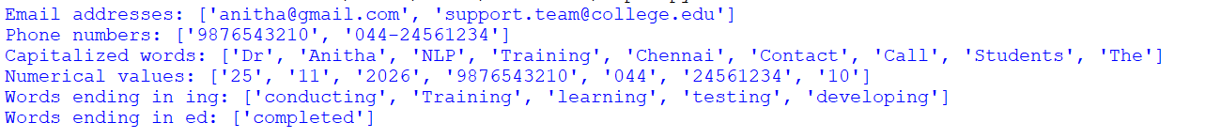Working
- Import the re module.
- Store the paragraph in a variable called text.
- Use re.findall() to extract email addresses and phone numbers.
- Use a capital-letter pattern to identify words beginning with uppercase letters.
- Extract numerical values using \d+.
- Identify words ending in ing and ed using appropriate regex patterns.
- Print each extracted category separately.
Result and Interpretation
The program successfully extracts email addresses, phone numbers, capitalized words, numerical values, and words ending in ing and ed.
Regular expressions are useful for extracting structured information from unstructured text.

QUESTION 2: Finite State Automata for Word Pattern Recognition
Aim: To implement a Finite State Automaton (FSA) using Python to recognize English words based on vowel and consonant patterns.
Concept
A Finite State Automaton (FSA) is a mathematical model used to recognize patterns in strings.
It consists of:
- States
- Input alphabet
- Transition function
- Initial state
- Final or accepting state
The automaton checks the following conditions:
- The word must start with a vowel.
- The word must end with a consonant.
- The word must contain consecutive vowels.
Python Program
VOWELS = set("aeiou")

def recognize_word(word):

word = word.lower()

if not word or not word.isalpha():
return False

starts_with_vowel = word[0] in VOWELS

ends_with_consonant = word[-1] not in VOWELS

consecutive_vowels = False
previous_vowel = False

for ch in word:

current_vowel = ch in VOWELS

if previous_vowel and current_vowel:
consecutive_vowels = True

previous_vowel = current_vowel

if (starts_with_vowel and ends_with_consonant
and consecutive_vowels):
return True

return False

words = ["aircraft", "apple", "audio",
"eagle", "education", "train"]

for word in words:

if recognize_word(word):
print(word, "ACCEPTED")
else:
print(word, "REJECTED")
Sample Output
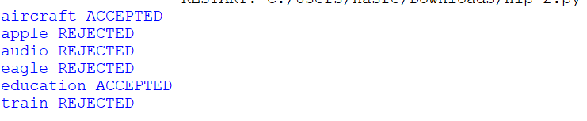
Working
- Define the vowels using a set containing a, e, i, o, u.
- Convert the input word into lowercase.
- Check whether the first character is a vowel.
- Check whether the last character is a consonant.
- Traverse the word character by character.
- Compare the current character with the previous character.
- If both are vowels, set consecutive_vowels to True.
- If all three conditions are satisfied, accept the word; otherwise, reject it.
Result and Interpretation
The program successfully recognizes words based on the specified vowel and consonant conditions.
For example, the word aircraft is accepted because:
- It starts with the vowel a.
- It contains consecutive vowels ai.
- It ends with the consonant t.
Thus, the FSA recognizes valid word patterns based on the given conditions.

QUESTION 3: Morphological Analysis of English Words
Aim: To develop a Python program to perform morphological analysis by identifying the root word, prefixes, suffixes, and morphological structure of English words.
Concept
Morphology is the branch of linguistics that studies the internal structure and formation of words.
A morpheme is the smallest meaningful unit of a word.
There are three important components:
- Root: The main meaningful part of a word.
- Prefix: An affix added before the root.
- Suffix: An affix added after the root.
Examples:
Word | Prefix | Root | Suffix
Unhappiness | un- | happy | -ness
Replaying | re- | play | -ing
Disagreement | dis- | agree | -ment
Careless | None | care | -less
Python Program
analysis = {

"unhappiness": {
"prefix": "un-",
"root": "happy",
"suffix": "-ness"
},

"replaying": {
"prefix": "re-",
"root": "play",
"suffix": "-ing"
},

"disagreement": {
"prefix": "dis-",
"root": "agree",
"suffix": "-ment"
},

"careless": {
"prefix": "None",
"root": "care",
"suffix": "-less"
}
}

for word, parts in analysis.items():

print("\nWord:", word)

print("Prefix:", parts["prefix"])

print("Root:", parts["root"])

print("Suffix:", parts["suffix"])
Sample Output
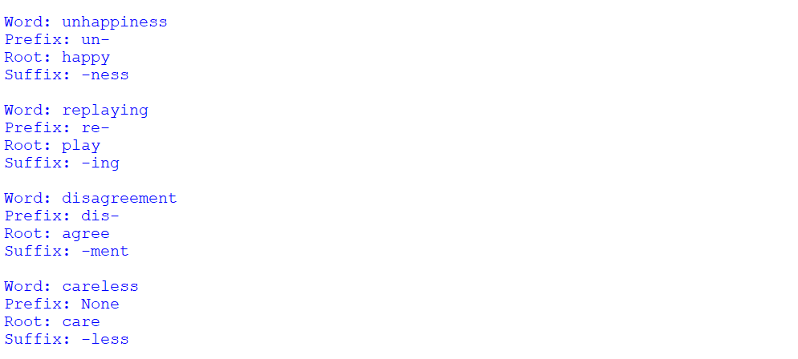Working
- Create a dictionary containing the four English words.
- Store the prefix, root, and suffix of each word.
- Use a for loop to access each word.
- Display its prefix, root, and suffix separately.
- Analyze how the affixes modify the meaning of the root word.
Result and Interpretation
The program successfully identifies the morphological components of English words.
For example:
- Unhappiness = un + happy + ness.
- Replaying = re + play + ing.
- Disagreement = dis + agree + ment.
- Careless = care + less.
This demonstrates how prefixes and suffixes change the meaning or grammatical category of words.

QUESTION 4: Inflectional and Derivational Morphology
Aim: To develop a Python program to identify and classify inflectional and derivational word forms from a given text.
Concept
Morphology is divided into two major types:
1. Inflectional Morphology
Inflectional morphology changes the grammatical form of a word without changing its basic meaning or word class.
Examples:
- Book → Books (Plural)
- Play → Played (Past tense)
- Read → Reading (Present participle)
2. Derivational Morphology
Derivational morphology creates a new word or changes the meaning or grammatical category of a word.
Examples:
- Happy → Unhappy
- Care → Careless
- Help → Helpful
Python Program
text = """
The students are reading books.
The workers completed their tasks.
A helpful teacher explained the lesson.
She is playing and carefully reviewing
the answers. The disagreement was unexpected.
"""

tokens = [w.strip(".,!?;:()").lower()
for w in text.split()]

plural_nouns = {
"students", "books", "workers",
"tasks", "answers"
}

past_tense = {"completed", "explained"}

present_participles = {
"reading", "playing", "reviewing"
}

derivational = {
"helpful", "carefully",
"disagreement", "unexpected"
}

print("Inflectional Forms:")

for word in tokens:

if word in plural_nouns:
print(word, "- Plural Noun")

elif word in past_tense:
print(word, "- Past Tense")

elif word in present_participles:
print(word, "- Present Participle")

print("\nDerivational Forms:")

for word in tokens:

if word in derivational:
print(word, "- Derivational")
Sample Output
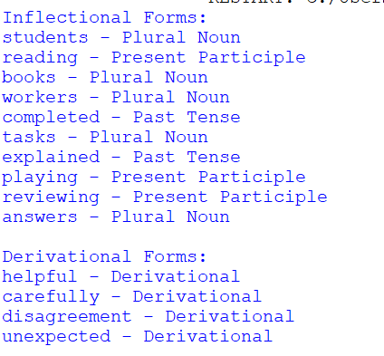
Working
- Store an English paragraph in a variable.
- Split the paragraph into individual words.
- Create separate sets for plural nouns, past-tense verbs, and present participles.
- Create another set for derivational words.
- Traverse the words using a for loop.
- Compare each word with the predefined sets.
- Classify and display the words according to their morphological categories.
Result and Interpretation
The program successfully identifies inflectional and derivational word forms.
Inflectional morphology represents grammatical changes such as tense and number, whereas derivational morphology creates new words or changes their meanings.
QUESTION 5: Porter Stemming Algorithm
Aim: To implement the Porter Stemming Algorithm using Python to identify the root forms of English words.
Concept
Stemming is the process of reducing words to their base or stem form by removing prefixes or suffixes.
The Porter Stemming Algorithm is a rule-based stemming algorithm used in Natural Language Processing.
Examples:
Original Word | Stemmed Word
Playing | play
Played | play
Studies | studi
Studying | studi
Connected | connect
Connection | connect
The Porter Stemmer is available in the NLTK library.
Installation
pip install nltk
Python Program
import nltk
from nltk.stem import PorterStemmer
from collections import defaultdict

nltk.download('punkt')
nltk.download('punkt_tab')

paragraph = """
The students are playing and studying.
They played games. Studies were completed.
The connected devices maintained their connection
while the team was connecting the system.
"""

stemmer = PorterStemmer()

words = nltk.word_tokenize(paragraph)

words = [word.lower() for word in words
if word.isalpha()]

stem_groups = defaultdict(list)

print("Original Word\tStemmed Word")

for word in words:

stem = stemmer.stem(word)

print(word, "\t\t", stem)

stem_groups[stem].append(word)

print("\nWords with Same Stem:")

for stem, original_words in stem_groups.items():

if len(original_words) > 1:

print(stem, ":", original_words)
Sample Output
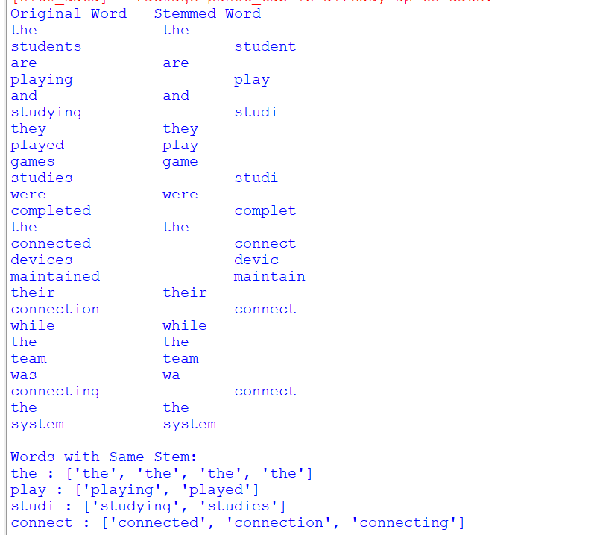
Working
- Import the NLTK library.
- Import PorterStemmer from nltk.stem.
- Store the paragraph in a variable.
- Tokenize the paragraph using word_tokenize().
- Create a PorterStemmer object.
- Apply stem() to each word.
- Display the original word and its stemmed form.
- Group words that produce the same stem using a dictionary.
Result and Interpretation
The program successfully reduces different forms of words into common stems.
For example:
- Playing and played become play.
- Studying and studies become studi.
- Connected, connection, and connecting become connect.
Stemming reduces vocabulary variation and helps improve text processing, information retrieval, and text classification.
Note: A stem is not always a meaningful dictionary word. For example, studi is a stem produced by the Porter algorithm.

QUESTION 6: Implementation of N-gram Language Models
Aim: To develop a Python program to implement Unigram, Bigram, and Trigram language models for a given English paragraph.
Concept
An N-gram is a sequence of N consecutive words in a text.
There are three important types:
1. Unigram
A sequence containing one word.
Example: I, like, language
2. Bigram
A sequence containing two consecutive words.
Example: I like, like language
3. Trigram
A sequence containing three consecutive words.
Example: I like natural, like natural language
N-gram models are used to predict the next word based on the previous words.
Python Program
import re
from collections import Counter

text = "I like natural language processing. I like language models."

tokens = re.findall(r"[a-z]+", text.lower())

unigrams = Counter(tokens)

bigrams = Counter(
zip(tokens, tokens[1:])
)

trigrams = Counter(
zip(tokens, tokens[1:], tokens[2:])
)

print("Tokens:", tokens)

print("\nUnigram Frequencies:")
print(unigrams)

print("\nBigram Frequencies:")
print(bigrams)

print("\nTrigram Frequencies:")
print(trigrams)

def bigram_probability(w1, w2):

return bigrams[(w1, w2)] / unigrams[w1]

def trigram_probability(w1, w2, w3):

return (trigrams[(w1, w2, w3)] /
bigrams[(w1, w2)])

print("\nBigram Probability:")
print("P(like | I) =",
bigram_probability("i", "like"))

print("\nTrigram Probability:")
print("P(processing | natural language) =",
trigram_probability(
"natural", "language", "processing"))
Sample Output
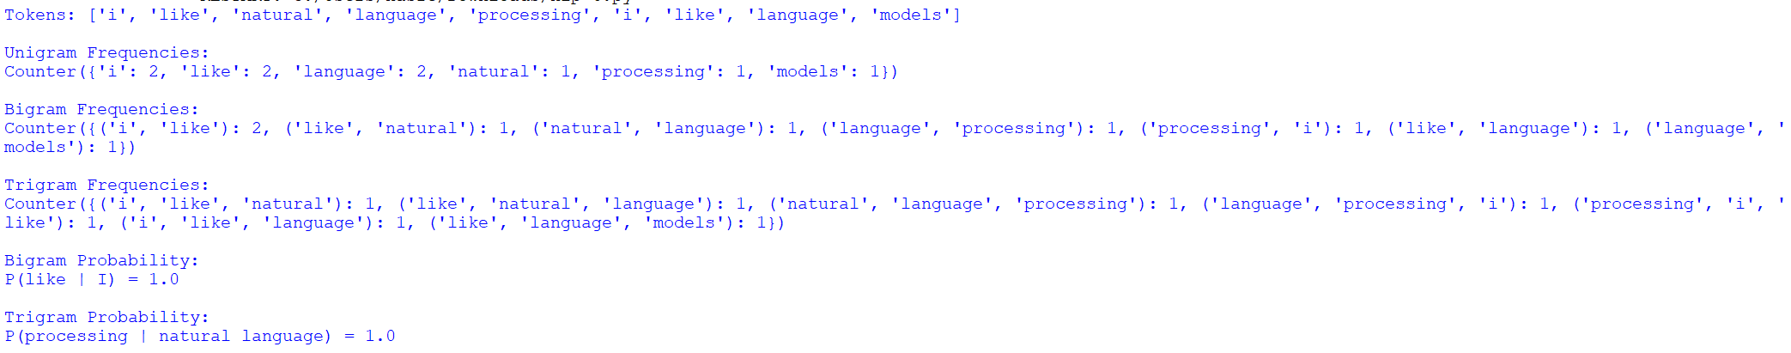Working
- Import re and Counter.
- Store the paragraph in a variable.
- Tokenize the text into individual words.
- Generate unigram sequences using Counter(tokens).
- Generate bigrams using zip(tokens, tokens[1:]).
- Generate trigrams using zip(tokens, tokens[1:], tokens[2:]).
- Count the frequency of each sequence.
- Calculate bigram and trigram probabilities using their frequency counts.
- Display all the results.
Result and Interpretation
The program successfully generates unigram, bigram, and trigram models and calculates their frequencies and probabilities.
Unigrams represent individual words, bigrams capture the relationship between two consecutive words, and trigrams capture relationships between three consecutive words.
N-gram models help in next-word prediction and language modelling.

QUESTION 7: Word Frequency and N-gram Smoothing
Aim: To develop a Python program to calculate word frequencies, generate bigram frequencies, and implement Add-One (Laplace) smoothing.
Concept
Word frequency represents the number of times a particular word appears in a corpus.
Bigram frequency represents the number of occurrences of two consecutive words.
Unsmoothed Bigram Probability:
\[ P(w_2|w_1)=\frac{C(w_1,w_2)}{C(w_1)} \]
Laplace Smoothing:
Laplace smoothing is used to avoid zero probabilities for unseen word combinations.
\[ P(w_2|w_1)= \frac{C(w_1,w_2)+1}{C(w_1)+V} \]
Where:
- C(w₁,w₂) = Bigram frequency
- C(w₁) = Frequency of the first word
- V = Vocabulary size
Python Program
import re
from collections import Counter

corpus = "we study NLP and we study language"

tokens = re.findall(r"[a-z]+", corpus.lower())

word_counts = Counter(tokens)

bigram_counts = Counter(
zip(tokens, tokens[1:])
)

vocabulary = set(tokens)

V = len(vocabulary)

print("Word Frequencies:")
print(word_counts)

print("\nBigram Frequencies:")
print(bigram_counts)

def unsmoothed(w1, w2):

if word_counts[w1] == 0:
return 0

return bigram_counts[(w1, w2)] / word_counts[w1]

def laplace(w1, w2):

return (bigram_counts[(w1, w2)] + 1) / (
word_counts[w1] + V
)

tests = [
("we", "study"),
("study", "nlp"),
("study", "we"),
("we", "language")
]

print("\nProbability Comparison:")

for w1, w2 in tests:

print(
w1, w2,
"Unsmoothed:", round(unsmoothed(w1, w2), 3),
"Laplace:", round(laplace(w1, w2), 3)
)
Sample Output
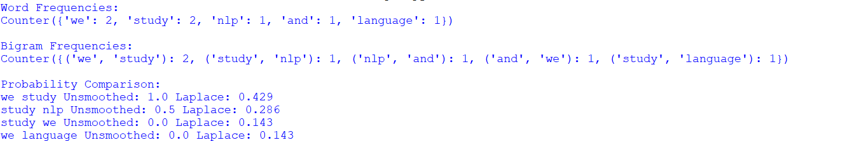Working
- Import the re and Counter modules.
- Tokenize the given corpus into individual words.
- Count word frequencies using Counter().
- Generate bigrams using zip().
- Calculate the vocabulary size using len(set(tokens)).
- Calculate unsmoothed bigram probabilities.
- Apply Add-One smoothing by adding 1 to the bigram count and vocabulary size to the denominator.
- Compare the probabilities before and after smoothing.
Result and Interpretation
The program successfully calculates word frequencies and bigram probabilities.
Without smoothing, unseen bigrams receive zero probability. Laplace smoothing assigns a small non-zero probability to unseen combinations.
Therefore, smoothing helps language models handle unseen word combinations more effectively.

QUESTION 8: Entropy Calculation for Language Models
Aim: To develop a Python program to calculate the entropy of a text corpus using unigram and bigram probability distributions.
Concept
Entropy is a measure of uncertainty or randomness in a language model.
It is based on Shannon's Entropy Formula:
\[ H(X)=-\sum P(x)\log_2 P(x) \]
Where:
- H(X) = Entropy
- P(x) = Probability of a word
- log₂ = Logarithm with base 2
Unigram Entropy: Measures uncertainty based on individual word probabilities.
Bigram Conditional Entropy: Measures uncertainty about the next word when the previous word is known.
Python Program
import re
import math
from collections import Counter, defaultdict

text = "we study NLP and we study language"

tokens = re.findall(r"[a-z]+", text.lower())

# Unigram Entropy

word_counts = Counter(tokens)

N = len(tokens)

H_unigram = -sum(
(c/N) * math.log2(c/N)
for c in word_counts.values()
)

# Bigram Entropy

next_counts = defaultdict(Counter)

for w1, w2 in zip(tokens, tokens[1:]):

next_counts[w1][w2] += 1

total = sum(
sum(counts.values())
for counts in next_counts.values()
)

H_bigram = 0

for previous, outcomes in next_counts.items():

context_count = sum(outcomes.values())

p_context = context_count / total

for count in outcomes.values():

p = count / context_count

H_bigram -= p_context * p * math.log2(p)

print("Tokens:", tokens)

print("Unigram Entropy:",
round(H_unigram, 4), "bits")

print("Bigram Conditional Entropy:",
round(H_bigram, 4), "bits")
Sample Output
Working
- Import the required Python libraries.
- Tokenize the input text into individual words.
- Calculate the frequency of each word using Counter().
- Calculate unigram probabilities by dividing each word frequency by the total number of words.
- Apply Shannon's entropy formula to calculate unigram entropy.
- Generate bigrams using consecutive word pairs.
- Calculate the conditional probability of the next word based on the previous word.
- Calculate bigram conditional entropy.
- Display and compare both entropy values.
Result and Interpretation
The program successfully calculates unigram entropy and bigram conditional entropy.
Unigram entropy measures uncertainty without considering context, whereas bigram conditional entropy considers the previous word.
In this example, the bigram conditional entropy is lower because the previous word provides information about the next word.
Thus, context helps reduce uncertainty in language prediction.
QUESTION 9: English Part-of-Speech Tagging
Aim: To develop a Python program to perform Part-of-Speech (POS) tagging on an English paragraph using the NLTK library.
Concept
Part-of-Speech tagging is the process of assigning grammatical categories to individual words in a sentence.
It identifies the grammatical role of each word.
Important POS categories:
Category | Meaning | Example
Noun | Name of a person, place, or thing | Student
Verb | Action or state | Running
Adjective | Describes a noun | Beautiful
Adverb | Describes a verb or adjective | Quickly
Preposition | Shows relationship between words | In, On, At
NLTK uses the Penn Treebank POS tagset.
Common tags:
Tag | Meaning
NN | Singular noun
NNS | Plural noun
VB | Base verb
VBD | Past-tense verb
VBG | Present participle
JJ | Adjective
RB | Adverb
IN | Preposition or subordinating conjunction
Installation
pip install nltk
Python Program
import nltk
from collections import Counter

nltk.download("punkt_tab")
nltk.download("averaged_perceptron_tagger_eng")

paragraph = """
The intelligent student carefully studies
natural language processing and writes
clear programs in Python.
"""

tokens = nltk.word_tokenize(paragraph)

tagged = nltk.pos_tag(tokens)

categories = {

"Nouns": {"NN", "NNS", "NNP", "NNPS"},

"Verbs": {"VB", "VBD", "VBG", "VBN", "VBP", "VBZ"},

"Adjectives": {"JJ", "JJR", "JJS"},

"Adverbs": {"RB", "RBR", "RBS", "WRB"},

"Prepositions": {"IN"}
}

counts = Counter()

print("Word\t\tPOS Tag")

for word, tag in tagged:

print(word, "\t\t", tag)

for category, tags in categories.items():

if tag in tags:

counts[category] += 1

print("\nPOS Category Frequencies:")

for category in categories:

print(category, ":", counts[category])
Sample Output
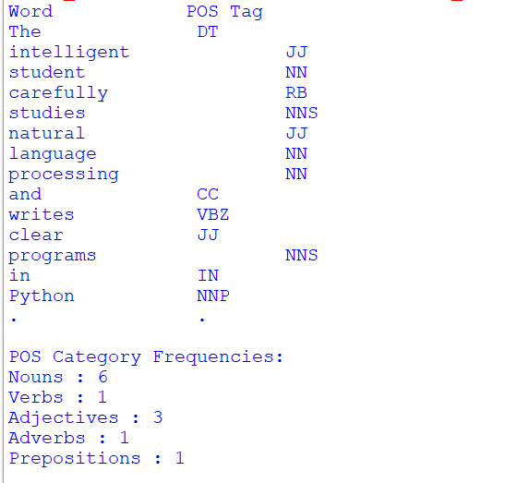

Working
- Import the NLTK library and Counter.
- Download the required tokenizer and POS-tagger resources.
- Store an English paragraph in a variable.
- Tokenize the paragraph using word_tokenize().
- Apply nltk.pos_tag() to assign POS tags to each word.
- Define the different POS categories and their corresponding tags.
- Use a loop to display each word with its POS tag.
- Count the frequency of each POS category.
- Display the final category counts.
Result and Interpretation
The program successfully performs POS tagging on the given English paragraph.
It identifies nouns, verbs, adjectives, adverbs, and prepositions and calculates their frequencies.
POS tagging helps computers understand the grammatical structure and context of sentences. It is widely used in machine translation, text analysis, and information extraction.

QUESTION 10: Comparative Analysis of POS Tagging Techniques
Aim: To develop a Python application to compare Rule-Based, Stochastic, and Transformation-Based POS tagging techniques.
Concept
POS tagging techniques assign grammatical categories to words using different approaches.
There are three major techniques:
1. Rule-Based POS Tagging
- Uses predefined grammatical rules.
- Assigns tags based on word patterns and grammatical conditions.
- Example: Words ending in ing may be tagged as verbs.
2. Stochastic POS Tagging
- Uses statistical probabilities learned from an annotated corpus.
- Predicts POS tags based on previously observed data.
- Example: NLTK UnigramTagger.
3. Transformation-Based POS Tagging
- Combines initial tagging with correction rules.
- Learns rules to correct incorrect POS tags.
- Also known as Brill Tagging.
Installation
pip install nltk
Python Program
import nltk

from nltk.corpus import treebank

from nltk.tag import (
UnigramTagger,
DefaultTagger,
brill,
brill_trainer
)

from nltk.tokenize import word_tokenize

nltk.download("treebank")
nltk.download("punkt_tab")

# Load dataset

tagged_sentences = treebank.tagged_sents()

split = int(0.8 * len(tagged_sentences))

train_data = tagged_sentences[:split]

test_data = tagged_sentences[split:]

# 1. Rule-Based Tagger

def rule_based_tag(word):

w = word.lower()

if w in {"the", "a", "an"}:
return "DT"

if w in {"is", "are", "was", "were", "be"}:
return "VB"

if w.endswith("ly"):
return "RB"

if w.endswith("ing"):
return "VBG"

if w.endswith("ed"):
return "VBD"

if w.endswith(("ous", "ful", "ive", "able")):
return "JJ"

if w.endswith("s"):
return "NNS"

return "NN"

# 2. Stochastic Tagger

backoff = DefaultTagger("NN")

stochastic_tagger = UnigramTagger(
train_data,
backoff=backoff
)

# 3. Transformation-Based Tagger

initial_tagger = UnigramTagger(
train_data,
backoff=backoff
)

templates = brill.brill24()

trainer = brill_trainer.BrillTaggerTrainer(
initial_tagger,
templates,
trace=0
)

brill_tagger = trainer.train(
train_data,
max_rules=50
)

# Input Sentence

sentence = "The quick student is studying natural language processing."

tokens = word_tokenize(sentence)

# Apply Three Taggers

rule_result = [
(w, rule_based_tag(w))
for w in tokens
]

stochastic_result = stochastic_tagger.tag(tokens)

brill_result = brill_tagger.tag(tokens)

# Display Results

def show(title, tagged):

print("\n", title)

for word, tag in tagged:

print(word, ":", tag)

show("Rule-Based Tagging", rule_result)

show("Stochastic Tagging", stochastic_result)

show("Transformation-Based Tagging", brill_result)

# Accuracy Comparison

print("\nStochastic Accuracy:",
round(stochastic_tagger.accuracy(test_data), 4))

print("Brill Accuracy:",
round(brill_tagger.accuracy(test_data), 4))
Output 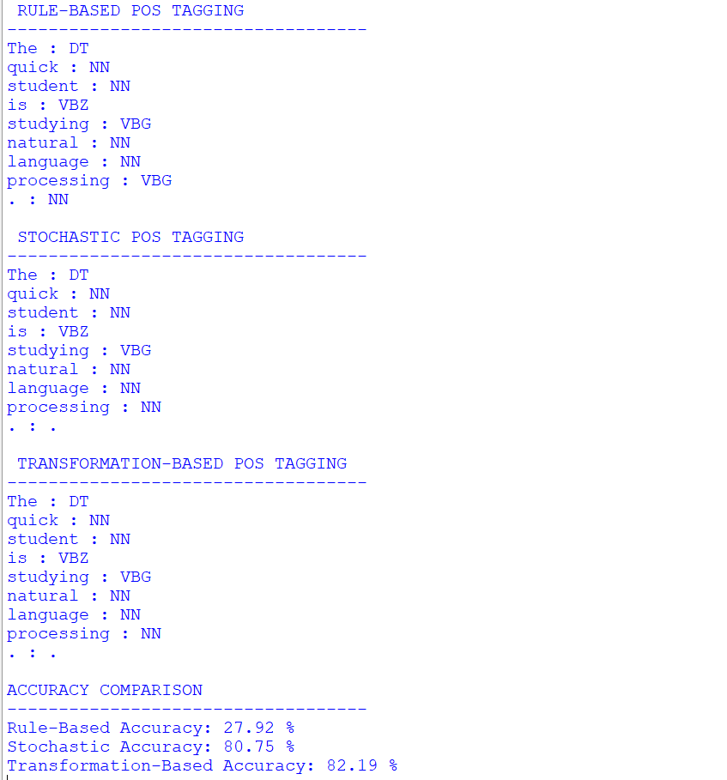Working
- Import the NLTK library and required modules.
- Download the Treebank dataset.
- Divide the tagged dataset into training and testing data.
- Implement a rule-based tagger using predefined grammatical rules.
- Train a stochastic UnigramTagger using the Treebank training data.
- Create an initial tagger for transformation-based tagging.
- Use Brill templates to generate transformation rules.
- Apply all three taggers to the same input sentence.
- Display the POS tagging results.
- Calculate the held-out accuracy of the stochastic and Brill taggers.
Result and Interpretation
The program demonstrates three different POS-tagging techniques.
- Rule-Based tagging depends on predefined grammatical rules.
- Stochastic tagging uses probabilities learned from an annotated dataset.
- Transformation-Based tagging improves initial tagging through learned correction rules.
The comparison demonstrates that statistical and transformation-based approaches can learn language patterns from training data, while rule-based approaches depend on manually defined conditions.

