Course code | DSA0504 | Course Title: | Query Processing For Data Science
CO Assessed | CO1 | Assessment | AT 2
Weightage |  | Total Marks
Student Name | O.S.Sabiha | Reg No | 192424264
Section/Batch | 2024 | Date of submission | 31-7-2026
Faculty In-Charge | Dr.MAHESHMUTHULAKSHMI R | Project mode | Individual  submission

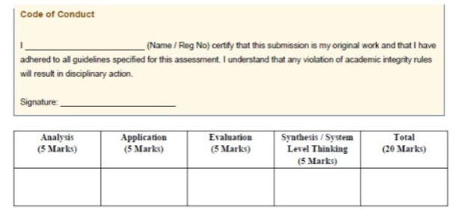

1. Student Admission Data Cleaning
Aim
To develop a Python application that reads student admission records from a CSV file, cleans and standardizes the data, removes duplicate records, and stores the cleaned data into a MySQL database.
Objectives
- Read student admission data from a CSV file.
- Remove duplicate records.
- Handle missing phone numbers.
- Standardize department names and student names.
- Store the cleaned data in a MySQL database.
- Generate a cleaned CSV file.
Description
The application imports student admission records from a CSV file. It performs data wrangling operations such as removing duplicate records, handling missing values, trimming unwanted spaces, and converting department names into a consistent format. The cleaned data is saved into a new CSV file and inserted into a MySQL database for future analysis.
Input
- CSV file containing:
  - Student ID
  - Student Name
  - Department
  - Phone Number
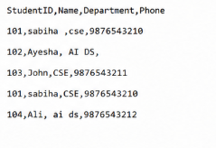
Output
- Cleaned CSV file.
- Student records stored in the MySQL database.
- Display of cleaned records.
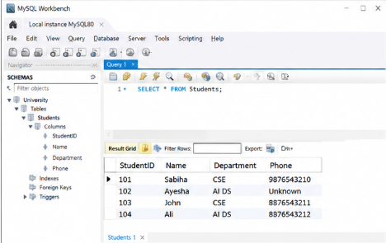
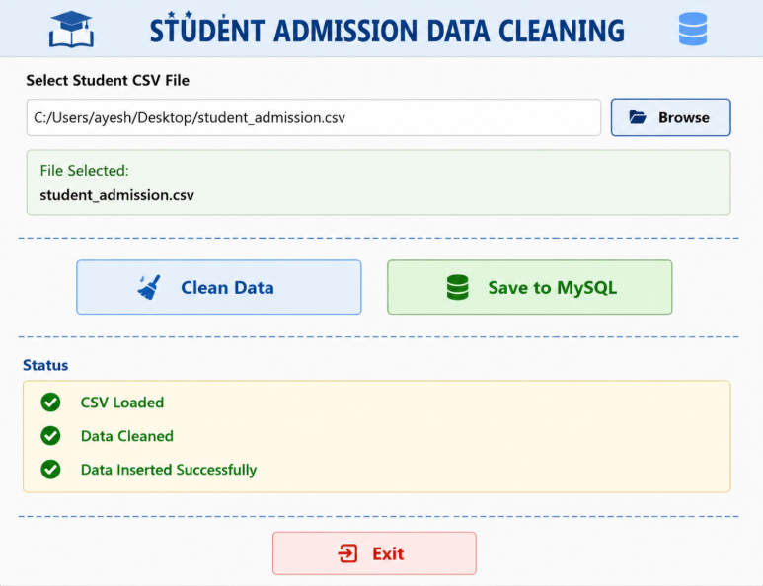

Conclusion
The application successfully cleans and standardizes student admission records, improving data quality and making the dataset suitable for database storage and further analysis.

2. Hospital Patient Data Validation
Aim
To develop a Python application that validates hospital patient records, removes duplicate entries, corrects invalid data, and stores the validated information in a MySQL database.
Objectives
- Read patient details from a CSV file.
- Identify duplicate patient IDs.
- Validate patient ages.
- Handle missing values.
- Store validated data into MySQL.
- Generate a validated CSV file.
Description
The application reads patient records from a CSV file and performs data validation by identifying duplicate patient IDs, correcting invalid age values, and handling missing information. After validation, the cleaned data is exported to a CSV file and inserted into a MySQL database.
Input
- CSV file containing:
  - Patient ID
  - Patient Name
  - Age
  - Blood Group
  - Contact Number
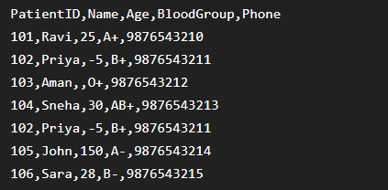
Output
- Validated CSV file.
- Patient records stored in MySQL.
- Display of validated records.
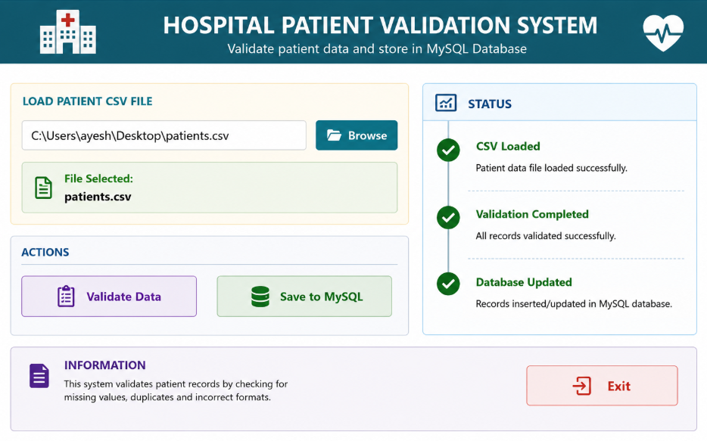

Conclusion
The developed application improves the accuracy and reliability of hospital patient records by validating and cleaning the dataset before database insertion.

3. Employee Payroll Preparation
Aim
To develop a Python application that integrates employee and salary information, identifies missing salary records, and prepares a payroll database using MySQL.
Objectives
- Read employee details from a CSV file.
- Read salary details from a JSON file.
- Merge both datasets using Employee ID.
- Identify employees with missing salary records.
- Store payroll information into MySQL.
Description
The application reads employee information from a CSV file and salary details from a JSON file. Both datasets are merged using the Employee ID. Employees without salary records are identified, and the consolidated payroll information is stored in a MySQL database.
Input
- Employee CSV file.
- Salary JSON file.
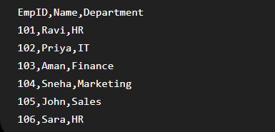
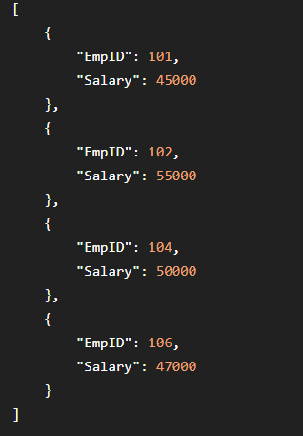
Output
- Consolidated payroll report.
- Payroll records stored in MySQL.
- Display of merged employee details.
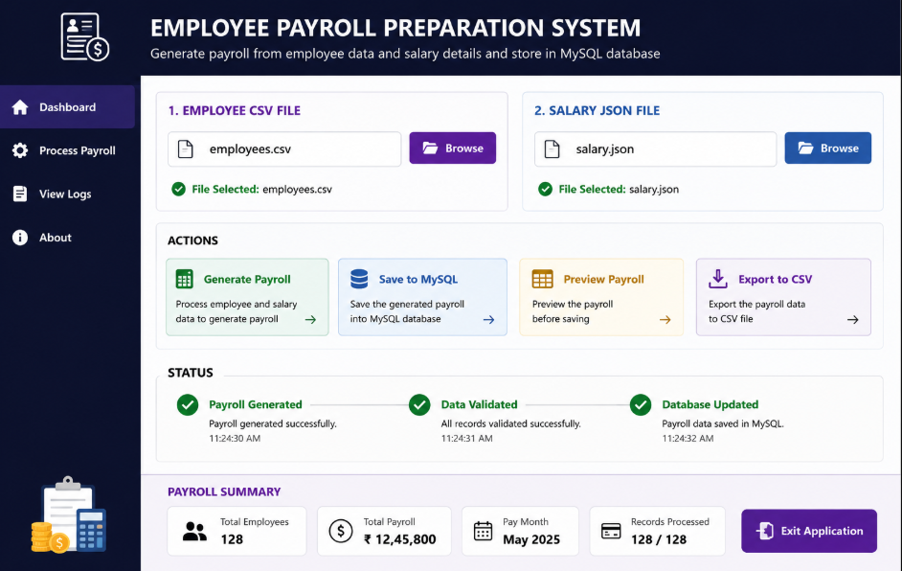
Conclusion
The application efficiently integrates employee and salary information, ensuring complete payroll data while identifying missing salary records.

4. Weather Monitoring System
Aim
To develop a Python program that parses weather observations from an XML file, replaces missing temperature values, and generates a cleaned CSV file.
Objectives
- Read weather data from an XML file.
- Identify missing temperature values.
- Replace missing values with the average temperature.
- Export the cleaned data into a CSV file.
Description
The program parses weather observations stored in XML format. It detects records with missing temperature values, replaces them with the average temperature of the available records, and exports the cleaned information into a CSV file for further analysis.
Input
- XML file containing:
  - City Name
  - Temperature 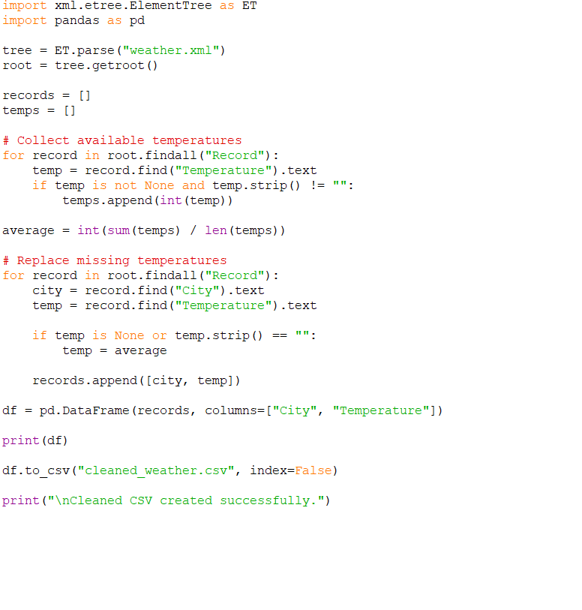
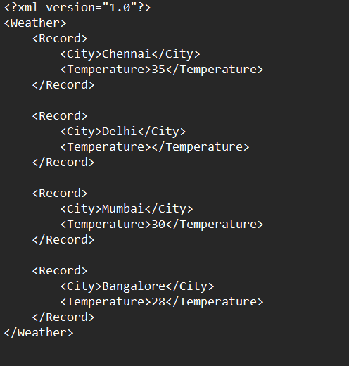
Output
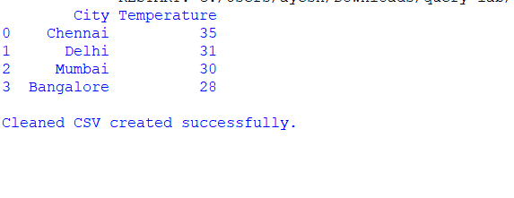
Conclusion
The program successfully cleans weather data by replacing missing temperature values, producing a reliable dataset for weather analysis.

5. Mobile Phone Sales Analysis
Aim
To develop a Python program that combines product information from a JSON file and sales transactions from a CSV file to calculate the total quantity sold for each mobile phone.
Objectives
- Read product details from a JSON file.
- Read sales transactions from a CSV file.
- Merge both datasets using Product ID.
- Calculate the total quantity sold for each product.
- Export the final report to a CSV file.
Description
The application reads product information from a JSON file and sales transactions from a CSV file. Both datasets are merged using the Product ID. The total quantity sold for each product is calculated using grouping operations, and the final report is saved as a CSV file.
Input
- JSON file containing product details.
- CSV file containing sales transactions.
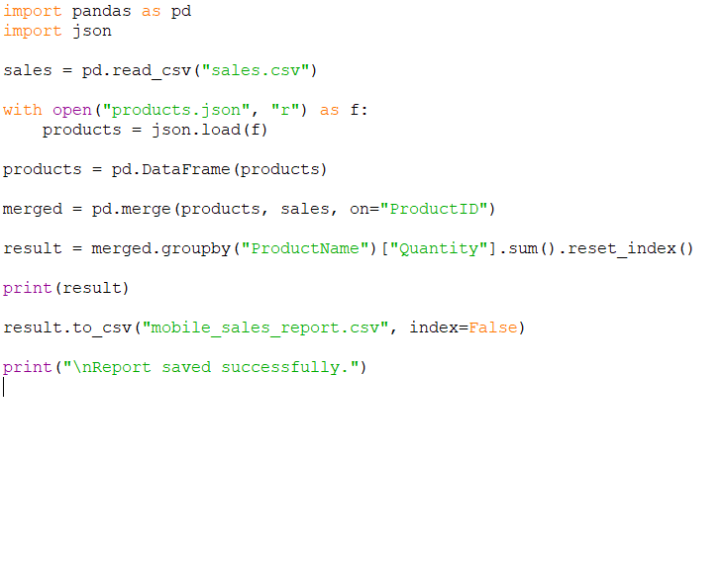

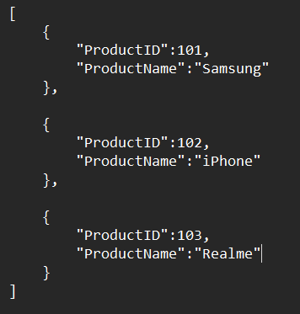

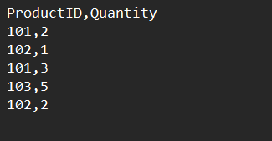

Output
- Mobile sales report in CSV format.
- Display of total quantity sold for each product.
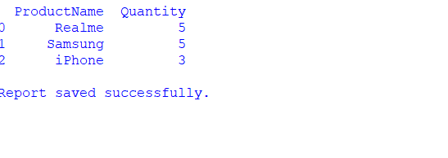
Conclusion
The application successfully integrates product and sales data, calculates total product sales, and generates a consolidated report suitable for business analysis.

