SIMATS ENGINEERING
SAVEETHA INSTITUTE OF MEDICAL AND TECHNICAL SCIENCES
CHENNAI – 602105
Department of Computer Science and Engineering
ASSESSMENT TOOL 3 – CASE STUDY ANALYSIS
Course Code: | DSA05 | Course Title: | Query Processing for Data  Science With Real Time  Applications
CO  Assessed: | CO1 | Assessment: | Tool 3 – Case Study Analysis
Weightage: |  | Total Marks: | 20 Marks
CO1 Statement: Explain the fundamentals of data wrangling, its importance, processes, and tools. Understand different data formats such as CSV, JSON, and XML along with machine readable data. (BL4, BL5 and BL6)
Student  Name: | O.S.Sabiha | Reg. No.: | 192424264
Section /  Batch: | 2024 | Date of  Submission: | 10-8-26
Faculty In  charge: | Dr.Maheshmuthulakshmi R | Assessment  Mode: | Individual Submission

Code of Conduct
I ___O.S.Sabiha(192424264)_____________ (Name / Reg No) certify that this submission is my original work and that I have adhered to all guidelines specified for this assessment. I understand that any violation of academic integrity rules will result in disciplinary action.
Signature: __O.S.Sabiha_______________________

Total Marks | 20 | Obtained  Marks

Case Study 1: Student Enrollment Data Integration
1. Analyze the Data Quality Issues
The university collects student information from three departments: Computer Science, Electronics, and Mechanical Engineering. Each department stores its information in a different file format. Computer Science uses CSV, Electronics uses JSON, and Mechanical Engineering uses XML.
The following data quality issues are identified:
Data Quality Issue | Example | Type
Duplicate records | Same student with raj@gmail.com in different departments | Duplicate
Inconsistent names | Raj Kumar, R. Kumar, Rajkumar | Format inconsistency
Missing email | Empty email field | Missing value
Missing phone number | Empty phone field | Missing value
Different date formats | 12-05-2005, 2005/05/12, 12/05/2005 | Format inconsistency
Different file formats | CSV, JSON, XML | Format inconsistency
Inconsistent capitalization | ARUN KUMAR | Format inconsistency
Different phone formats | 9876543210, +91-9876543210, +91 9876543210 | Format inconsistency

Major Problems
1. Duplicate Records:
The same student may appear in multiple departmental records because of interdisciplinary enrollment.
2. Missing Values:
Some student records have missing email addresses or phone numbers.
3. Inconsistent Names:
The same student may be represented as Raj Kumar, R. Kumar, or Rajkumar.
4. Inconsistent Dates:
Different departments use different date formats for the date of birth.
5. Different Data Formats:
The datasets are stored as CSV, JSON, and XML and must be converted into a common structure.
2. Categorize the Issues
A. Duplicate Issues
- Same student appearing in multiple department records.
- Duplicate records with the same email address.
- Repeated records due to interdisciplinary enrollment.
B. Missing Value Issues
- Missing email addresses.
- Missing phone numbers.
- Empty fields in the source datasets.
C. Format Inconsistency Issues
- Different student name formats.
- Different capitalization of names.
- Different date formats.
- Different phone number formats.
- Different file formats such as CSV, JSON, and XML.
3. Complete Data Wrangling Process
The following workflow is implemented using Python, Pandas, JSON, XML ElementTree, and Regular Expressions.
Step 1: Create the Source Datasets
Three source files are created:
- Computer Science → CS.csv
- Electronics → Electronics.json
- Mechanical Engineering → Mechanical.xml
The datasets contain the following fields:
Student_ID
Name
Email
Phone
Date_of_Birth
Department
Step 2: Load the CSV Dataset
The Computer Science dataset is loaded using Pandas:
cs_df = pd.read_csv("CS.csv")
This reads the CSV file and stores the data in a Pandas DataFrame.
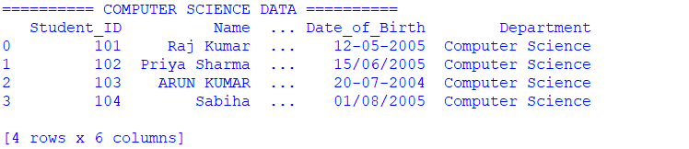
Step 3: Load the JSON Dataset
The Electronics dataset is loaded using:
electronics_df = pd.read_json("Electronics.json")
The JSON data is converted into a Pandas DataFrame.
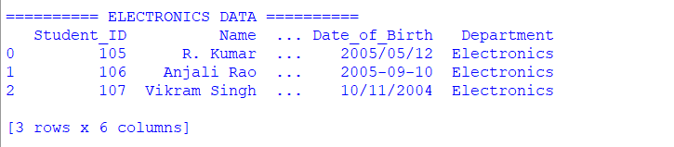
Step 4: Load the XML Dataset
The Mechanical Engineering dataset is read using the XML ElementTree library:
tree = ET.parse("Mechanical.xml")
root = tree.getroot()
The XML elements are extracted and converted into a Pandas DataFrame.
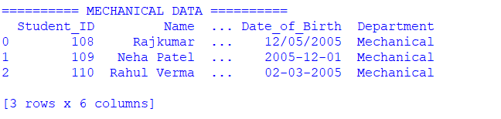

Step 5: Combine the Datasets
The three departmental datasets are combined into one DataFrame:
df = pd.concat(
[cs_df, electronics_df, mechanical_df],
ignore_index=True
)
This creates a single dataset containing student records from all departments.
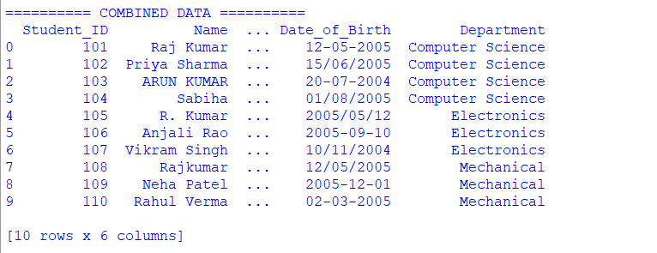
Step 6: Check Missing Values
Missing values are identified using:
df.isnull().sum()
This helps determine which columns contain missing information.
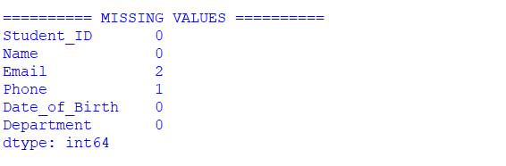
Step 7: Standardize Student Names
Extra spaces are removed and names are converted to proper case:
df["Name"] = df["Name"].str.strip()
df["Name"] = df["Name"].str.title()
Known variations are also corrected:
df["Name"] = df["Name"].replace({
"R. Kumar": "Raj Kumar",
"Rajkumar": "Raj Kumar"
})
Thus:
R. Kumar
Rajkumar
Raj Kumar
are standardized as:
Raj Kumar
Step 8: Handle Missing Values
Empty email and phone fields are converted into missing values:
df["Email"] = df["Email"].replace("", pd.NA)
df["Phone"] = df["Phone"].replace("", pd.NA)
The missing values are then replaced with:
df["Email"] = df["Email"].fillna("Not Available")
df["Phone"] = df["Phone"].fillna("Not Available")
Therefore, missing information is represented as Not Available instead of being left blank.
Step 9: Standardize Phone Numbers
The re library is used to remove unnecessary characters from phone numbers.
def clean_phone(phone):

if phone == "Not Available":
return phone

digits = re.sub(r"\D", "", str(phone))

if len(digits) == 10:
return "+91-" + digits

if digits.startswith("91") and len(digits) == 12:
return "+91-" + digits[2:]

return str(phone)
The function is applied to the phone column:
df["Phone"] = df["Phone"].apply(clean_phone)
Different formats such as:
9876543210
+91-9876543210
+91 9876543210
are standardized to:
+91-9876543210
Step 10: Standardize Dates
Different date formats are converted into one standard format:
df["Date_of_Birth"] = pd.to_datetime(
df["Date_of_Birth"],
errors="coerce",
dayfirst=True
)

df["Date_of_Birth"] = df["Date_of_Birth"].dt.strftime(
"%Y-%m-%d"
)
The final date format is:
YYYY-MM-DD
For example:
12/05/2005
becomes:
2005-05-12
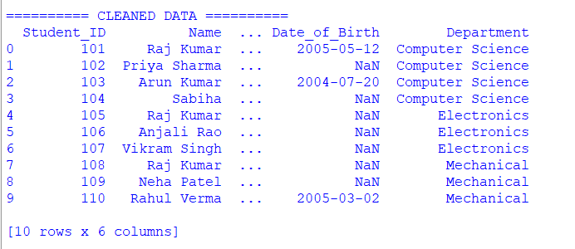
Step 11: Identify Duplicate Records
Possible duplicate students are identified using their email addresses:
duplicates = df[
df.duplicated("Email", keep=False) &
(df["Email"] != "Not Available")
]
This identifies records having the same email address.
Step 12: Remove Duplicate Records
Duplicate records are removed using the email address:
df = df.drop_duplicates(
subset=["Email"],
keep="first"
)
The first occurrence of the duplicate record is retained.
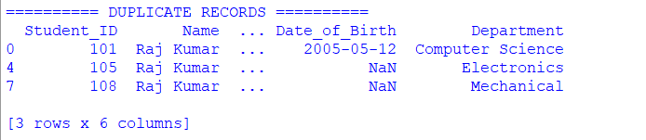
Step 13: Validate the Cleaned Dataset
The final dataset is checked for missing values:
print(df.isnull().sum())
Duplicate records are also checked:
print(df.duplicated().sum())
This confirms whether the data has been successfully cleaned.
Step 14: Save the Clean Dataset
The final integrated dataset is saved as:
df.to_csv(
"Cleaned_Student_Data.csv",
index=False
)
The final output file is:
Cleaned_Student_Data.csv
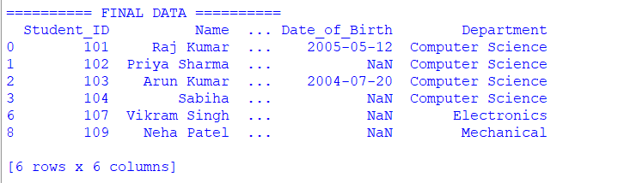
4. Recommended Tools and Techniques
Tool/Technique | Purpose
Python | Automates the data-wrangling process
Pandas | Loads, cleans, combines, and validates data
JSON | Reads Electronics department data
ElementTree | Reads Mechanical department XML data
Regular Expressions (Regex) | Cleans phone numbers
String Functions | Standardizes student names
Deduplication | Removes repeated student records
Data Validation | Checks the quality of cleaned data
CSV | Stores the final integrated dataset
Python Libraries Used
import pandas as pd
import json
import xml.etree.ElementTree as ET
import re
Pandas is the main library used for data manipulation, cleaning, integration, and validation.
5. Benefits of Clean and Integrated Student Data
1. Accurate Student Records
The university can maintain reliable and consistent student information.
2. Reduced Duplicate Records
Repeated student records can be identified and removed.
3. Consistent Data
Names, phone numbers, and dates follow a common format.
4. Better Academic Analysis
The university can accurately analyze:
- Student enrollment
- Department-wise student counts
- Attendance
- Academic performance

5. Improved Reporting
Clean data produces more accurate university reports.
6. Better Decision-Making
Administrators can make decisions using reliable and consistent student information.
7. Centralized Data Management
Student information from different departments can be managed in a single integrated dataset.
Overall Data Wrangling Workflow
Computer Science
CSV
│
▼
Load Data
│
│
Electronics
JSON
│
▼
Load Data
│
│
Mechanical
XML
│
▼
Load Data
│
▼
Combine Datasets
│
▼
Check Missing Values
│
▼
Standardize Names
│
▼
Handle Missing Values
│
▼
Standardize Phone Numbers
│
▼
Standardize Dates
│
▼
Identify Duplicates
│
▼
Remove Duplicates
│
▼
Validate Data
│
▼
Cleaned Student Dataset
│
▼
Cleaned_Student_Data.csv
Conclusion
The student enrollment datasets from the Computer Science, Electronics, and Mechanical Engineering departments were successfully integrated using Python. The data-wrangling process handled missing values, inconsistent names, different phone number formats, different date formats, and duplicate records. CSV, JSON, and XML data were converted into a common Pandas DataFrame and cleaned using appropriate techniques. Finally, the validated data was stored in Cleaned_Student_Data.csv. The cleaned and integrated dataset can be used for accurate student enrollment, attendance, academic performance analysis, and university reporting.

