SIMATS ENGINEERING
SAVEETHA INSTITUTE OF MEDICAL AND TECHNICAL SCIENCES
CHENNAI – 602105
Department of Computer Science and Engineering
ASSESSMENT TOOL 3 – OPEN DATA ANALYSIS PROJECT
Course Code: | DSA05 | Course Title: | Query Processing for Data Science in Real Time Applications
CO Assessed: | CO4 | Assessment: | Tool 3 – Open Data Analysis Project
Weightage: |  | Total Marks: | 50 Marks
CO4 Statement: Explore datasets using analytical techniques such as grouping, correlation detection, joining datasets, and extracting meaningful insights.. (BL4, BL5 and BL6)
Student Name: | O.S.Sabiha | Reg. No.: | 192424264
Section /  Batch: | 2024 | Date of  Submission: | 19 – 06 – 2026
Faculty In  charge: | Dr.MAHESHMUTHULAKSHMI R | Assessment  Mode: | Individual Submission

Code of Conduct
I __O.S.Sabiha(192424264)___________________ (Name / Reg No) certify that this submission is my original work and that I have adhered to all guidelines specified for this assessment. I understand that any violation of academic integrity rules will result in disciplinary action.
Signature: __O.S.Sabiha_______________________

Data Collection &  Understanding (10 Marks) | Data Cleaning & Preparation  (10 Marks) | Exploratory  Data Analysis  (10 Marks) | Visualization & Dashboard  Design  (10 Marks) | Demonstration (10 Marks) | Total  (50 Marks)

DATA ANALYSIS PROJECT
Analysis of COVID-19 Trends, Road Accidents, and Global Temperature

1. Introduction
This project presents a comparative data analysis of three real-world datasets: Global COVID-19 Trends and Vaccination Analysis, Road Accident Analysis and Traffic Safety Evaluation, and Climate Change and Global Temperature Analysis. Python and libraries such as Pandas, NumPy, and Matplotlib were used for data collection, cleaning, exploratory data analysis, statistical analysis, and visualization. The purpose of the project is to transform raw datasets into meaningful information that can support interpretation and data-driven decision making.

2. Tools and Technologies Used
- Python
- Python IDLE
- Pandas – data loading, cleaning, transformation, and analysis
- NumPy – numerical and statistical operations
- Matplotlib – data visualization
- CSV datasets from public and official data sources

3. Question 1 – Global COVID-19 Trends and Vaccination Analysis

3.1 Objective
The objective of this analysis is to study the global and country-wise trends in COVID-19 cases, deaths, and vaccination coverage. The analysis also examines the relationship between vaccination coverage and mortality-related measures.

3.2 Data Source
The dataset was obtained from Our World in Data (OWID). It contains country-wise and date-wise information about COVID-19 cases, deaths, population, and vaccination.

3.3 Important Variables
- Location – country or reporting location
- Date – date of the observation
- Total Cases – cumulative confirmed cases
- New Cases – newly reported cases
- Total Deaths – cumulative deaths
- New Deaths – newly reported deaths
- Population – population of the location
- People Vaccinated – people who received at least one vaccine dose
- People Fully Vaccinated – people who completed the primary vaccination course

3.4 Data Collection and Understanding
The COVID-19 CSV file was loaded into Python using Pandas. The dataset structure was examined using head(), shape, columns, and info(). The number of records, variables, countries, and data types were identified before analysis.

3.5 Data Cleaning and Preparation
- Converted the date field into a proper datetime format.
- Removed duplicate records.
- Removed records without valid population information.
- Converted numerical variables into numeric data types.
- Handled missing case and death values where appropriate.
- Created cases per 100,000 population and deaths per 100,000 population.
- Calculated vaccination coverage as the percentage of the population fully vaccinated.

3.6 Exploratory Data Analysis
- Global new COVID-19 cases were analyzed over time to identify major pandemic waves.
- Global new deaths were analyzed over time.
- Selected countries such as India, the United States, the United Kingdom, and Brazil were compared.
- Vaccination coverage was examined over time.
- A scatter plot was used to examine the association between vaccination coverage and deaths per 100,000 population.
- Correlation was calculated to provide a statistical measure of the relationship.

3.7 Visualizations
- Global COVID-19 New Cases Over Time – Line Chart
- Global COVID-19 Deaths Over Time – Line Chart
- COVID-19 Total Cases by Country – Line Chart
- COVID-19 Vaccination Coverage – Line Chart
- Vaccination Coverage vs Death Rate – Scatter Plot

3.8 Findings and Interpretation
The analysis provides a clear view of how COVID-19 cases and deaths changed over time and how vaccination coverage increased across countries. Major waves can be identified from the case and death time-series graphs. Country comparisons show that pandemic outcomes differed between locations. The vaccination-versus-mortality analysis provides evidence about association, but correlation alone does not establish that vaccination caused a particular mortality outcome because other factors such as age structure, healthcare capacity, variants, testing, and reporting practices can also influence the results.

3.9 Recommendations
- Continue systematic monitoring of infectious disease trends.
- Maintain reliable vaccination and health reporting systems.
- Use population-normalized indicators when comparing countries.
- Use multiple factors rather than a single variable when evaluating public-health outcomes.

4. Question 2 – Road Accident Analysis and Traffic Safety Evaluation

4.1 Objective
The objective is to analyze road accident patterns and identify factors associated with accident frequency and severity. The study examines time, weather, road type, speed limit, casualties, severity, and geographic distribution.

4.2 Data Source
The road accident data was obtained from the UK Government Road Safety Open Data. The collision dataset contains information about road collisions and related conditions.

4.3 Important Variables
- Date and Time – when the collision occurred
- Weather Conditions – weather at the time of the collision
- Road Type – type of road involved
- Speed Limit – posted speed limit
- Light Conditions – lighting conditions
- Road Surface Conditions – surface condition
- Accident Severity – severity classification
- Number of Vehicles – vehicles involved
- Number of Casualties – casualties resulting from the collision
- Latitude and Longitude – geographic location where available

4.4 Data Collection and Understanding
The collision CSV was loaded using Pandas. The first records, dimensions, column names, and data types were inspected. This step helped identify the variables needed for accident-frequency, severity, and location analysis.

4.5 Data Cleaning and Preparation
- Inspected missing values.
- Removed duplicate records.
- Converted the date field to datetime format.
- Extracted year, month, day, and day of week.
- Extracted the hour from the time field where available.
- Converted speed limit, casualty count, vehicle count, latitude, and longitude to numeric values.

4.6 Exploratory Data Analysis
- Accident frequency was analyzed by month.
- Accident frequency was compared across days of the week.
- Accidents were analyzed by hour to identify high-risk periods.
- Weather conditions were compared with accident frequency.
- Road types were compared based on accident counts.
- Accident severity was analyzed.
- Speed-limit categories were examined.
- Speed limit and accident severity were compared using a cross-tabulation.
- Geographic coordinates were visualized to identify the spatial distribution of accidents.

4.7 Visualizations
- Accidents by Month – Bar Chart
- Accidents by Day of Week – Bar Chart
- Accidents by Hour – Line Chart
- Accidents by Weather Condition – Bar Chart
- Accidents by Road Type – Bar Chart
- Accident Severity Distribution – Bar Chart
- Accidents by Speed Limit – Bar Chart
- Geographic Distribution of Road Accidents – Scatter/Map Visualization

4.8 Findings and Interpretation
The analysis identifies periods, road conditions, weather categories, and road types with higher accident frequencies in the selected dataset. Severity analysis distinguishes less severe collisions from serious or fatal outcomes. Geographic visualization can be used to identify areas requiring closer traffic-safety attention. The results should be interpreted as patterns in the available data rather than proof that one factor alone causes accidents.

4.9 Recommendations
- Improve road lighting and signage in locations identified as high risk.
- Strengthen speed monitoring and enforcement where appropriate.
- Improve road-surface maintenance.
- Increase traffic-safety awareness during high-risk periods.
- Use accident hotspot information to prioritize safety improvements.

5. Question 3 – Climate Change and Global Temperature Analysis

5.1 Objective
The objective is to investigate long-term changes in global temperature anomalies, compare temperature patterns across decades and months, identify unusually high or low temperature years, and summarize the overall trend.

5.2 Data Source
The dataset was obtained from NASA GISS Surface Temperature Analysis (GISTEMP). The dataset provides global monthly, seasonal, and annual temperature anomalies from 1880 to the present. Temperature anomaly represents the difference from the dataset's reference-period average.

5.3 Important Variables
- Year – year of observation
- Jan to Dec – monthly temperature anomalies
- J-D – annual temperature anomaly
- DJF, MAM, JJA, SON – seasonal averages where provided

5.4 Data Collection and Understanding
The NASA GISTEMP CSV was loaded using Pandas. The rows, columns, data types, and missing values were examined. The annual J-D value was selected as the main variable for yearly trend analysis.

5.5 Data Cleaning and Preparation
- Skipped the descriptive header row in the NASA CSV format.
- Removed spaces from column names.
- Converted Year into numeric form.
- Converted monthly and annual temperature values to numeric values.
- Removed records with invalid year or annual-temperature values.
- Created a Decade variable for decade-wise comparison.

5.6 Exploratory Data Analysis
- A yearly time-series was used to study long-term temperature changes.
- Decade-wise average temperature anomalies were calculated.
- Monthly average anomalies were calculated to examine seasonal patterns.
- The 10 warmest and 10 coolest years were identified.
- A histogram was used to study the distribution of annual temperature anomalies.
- Z-score analysis was used to identify unusually high or low annual observations.

5.7 Visualizations
- Global Temperature Anomaly Over Time – Line Chart
- Average Global Temperature Anomaly by Decade – Bar Chart
- Average Monthly Temperature Anomaly – Line Chart
- Distribution of Global Temperature Anomalies – Histogram

5.8 Findings and Interpretation
The time-series analysis provides evidence of a long-term change in global temperature anomalies. Decade-wise averages make it easier to compare different periods, while monthly analysis reveals recurring seasonal patterns. The warmest and coolest years provide useful extreme-value comparisons. Z-score analysis identifies years that are statistically unusual relative to the distribution used in the study.

5.9 Recommendations
- Continue long-term monitoring of global temperature indicators.
- Promote renewable energy and energy-efficiency measures.
- Reduce greenhouse-gas emissions.
- Strengthen climate adaptation and risk-management planning.
- Improve public awareness of climate-related changes.

6. Dashboard Design
For each dataset, an interactive dashboard can be developed using the outputs generated during analysis. The dashboard should contain KPI cards, charts, filters, and a concise findings section.

6.1 COVID-19 Dashboard
- Total Cases
- Total Deaths
- Vaccination Coverage
- Country-wise Case Trend
- Vaccination Trend
- Vaccination vs Mortality
- Country and date filters

6.2 Road Accident Dashboard
- Total Accidents
- Total Casualties
- Severity Distribution
- Accidents by Month
- Accidents by Hour
- Weather and Road Type Analysis
- Accident Location Map

6.3 Climate Dashboard
- Average Temperature Anomaly
- Highest and Lowest Anomaly
- Yearly Temperature Trend
- Decade-wise Average
- Monthly Pattern
- Anomaly Distribution

7. Demonstration / Presentation Procedure
During the demonstration, each project can be explained using the following sequence: introduce the problem, show the dataset source, explain important columns, demonstrate data cleaning, show the EDA graphs, explain the main findings, and finally demonstrate the dashboard. The explanation should focus on what was done, why it was done, and what the resulting graphs show.

8. Overall Conclusion
The three analyses demonstrate how data analytics can be applied to real-world problems. The COVID-19 study focuses on pandemic trends and vaccination, the road-accident study focuses on traffic safety and accident patterns, and the climate study focuses on long-term temperature changes. Across all three datasets, the workflow includes data collection, data cleaning, exploratory analysis, statistical analysis, visualization, and interpretation. The results can support evidence-based decisions while also demonstrating the importance of careful data preparation and responsible interpretation.

9. References
1. Our World in Data – COVID-19 Data.
2. UK Government – Road Safety Open Data.
3. NASA GISS – Surface Temperature Analysis (GISTEMP).
4. Python documentation and Pandas/NumPy/Matplotlib documentation.

10. Python Implementation – Question 1
The following Python program performs data loading, cleaning, preparation, exploratory analysis, statistical analysis, and visualization for the COVID-19 dataset.
import pandas as pd
import numpy as np
import matplotlib.pyplot as plt
# Load dataset
df = pd.read_csv("owid-covid-data-for-project.csv")
# Understand data
print(df.head())
print("Shape:", df.shape)
print(df.info())
# Clean data
df["date"] = pd.to_datetime(df["date"], errors="coerce")
df = df.drop_duplicates()
df = df.dropna(subset=["location", "date", "population"])
df = df[df["population"] > 0]
num_cols = ["total_cases", "new_cases", "total_deaths", "new_deaths"]
for col in num_cols:
df[col] = pd.to_numeric(df[col], errors="coerce").fillna(0)
df["people_fully_vaccinated"] = pd.to_numeric(
df["people_fully_vaccinated"], errors="coerce"
)
# Create new variables
df["cases_per_100k"] = df["total_cases"] / df["population"] * 100000
df["deaths_per_100k"] = df["total_deaths"] / df["population"] * 100000
df["vaccination_percentage"] = (
df["people_fully_vaccinated"] / df["population"] * 100
).clip(0, 100)
# Global cases
global_cases = df.groupby("date")["new_cases"].sum()
plt.figure(figsize=(12,5))
plt.plot(global_cases.index, global_cases.values)
plt.title("Global COVID-19 New Cases Over Time")
plt.xlabel("Date")
plt.ylabel("New Cases")
plt.grid()
plt.show()
# Global deaths
global_deaths = df.groupby("date")["new_deaths"].sum()
plt.figure(figsize=(12,5))
plt.plot(global_deaths.index, global_deaths.values)
plt.title("Global COVID-19 Deaths Over Time")
plt.xlabel("Date")
plt.ylabel("New Deaths")
plt.grid()
plt.show()
# Country comparison
countries = ["India", "United States", "United Kingdom", "Brazil"]
country_df = df[df["location"].isin(countries)]
plt.figure(figsize=(12,5))
for country in countries:
temp = country_df[country_df["location"] == country]
plt.plot(temp["date"], temp["total_cases"], label=country)
plt.title("COVID-19 Cases by Country")
plt.xlabel("Date")
plt.ylabel("Total Cases")
plt.legend()
plt.grid()
plt.show()
# Vaccination comparison
plt.figure(figsize=(12,5))
for country in countries:
temp = country_df[country_df["location"] == country]
plt.plot(temp["date"], temp["vaccination_percentage"], label=country)
plt.title("COVID-19 Vaccination Coverage")
plt.xlabel("Date")
plt.ylabel("Fully Vaccinated (%)")
plt.legend()
plt.grid()
plt.show()
# Latest country data and correlation
latest = df.sort_values("date").groupby("location").tail(1)
analysis = latest[["vaccination_percentage", "deaths_per_100k"]].dropna()
if len(analysis) > 2:
correlation = analysis.corr().iloc[0, 1]
print("Vaccination vs death-rate correlation:", round(correlation, 3))
plt.figure(figsize=(8,5))
plt.scatter(
analysis["vaccination_percentage"],
analysis["deaths_per_100k"],
alpha=0.5
)
plt.title("Vaccination Coverage vs Death Rate")
plt.xlabel("Fully Vaccinated (%)")
plt.ylabel("Deaths per 100,000")
plt.grid()
plt.show()
print("COVID-19 analysis completed.")

Output – Question 1
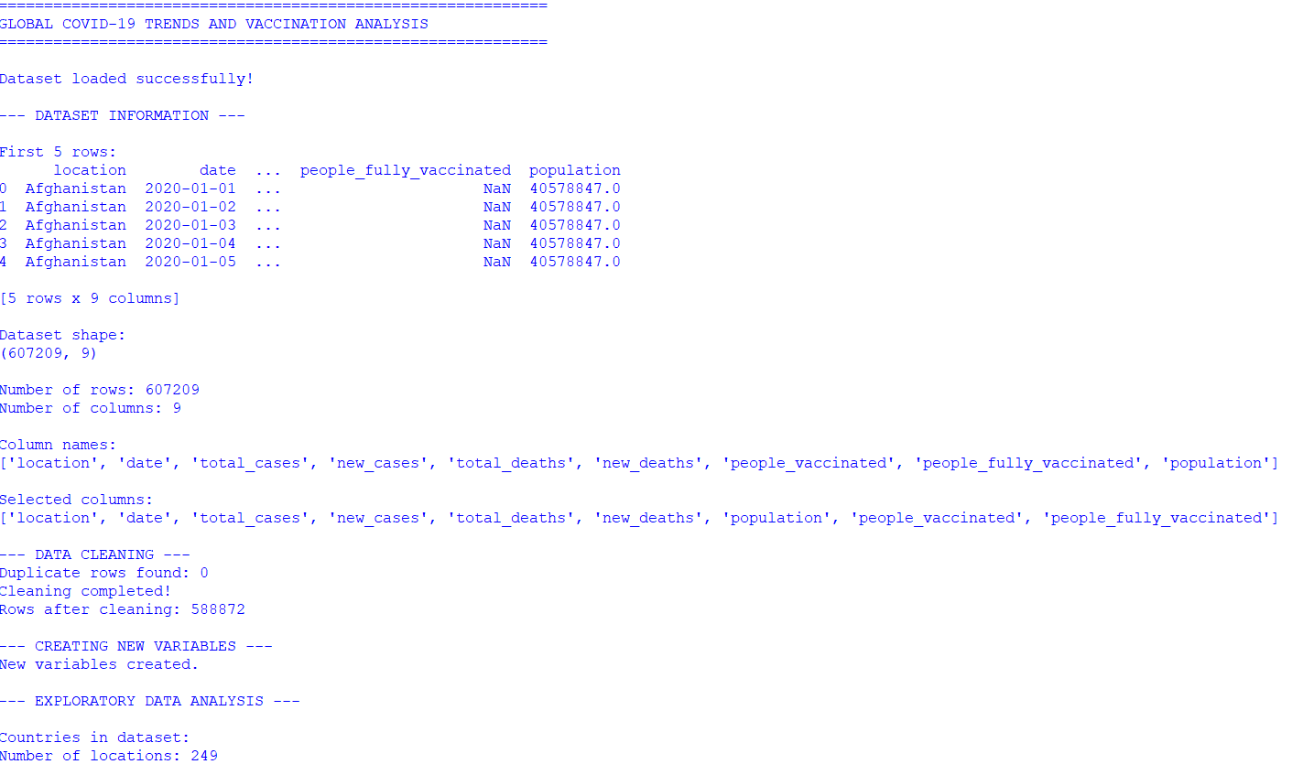
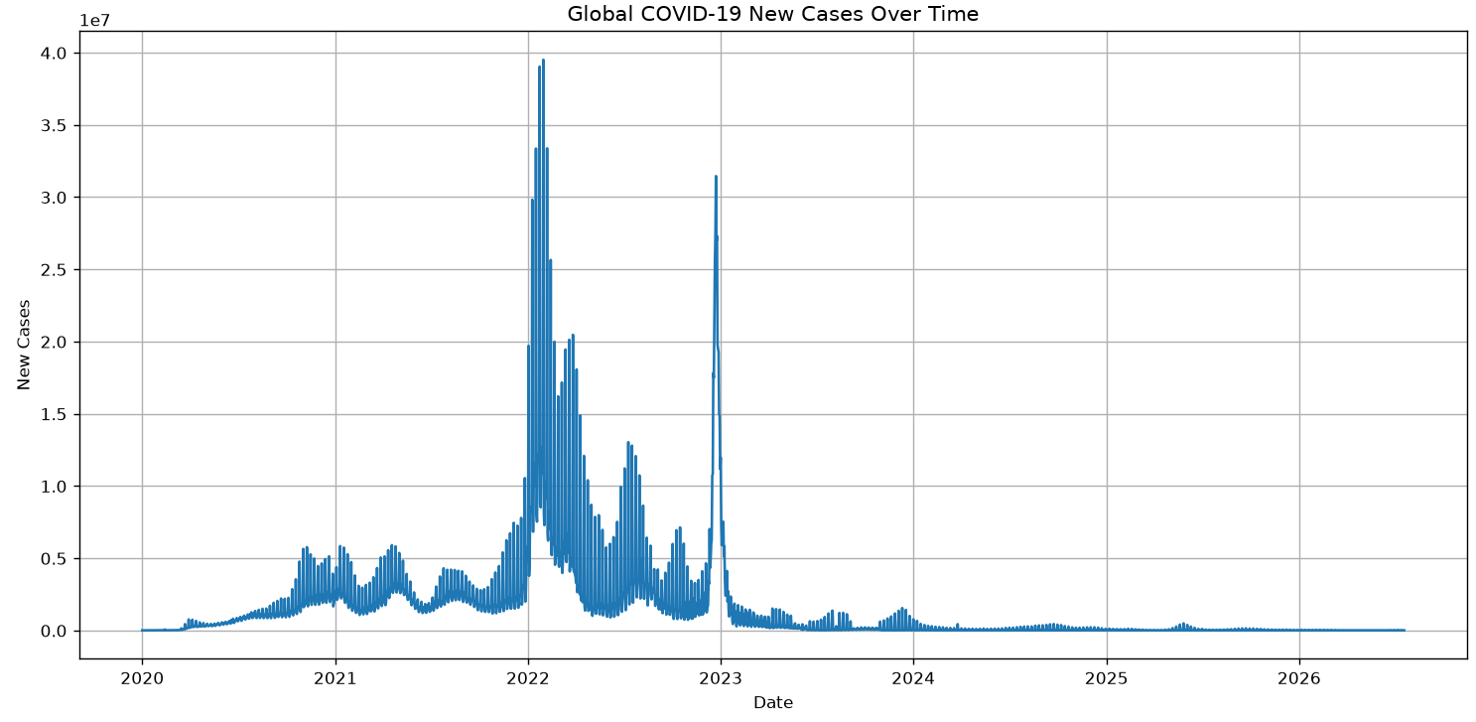

11. Python Implementation – Question 2
The following program analyzes road accidents by time, weather, road type, severity, speed limit, casualties, and geographic location.
import pandas as pd
import numpy as np
import matplotlib.pyplot as plt
# Load dataset
df = pd.read_csv("road_accidents.csv")
# Understand data
print(df.head())
print("Shape:", df.shape)
print(df.info())
# Standardize column names
df.columns = (
df.columns.str.strip()
.str.lower()
.str.replace(" ", "_")
)
# Clean date
if "date" in df.columns:
df["date"] = pd.to_datetime(df["date"], errors="coerce")
df["year"] = df["date"].dt.year
df["month"] = df["date"].dt.month
df["day_of_week"] = df["date"].dt.day_name()
# Clean time
if "time" in df.columns:
df["hour"] = pd.to_datetime(
df["time"].astype(str),
format="%H:%M",
errors="coerce"
).dt.hour
df = df.drop_duplicates()
# Numeric columns
for col in ["number_of_vehicles", "number_of_casualties",
"speed_limit", "latitude", "longitude"]:
if col in df.columns:
df[col] = pd.to_numeric(df[col], errors="coerce")
print("Rows after cleaning:", len(df))
# Accidents by month
if "month" in df.columns:
monthly = df.groupby("month").size()
plt.figure(figsize=(10,5))
plt.bar(monthly.index, monthly.values)
plt.title("Road Accidents by Month")
plt.xlabel("Month")
plt.ylabel("Number of Accidents")
plt.show()
# Accidents by day
if "day_of_week" in df.columns:
days = ["Monday","Tuesday","Wednesday","Thursday",
"Friday","Saturday","Sunday"]
day_counts = df["day_of_week"].value_counts().reindex(days)
plt.figure(figsize=(10,5))
plt.bar(day_counts.index, day_counts.values)
plt.title("Road Accidents by Day of Week")
plt.xticks(rotation=30)
plt.ylabel("Number of Accidents")
plt.show()
# Accidents by hour
if "hour" in df.columns:
hourly = df.groupby("hour").size()
plt.figure(figsize=(10,5))
plt.plot(hourly.index, hourly.values, marker="o")
plt.title("Road Accidents by Hour")
plt.xlabel("Hour")
plt.ylabel("Number of Accidents")
plt.grid()
plt.show()
# Weather
weather = "weather_conditions"
if weather in df.columns:
counts = df[weather].value_counts().head(10)
plt.figure(figsize=(10,5))
plt.bar(counts.index.astype(str), counts.values)
plt.title("Accidents by Weather Condition")
plt.xticks(rotation=45)
plt.show()
# Road type
if "road_type" in df.columns:
counts = df["road_type"].value_counts().head(10)
plt.figure(figsize=(10,5))
plt.bar(counts.index.astype(str), counts.values)
plt.title("Accidents by Road Type")
plt.xticks(rotation=45)
plt.show()
# Severity
if "accident_severity" in df.columns:
counts = df["accident_severity"].value_counts()
print("Accident severity:")
print(counts)
plt.figure(figsize=(8,5))
plt.bar(counts.index.astype(str), counts.values)
plt.title("Accident Severity Distribution")
plt.show()
# Speed limit
if "speed_limit" in df.columns:
counts = df["speed_limit"].value_counts().sort_index()
plt.figure(figsize=(10,5))
plt.bar(counts.index.astype(str), counts.values)
plt.title("Accidents by Speed Limit")
plt.xlabel("Speed Limit")
plt.ylabel("Number of Accidents")
plt.show()
# Speed limit vs severity
if "speed_limit" in df.columns and "accident_severity" in df.columns:
print("Speed Limit vs Severity:")
print(pd.crosstab(df["speed_limit"], df["accident_severity"]))
# Casualties
if "number_of_casualties" in df.columns:
print("Total casualties:", int(df["number_of_casualties"].sum()))
print("Average casualties:",
round(df["number_of_casualties"].mean(), 2))
# Geographic distribution
if "latitude" in df.columns and "longitude" in df.columns:
loc = df[["latitude","longitude"]].dropna()
if len(loc) > 0:
plt.figure(figsize=(10,6))
plt.scatter(loc["longitude"], loc["latitude"], alpha=0.3, s=10)
plt.title("Geographic Distribution of Road Accidents")
plt.xlabel("Longitude")
plt.ylabel("Latitude")
plt.show()
print("Road accident analysis completed.")

Output – Question 2
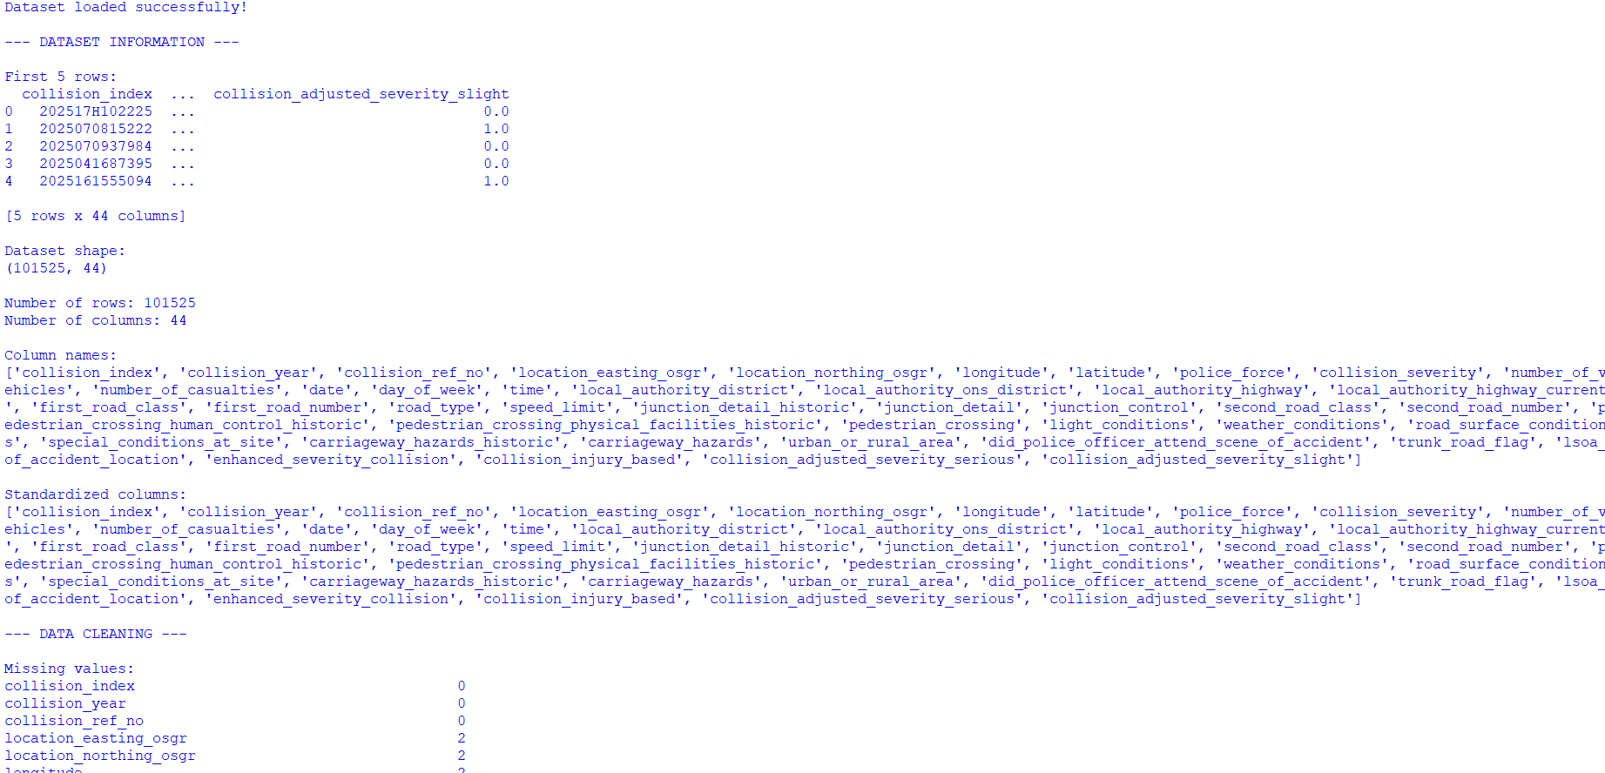

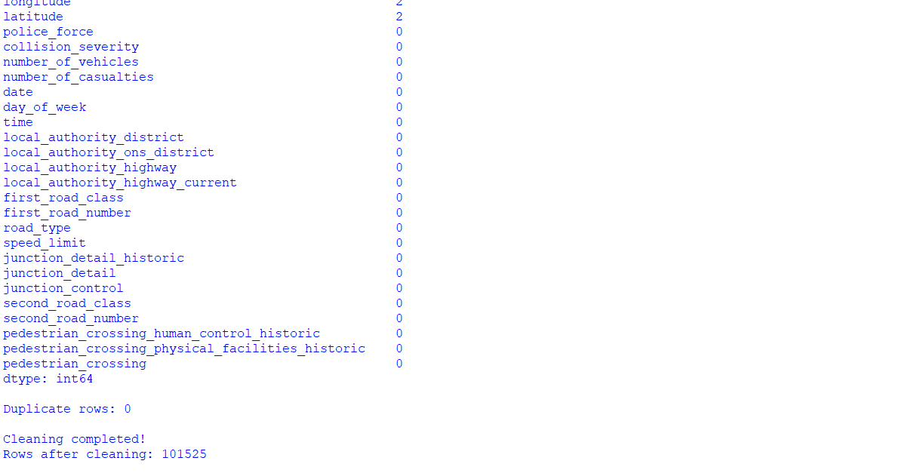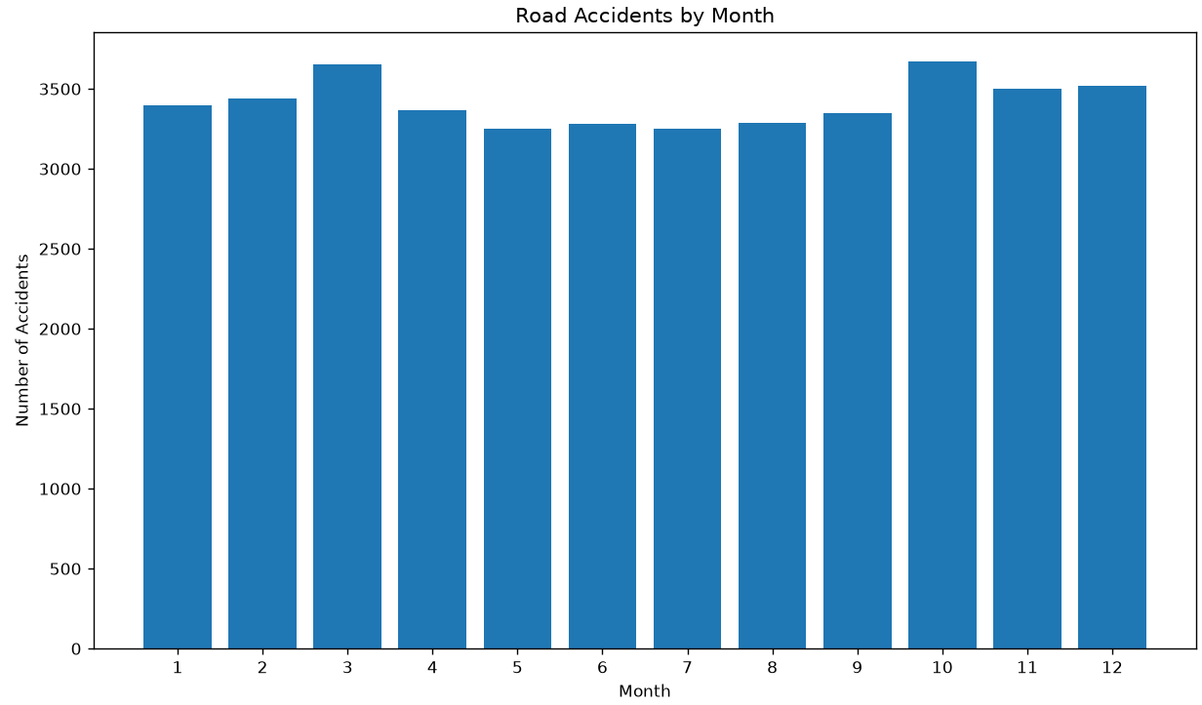

12. Python Implementation – Question 3
The following program analyzes the NASA GISTEMP global temperature dataset. It studies yearly trends, decade averages, monthly patterns, extreme years, distribution, and statistical anomalies.
import pandas as pd
import numpy as np
import matplotlib.pyplot as plt
# Load NASA GISTEMP dataset
df = pd.read_csv("global_temperature.csv", skiprows=1)
print(df.head())
print("Shape:", df.shape)
print("Columns:", df.columns.tolist())
# Clean column names
df.columns = df.columns.str.strip()
# Convert Year
df["Year"] = pd.to_numeric(df["Year"], errors="coerce")
# Convert temperature columns
months = ["Jan","Feb","Mar","Apr","May","Jun",
"Jul","Aug","Sep","Oct","Nov","Dec"]
for col in months + ["J-D","D-N","DJF","MAM","JJA","SON"]:
if col in df.columns:
df[col] = pd.to_numeric(df[col], errors="coerce")
# Use J-D as annual temperature anomaly
df["Annual_Temperature"] = df["J-D"]
# Remove invalid records
df = df.dropna(subset=["Year", "Annual_Temperature"])
# Create decade
df["Decade"] = (df["Year"] // 10) * 10
print("Rows after cleaning:", len(df))
print("Missing annual values:",
df["Annual_Temperature"].isnull().sum())
# Yearly trend
plt.figure(figsize=(12,5))
plt.plot(df["Year"], df["Annual_Temperature"])
plt.title("Global Temperature Anomaly Over Time")
plt.xlabel("Year")
plt.ylabel("Temperature Anomaly (°C)")
plt.grid()
plt.show()
# Decade average
decade_avg = df.groupby("Decade")["Annual_Temperature"].mean()
print("Decade-wise averages:")
print(decade_avg.round(3))
plt.figure(figsize=(12,5))
plt.bar(decade_avg.index.astype(str), decade_avg.values)
plt.title("Average Global Temperature Anomaly by Decade")
plt.xlabel("Decade")
plt.ylabel("Temperature Anomaly (°C)")
plt.xticks(rotation=45)
plt.show()
# Monthly average
monthly_avg = df[months].mean()
print("Monthly averages:")
print(monthly_avg.round(3))
plt.figure(figsize=(12,5))
plt.plot(monthly_avg.index, monthly_avg.values, marker="o")
plt.title("Average Monthly Temperature Anomaly")
plt.xlabel("Month")
plt.ylabel("Temperature Anomaly (°C)")
plt.grid()
plt.show()
# Distribution
plt.figure(figsize=(10,5))
plt.hist(df["Annual_Temperature"], bins=20)
plt.title("Distribution of Global Temperature Anomalies")
plt.xlabel("Temperature Anomaly (°C)")
plt.ylabel("Number of Years")
plt.show()
# Warmest and coolest years
warmest = df.nlargest(10, "Annual_Temperature")
coolest = df.nsmallest(10, "Annual_Temperature")
print("10 warmest years:")
print(warmest[["Year","Annual_Temperature"]].to_string(index=False))
print("10 coolest years:")
print(coolest[["Year","Annual_Temperature"]].to_string(index=False))
# Z-score anomaly detection
mean = df["Annual_Temperature"].mean()
std = df["Annual_Temperature"].std()
df["Z_Score"] = (
df["Annual_Temperature"] - mean
) / std
anomalies = df[df["Z_Score"].abs() > 2]
print("Detected unusual years:")
print(anomalies[["Year","Annual_Temperature","Z_Score"]]
.to_string(index=False))
print("Average anomaly:", round(mean, 3))
print("Highest anomaly:", round(df["Annual_Temperature"].max(), 3))
print("Lowest anomaly:", round(df["Annual_Temperature"].min(), 3))
change = (
df.iloc[-1]["Annual_Temperature"]
- df.iloc[0]["Annual_Temperature"]
)
print("Change between first and last records:",
round(change, 3), "°C")
print("Climate analysis completed.")

Output – Question 3

