QUESTION 2 — Investigate Increase from 1,000 to 1,275 Records
Aim
To investigate the unexpected increase in records from 1,000 to 1,275 after integrating Student Details with Placement Details, identify students with multiple placement records, and determine whether the increase represents duplicate data or a legitimate one-to-many relationship.
Description
The Student Details dataset contains 1,000 students, while the Placement Details dataset contains 1,275 records but only 1,000 unique Student_ID values. The repeated Student_ID values are investigated by counting placement records for each student. If a student has multiple different placement records and there are no complete duplicate rows, the relationship is considered a legitimate one-to-many relationship rather than erroneous duplication. The analysis found 275 students with multiple placement records, producing 275 additional rows.
Code
import pandas as pd
# Load datasets
students = pd.read_csv("Student_Details.csv")
placement = pd.read_csv("Placement_Details.csv")
# Display basic information
print("Student Details Records:",
len(students))
print("Unique Students:",
students["Student_ID"].nunique())
print("\nPlacement Records:",
len(placement))

print("Unique Students in Placement:",
placement["Student_ID"].nunique())
# Count placement records for each student
placement_count = (
placement
.groupby("Student_ID")
.size()
.reset_index(name="Placement_Count")
)
# Find students with multiple placement records
multiple = placement_count[
placement_count["Placement_Count"] > 1
]
print("\nStudents with multiple placement records:",
len(multiple))
print(multiple)
# Calculate additional rows
frequency = placement["Student_ID"].value_counts()
extra_rows = (
frequency - 1
)
extra_rows = extra_rows[
extra_rows > 0
].sum()
print("\nAdditional rows:",
extra_rows)
# Check complete duplicate records
print(
"\nComplete duplicate placement records:",
placement.duplicated().sum()
)
# Conclusion
print("\nConclusion:")
print("""
The increase from 1000 to 1275 rows is caused by
multiple placement records for some students.
275 students have multiple placement records,
creating 275 additional rows.
There are no complete duplicate placement records.
Therefore, this represents a legitimate one-to-many
relationship rather than erroneous duplicate data.
""")

Output:
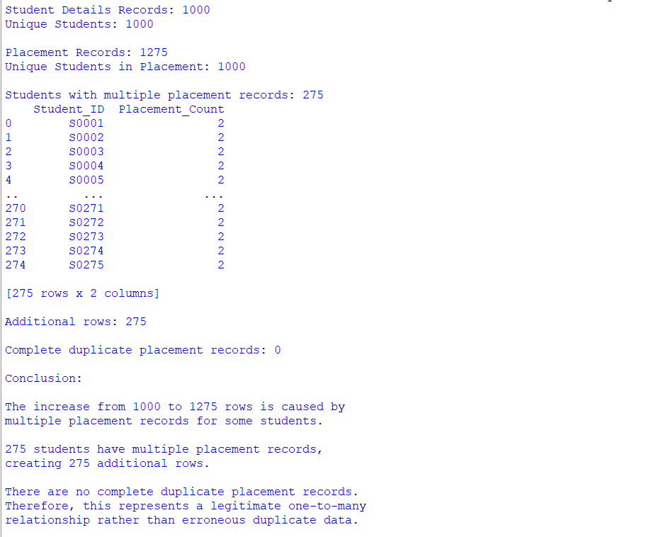

Conclusion: The increase from 1,000 to 1,275 records is legitimate and is caused by a one-to-many relationship between students and placement records.

QUESTION 3 — Integrate Academic Data While Keeping All Students
Aim
To integrate Student Details with Academic Performance using an appropriate join so that all 1,000 registered students remain in the final dataset, and to identify the 40 students whose academic information is unavailable.
Description
The Student Details dataset contains 1,000 registered students, whereas the Academic Performance dataset contains only 960 records. Since every registered student must remain in the final dataset, a LEFT JOIN is selected. This preserves all students from the Student Details dataset while representing unavailable academic information as missing values. The analysis identifies 40 students without academic records.
Code
import pandas as pd
# Load datasets
students = pd.read_csv(
"Student_Details.csv"
)
academic = pd.read_csv(
"Academic_Performance.csv"
)
# Display record counts
print("Registered Students:",
len(students))
print("Academic Records:",
len(academic))
# Find students without academic records
missing_academic = students[
~students["Student_ID"].isin(
academic["Student_ID"]
)
]
print(
"\nStudents without academic information:",
len(missing_academic)
)
print("\nStudent IDs:")
print(
missing_academic["Student_ID"].tolist()
)
# Perform LEFT JOIN
result = pd.merge(
students,
academic,
on="Student_ID",
how="left"
)
# Validate the result
print("\n========== VALIDATION ==========")
print(
"Original Student Records:",
len(students)
)
print(
"Final Records:",
len(result)
)
print(
"Original Unique Students:",
students["Student_ID"].nunique()
)
print(
"Final Unique Students:",
result["Student_ID"].nunique()
)
# Check missing academic information
print("\nMissing Academic Values:")
print(
result[
[
"CGPA",
"Attendance_Percentage",
"Backlogs",
"Academic_Performance"
]
].isnull().sum()
)
# Export result
result.to_csv(
"Student_Academic_Integrated.csv",
index=False
)
Output:
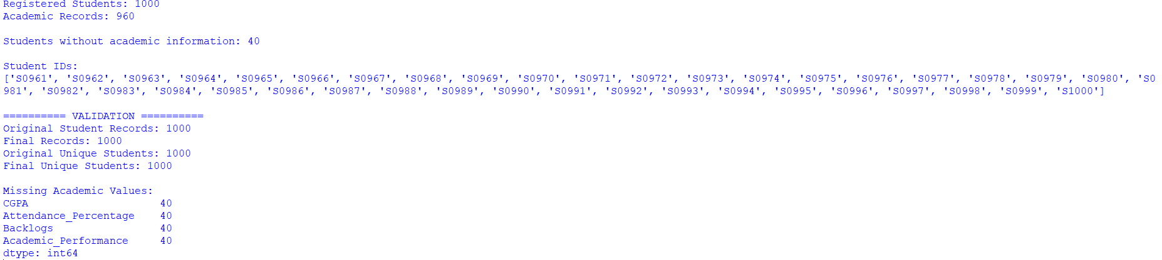
Conclusion: A LEFT JOIN was correctly selected because the requirement is to retain every registered student. The 40 students without academic information are retained rather than deleted.

QUESTION 4 — Systematic Validation of Integrated Dataset
Aim
To design and implement a systematic validation procedure using Pandas to identify integration problems by checking row counts, unique identifiers, duplicate keys, missing values, data types, and unmatched records after each major merge.

Description
A successful Pandas merge does not necessarily mean that the integrated dataset is correct. Therefore, validation is performed after every major integration step. Row counts are checked for unexpected increases or decreases, unique Student_ID values are checked to identify lost students, duplicate keys are examined to identify one-to-many relationships, missing values are checked for unavailable information, data types are checked for consistency, and unmatched records are identified using Student_ID comparisons. The final validation confirms 1,275 rows and 1,000 unique students, with no complete duplicate records and no registered students lost.
Code
import pandas as pd
# ==========================================
# LOAD DATASETS
# ==========================================
students = pd.read_csv(
"Student_Details.csv"
)
academic = pd.read_csv(
"Academic_Performance.csv"
)

skills = pd.read_csv(
"Skills.csv"
)

placement = pd.read_csv(
"Placement_Details.csv"
)
# ==========================================
# VALIDATION FUNCTION
# ==========================================

def validate(df, name):

print("\n" + "=" * 50)
print(name)
print("=" * 50)

# Row count
print(
"Row Count:",
len(df)
)

# Unique identifiers
print(
"Unique Student_ID:",
df["Student_ID"].nunique()
)

# Complete duplicate rows
print(
"Complete Duplicate Rows:",
df.duplicated().sum()
)

# Duplicate keys
print(
"Duplicate Student_ID Records:",
df["Student_ID"].duplicated().sum()
)

# Missing values
print("\nMissing Values:")

missing = df.isnull().sum()
missing = missing[missing > 0]

if len(missing) == 0:
print("No missing values")
else:
print(missing)

# Data types
print("\nData Types:")
print(df.dtypes)

# ==========================================
# VALIDATE ORIGINAL DATASETS
# ==========================================

validate(
students,
"Student Details"
)

validate(
academic,
"Academic Performance"
)

validate(
skills,
"Skills"
)

validate(
placement,
"Placement Details"
)

# ==========================================
# CHECK UNMATCHED RECORDS
# ==========================================

print("\n" + "=" * 50)
print("UNMATCHED RECORDS")
print("=" * 50)

academic_unmatched = academic[
~academic["Student_ID"].isin(
students["Student_ID"]
)
]

print(
"Academic unmatched:",
len(academic_unmatched)
)

skills_unmatched = skills[
~skills["Student_ID"].isin(
students["Student_ID"]
)
]

print(
"Skills unmatched:",
len(skills_unmatched)
)

placement_unmatched = placement[
~placement["Student_ID"].isin(
students["Student_ID"]
)
]

print(
"Placement unmatched:",
len(placement_unmatched)
)

# ==========================================
# MERGE 1: STUDENT + ACADEMIC
# ==========================================

merge1 = pd.merge(
students,
academic,
on="Student_ID",
how="left"
)

validate(
merge1,
"After Student + Academic"
)

# ==========================================
# MERGE 2: ADD SKILLS
# ==========================================

merge2 = pd.merge(
merge1,
skills,
on="Student_ID",
how="left"
)

validate(
merge2,
"After Adding Skills"
)

# ==========================================
# MERGE 3: ADD PLACEMENT
# ==========================================

final = pd.merge(
merge2,
placement,
on="Student_ID",
how="left"
)

validate(
final,
"Final Integrated Dataset"
)

# ==========================================
# CHECK STUDENTS LOST
# ==========================================

lost_students = students[
~students["Student_ID"].isin(
final["Student_ID"]
)
]

print(
"\nStudents lost during integration:",
len(lost_students)
)

# ==========================================
# FINAL VALIDATION
# ==========================================

print("\n" + "=" * 50)
print("FINAL VALIDATION RESULTS")
print("=" * 50)

print(
"Original Students:",
len(students)
)

print(
"Final Rows:",
len(final)
)

print(
"Original Unique Students:",
students["Student_ID"].nunique()
)

print(
"Final Unique Students:",
final["Student_ID"].nunique()
)

print(
"Complete Duplicate Rows:",
final.duplicated().sum()
)

print(
"Repeated Student_ID Records:",
final["Student_ID"].duplicated().sum()
)

# ==========================================
# EXPORT FINAL DATASET
# ==========================================

final.to_csv(
"Final_Integrated_Dataset.csv",
index=False
)

print(
"\nFinal_Integrated_Dataset.csv "
"created successfully."
)
Output:
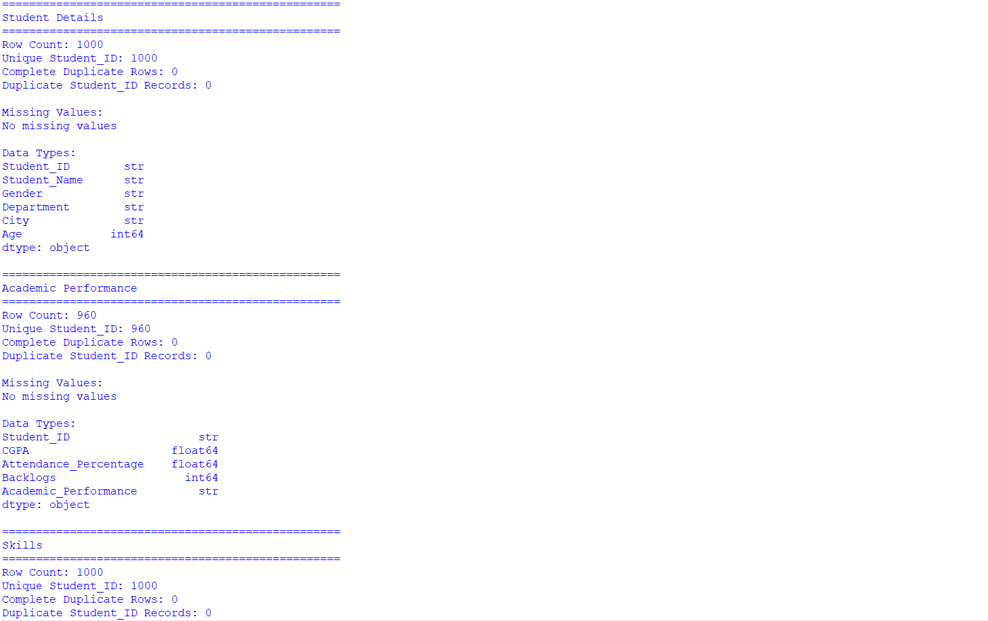
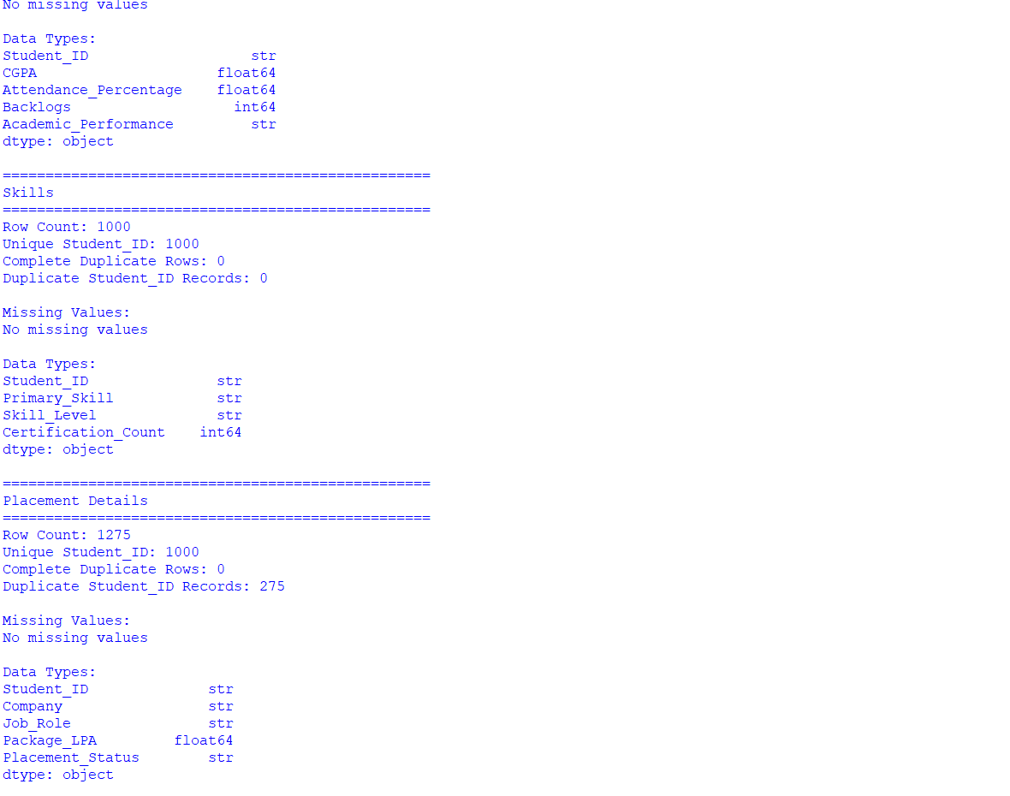
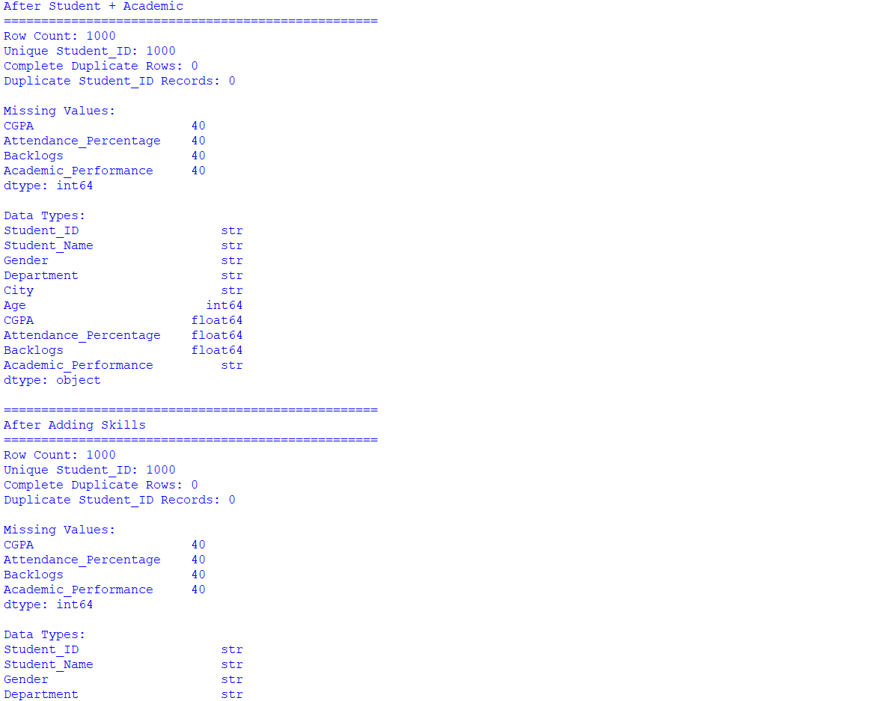

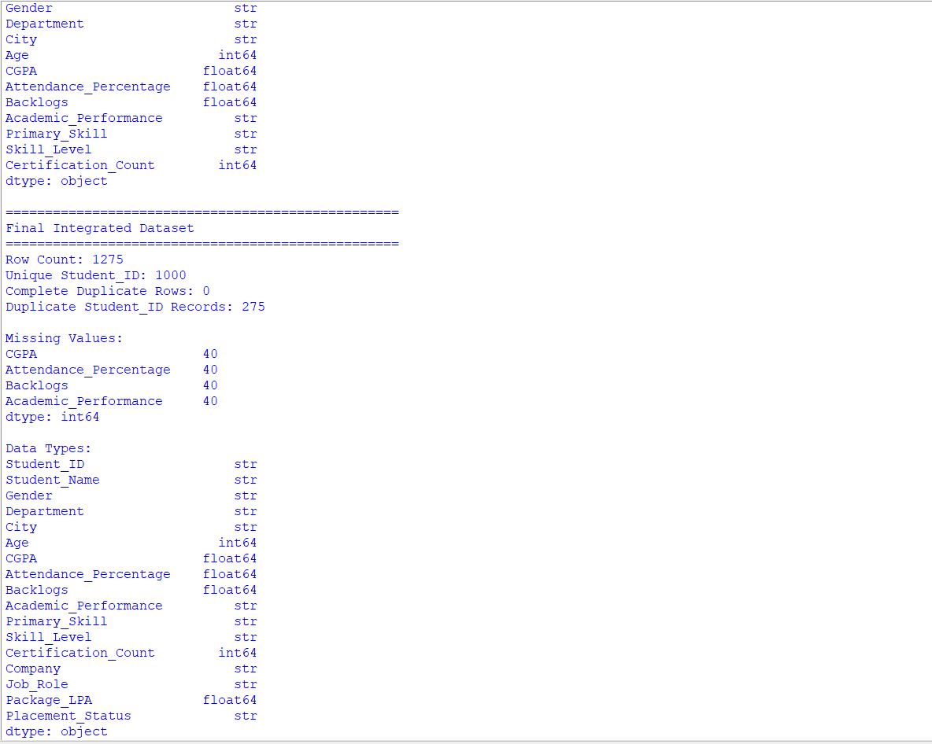
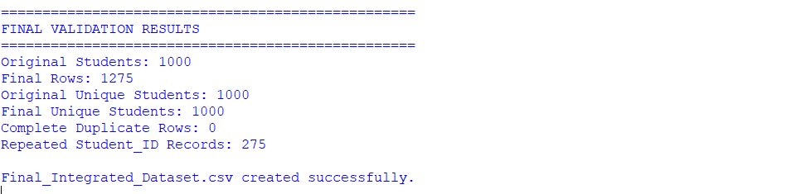
Conclusion: The validation confirms that no registered students were lost. The repeated Student_ID values in the final dataset are explained by the legitimate one-to-many placement relationship rather than complete duplicate records.

