Preface
Content
Chapter Page No.

1. Arduino ....................................................................................................... 1
(Introduction, Board Type, Installation, Programme Structure)

Chapter – 1

Arduino

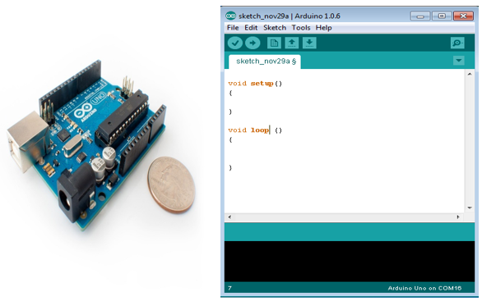
Arduino Board
Arduino IDE (Integerated Development Environment)

1.1 Introduction
Arduino is a prototype platform (open-source) based on an easy-to-use hardware and software. It consists of a circuit board, which can be programed (referred to as a microcontroller) and a ready-made software called Arduino IDE (Integrated Development Environment), which is used to write and upload the computer code to the physical board.
Arduino provides a standard form factor that breaks the functions of the micro-controller into a more accessible package.
The key features are −
- Arduino boards are able to read analog or digital input signals from different sensors and turn it into an output such as activating a motor, turning LED on/off, connect to the cloud and many other actions.

- You can control your board functions by sending a set of instructions to the microcontroller on the board via Arduino IDE (referred to as uploading software).

- Unlike most previous programmable circuit boards, Arduino does not need an extra piece of hardware (called a programmer) in order to load a new code onto the board. You can simply use a USB cable.

- Additionally, the Arduino IDE uses a simplified version of C++, making it easier to learn to program.

- Finally, Arduino provides a standard form factor that breaks the functions of the micro-controller into a more accessible package.

1.2 Board Types
Various kinds of Arduino boards are available depending on different microcontrollers used. However, all Arduino boards have one thing in common: they are programed through the Arduino IDE.
The differences are based on the number of inputs and outputs (the number of sensors, LEDs, and buttons you can use on a single board), speed, operating voltage, form factor etc. Some boards are designed to be embedded and have no programming interface (hardware), which you would need to buy separately. Some can run directly from a 3.7V battery, others need at least 5V.
Here is a list of different Arduino boards available.
Arduino boards based on ATMEGA328 microcontroller
Board Name | Operating Volt | Clock Speed | Digital i/o | Analog Inputs | PWM | UART | Programming Interface
Arduino Uno R3 | 5V | 16MHz | 14 | 6 | 6 | 1 | USB via ATMega16U2
Arduino Pro 3.3v/8 MHz | 3.3V | 8MHz | 14 | 6 | 6 | 1 | FTDI-Compatible Header
Arduino Pro mini 3.3v/8mhz | 3.3V | 8MHz | 14 | 8 | 6 | 1 | FTDI-Compatible Header
Arduino Pro mini 5v/16mhz | 5V | 16MHz | 14 | 8 | 6 | 1 | FTDI-Compatible Header
Arduino Ethernet | 5V | 16MHz | 14 | 6 | 6 | 1 | FTDI-Compatible Header
LilyPad Arduino 328 main board | 3.3V | 8MHz | 14 | 6 | 6 | 1 | FTDI-Compatible Header
LilyPad Arduino simple board | 3.3V | 8MHz | 9 | 4 | 5 | 0 | FTDI-Compatible Header

Arduino boards based on ATMEGA32u4 microcontroller
Board Name | Operating Volt | Clock Speed | Digital i/o | Analog Inputs | PWM | UART | Programming Interface
Arduino Leonardo | 5V | 16MHz | 20 | 12 | 7 | 1 | Native USB
Pro micro 3.3V/8MHz | 5V | 16MHz | 14 | 6 | 6 | 1 | Native USB
LilyPad Arduino USB | 3.3V | 8MHz | 14 | 6 | 6 | 1 | Native USB
Arduino boards based on ATMEGA2560 microcontroller
Board Name | Operating Volt | Clock Speed | Digital i/o | Analog Inputs | PWM | UART | Programming Interface
Arduino Mega 2560 R3 | 5V | 16MHz | 54 | 16 | 14 | 4 | USB via ATMega16U2B
Mega Pro 3.3V | 3.3V | 8MHz | 54 | 16 | 14 | 4 | FTDI-Compatible Header
Mega Pro 5V | 5V | 16MHz | 54 | 16 | 14 | 4 | FTDI-Compatible Header
Mega Pro Mini 3.3V | 3.3V | 8MHz | 54 | 16 | 14 | 4 | FTDI-Compatible Header

Arduino boards based on AT91SAM3X8E microcontroller
Board Name | Operating Volt | Clock Speed | Digital i/o | Analog Inputs | PWM | UART | Programming Interface
Arduino Mega 2560 R3 | 3.3V | 84MHz | 54 | 12 | 12 | 4 | USB native

1.3 Installation

After learning about the main parts of the Arduino UNO board, we are ready to learn how to set up the Arduino IDE. Once we learn this, we will be ready to upload our program on the Arduino board.
In this section, we will learn in easy steps, how to set up the Arduino IDE on our computer and prepare the board to receive the program via USB cable.
Step 1 − First you must have your Arduino board (you can choose your favorite board) and a USB cable. In case you use Arduino UNO, Arduino Duemilanove, Nano, Arduino Mega 2560, or Diecimila, you will need a standard USB cable (A plug to B plug), the kind you would connect to a USB printer as shown in the following image.
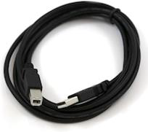
In case you use Arduino Nano, you will need an A to Mini-B cable instead as shown in the following image.
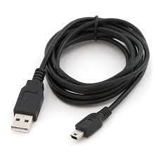
Step 2 − Download Arduino IDE Software.
You can get different versions of Arduino IDE from the Download page on the Arduino Official website. You must select your software, which is compatible with your operating system (Windows, IOS, or Linux). After your file download is complete, unzip the file.
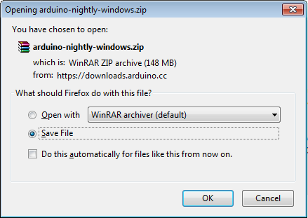

Step 3 − Power up your board.
The Arduino Uno, Mega, Duemilanove and Arduino Nano automatically draw power from either, the USB connection to the computer or an external power supply. If you are using an Arduino Diecimila, you have to make sure that the board is configured to draw power from the USB connection. The power source is selected with a jumper, a small piece of plastic that fits onto two of the three pins between the USB and power jacks. Check that it is on the two pins closest to the USB port.
Connect the Arduino board to your computer using the USB cable. The green power LED (labeled PWR) should glow.
Step 4 − Launch Arduino IDE.
After your Arduino IDE software is downloaded, you need to unzip the folder. Inside the folder, you can find the application icon with an infinity label (application.exe). Double-click the icon to start the IDE.
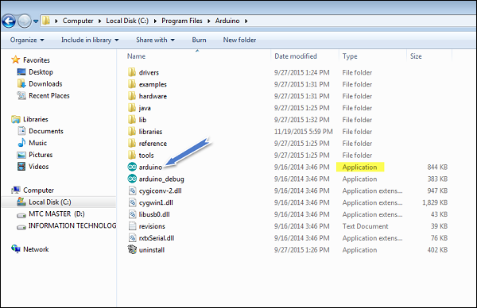
Step 5 − Open your first project.
Once the software starts, you have two options −
- Create a new project.
- Open an existing project example.

To create a new project, select File → New.
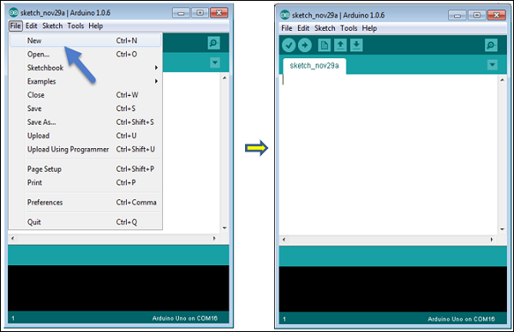

To open an existing project example, select File → Example → Basics → Blink.
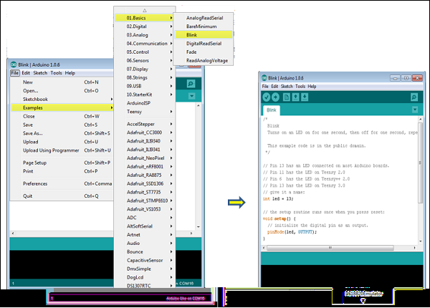
Here, we are selecting just one of the examples with the name Blink. It turns the LED on and off with some time delay. You can select any other example from the list.
Step 6 − Select your Arduino board.
To avoid any error while uploading your program to the board, you must select the correct Arduino board name, which matches with the board connected to your computer.
Go to Tools → Board and select your board.
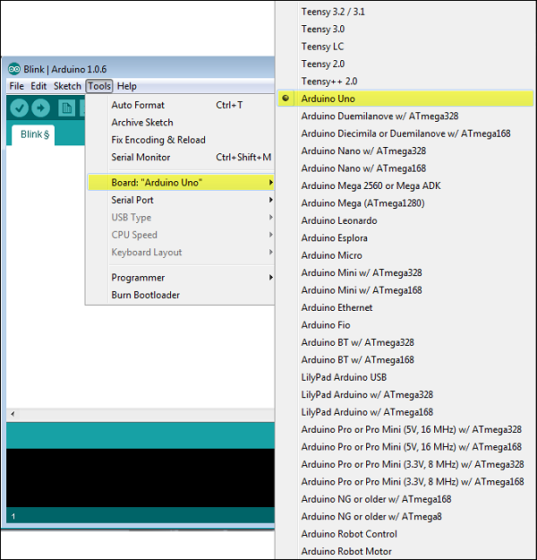
Here, we have selected Arduino Uno board according to our tutorial, but you must select the name matching the board that you are using.

Step 7 − Select your serial port.
Select the serial device of the Arduino board. Go to Tools → Serial Port menu. This is likely to be COM3 or higher (COM1 and COM2 are usually reserved for hardware serial ports). To find out, you can disconnect your Arduino board and re-open the menu, the entry that disappears should be of the Arduino board. Reconnect the board and select that serial port.
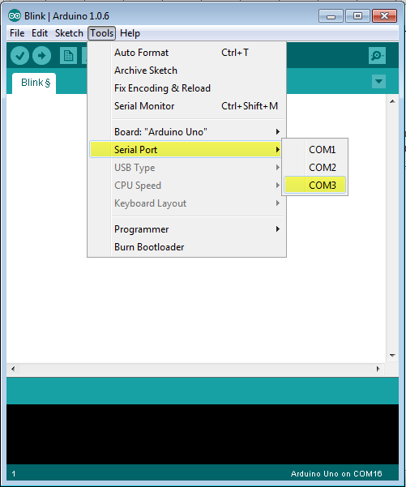

Step 8 − Upload the program to your board.
Before explaining how we can upload our program to the board, we must demonstrate the function of each symbol appearing in the Arduino IDE toolbar.
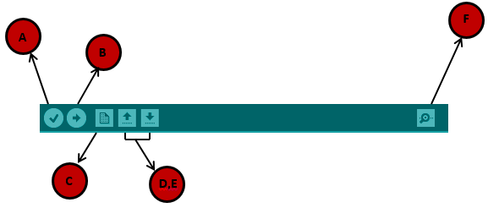
A− Used to check if there is any compilation error.
B− Used to upload a program to the Arduino board.
C− Shortcut used to create a new sketch.
D− Used to directly open one of the example sketch.
E− Used to save your sketch.
F− Serial monitor used to receive serial data from the board and send the serial data to the board.
Now, simply click the "Upload" button in the environment. Wait a few seconds; you will see the RX and TX LEDs on the board, flashing. If the upload is successful, the message "Done uploading" will appear in the status bar.
Note − If you have an Arduino Mini, NG, or other board, you need to press the reset button physically on the board, immediately before clicking the upload button on the Arduino Software.

1.4 Programme Structure

In this chapter, we will study in depth, the Arduino program structure and we will learn more new terminologies used in the Arduino world. The Arduino software is open-source. The source code for the Java environment is released under the GPL and the C/C++ microcontroller libraries are under the LGPL.
Sketch − The first new terminology is the Arduino program called “sketch”.

Structure
Arduino programs can be divided in three main parts: Structure, Values(variables and constants), and Functions. In this tutorial, we will learn about the Arduino software program, step by step, and how we can write the program without any syntax or compilation error.
Let us start with the Structure.Software structure consist of two main functions −
- Setup( ) function
- Loop( ) function
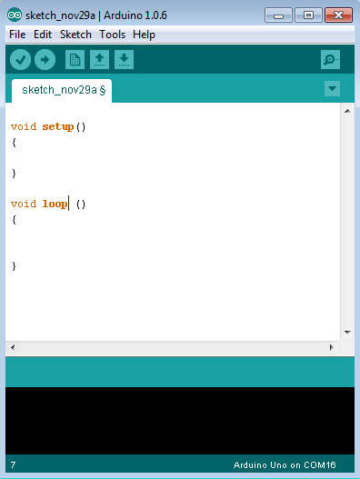
Void setup ( ) {

}
- PURPOSE − The setup() function is called when a sketch starts. Use it to initialize the variables, pin modes, start using libraries, etc. The setup function will only run once, after each power up or reset of the Arduino board.
- INPUT − -
- OUTPUT − -
- RETURN − -
Void Loop ( ) {

}
- PURPOSE − After creating a setup() function, which initializes and sets the initial values, the loop() function does precisely what its name suggests, and loops consecutively, allowing your program to change and respond. Use it to actively control the Arduino board.
- INPUT − -
- OUTPUT − -
- RETURN − -

