Preface
Content
Chapter Page No.

1. Arduino ....................................................................................................... 1

Chapter – 1

Arduino

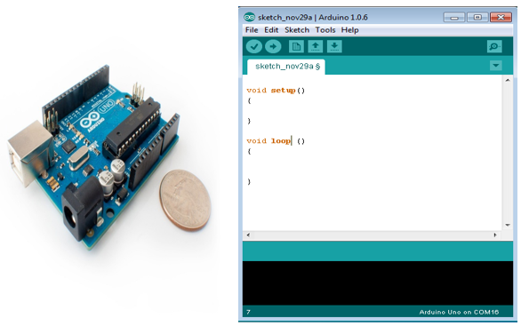
Arduino Board
Arduino IDE (Integerated Development Environment)

Arduino is a prototype platform (open-source) based on an easy-to-use hardware and software. It consists of a circuit board, which can be programed (referred to as a microcontroller) and a ready-made software called Arduino IDE (Integrated Development Environment), which is used to write and upload the computer code to the physical board.
Arduino provides a standard form factor that breaks the functions of the micro-controller into a more accessible package.
The key features are −
- Arduino boards are able to read analog or digital input signals from different sensors and turn it into an output such as activating a motor, turning LED on/off, connect to the cloud and many other actions.

- You can control your board functions by sending a set of instructions to the microcontroller on the board via Arduino IDE (referred to as uploading software).

- Unlike most previous programmable circuit boards, Arduino does not need an extra piece of hardware (called a programmer) in order to load a new code onto the board. You can simply use a USB cable.

- Additionally, the Arduino IDE uses a simplified version of C++, making it easier to learn to program.

- Finally, Arduino provides a standard form factor that breaks the functions of the micro-controller into a more accessible package.

Board Types
Various kinds of Arduino boards are available depending on different microcontrollers used. However, all Arduino boards have one thing in common: they are programed through the Arduino IDE.
The differences are based on the number of inputs and outputs (the number of sensors, LEDs, and buttons you can use on a single board), speed, operating voltage, form factor etc. Some boards are designed to be embedded and have no programming interface (hardware), which you would need to buy separately. Some can run directly from a 3.7V battery, others need at least 5V.

