

**CSE464: Advance Database Systems**

**[Fall 2022]**

**Section: 01**

**Project SRS**

**Blogger Spirit**

**Submitted by:**

|  |  |
| --- | --- |
| **Student ID** | **Student Name** |
| **2019-1-60-256** | **Md. Sabik Alam Rahat** |
| **2018-3-60-052** | **Sourav Saha** |

**Project File:** [**https://github.com/sabikrahat/blogger_spirit**](https://github.com/sabikrahat/blogger_spirit)

**Blogger Spirit**

**Introduction:**

**Blogger Spirit** is a web-based application where a person can easily write his or her blog. For each post 10 points will be reduced. Users can also transfer point from one account to another. User can also see his transferred points and received points. Users can also give feedback and also see other feedbacks

**Technologies:**

We had use **Python (Django)** to develop this system because python is a very secure language and easy to use. For designing, we had use **HTML, CSS, JavaScript, Bootstrap.** We had use **Xampp Control Panel** as a main server because it is a locally created virtual server in which we can easily create **Apache** **MySQL** server for our project. Moreover, Xampp is free of cost and easy to use. We had also use **mongo dB** database to store users’ feedbacks. Besides, we had use git version control to track our workflow neat and clearly.

**Trigger Commands:**

**Fig: Trigger Commands**

**Procedure Commands:**

**Fig: Procedure Commands**

**Functions Commands:**

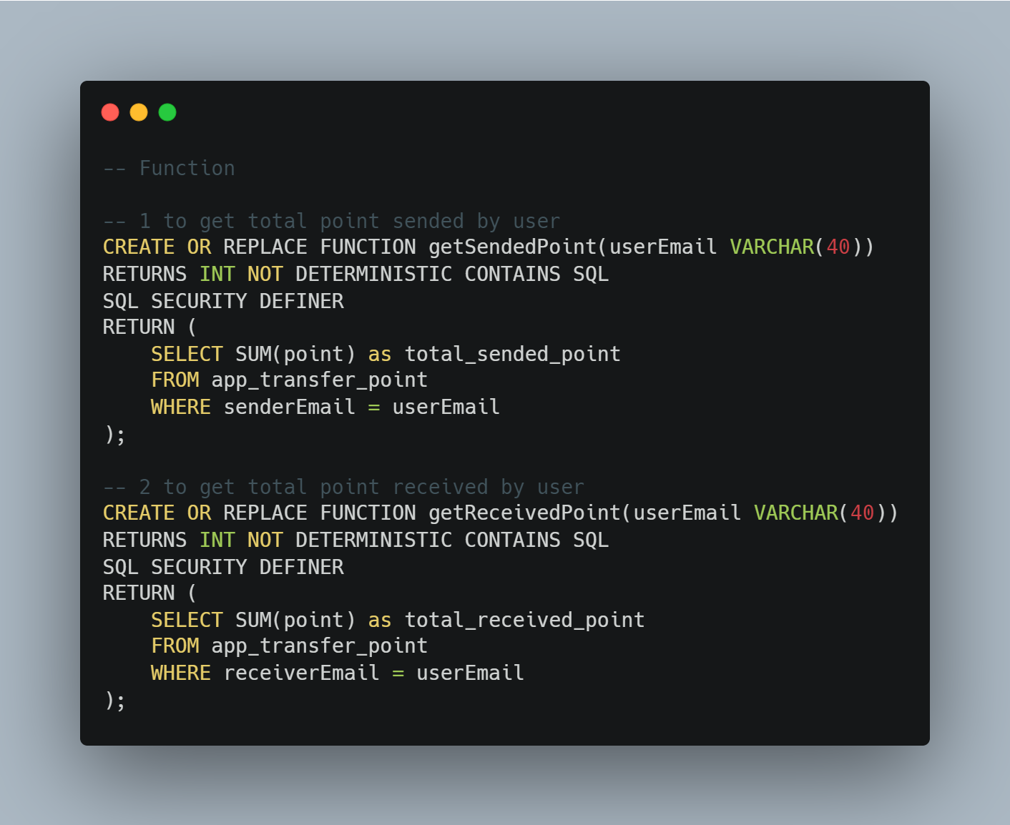

**Fig: Functions Commands**

**Databases:**

**GUI Screenshots:**



