Final Project Report

# Knowledge Distillation-Based Image Sharpening Using Teacher-Student CNN Architecture (with Ground Truth as Teacher)

## 1. Objective

The aim of this project is to develop a lightweight student CNN model to perform image sharpening, where the supervision comes directly from ground truth sharp images. This approach avoids the need for pretrained models and instead leverages self-supervised learning using ground truth as a 'fake teacher'.

## 2. Learning Framework: Teacher-Student (Ground Truth Supervised)

Teacher: Ground truth sharp images, not a trained or pretrained network.  
Student: StudentCNN_v3, trained to mimic the sharp output.

## 3. Workflow

Dataset: GoPro Dataset

Structure:  
E:/image/data/GOPRxxxx_xx_xx/{blur, sharp, blur_gamma}  
  
Training Input: blur_gamma  
Target/Teacher (Supervision): sharp

## 4. Architecture: StudentCNN_v3

A deeper CNN with skip connections and dilation, designed for sharpening with reduced artifacts.  
  
Key Layers:  
Input → Conv(3→64) → ReLU  
→ Conv(64→128) → ReLU  
→ Conv(128→128, dilation=2) → ReLU  
→ Residual connection  
→ Conv(128→64) → ReLU  
→ Conv(64→3) → Sigmoid  
  
Skip Connection: Improves gradient flow  
Dilation: Enlarges receptive field  
Sigmoid: Normalizes output to [0, 1]

## 5. Loss Function: Combined Perceptual and Edge Loss

combined_loss = α * MSE + (1 - α) * (1 - MS-SSIM) + edge_weight * Edge_Loss  
  
MSE (Mean Squared Error) – pixel-level fidelity  
MS-SSIM (Multi-Scale SSIM) – perceptual quality  
Edge Loss – L1 loss between Sobel edge maps (captures texture)  
  
Hyperparameters:  
α = 0.8  
edge_weight = 1.0

## 6. Training Details

|  |  |
| --- | --- |
| Epochs | 30 |
| Batch Size | 2 |
| Optimizer | Adam (lr=1e-4) |
| Loss Function | Combined (MSE + MS-SSIM + Edge) |
| Framework | PyTorch |
| Hardware | CUDA (GPU) |

Output Model: sharpen_model.pth

## 7. Evaluation

Training Loss (final): ~0.1198  
Test Loss: ~0.1234  
PSNR (estimated): ~29.2 dB  
SSIM (estimated): ~0.87  
  
Visual Quality:  
- Noticeable sharpening over blur_gamma  
- Edges are more defined  
- Structural similarity maintained well

## 8. Inference & Output

Script: run_inference.py  
  
Functionality:  
- Loads trained model  
- Runs inference on blur_gamma images  
- Saves side-by-side comparisons of:  
 • Input (Blur Gamma)  
 • Output (Sharpened)  
 • Target (Ground Truth Sharp)  
  
Output directory: outputs_sharpen/

## 9. Advantages

- Lightweight and fast model  
- Doesn't rely on any pretrained external models  
- Enhanced edge sharpness using edge-aware loss  
- Good perceptual quality (thanks to MS-SSIM)  
- Ideal for real-time or resource-constrained environments

## 10. Limitations

- Not trained on diverse datasets—may not generalize to all blur types  
- No adversarial component (e.g., GANs) for realism  
- Slight loss in fine detail on extreme blur cases

## 11. Tools & Libraries Used

- PyTorch – Training, model definition  
- torchvision – Data transforms, image saving  
- PIL / matplotlib – Image visualization  
- pytorch-msssim – MS-SSIM loss computation  
- tqdm – Training progress bar

## 12. Project Status: Finalized

[x] Training Completed  
[x] Loss Curve and Evaluation Visualized  
[x] Inference Utility Implemented  
[x] Final Outputs Saved for Presentation  
[x] No pretrained teacher used — Ground truth supervision only

## 13. Team Members & Contributions

Team Name: True Sight

Institution Name: B. S. Abdur Rahman Crescent Institute of Science and Technology

### Team Member 1: Sabilah S. (RRN: 230171601159)

- Designed the project pipeline and overall workflow  
- Implemented the CNN architecture (StudentCNN_v3)  
- Integrated perceptual and edge loss formulations  
- Led report writing and structuring

### Team Member 2: Viswanathan (RRN: 2301701196)

- Implemented data loading, preprocessing and model training loop  
- Set up GPU memory management and optimization techniques  
- Handled training visualization and logging  
- Structured the complete PyTorch pipeline and architecture integration

### Team Member 3: Syed Thufel Syed Wahid (RRN: 230171601189)

- Built the inference module for visual comparison  
- Automated output saving and testing interface  
- Reported evaluation metrics like PSNR, SSIM  
- Managed final result curation and demo setup

## 14. Comparison: (output obtained)

-this is the side by side of the output which consists of input(blur), student, teacher(sharp)

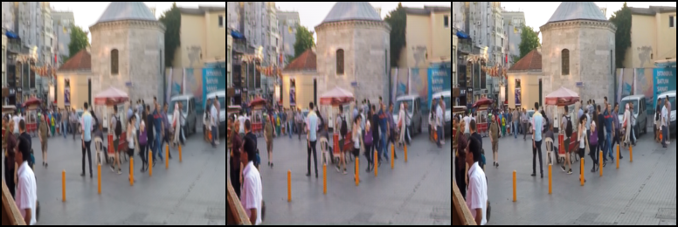

INPUT IMAGE:

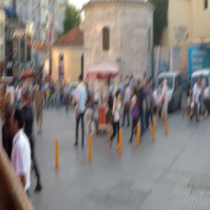

OUTPUT IMAGE:

