ITS10-02 Software Engineering Project

FINAL REPORT

Nepalese Student Association (NSA) Website

Submitted to:
Prof. Ibrahim Musa Ishag Musa
Department of International Studies-IT Major
College of Glocal Autonomous Major
Dongshin University

Submitted by:
NSA Website Development Team

June 2026
Dongshin University, Republic of Korea

NSA Website Development Team
Student ID | Name
2401138 | Bahala Shrestha Sabin
2401192 | Glen Milan
2400991 | Sunuwar Ramuna
2400580 | Koirala Sumit
2400056 | Uprety Anish

Abstract
The Nepalese Student Association (NSA) Website is a full-stack web-based management platform developed to improve communication, transparency, and engagement among students and administrators of the Nepalese Student Association at Dongshin University. Traditional methods of sharing information through social media platforms and messaging applications often resulted in fragmented communication, missed announcements, and inefficient management of association activities.
To address these challenges, the NSA Website was developed as a centralized platform integrating event management, notice dissemination, Google Forms-style survey collection, job opportunity sharing, resource management, budget transparency, and role-based user management functionalities.
The system was implemented using React.js for the frontend, Node.js and Express.js for the backend, and MySQL as the relational database management system. The platform was deployed on Railway cloud services with a custom domain (sabinbahala.com.np). Security features including JWT authentication, bcrypt password hashing, and email-based OTP verification were implemented to ensure secure access. The development followed Agile Software Engineering principles with iterative delivery, UML modelling, and comprehensive testing.

Table of Contents

Abstract 3
Table of Contents 4
Chapter 1: Introduction 6
1.1 Purpose and Scope 6
1.2 Product Overview 6
1.3 Structure of the Document 7
1.4 Terms, Acronyms, and Abbreviations 7
Chapter 2: Project Management Plan 8
2.1 Project Organization 8
2.2 Lifecycle Model Used 8
2.3 Risk Analysis 8
2.4 Hardware and Software Resource Requirements 9
2.5 Deliverables and Schedule 9
2.6 Monitoring, Reporting, and Controlling Mechanisms 10
2.7 Professional Standards 10
2.8 Configuration Management 10
2.9 Impact on Individuals and Organizations 10
Chapter 3: Requirement Specifications 12
3.1 Stakeholders for the System 12
3.2 Use Case Model 12
3.3 Rationale for Use Case Model 15
3.4 Non-Functional Requirements 15
Chapter 4: Architecture 17
4.1 Architectural Style Used 17
4.2 Architectural Model 17
4.3 Technology, Software, and Hardware Used 18
4.4 Rationale for Architectural Style and Model 19
Chapter 5: Design 20
5.1 GUI Design 20
5.2 Static Model – Class Diagram 22
5.3 Dynamic Model – Sequence Diagrams 24
5.4 Database Design (ER Diagram) 27
5.5 Traceability from Requirements to Detailed Design Model 28
Chapter 6: Test Plan 29
6.1 Requirements/Specifications-Based System Level Test Cases 29
6.2 Traceability of Test Cases to Use Cases 32
6.3 Techniques Used for Test Generation 33
6.4 Assessment of the Goodness of the Test Suite 34
Acknowledgment 35
References 36
Appendix A – Project Resources 37
Appendix B – AI tools 37
Appendix C – Future Business Opportunities 37
Appendix D – Development Team Photo 38

Chapter 1: Introduction

1.1 Purpose and Scope
The Nepalese Student Association (NSA) Website is a web-based platform developed to improve communication, information sharing, event management, and student engagement among Nepalese students at Dongshin University. Traditionally, important information was shared through social media and messaging applications, which resulted in scattered communication and inefficient management.
The purpose of this project is to provide a centralized digital platform where students and administrators can efficiently manage and access association-related information.
The scope of the project includes:
- User registration and authentication with OTP email verification
- Role-based access control (Admin and Student)
- Event management system with registration
- Notice board management
- Job opportunity portal with applications
- Google Forms-style survey system with per-question responses
- Budget transparency module
- Resource management (PDF uploads)
- User management system
- Responsive web interface accessible from multiple devices
- Cloud deployment on Railway with custom domain
The system does not include payment processing, direct messaging, or mobile application support in the current version.

1.2 Product Overview
The NSA Website is a full-stack web application that serves as the official digital platform for the Nepalese Student Association. The system follows a three-tier client-server architecture: React.js frontend, Node.js/Express.js backend, and MySQL database, deployed on Railway cloud platform.
Key Capabilities
User Management: Students register using academic information. Administrators manage accounts and assign roles.
Authentication and Security: Secure login using bcrypt-encrypted passwords and JWT tokens. Email-based OTP verification is integrated for registration and password recovery.
Event Management: Administrators create, update, and delete events. Students view and register for events.
Notice Management: Administrators publish official announcements. Students access notices in real time.
Job Portal: Administrators post-employment opportunities. Students browse and apply for positions.
Survey System: Administrators build Google Forms-style surveys with multiple question types (Short Answer, Paragraph, Multiple Choice, Checkboxes). Students fill out surveys and responses are analyzed with per-question summaries.
Budget Transparency: Administrators maintain income and expense records visible to all members.
Resource Management: Administrators upload PDF resources. Students download academic and association materials.

1.3 Structure of the Document
Chapter 1 – Introduction: Purpose, scope, product overview, and terminology.
Chapter 2 – Project Management Plan: Organization, lifecycle, risk analysis, resources, and schedule.
Chapter 3 – Requirement Specifications: Stakeholders, use cases, and non-functional requirements.
Chapter 4 – Architecture: Architectural style, technology stack, and design decisions.
Chapter 5 – Design: GUI design, class diagrams, sequence diagrams, database design, and traceability.
Chapter 6 – Test Plan: Test cases, testing techniques, traceability, and test quality metrics.

1.4 Terms, Acronyms, and Abbreviations
Term | Description
NSA | Nepalese Student Association
GUI | Graphical User Interface
JWT | JSON Web Token
RBAC | Role-Based Access Control
API | Application Programming Interface
OTP | One-Time Password
CRUD | Create, Read, Update, Delete
UML | Unified Modeling Language
ER Diagram | Entity Relationship Diagram
React | Frontend JavaScript UI Library
Node.js | Server-side JavaScript Runtime
Express.js | Web Framework for Node.js
MySQL | Relational Database Management System
Railway | Cloud deployment platform
Brevo | Email API service for OTP delivery
Vite | Frontend build tool

Chapter 2: Project Management Plan

2.1 Project Organization
The NSA Website project was developed as part of the Software Engineering course (ITS10-02) at Dongshin University. Team members shared responsibilities across system modules.
Role | Responsibilities
Project Manager | Planning, scheduling, coordination, progress monitoring, report preparation
Backend Developer | REST API development, database integration, authentication, business logic
Frontend Developer | UI development, page navigation, user experience design
Database Designer | Database schema creation, ER diagram, data management
Tester | Functional testing, bug identification, validation
Documentation Manager | SRS, design documents, RTM, final report preparation

2.2 Lifecycle Model Used
The project adopted the Agile Software Development Model. Agile was selected because it allows continuous development, frequent testing, and iterative improvement. Since requirements evolved during development, Agile provided the flexibility needed.
Development Iterations
- Iteration 1 – Requirements Analysis: Stakeholder identification, requirement gathering, SRS preparation, use case development
- Iteration 2 – System Design: Architecture design, database design, class diagrams, sequence diagrams
- Iteration 3 – Backend Development: Authentication, user management, event, notice, job, survey, and resource APIs
- Iteration 4 – Frontend Development: Registration, login, dashboard, event management, job portal, survey system
- Iteration 5 – Testing and Integration: Functional, API, database testing, and bug fixing
- Iteration 6 – Deployment and Documentation: Railway deployment, database migration, final report

2.3 Risk Analysis
Risk | Probability | Impact | Mitigation Strategy
Requirement changes | Medium | High | Regular stakeholder discussions
Database connection failures | High | High | Connection pooling, keep-alive configuration
Deployment issues | High | Medium | Continuous deployment testing on Railway
Security vulnerabilities | Medium | High | JWT authentication and bcrypt password hashing
Data loss | Low | High | Regular database backups via Railway
Schedule delays | Medium | Medium | Milestone tracking and task prioritization
Third-party email service failure | Medium | Medium | Brevo API with fallback configuration
Exposed environment variables | Medium | High | Environment variables stored in Railway, not in repository
During deployment, the team experienced database TCP_TOO_OLD connection errors on Railway. This was resolved by implementing connection pooling with keep-alive pings and storing environment variables directly in Railway's variable dashboard rather than the repository.

2.4 Hardware and Software Resource Requirements
Hardware Requirements
Component | Specification
Processor | Intel Core i5 or higher
RAM | 8 GB minimum
Storage | 256 GB SSD minimum
Internet | Broadband connection
Deployment Server | Railway Cloud Platform (managed)

Software Requirements
Software | Purpose
Visual Studio Code | Primary source code editor
Node.js v18+ | Backend JavaScript runtime environment
Express.js v5 | RESTful API web framework
React.js v19 | Frontend component-based UI library
Vite v8 | Frontend build and development tool
MySQL | Relational database management system
Railway | Cloud deployment and database hosting
Git & GitHub | Version control and source code repository
Postman | API endpoint testing tool
Figma | UI/UX wireframe and mockup design
Brevo | Transactional email and OTP API service

New Technologies Learned During the Project
Technology | Learning Outcome
React.js with Hooks | Component-based frontend architecture and state management
Express.js REST APIs | Backend route handling, middleware, and controller pattern
JWT Authentication | Stateless secure user authentication using signed tokens
Railway Cloud Deployment | Cloud application hosting, environment variables, auto-deploy from GitHub
MySQL Integration | Relational database design, foreign keys, and connection pooling
Brevo Email API | Transactional email delivery for OTP verification
Git & GitHub | Collaborative version control and branch management

2.5 Deliverables and Schedule
Deliverable | Description | Status
Software Requirements Specification (SRS) | Functional and non-functional requirements document | Completed
Context Diagram | System boundary and external entity diagram | Completed
Use Case Diagram | Actor-system interaction model | Completed
ER Diagram | Database entity relationship model | Completed
Class Diagram | Object-oriented static model | Completed
Sequence Diagrams | Dynamic interaction models | Completed
Implemented System | Fully functional deployed web application | Completed
Final Report | Complete software engineering project documentation | Completed

2.6 Monitoring, Reporting, and Controlling Mechanisms
The team used the following mechanisms throughout the project:
- GitHub repository for source code version control and commit history tracking
- Railway deploy logs for monitoring backend deployment status
- Browser DevTools (Network tab) for API response monitoring during testing
- Weekly progress reviews among team members
- Issue tracking through GitHub commits with descriptive commit messages

2.7 Professional Standards
The project followed several professional software engineering standards:
- IEEE Std 830-1998 for Software Requirements Specification format
- UML 2.0 notation for use case, class, and sequence diagrams
- REST API design principles for backend architecture
- IEEE Conference Proceedings citation format for references
- OWASP security practices including password hashing and JWT for authentication

2.8 Configuration Management
All source code, documentation, and configuration files are maintained in the GitHub repository at: https://github.com/sabin2002/NSA-website
Configuration management practices included:
- All code changes committed with descriptive messages (e.g., 'Fix gitignore and db config')
- Environment variables stored securely in Railway dashboard, never committed to repository
- A .gitignore file configured to exclude node_modules/, .env, and build artifacts
- The main branch is directly connected to Railway for continuous deployment

2.9 Impact on Individuals and Organizations
For individual students, the NSA Website provides a single platform to access events, job opportunities, notices, surveys, and downloadable resources. This reduces dependence on informal messaging platforms and improves awareness of association activities.
For the Nepalese Student Association as an organization, the platform enables transparent budget management, structured survey collection, and centralized communication, improving administrative efficiency.
For Dongshin University, the project demonstrates the capability of students to design, implement, test, and deploy a real-world full-stack web application applying software engineering principles.

Chapter 3: Requirement Specifications

3.1 Stakeholders for the System
Stakeholder | Role | Interaction with System
NSA Administrator | Primary system manager | Manages all content: events, notices, jobs, surveys, budget, users
NSA Student Members | Primary end users | Views content, registers for events, submits surveys, applies for jobs
Dongshin University | Institutional sponsor | Provides academic context and infrastructure support
Prof. Ibrahim Musa | Academic supervisor | Reviews requirements and system deliverables
Brevo Email Service | External service provider | Delivers OTP emails for registration and password reset
Railway Platform | Infrastructure provider | Hosts application backend and MySQL database

3.2 Use Case Model
3.2.1 Graphic Use Case Model
The system includes two primary actors: Administrator and Student. The Administrator has access to all management functions, while the student has access to viewing and participation functions.
Administrator Use Cases: Login, Manage Events, Manage Notices, Manage Jobs, Manage Surveys (create with multiple question types), View Survey Responses, Manage Budget, Manage Users, Manage Resources, View Event Participants, View Job Applications.
Student Use Cases: Register, Login, Reset Password, View Events, Register for Events, View Notices, Browse Jobs, Apply for Jobs, Fill Out Surveys, View Budget, Download Resources, Edit Profile.
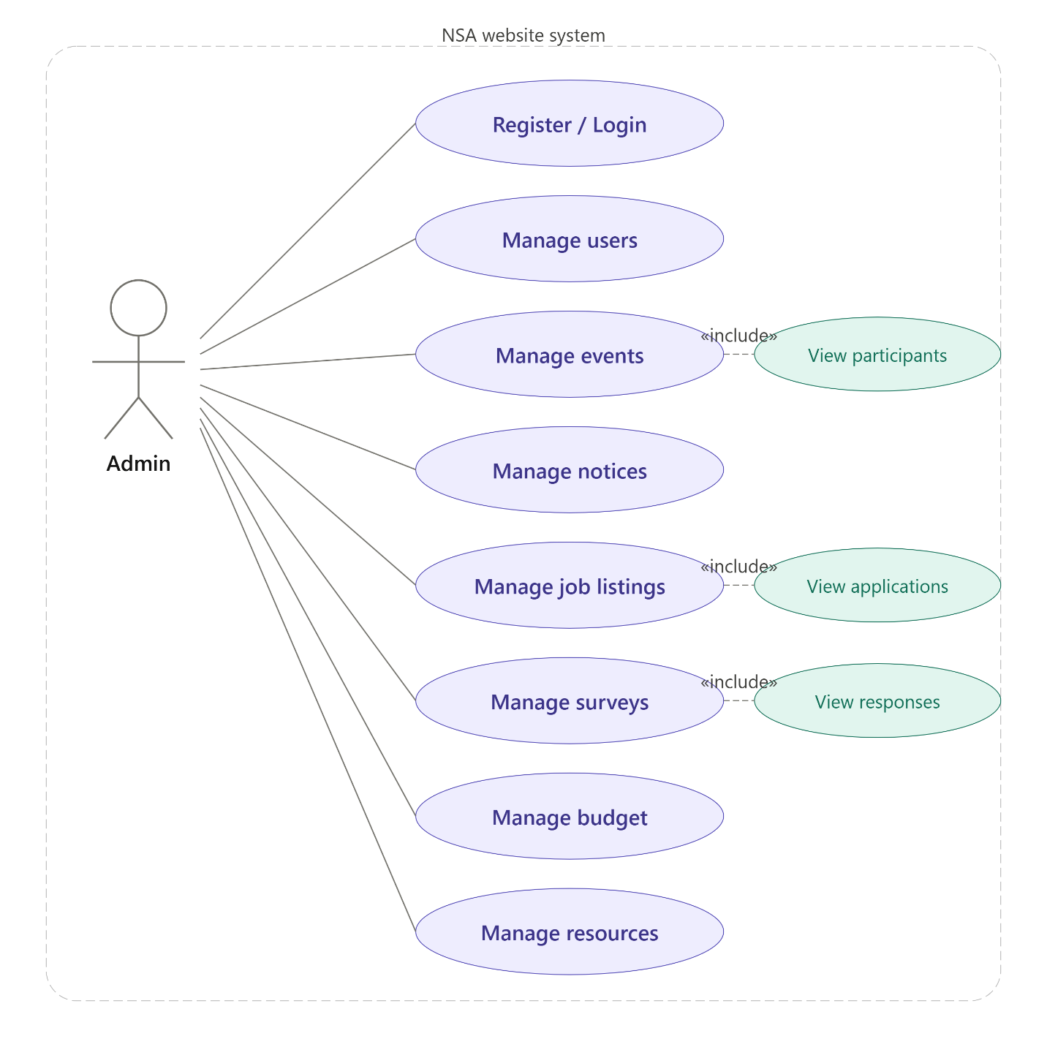

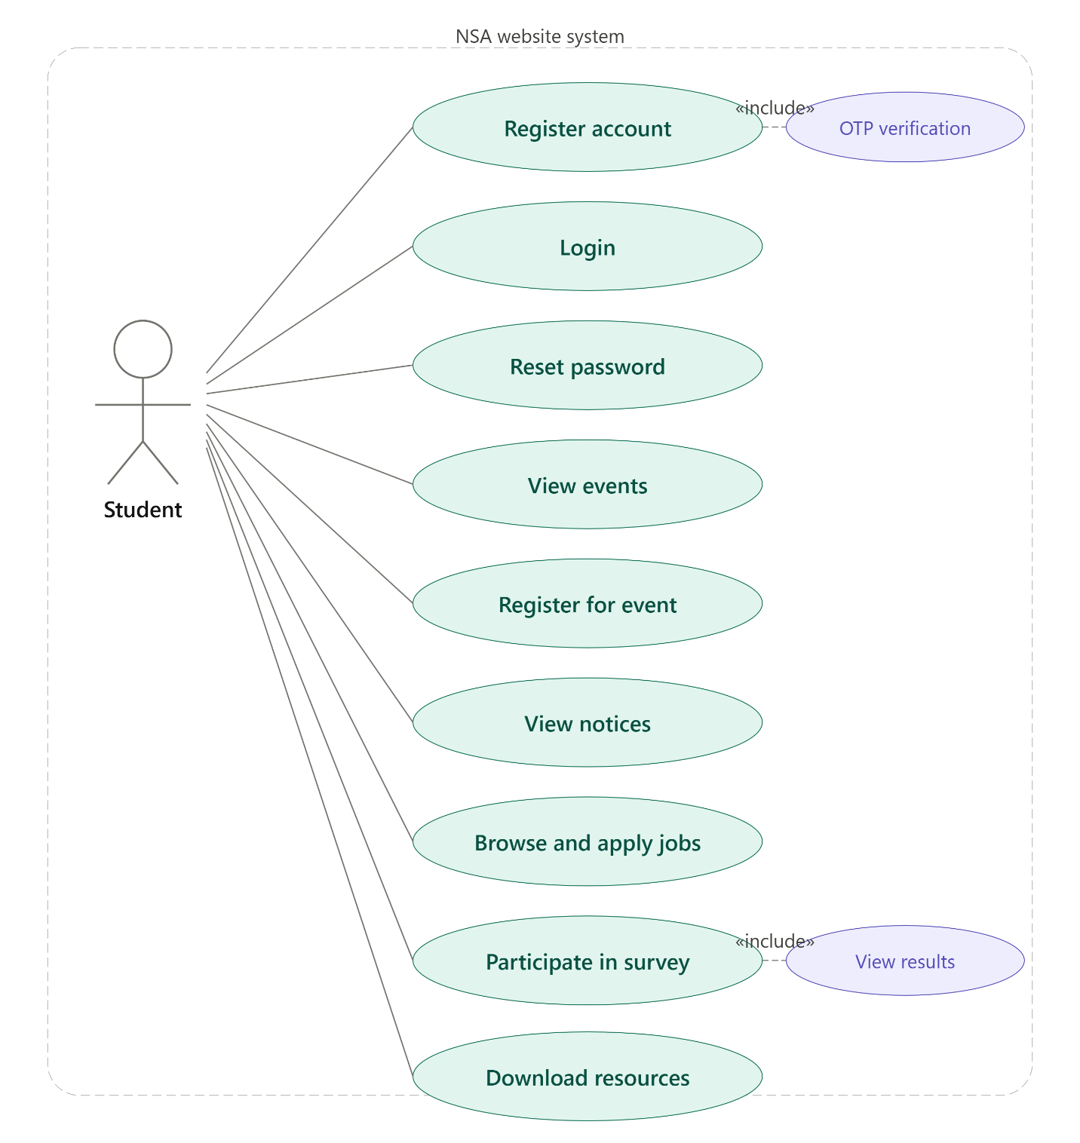
3.2.2 Textual Description for Key Use Cases
Use Case UC-01: User Registration
Item | Description
Use Case ID | UC-01
Name | User Registration
Actor | Student
Precondition | User has a valid academic email address
Main Flow | 1. User opens registration page.  2. User enters student ID, name, email, password, and academic details.  3. User requests OTP.  4. System sends OTP to email via Brevo.  5. User enters OTP.  6. System verifies OTP.  7. User submits registration form. 8. System creates account and stores in database.
Postcondition | New user account created and user can login
Alternative Flow | If OTP is invalid or expired, system displays error and user must re-request OTP

Use Case UC-02: Admin Creates Survey
Item | Description
Use Case ID | UC-02
Name | Admin Creates Survey with Questions
Actor | Administrator
Precondition | Admin is authenticated and on Survey Management page
Main Flow | 1. Admin enters survey title, description, and optional deadline.  2. Admin adds questions of types: Short Answer, Paragraph, Multiple Choice, or Checkboxes.  3. For MCQ/Checkbox, admin enters answer options.  4. Admin marks questions as required or optional.  5. Admin clicks Create Survey.  6. System saves survey and questions to database.
Postcondition | Survey is published and visible to students
Alternative Flow | If any required field is missing, system displays validation error

Use Case UC-03: Student Submits Survey
Item | Description
Use Case ID | UC-03
Name | Student Submits Survey Response
Actor | Student
Precondition | Student is logged in and a survey is available
Main Flow | 1. Student navigates to Surveys page.  2. Student selects a survey.  3. System loads survey questions.  4. Student answers each question.  5. Student clicks Submit.  6. System validates required fields.  7. System saves per-question responses and prevents duplicate submission.
Postcondition | Response stored, success confirmation shown, student cannot re-submit
Alternative Flow | If required question is unanswered, system shows validation alert

3.3 Rationale for Use Case Model
The use case model was selected because it clearly captures user-system interactions from the perspective of each actor without exposing internal implementation details. It provides a shared understanding between developers and stakeholders and maps directly to testable scenarios. The separation of Administrator and Student use cases reflects the role-based access control implemented in the system.

3.4 Non-Functional Requirements
Category | Requirement | Metric
Security | All passwords must be hashed using bcrypt | No plain-text passwords stored
Security | All API routes requiring authentication must validate JWT tokens | 401 response for invalid tokens
Security | Admin routes must verify admin role | 403 response for non-admin access
Performance | Page load time should be under 3 seconds on standard connection | Measured during UAT
Reliability | System should handle database reconnection automatically | Keep-alive pool configured
Usability | Interface must be navigable without training | Validated during UAT
Scalability | System should support at least 100 concurrent users | Railway cloud hosting
Maintainability | Code organized in MVC pattern with separate controllers and routes | Code review
Availability | System available 24/7 via cloud deployment | Railway managed hosting
Portability | System accessible from any modern browser on any device | Tested on Chrome, Edge

Chapter 4: Architecture

4.1 Architectural Style Used
The NSA Website uses a Three-Tier Client-Server Architecture combined with a RESTful API architectural style.
- Presentation Tier: React.js single-page application running in the browser
- Application Tier: Node.js/Express.js REST API server handling business logic
- Data Tier: MySQL relational database managing persistent data
This architectural style was chosen because it clearly separates concerns, allows independent scaling of each layer, and is the industry standard for modern web applications.

4.2 Architectural Model
Client Layer: The React.js frontend communicates with the backend exclusively through HTTP REST API calls using the Axios library. React Router handles client-side navigation. The frontend is hosted on Railway as a static build served via Vite.
Application Layer: The Express.js backend follows the MVC pattern with separate route files, controller files, and middleware. JWT middleware authenticates requests. The backend is deployed on Railway and listens on port 8080.
Data Layer: MySQL database hosted on Railway's managed MySQL service. The backend connects using a mysql2 connection pool with keep-alive configuration. Tables include: users, surveys, survey_questions, survey_question_responses, events, event_registrations, notices, jobs, job_applications, budget, resources, otp_verifications.
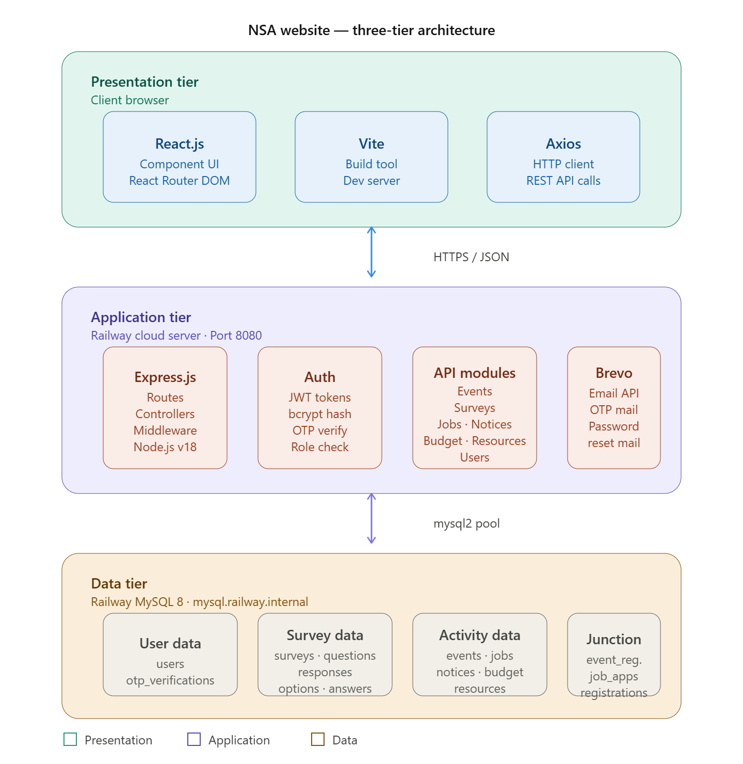

4.3 Technology, Software, and Hardware Used
Layer | Technology | Version | Purpose
Frontend | React.js | 19.x | Component-based UI development
Frontend | Vite | 8.x | Build tool and dev server
Frontend | React Router DOM | 7.x | Client-side routing
Frontend | Axios | 1.x | HTTP API communication
Frontend | React Icons | 5.x | Icon library
Frontend | Recharts | 3.x | Dashboard charts
Backend | Node.js | 18+ | JavaScript runtime
Backend | Express.js | 5.x | REST API framework
Backend | jsonwebtoken | 9.x | JWT authentication
Backend | bcryptjs | 3.x | Password hashing
Backend | mysql2 | 3.x | MySQL database driver
Backend | multer | 2.x | File upload handling
Backend | nodemailer/Brevo | Latest | Email OTP delivery
Database | MySQL | 8.x | Relational data storage
Deployment | Railway | Cloud | App and database hosting
DevOps | GitHub | - | Source control and CI/CD

4.4 Rationale for Architectural Style and Model
The three-tier architecture was selected for the following reasons:
- Separation of concerns: Frontend, backend, and database can be developed, tested, and deployed independently
- Scalability: Each tier can be scaled independently on Railway cloud
- Security: The database is never directly accessible from the browser; all access goes through authenticated API endpoints
- Maintainability: MVC pattern in the backend makes it easy to add new features
- Industry standard: React + Node.js + MySQL is a widely adopted stack with strong community support

Chapter 5: Design

5.1 GUI Design
The user interface follows a consistent design language across all pages: dark red (#8B1414) as the primary brand color, clean white card-based layouts, and a responsive grid system.
Key Interface Pages
- Login Page: Email and password fields with 'Forgot Password' link
- Registration Page: Multi-field form with OTP verification step
- Home Page: Hero banner, event highlights, and navigation
- Admin Dashboard: Statistics cards, bar chart (system overview), pie chart (budget summary), quick navigation
- Survey Management (Admin): Two-column layout – form on left with question builder (add/remove questions, MCQ options, required toggle), survey table on right
- Survey Page (Student): Survey list, per-question form with all question types rendered appropriately, success confirmation screen
- Admin Survey Responses: Sidebar survey selector, Summary tab with bar charts per question, Individual tab with expandable respondent rows
- Job Portal: Job cards with apply functionality
- Events Page: Event cards with registration
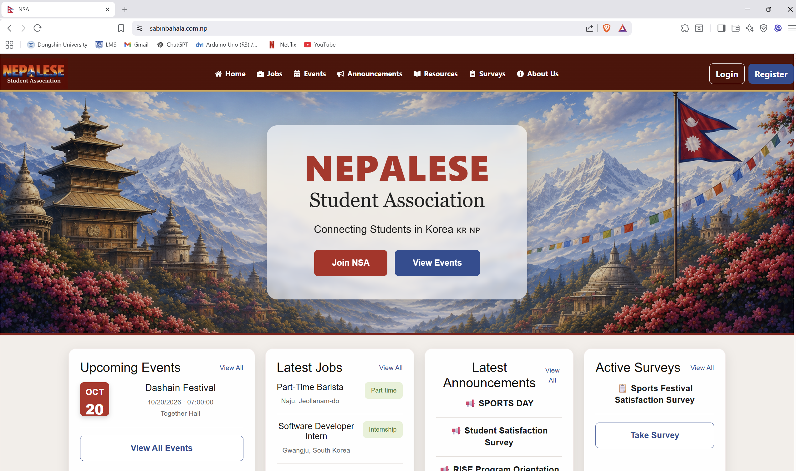

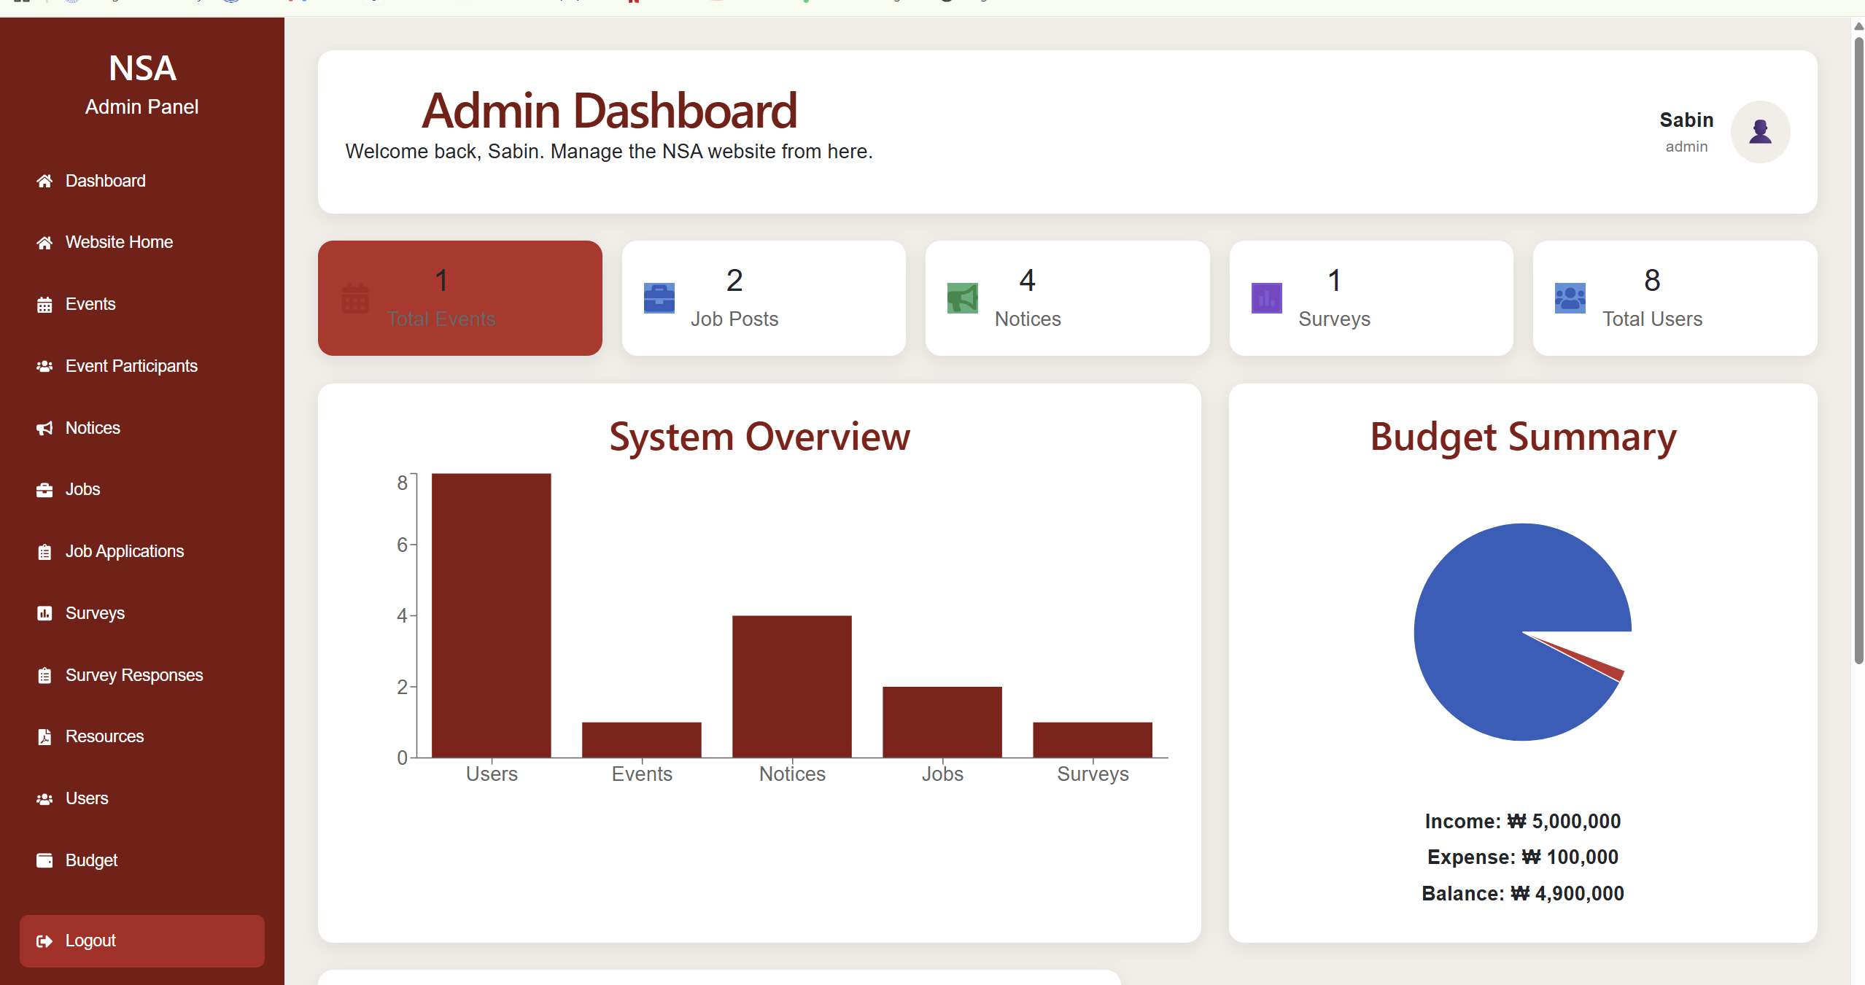

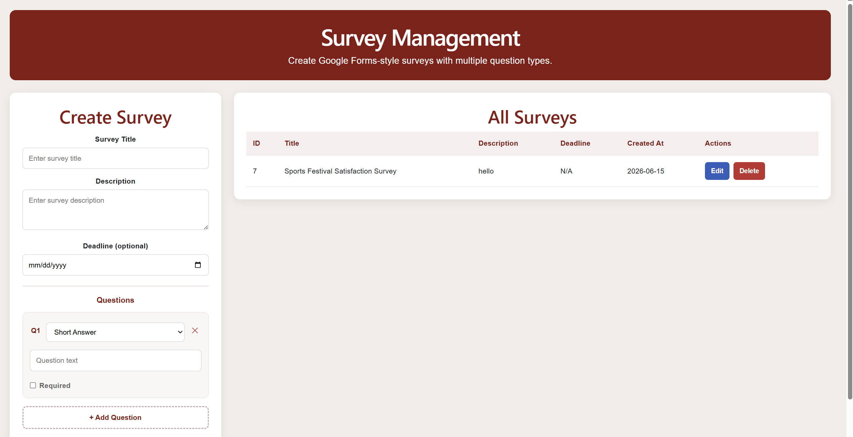
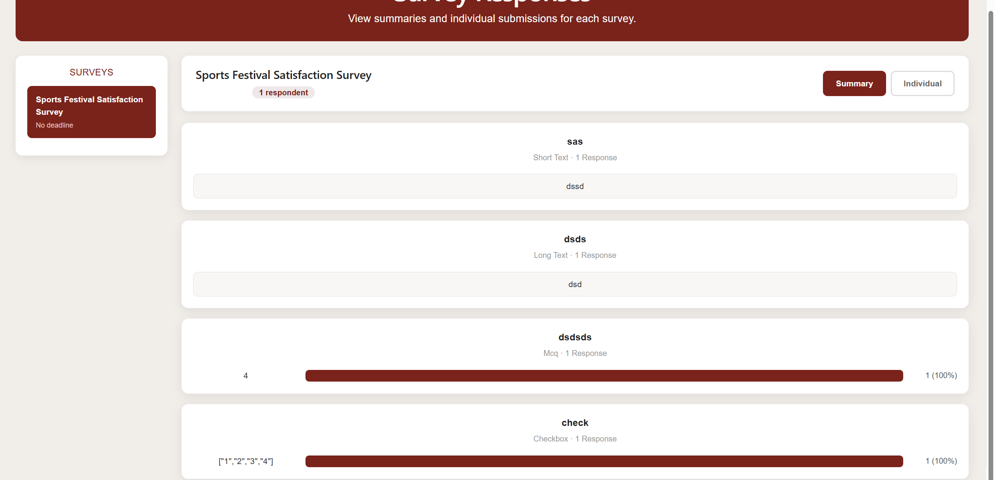

5.2 Static Model – Class Diagram
The class diagram models the main entities and their relationships in the system. Key classes include:
- User: user_id, student_id, name, email, pass_hash, role, ph_number, nationality, department, major, enrollment_year
- Survey: survey_id, created_by_user_id, title, description, deadline, created_at
- SurveyQuestion: question_id, survey_id, question_text, question_type, options (JSON), is_required
- SurveyQuestionResponse: response_id, survey_id, user_id, question_id, answer_text, submitted_at
- Event: event_id, title, description, date, location, created_by
- EventRegistration: registration_id, event_id, user_id
- Job: job_id, title, company, location, type, description, contact, deadline
- Notice: notice_id, title, content, created_at
- Budget: budget_id, type, category, amount, description, date
- Resource: resource_id, title, file_path, uploaded_at
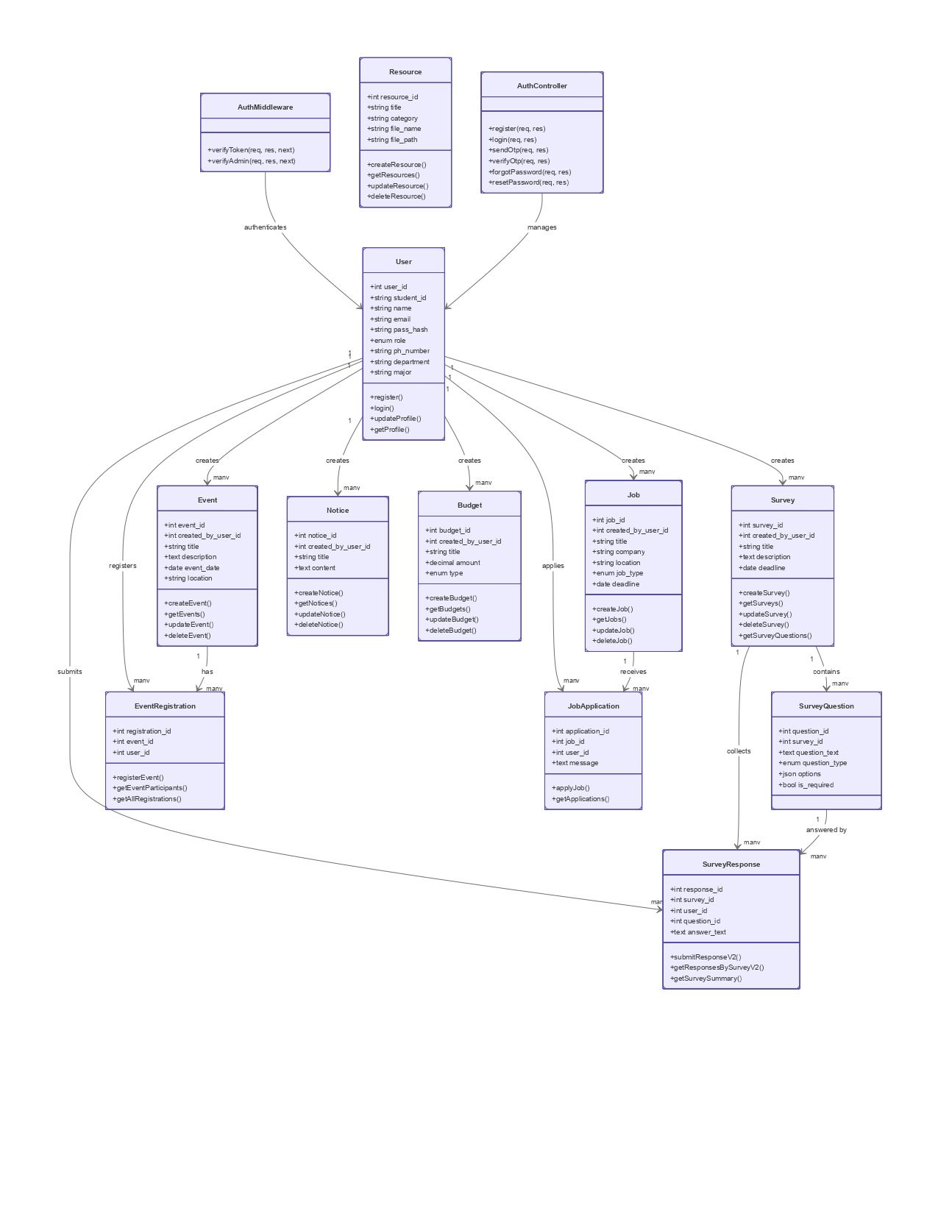

5.3 Dynamic Model – Sequence Diagrams
Sequence Diagram 1: User Login
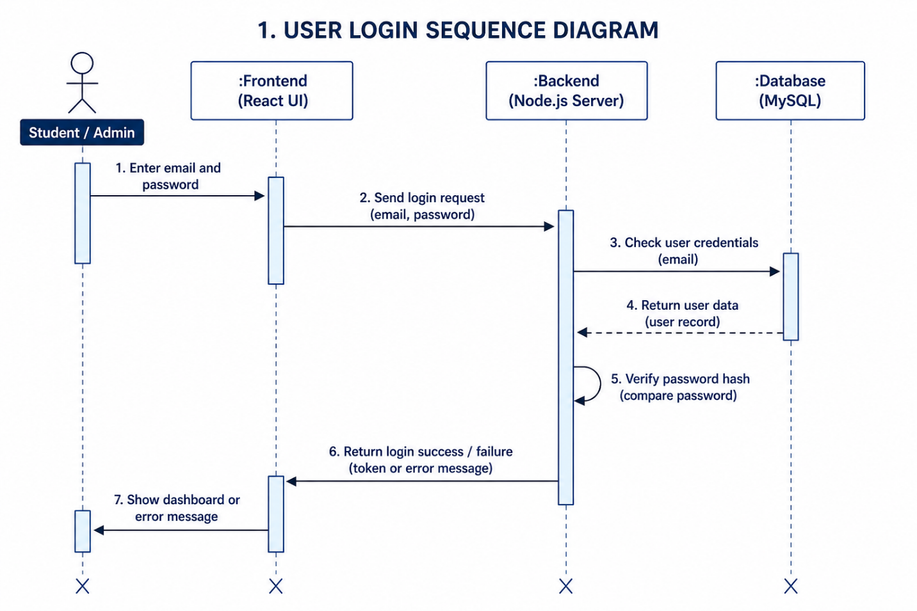
1. User submits email and password via Login page.
2. React sends POST /api/auth/login to Express server.
3. Express queries MySQL for user by email.
4. MySQL returns user record.
5. Express compares password with bcrypt hash.
6. Express generates and returns JWT token.
7. React stores token in localStorage and redirects to dashboard.

Sequence Diagram 2: Admin Creates Events
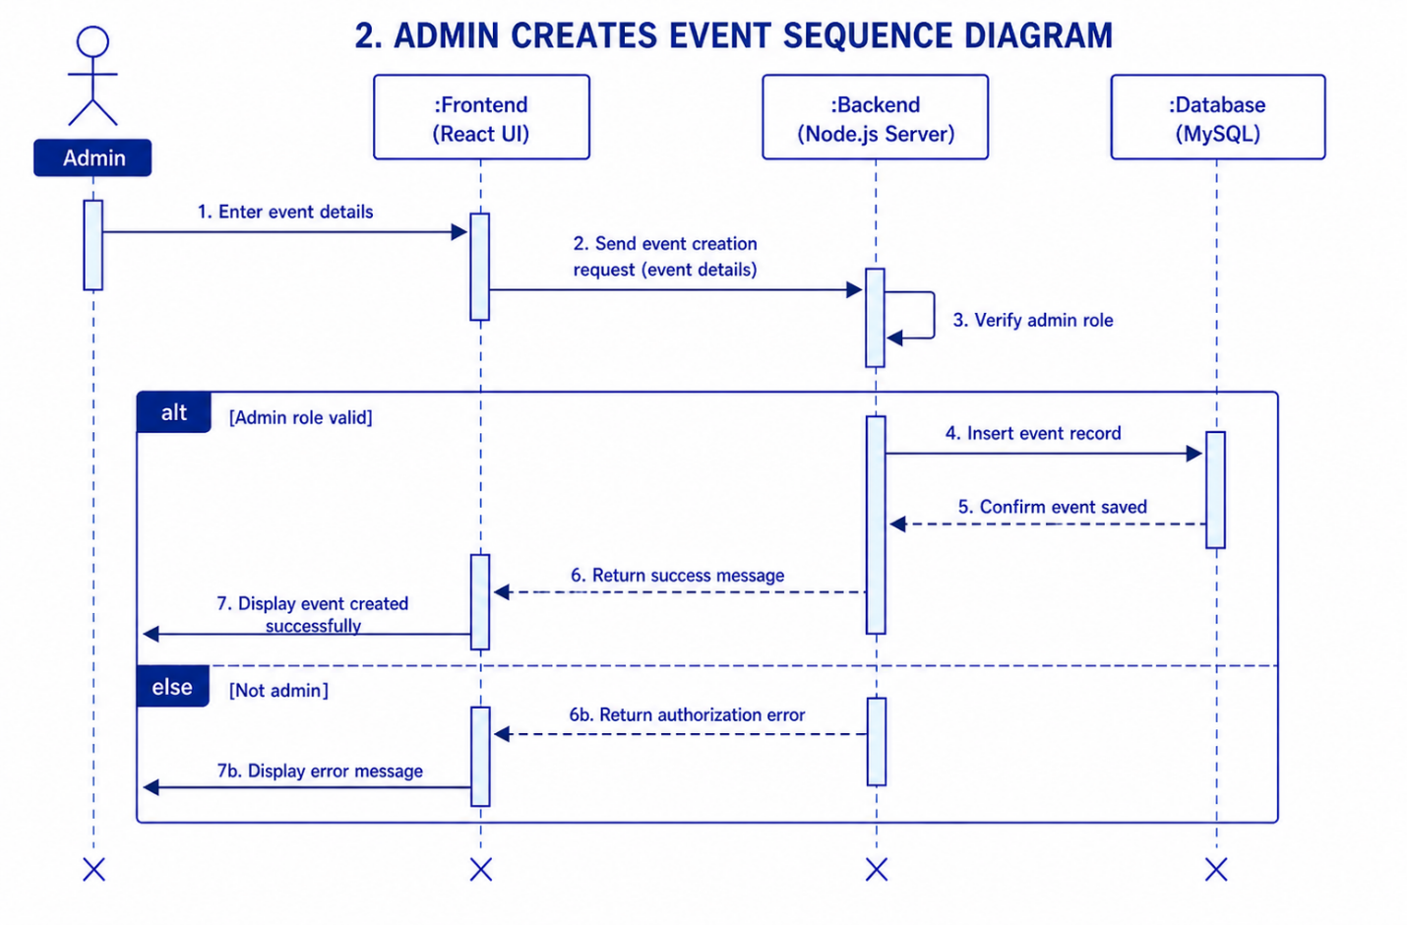
- Admin enters event information.
- Frontend submits event request.
- Backend validates admin role.
- Event data is inserted into database.
- Success response is returned.
- Event becomes available to students.

Sequence Diagram 3: Student Submits Survey
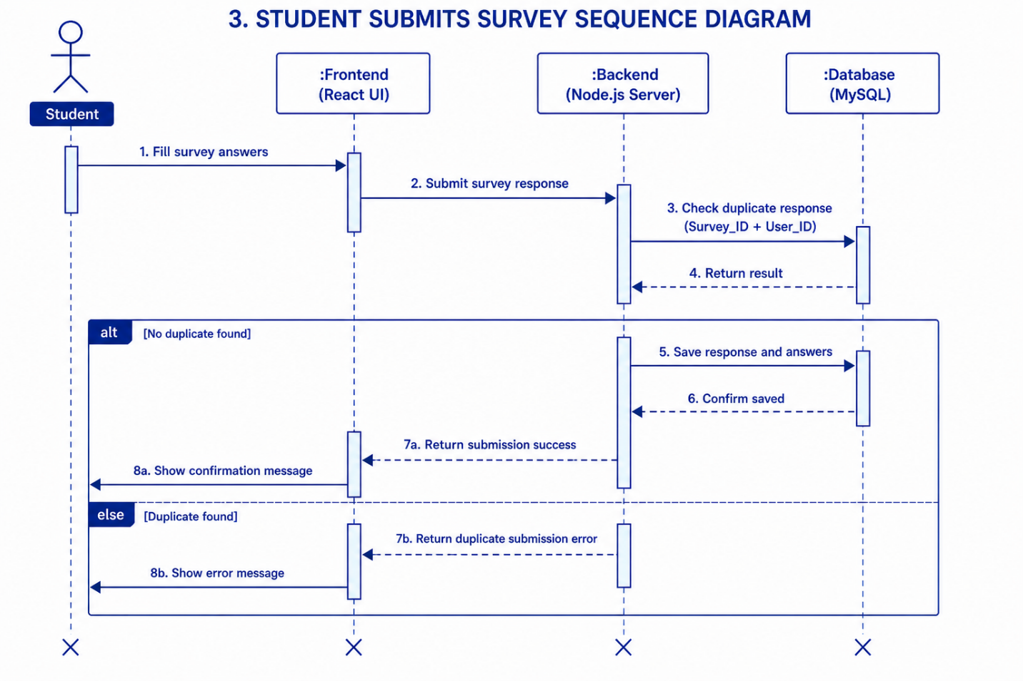
1. Student selects survey from list.
2. React fetches GET /api/surveys/:id/questions.
3. Student fills in all questions.
4. React sends POST /api/survey-responses/v2 with answers object.
5. Express checks for duplicate submission in survey_question_responses.
6. Express bulk-inserts one row per question answer.
7. Success confirmation displayed to student.

5.4 Database Design (ER Diagram)
The database consists of 17 tables with the following key relationships:
- users ← surveys (created_by_user_id)
- surveys ← survey_questions (survey_id, CASCADE DELETE)
- survey_questions ← survey_question_responses (question_id, CASCADE DELETE)
- users ← survey_question_responses (user_id)
- users ← event_registrations ← events (many-to-many)
- users ← job_applications ← jobs (many-to-many)
- UNIQUE constraint on (user_id, survey_id, question_id) prevents duplicate survey submissions
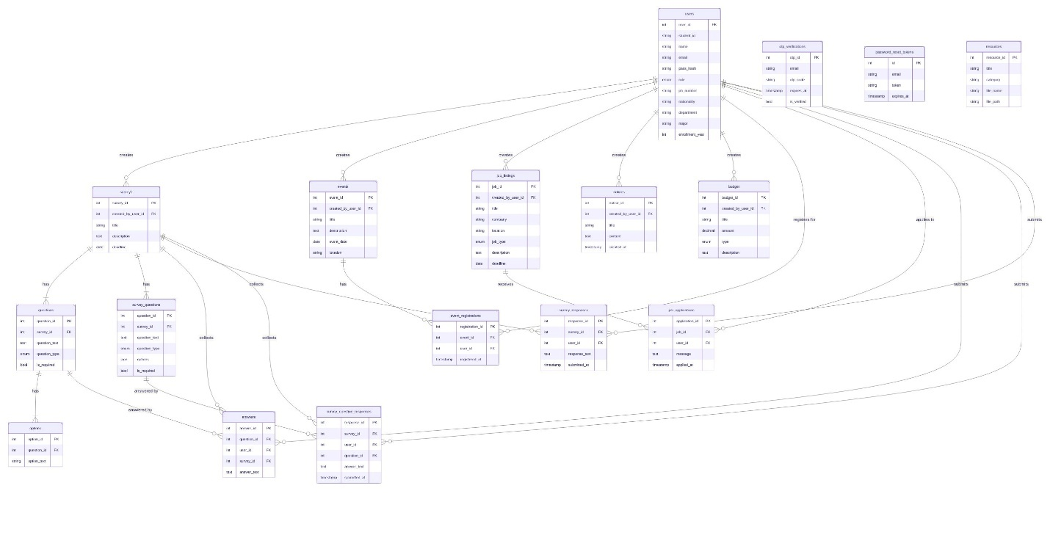

5.5 Traceability from Requirements to Detailed Design Model
Requirement ID | Requirement | Design Element | Implementation
REQ-01 | Admin manages events | Event class, Admin UC | AdminEvents.jsx + eventController.js
REQ-02 | Students register for events | EventRegistration class | Events.jsx + eventRegistrationController.js
REQ-03 | Admin posts jobs | Job class | AdminJobs.jsx + jobController.js
REQ-04 | Students browse/apply for jobs | JobApplication class | Jobs.jsx + jobApplicationController.js
REQ-05 | Admin creates surveys with questions | Survey, SurveyQuestion classes | AdminSurveys.jsx + surveyController.js
REQ-06 | Students submit per-question responses | SurveyQuestionResponse class | Surveys.jsx + surveyResponseController.js
REQ-07 | Admin manages notices | Notice class | AdminNotices.jsx + noticeController.js
REQ-08 | Admin manages budget | Budget class | Budget.jsx + budgetController.js
REQ-09 | Admin manages resources | Resource class | AdminResources.jsx + resourceController.js
REQ-10 | Secure authentication | JWT middleware | authMiddleware.js + authController.js
REQ-11 | OTP email verification | OTP class | sendEmail.js + Brevo API
REQ-12 | Role-based access control | verifyAdmin middleware | authMiddleware.js + AdminRoute.jsx

Chapter 6: Test Plan

6.1 Requirements/Specifications-Based System Level Test Cases
The following test cases were derived directly from functional requirements and use cases. All tests were performed on the deployed system at sabinbahala.com.np.
Item | Description
Test Case ID | TC-01
Requirement | REQ-12
Objective | User Registration
Input | Valid student details + correct OTP
Expected Result | Account created, redirected to login
Actual Result | Account created, redirected to login
Status | Pass

Item | Description
Test Case ID | TC-02
Requirement | REQ-11
Objective | User Login – Valid
Input | Registered email and correct password
Expected Result | JWT token returned, redirected to dashboard
Actual Result | JWT token returned, redirected to dashboard
Status | Pass

Item | Description
Test Case ID | TC-03
Requirement | REQ-11
Objective | User Login – Invalid Password
Input | Registered email and wrong password
Expected Result | Error: Invalid email or password
Actual Result | Error: Invalid email or password
Status | Pass

Item | Description
Test Case ID | TC-04
Requirement | REQ-11
Objective | Password Reset via OTP
Input | Registered email address
Expected Result | OTP email received, password successfully reset
Actual Result | OTP email received, password successfully reset
Status | Pass

Item | Description
Test Case ID | TC-05
Requirement | REQ-01
Objective | Event Creation
Input | Valid event title, description, date, location
Expected Result | Event stored and visible to students
Actual Result | Event stored and visible to students
Status | Pass

Item | Description
Test Case ID | TC-06
Requirement | REQ-01
Objective | Event Update
Input | Modified event details
Expected Result | Event updated in database
Actual Result | Event updated in database
Status | Pass

Item | Description
Test Case ID | TC-07
Requirement | REQ-01
Objective | Event Deletion
Input | Existing event ID
Expected Result | Event removed from database and UI
Actual Result | Event removed from database and UI
Status | Pass

Item | Description
Test Case ID | TC-08
Requirement | REQ-02
Objective | Event Registration by Student
Input | Student selects event and registers
Expected Result | Registration saved, student listed in participants
Actual Result | Registration saved, student listed in participants
Status | Pass

Item | Description
Test Case ID | TC-09
Requirement | REQ-07
Objective | Notice Creation
Input | Valid notice title and content
Expected Result | Notice visible to all students immediately
Actual Result | Notice visible to all students immediately
Status | Pass

Item | Description
Test Case ID | TC-10
Requirement | REQ-07
Objective | Notice Deletion
Input | Existing notice ID
Expected Result | Notice removed from system
Actual Result | Notice removed from system
Status | Pass

Item | Description
Test Case ID | TC-11
Requirement | REQ-03
Objective | Job Posting
Input | Job title, company, location, type, deadline
Expected Result | Job appears in student job portal
Actual Result | Job appears in student job portal
Status | Pass

Item | Description
Test Case ID | TC-12
Requirement | REQ-04
Objective | Job Application
Input | Student selects job and applies
Expected Result | Application stored, visible to admin
Actual Result | Application stored, visible to admin
Status | Pass

Item | Description
Test Case ID | TC-13
Requirement | REQ-05
Objective | Survey Creation with MCQ
Input | Title + MCQ question with 4 options
Expected Result | Survey and questions saved to database
Actual Result | Survey and questions saved to database
Status | Pass

Item | Description
Test Case ID | TC-14
Requirement | REQ-05
Objective | Survey Creation with Checkboxes
Input | Title + checkbox question with 3 options
Expected Result | Survey published with correct question type
Actual Result | Survey published with correct question type
Status | Pass

Item | Description
Test Case ID | TC-15
Requirement | REQ-06
Objective | Survey Submission by Student
Input | All required questions answered
Expected Result | Per-question responses stored, success screen shown
Actual Result | Per-question responses stored, success screen shown
Status | Pass

Item | Description
Test Case ID | TC-16
Requirement | REQ-06
Objective | Duplicate Survey Submission Blocked
Input | Same student submits same survey twice
Expected Result | Error: You have already submitted this survey
Actual Result | Error: You have already submitted this survey
Status | Pass

Item | Description
Test Case ID | TC-17
Requirement | REQ-06
Objective | Required Field Validation
Input | Required question left blank
Expected Result | Alert shown, form not submitted
Actual Result | Alert shown, form not submitted
Status | Pass

Item | Description
Test Case ID | TC-18
Requirement | REQ-08
Objective | Budget Entry Creation
Input | Income/expense type, amount, category
Expected Result | Budget entry saved and balance updated
Actual Result | Budget entry saved and balance updated
Status | Pass

Item | Description
Test Case ID | TC-19
Requirement | REQ-09
Objective | Resource Upload
Input | PDF file with title
Expected Result | File stored on server, downloadable by students
Actual Result | File stored on server, downloadable by students
Status | Pass

Item | Description
Test Case ID | TC-20
Requirement | REQ-12
Objective | Admin Access Control
Input | Student attempts to access /admin/surveys
Expected Result | Redirected to login, access denied
Actual Result | Redirected to login, access denied
Status | Pass

6.2 Traceability of Test Cases to Use Cases
Use Case | Test Cases | Coverage
UC-01: User Registration | TC-01 | Covered
UC-02: User Login | TC-02, TC-03 | Covered
UC-03: Password Reset | TC-04 | Covered
UC-04: Manage Events | TC-05, TC-06, TC-07 | Covered
UC-05: Event Registration | TC-08 | Covered
UC-06: Manage Notices | TC-09, TC-10 | Covered
UC-07: Manage Jobs | TC-11 | Covered
UC-08: Job Application | TC-12 | Covered
UC-09: Manage Surveys | TC-13, TC-14 | Covered
UC-10: Submit Survey | TC-15, TC-16, TC-17 | Covered
UC-11: Manage Budget | TC-18 | Covered
UC-12: Manage Resources | TC-19 | Covered
UC-13: Access Control | TC-20 | Covered

6.3 Techniques Used for Test Generation
Black Box Testing
Black box testing was used to verify system functionality without examining internal code. Test inputs were defined from requirements and expected outputs were validated against the UI and database.
- Registration and login testing
- Event, notice, and job CRUD operations
- Survey creation and submission
Equivalence Partitioning
Inputs were partitioned into valid and invalid classes to reduce the number of test cases while maintaining coverage.
- Valid login credentials vs. invalid credentials (TC-02, TC-03)
- Complete survey submission vs. incomplete required fields (TC-15, TC-17)
- First-time survey submission vs. duplicate submission (TC-15, TC-16)
Boundary Value Analysis
Edge cases were tested for date fields (event deadlines, survey deadlines) and required field validation.
Functional Testing
Each implemented feature was tested against its corresponding functional requirement to verify completeness and correctness.
Integration Testing
Integration testing verified communication between system layers:
- React frontend ↔ Express backend (verified via Network tab in DevTools)
- Express backend ↔ MySQL database (verified via Railway deploy logs and Thunder Client REST API testing)
- Backend ↔ Brevo Email API (verified by receiving OTP emails)
User Acceptance Testing (UAT)
UAT was performed by NSA members to validate that the system meets real-world usability expectations:
- Ease of navigation across all pages
- Survey form usability with different question types
- Event registration process
Deployment Testing
The deployed system at sabinbahala.com.np was tested to verify:
- Login functionality works on live server
- Database connections stable (TCP keep-alive configuration)
- Environment variables correctly injected in Railway
- Custom domain routing working correctly

6.4 Assessment of the Goodness of the Test Suite
Requirement Coverage
Requirement Type | Total | Tested | Coverage
Functional Requirements | 12 | 12 | 100%
Non-Functional Requirements (Security) | 3 | 3 | 100%
Non-Functional Requirements (Performance/Other) | 5 | 4 | 80%

Use Case Coverage
Metric | Value
Total Major Use Cases | 13
Use Cases Tested | 13
Use Case Coverage | 100%

Test Pass Rate
Metric | Value
Total Test Cases | 20
Passed | 20
Failed | 0
Success Rate | 100%

Defects Identified and Resolved
Defect | Description | Resolution
DB-01 | Database connection refused on Railway (ECONNREFUSED 127.0.0.1) | Added environment variables to Railway Variables dashboard
DB-02 | TCP_TOO_OLD errors causing login failures | Implemented connection pool with keep-alive and 30-second ping
SUR-01 | Old surveys could not be deleted due to foreign key constraint | Cleared legacy survey_responses before deletion; cascade delete added to new tables
AUTH-01 | JWT token not sent on some API calls | Fixed Authorization header in all API calls
ENV-01 | Brevo API key exposed in git history | Key rotated; new key stored only in Railway Variables

Overall Assessment
The test suite provides comprehensive coverage of all functional requirements and use cases. The combination of black box testing, equivalence partitioning, integration testing, and UAT ensures confidence in the system's reliability. All 20 test cases passed on the deployed production system, and all identified defects were resolved prior to final submission.

Acknowledgment
The project team would like to express sincere gratitude to Prof. Ibrahim Musa Ishag Musa for his valuable guidance, continuous support, and constructive feedback throughout the development of this project. His expertise and encouragement played a significant role in the successful completion of the NSA Website.
The team would also like to thank Dongshin University and the College of Glocal Autonomous Major for providing the resources, facilities, and academic environment necessary for completing this Software Engineering project.

References
[1] I. Sommerville, Software Engineering, 10th ed. Boston, MA, USA: Pearson, 2016.
[2] R. S. Pressman and B. R. Maxim, Software Engineering: A Practitioner's Approach, 9th ed. New York, NY, USA: McGraw-Hill Education, 2020.
[3] IEEE Computer Society, IEEE Recommended Practice for Software Requirements Specifications, IEEE Std 830-1998, 1998.
[4] React Team, "React Documentation," Meta Platforms Inc. [Online]. Available: https://react.dev. [Accessed: Jun. 15, 2026].
[5] Node.js Foundation, "Node.js Documentation." [Online]. Available: https://nodejs.org. [Accessed: Jun. 15, 2026].
[6] Express.js, "Express Web Framework." [Online]. Available: https://expressjs.com. [Accessed: Jun. 15, 2026].
[7] Oracle Corporation, "MySQL Documentation." [Online]. Available: https://dev.mysql.com/doc. [Accessed: Jun. 15, 2026].
[8] Railway, "Railway Documentation." [Online]. Available: https://docs.railway.app. [Accessed: Jun. 15, 2026].
[9] GitHub Inc., "GitHub Documentation." [Online]. Available: https://docs.github.com. [Accessed: Jun. 15, 2026].
[10] Axios Contributors, "Axios Documentation." [Online]. Available: https://axios-http.com. [Accessed: Jun. 15, 2026].
[11] Brevo, "Brevo Email API Documentation." [Online]. Available: https://developers.brevo.com. [Accessed: Jun. 15, 2026].
[12] R. C. Martin, Clean Code: A Handbook of Agile Software Craftsmanship. Upper Saddle River, NJ, USA: Prentice Hall, 2008.

Appendix A – Project Resources
Resource | URL / Details
GitHub Repository | https://github.com/sabin2002/NSA-website
Live System URL | https://sabinbahala.com.np
Backend API URL | https://nsa-website-production.up.railway.app
Deployment Platform | Railway Cloud Platform
Database | Railway MySQL 8.x (mysql.railway.internal)
Frontend Hosting | Railway (auto-deployed from GitHub main branch)

Appendix B – AI tools
AI Tool | Use | URL
ChatGPT | For Coding, UI design | https://chatgpt.com
Claude AI | For Architecture Design, Design  Documentation, Coding | https://claude.ai
NotebookLM | For Documentation | https://notebooklm.google.com
Gemini | For searching Hosting servers | https://gemini.google.com

Appendix C – Future Business Opportunities
1. Multi-University SaaS
License the platform to other international student associations across Korean universities as a subscription service.
2. Job Placement Partnerships
Partner with Korean companies to post featured job listings targeting international students for a fee.
3. University Survey Licensing
License the survey module to university departments for collecting official student feedback.
4. Paid Event Ticketing
Add ticketing for cultural events and orientations with KakaoPay/Toss payment integration.
5. Study Resource Marketplace
Allow students to sell study materials and past papers, with the platform taking a small commission.

Appendix D – Development Team Photo

