Software Requirements Specification

for

Nepalese Student Association Website
Prepared by Bahala Shrestha Sabin, Glen Milan, Sunuwar Ramuna, Koirala Sumit, Uprety Anish
Dongshin University-IT Department
2026.04.07

Table of Contents
Table of Contents ii
Revision History ii
1. Introduction 1
1.1 Purpose 1
1.2 Document Conventions 1
1.3 Intended Audience and Reading Suggestions 2
1.4 Product Scope 2
1.5 References 2
2. Overall Description 4
2.1 Product Perspective 4
2.2 Product Functions 4
2.3 User Classes and Characteristics 4
2.4 Operating Environment 4
2.5 Design and Implementation Constraints 4
2.6 User Documentation 5
2.7 Assumptions and Dependencies 5
3. External Interface Requirements 7
3.1 User Interfaces 7
3.2 Hardware Interfaces 7
3.3 Software Interfaces 7
3.4 Communications Interfaces 7
4. System Features 9
4.1 System Feature: Event & Calendar Management 9
4.2 System Feature: Job Opportunity Portal 9
4.3 System Feature: Financial Transparency (Budget Viewer) 10
4.4 System Feature: Notice Board & Announcements 10
4.5 System Feature: Student Feedback (Surveys) 10
4.6 System Feature: User Account & Authentication 11
5. Other Nonfunctional Requirements 12
5.1 Performance Requirements 12
5.2 Safety Requirements 12
5.3 Security Requirements 12
5.4 Software Quality Attributes 13
5.5 Business Rules 13
6. Other Requirements 14
Appendix A: Glossary 16
Appendix B: Analysis Models 17
Appendix C: To Be Determined List 24

Revision History
Name | Date | Reason For Changes | Version
Bahala Shrestha Sabin | 2026.04.07 | Initial Submission | 1.0

Introduction

Purpose
This Software Requirements Specification (SRS) defines the technical and functional requirements for the Nepalese Student Association (NSA) Web Platform. This document centralizes all association activities into a single digital repository to provide a unified environment for students and administrative officers, ensuring clarity for developers and stakeholders alike.

Document Conventions
This document follows the IEEE 830-1998 Software Requirements Specification (SRS) standard. The following conventions and formatting rules are used throughout this document to ensure clarity, consistency, and traceability.

1.2.1 Requirement Keywords
The following keywords indicate the level of obligation:
Keyword | Meaning
SHALL | Indicates a mandatory requirement. The system must implement this requirement.
SHOULD | Indicates a recommended requirement. It is desirable but not mandatory.
MAY | Indicates an optional feature that can be implemented if resources permit.
WILL | Indicates a future action or statement of fact about system behavior.
All functional and non-functional requirements in this document use SHALL statements for mandatory behavior.

1.2.2 Requirement Identification Format
Each requirement is uniquely identified using the following format:
REQ-XX
Where:
- REQ = Requirement
- XX = Sequential number
Example:
- REQ-1: The system SHALL allow administrators to create events.
This numbering ensures traceability during design, development, and testing phases.

1.2.3 Priority Levels
Each system feature is assigned a priority level:
Priority | Definition
High | Essential for system operation and must be implemented in the first release.
Medium | Important but can be implemented after core features.
Low | Optional enhancement features.

1.2.4 Formatting Standards
- Section headings follow IEEE hierarchical numbering (1, 1.1, 1.1.1).
- Functional requirements are written in clear, testable statements.
- Nonfunctional requirements specify measurable criteria where possible.
- Diagrams are included in Appendix B.
- Glossary terms are defined in Appendix A.

1.2.5 Abbreviations
All abbreviations are defined in Appendix A (Glossary) upon first use.

Intended Audience and Reading Suggestions
This document is intended for project managers, developers, and the NSA executive committee. Developers should focus on Section 3 (External Interfaces) and Section 4 (System Features), while NSA stakeholders should prioritize Section 2 (Overall Description).

Product Scope
The NSA platform will replace existing informal communication methods (e.g., WhatsApp, Facebook groups) with a structured, centralized system [NSA context]. It aims to enhance transparency through budget viewing and increase student engagement via surveys and job listings.

References
[1] IEEE Computer Society, IEEE Std 830-1998, IEEE Recommended Practice for Software Requirements Specifications, 1998.

[2] I. Sommerville, Software Engineering, 10th ed., Pearson, 2016.

[3] React Documentation, https://react.dev/

[4] Node.js Documentation, https://nodejs.org/

[5] MySQL 8.0 Reference Manual, https://dev.mysql.com/doc/

Overall Description

Product Perspective
This system serves as a replacement for current unstructured communication methods. It utilizes modern web technologies: React.js for the frontend, Node.js for the backend, and MySQL for the database, hosted on cloud services like AWS
This system serves as a replacement for current unstructured communication methods. It utilizes modern web technologies: React.js for the frontend, Node.js for the backend, and MySQL for the database, hosted on cloud services like AWS

Product Functions
Core capabilities are categorized by the following roles:
- Admin Functions:
  - Association budget management and financial reporting.
  - Digital survey creation and distribution.
  - System-wide content management and user auditing.
- Student Functions:
  - Employment opportunity discovery and application.
  - Participation in association-led surveys.
  - Secure personal profile management.

User Classes and Characteristics
User Class | Description | Access Level
Admin | Elected NSA officers responsible for financial and data management. They require some technical understanding. | High
Student | Registered association members consuming services and providing data. They require basic internet skills. | Medium
Guest | Unauthenticated visitors viewing public-facing career summaries. | Low

Operating Environment
The system runs on a web browser (Chrome, Firefox, Safari), so users don’t need to install anything. The UI SHALL be responsive to support both Mobile and Laptop hardware configurations.

Design and Implementation Constraints
- Limited Budget: Requires the use of open-source frameworks and efficient resource allocation.
- Internet Requirement: The system requires active connectivity for all transaction processing.
- Security Needs
User data must be protected and login should be secure.
- Academic Schedule: Milestones must align strictly with the semester calendar.

User Documentation
User Manual: A comprehensive guide for members covering registration, navigation, event The NSA Web Platform SHALL provide appropriate documentation to support all users of the system.
2.6.1 Student User Guide
A user manual SHALL be provided for students, covering account registration, navigation, viewing events and jobs, participating in surveys, and accessing budget information.
2.6.2 Administrator Guide
An administrative guide SHALL describe procedures for managing users, posting events and jobs, updating budgets, creating surveys, and moderating content.
2.6.3 Online Help
The system SHALL include built-in help features such as tooltips, FAQs, and clear error messages to assist users during system interaction.
2.6.4 Demonstration Materials
The project SHALL provide system demonstration materials, including presentation slides and example usage scenarios.

Assumptions and Dependencies
2.7.1 Assumptions
- Connectivity and Access: It is assumed that all primary users (Students and Admins) have consistent access to the internet and own or have access to a compatible device, such as a laptop or mobile phone, to interact with the platform.
- User Proficiency: The project assumes that student users possess basic internet skills, such as the ability to navigate web menus, fill out registration forms, and browse job listings without specialized training.
- Administrative Diligence: The effectiveness of the platform assumes that Association Admins will regularly update the system with new events, notices, and budget data to maintain the site as a reliable and structured resource for the community.
- Hosting Sustainability: It is assumed that low-cost hosting solutions (e.g., AWS educational or free-tier services) will remain available and sufficient for the association's traffic needs throughout the project lifecycle.

2.7.2 Dependencies
- Cloud Infrastructure: The system's availability is directly dependent on the server availability and uptime of third-party cloud providers (e.g., AWS).
- Database Integrity: Core platform functions, including user management and budget transparency, depend on the proper functioning and data persistence of the MySQL database.
- Browser Compatibility: The frontend functionality depends on the end-user's use of modern web browsers (e.g., Chrome, Firefox, Safari) that adhere to current web standards and protocols.
- Framework Stability: The application's logic and interface are dependent on the continued support and security patches for the React.js and Node.js frameworks used in the client-server structure.
- Third-Party APIs: Should the platform integrate automated email or SMS notifications, it will depend on the API functionality and availability of external communication gateways.

External Interface Requirements

User Interfaces
The system SHALL provide a user-friendly, dynamic, and responsive web interface designed to work across multiple screen sizes. The user interface (UI) components are categorized by user role:
- Student Interface: Includes a personalized Dashboard for activity tracking, an Event Calendar for scheduled activities, and a Job Portal for browsing part-time opportunities.
- Administrator Interface: A restricted Management Panel for controlling events, updating notices, managing association budgets, and overseeing user accounts.
- Guest Interface: Allows unregistered users to browse public notices and available job listings using basic filters.
The UI will follow consistent design standards, including a standard header/footer layout and the use of breadcrumbs to reinforce page hierarchy. To assist users, the platform SHALL provide context-sensitive help through tooltips and a dedicated FAQ center. Error messages SHALL be meaningful and informative without exposing sensitive system data.

Hardware Interfaces
The NSA platform acts as a web-based client-server application that must interface with the following hardware:
- Client Devices: The system SHALL support interaction via desktop computers, laptops, tablets, and smartphones.
- Server Infrastructure: The platform interfaces with cloud-based hardware provided by AWS, including application servers for logic processing and high-capacity storage systems.
- Network Equipment: The system depends on load balancers and firewalls to manage traffic and ensure secure data transmission.
The system is designed to minimize hardware dependencies, allowing it to support a wide range of client device configurations as long as they have active internet access

Software Interfaces
The application integrates several software components to deliver its core functions:
- Database Management System: The system interfaces with a MySQL database for persistent data storage of users, events, and budget records.
- Frontend/Backend Frameworks: The React.js presentation layer communicates with the Node.js application server through a structured API layer.
- Operating Systems: The platform SHALL be compatible with server-side environments like Linux and client-side operating systems including Windows, iOS, and Android.
- External Gateways: The platform integrates with SMTP email providers and SMS gateways to send automated notices and registration codes to students.

Communications Interfaces
The system SHALL utilize the following communication standards to ensure interoperability and security:
- Web Protocols: All interactions between the web browser and the server SHALL use HTTP/HTTPS protocols to ensure encrypted data transfer.
- Data Exchange Formats: The system will utilize JSON as the primary format for exchanging data between the React frontend and the Node.js backend API.
- Notification Standards: The platform uses SMTP for email-based announcements and Web Sockets where real-time dashboard notifications are required.
- Security Standards: All communications SHALL be secured using SSL/TLS 1.3 or higher to protect user privacy and association data.

System Features
This section organizes the functional requirements for the Nepalese Student Association (NSA) Platform by major system features, defining the services provided and the sequences of interaction.

Event & Calendar Management

4.1.1 Description and Priority
This feature allows administrators to centralize association activities into one structured location, replacing confusing social media messages. It enables students to discover upcoming events through an organized calendar format.
- Priority: High.

4.1.2 Stimulus/Response Sequences
- Stimulus: Admin inputs event title, date, and description and clicks "Post."
- Response: System validates data, updates the database, and displays the event on the public calendar.

- Stimulus: Student selects a specific date on the calendar.
- Response: System displays a list of all events scheduled for that day.

4.1.3 Functional Requirements
- REQ-1: The system SHALL allow administrators to create, update, and delete association events with full details.
- REQ-2: The system SHALL provide a dedicated Calendar View for students to browse scheduled activities by month or day.

4.2 Job Opportunity Portal
4.2.1 Description and Priority
A specialized board for part-time job listings relevant to the student community to enhance engagement and provide local opportunities.
- Priority: High.

4.2.2 Stimulus/Response Sequences
- Stimulus: Admin uploads a new job listing with required qualifications.
- Response: System tags the post and makes it visible in the student job portal.

- Stimulus: Student clicks "Browse Jobs."
- Response: System displays a searchable list of current part-time opportunities.

4.2.3 Functional Requirements
- REQ-3: The system SHALL allow administrators to upload and manage job postings, including descriptions and contact details.
- REQ-4: The system SHALL provide students with the ability to browse and filter available jobs based on their needs.

4.3 Financial Transparency (Budget Viewer)
4.3.1 Description and Priority
This feature ensures association accountability by allowing admins to post financial records and students to view them.
- Priority: Medium.
4.3.2 Stimulus/Response Sequences
- Stimulus: Admin enters expense data for a recent event.
- Response: System updates the association's transparency dashboard.

- Stimulus: Student accesses the "View Budget" section.
- Response: System displays a detailed summary of income and expenses.

4.3.3 Functional Requirements
- REQ-5: The system SHALL enable administrators to add and update budget and expense information for association-wide transparency.
- REQ-6: The system SHALL allow registered students to view financial summaries to ensure event-related expense accountability.

4.4 Notice Board & Announcements

4.4.1 Description and Priority
Provides a structured environment for official announcements, ensuring important information is not lost in unstructured chat groups.
- Priority: High.

4.4.2 Stimulus/Response Sequences
- Stimulus: Admin drafts a new notice and clicks "Publish."
- Response: System archives the old notice and displays the new announcement on the student dashboard.

4.4.3 Functional Requirements
- REQ-7: The system SHALL provide tools for administrators to post and edit important notices for the association membership.
- REQ-8: The system SHALL provide students with a read-only view of official association announcements.

4.5 Student Feedback (Surveys)
4.5.1 Description and Priority
Allows the executive committee to collect student opinions and feedback to improve association services.
- Priority: Medium.

4.5.2 Stimulus/Response Sequences
- Stimulus: Admin creates a survey with multiple-choice questions.
- Response: System notifies students that a new survey is available.

- Stimulus: Student submits survey responses.
- Response: System records the data in the database and prevents duplicate submissions.

4.5.3 Functional Requirements
- REQ-9: The system SHALL allow administrators to design and deploy surveys to collect student opinions.
- REQ-10: The system SHALL enable students to participate in and submit feedback through admin-created surveys.

4.6 User Account & Authentication

4.6.1 Description and Priority
Secures the system by ensuring only authorized users can manage content and only registered students can access protected features.
- Priority: High.

4.6.3 Functional Requirements
- REQ-11: The system SHALL provide a secure login for administrators to access restricted system controls.
- REQ-12: The system SHALL allow students to perform self-registration and login to manage their personal activity.
- REQ-13: The system SHALL provide administrators with tools to manage user accounts, including monitoring and controlling access if needed.

Other Nonfunctional Requirements
This section defines the quality attributes, performance goals, and constraints for the Nepalese Student Association (NSA) platform, specifying how the system must behave rather than what it must do.

Performance Requirements
The system's performance is critical for student engagement and shall be measured against specific benchmarks.
- Response Time: The system SHALL provide page load times of less than 3 seconds for standard operations under normal load. Standard search queries SHALL return results within 2 seconds.
- Throughput: The platform SHALL support at least 1,000 concurrent users during normal operations without significant degradation.
- Availability: The system SHALL maintain 99% uptime performance, excluding scheduled maintenance periods which must be performed during lowest usage.
- Resource Utilization: The application logic SHALL be optimized to ensure that database queries minimize I/O operations and response times.

Safety Requirements
Safety requirements address the protection of association data and the prevention of damage resulting from system failure.
- Data Integrity: The system SHALL implement database replication to prevent data loss in the event of a single component failure.
- Disaster Recovery: Regular backups SHALL be maintained, with full backups occurring weekly and incremental backups daily. These backups SHALL be stored in a separate cloud environment (e.g., geographically separate AWS region).
- Error Handling: Meaningful error messages SHALL be provided to users to prevent confusion, but these messages SHALL NOT expose sensitive internal system information.

Security Requirements
Security measures ensure that only authorized association members can access specific data and management tools.
- Authentication: The system SHALL implement role-based access control (RBAC) to restrict management functions to administrators.
- Access Control: Administrative accounts SHALL implement multi-factor authentication (MFA) to prevent unauthorized access to association budget and user records.
- Data Protection: All data in transit between the client browser and the server SHALL be encrypted using TLS 1.3 or higher. Sensitive user passwords SHALL be salted and hashed before storage.
- Auditing: The system SHALL maintain a detailed audit log of all administrative actions, such as budget updates and notice deletions, for accountability.

Software Quality Attributes
These attributes define the long-term value and usability of the platform for the NSA community.
- Usability: The interface SHALL be simple and easy to use, featuring clear navigation so that students and admins can understand it without extensive formal training.
- Maintainability: The platform SHALL follow a modular client-server architecture using standard frameworks (React.js, Node.js) to facilitate future updates and bug fixes.
- Portability: The system SHALL be a web-based platform fully responsive to standard browsers on laptops, tablets, and smartphones.
- Reliability: The platform's core services, including notice delivery and budget transparency, SHALL deliver correct information as specified without failure over its lifetime.

Business Rules
The association's operational principles dictate the following system constraints:
- Administrative Authority: Only verified association executives (Admins) may post job opportunities, create surveys, or modify the association budget [Milan Source].
- Student Privacy: Personal registration data SHALL only be viewable by the user themselves or high-level system administrators.
- Notice Transparency: All official association notices SHALL be archived and remain viewable for the duration of the current academic year.

Other Requirements
This section defines additional requirements for the Nepalese Student Association (NSA) platform that are not captured in the functional or non-functional sections. These include data-specific needs, legal compliance, and training objectives necessary for successful deployment.
6.1 Database Requirements
The system SHALL utilize a MySQL database for persistent data storage.
- Logical Organization: The database SHALL define logical relationships between users, events, notices, and job listings to ensure data integrity.
- Data Retention: The system SHALL retain association records, including budget history and official notices, for a minimum of three academic years.
- Integrity: The database SHALL implement referential integrity constraints to prevent orphaned records (e.g., ensuring a budget entry is always linked to a specific event.

6.2 Internationalization Requirements
While the primary interface will be in English, the system SHALL be designed to support the specific needs of the Nepalese student community.
- Unicode Support: The system SHALL support UTF-8 encoding to allow for the correct display and entry of Nepali script (Devanagari) in notices and student profiles.
- Localization Framework: The UI SHALL utilize a localization framework (e.g., i18next) to facilitate a potential future transition to a fully bilingual (English/Nepali) interface without code modifications.
6.3 Legal and Privacy Requirements
The association platform SHALL adhere to relevant data protection standards to ensure the privacy of its members.
- Data Privacy: Personal information provided during registration SHALL NOT be shared with third parties without explicit user consent.
- Legal Compliance: The system SHALL comply with regional regulations regarding the storage of student data and employment-related information in the job portal.
- Attribution: The platform SHALL provide appropriate attribution for any third-party components or open-source libraries used in development.

6.4 Reuse Objectives
To ensure long-term maintainability and cost-effectiveness, the project emphasizes the use of standardized components.
- Component-Based Architecture: The system SHALL be developed using modular, independent software units that conform to standard models (React/Node.js) to allow for easier updates.
- Standard Libraries: The development team SHALL prioritize the use of well-documented, widely supported open-source libraries for common tasks such as form validation and calendar rendering.

6.5 Training Requirements
Provisions SHALL be made to ensure that all user classes can effectively operate the system.
- Administrator Training: The development team SHALL provide a training session for the NSA executive committee covering event moderation, budget updates, and user account management.
- Self-Service Resources: The platform SHALL include embedded tutorials and a downloadable "Quick Start" PDF for new students to learn how to browse jobs and participate in surveys.

Appendix A: Glossary
• NSA: Nepalese Student Association, the student organization for which this web platform is developed.
• Admin: An authorized NSA executive member with privileges to manage events, jobs, notices, budgets, surveys, and user accounts.
• Student: A registered NSA member who can access system features such as viewing events, browsing jobs, and participating in surveys.
• Guest: An unauthenticated user who can view public information but cannot access restricted features.
• SRS: Software Requirements Specification, a formal document describing system requirements.
• API: Application Programming Interface, a mechanism that enables communication between the frontend and backend systems.
• Front-End (FE): The client-side component of the system developed using React.js that handles the user interface.
• Back-End (BE): The server-side component developed using Node.js that processes requests and manages business logic.
• Database: A structured collection of data stored in MySQL for persistent information management.
• MySQL: A relational database management system used to store system data.
• RBAC: Role-Based Access Control, a security mechanism that restricts access based on user roles.
• MFA: Multi-Factor Authentication, a security method requiring multiple verification steps.
• HTTPS: Hypertext Transfer Protocol Secure, a protocol used for encrypted communication.
• JSON: JavaScript Object Notation, a lightweight data format used for system communication.
• React.js: A JavaScript library used to build the user interface of the system.
• Node.js: A JavaScript runtime environment used to develop the server-side logic.
• AWS: Amazon Web Services, a cloud platform used to host the system infrastructure.
• UTF-8: A character encoding standard that supports multilingual text, including Nepali script.

Appendix B: Analysis Models
1) Context Diagram
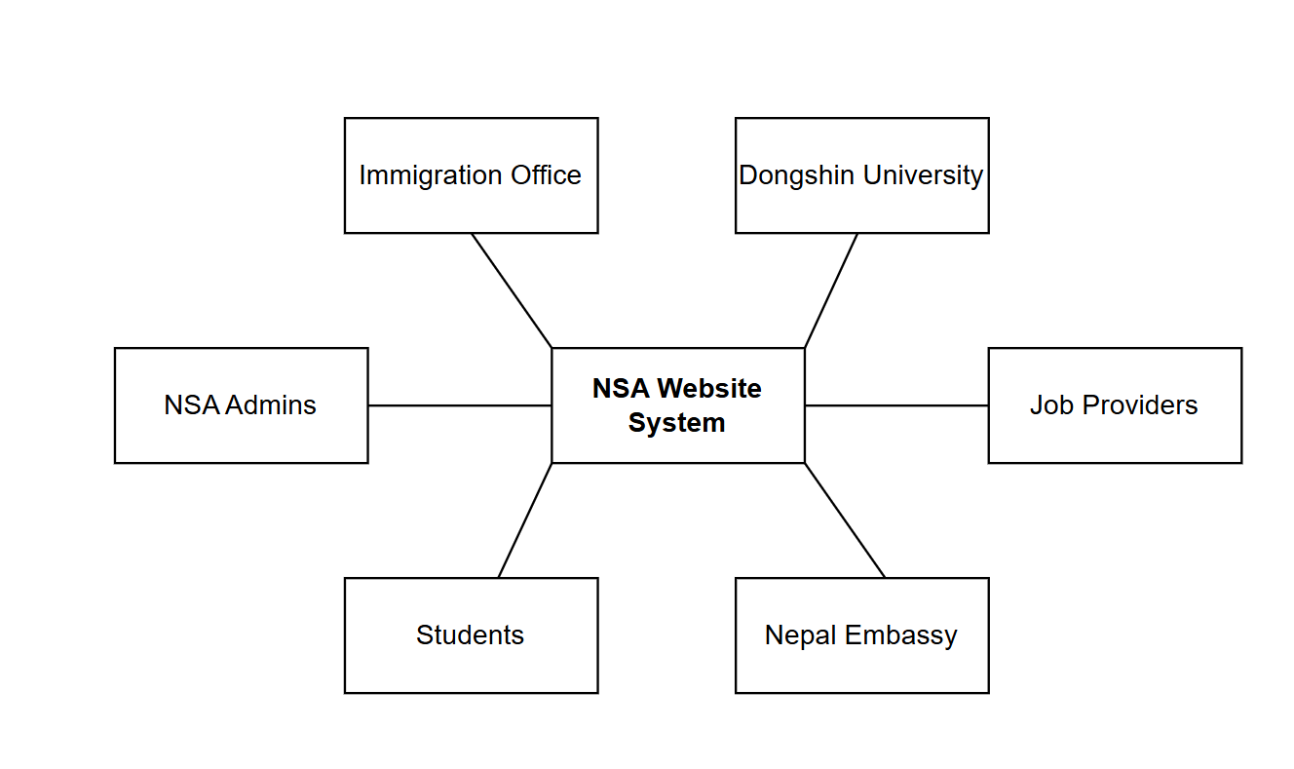

2) Use case diagrams

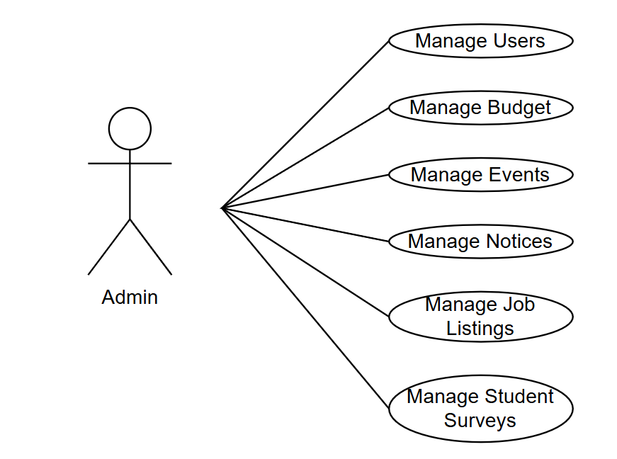
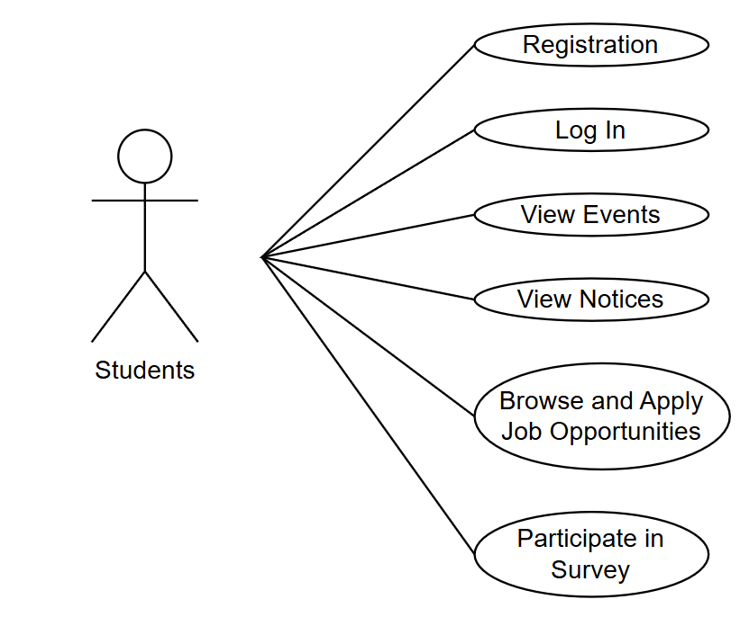



3) Sequence Diagram
a) User Login (Authentication)

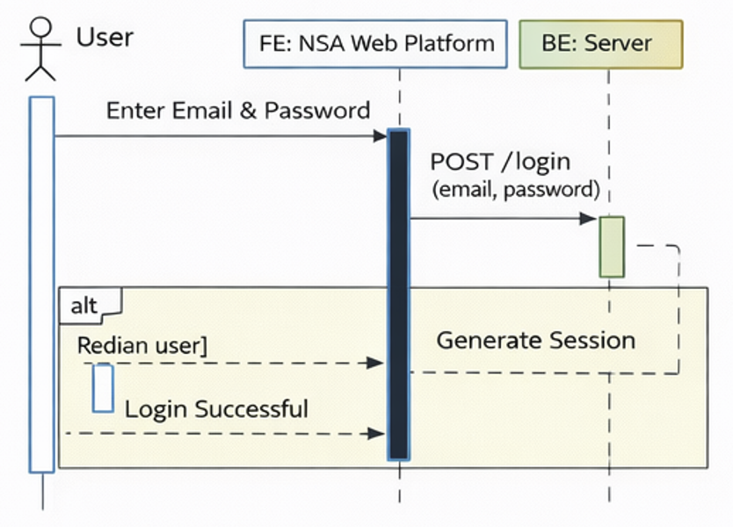

b) Admin Creates Event
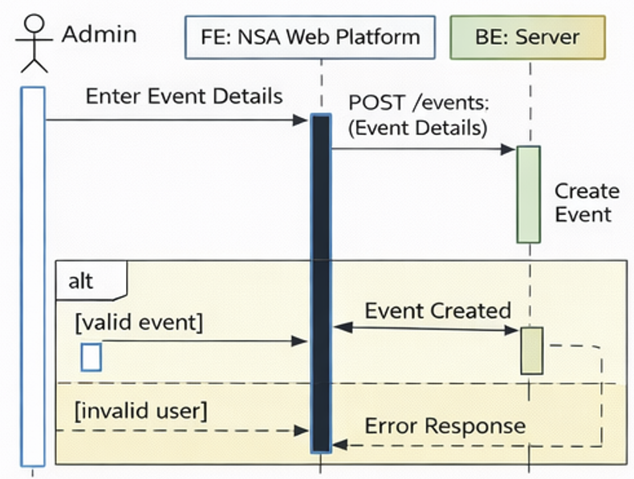
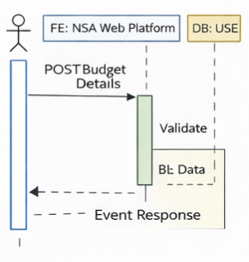

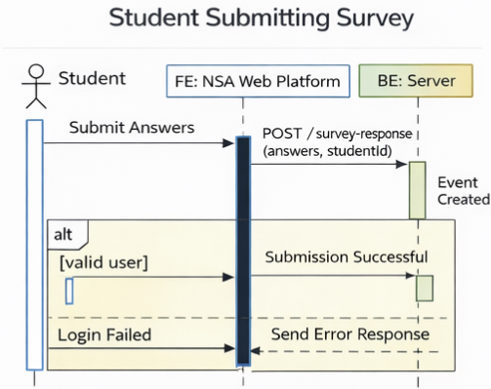
c) Student Submitting Survey

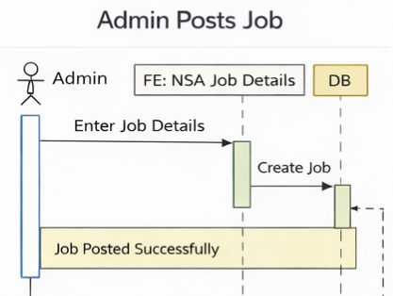
d) Admin Posts Jobs
4) ER Diagram

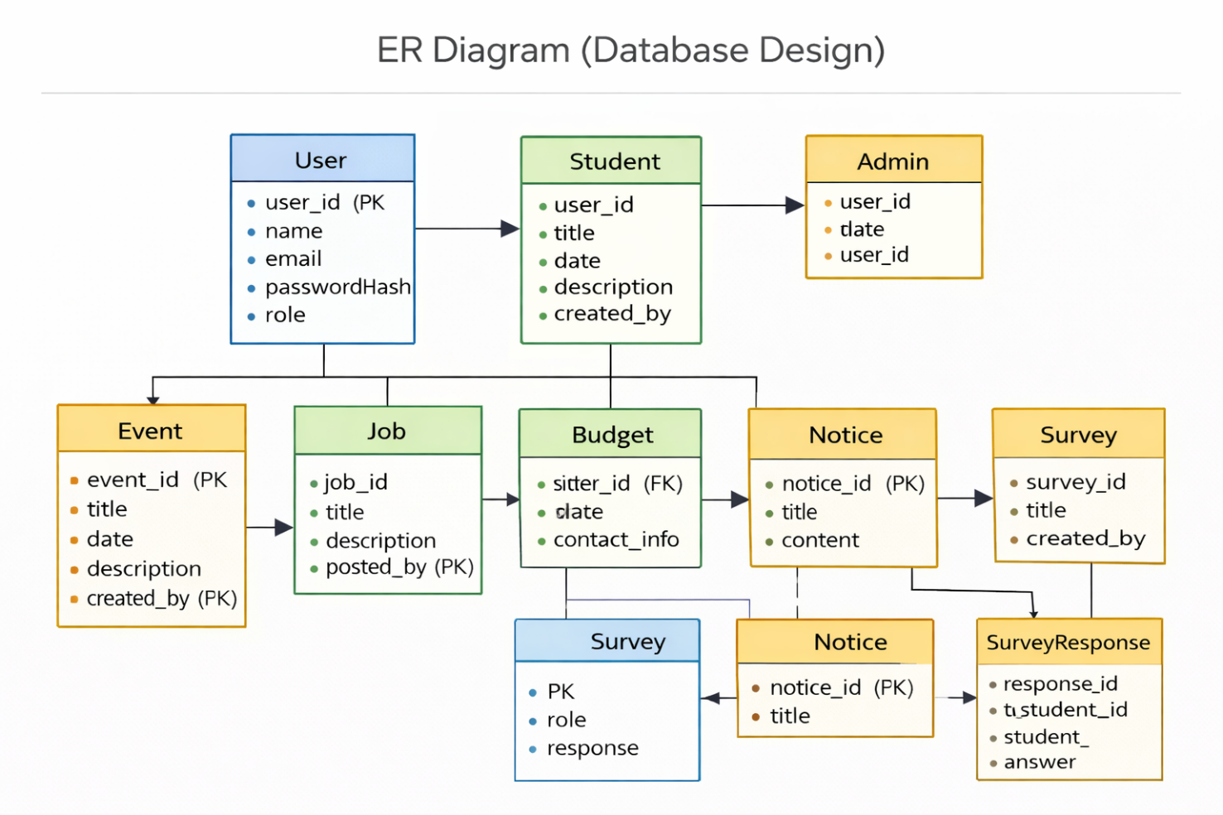

5) Class Diagram
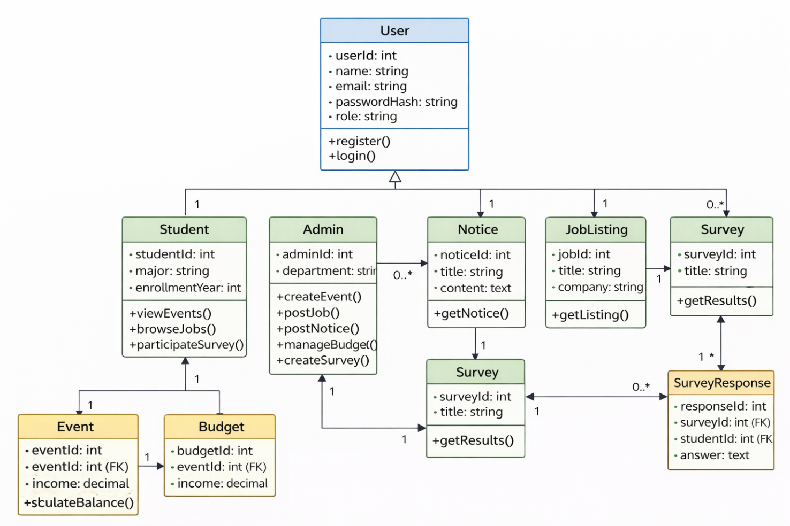

Appendix C: To Be Determined List
- Hosting Specifics: Final decision on AWS free-tier vs. paid-tier resource limits.
- External APIs: Selection of specific SMTP or SMS gateway providers for student notifications.

