First, a bot is created with AWS Lex. Then, sample utterances and a slot name “city_name” are provided.

An account on <https://openweathermap.org/> is created to fetch weather data.

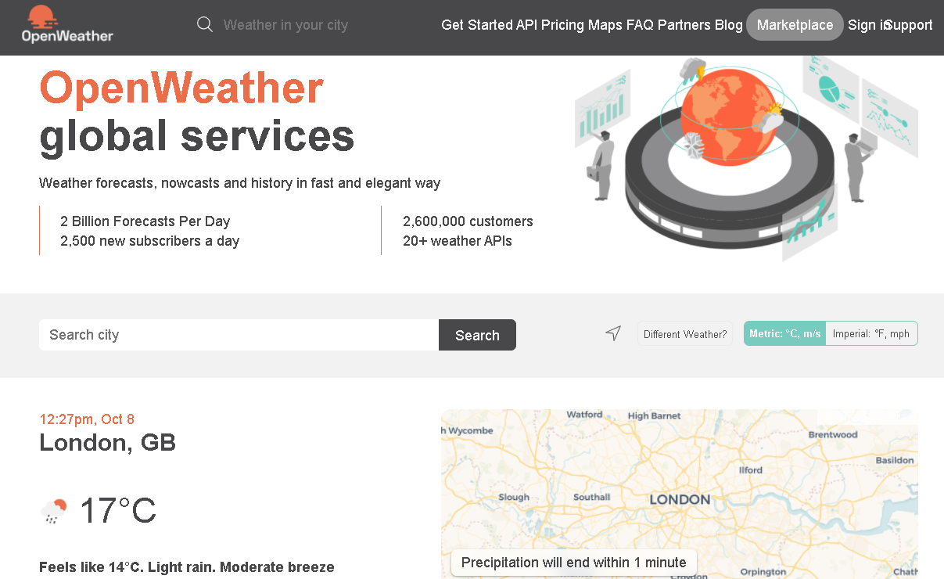

A lambda function is created with the help of serverless framework. This function deals with the logic behind returning weather data of provided city from open weather map.

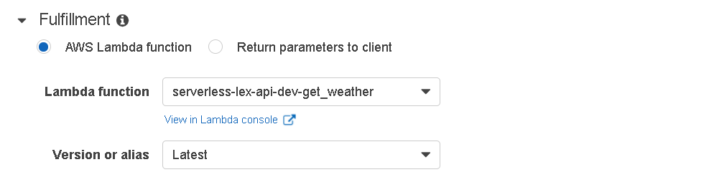The Lambda function is connected to the weather bot.

Error Handling setting is configured to only prompt user with the city name twice.

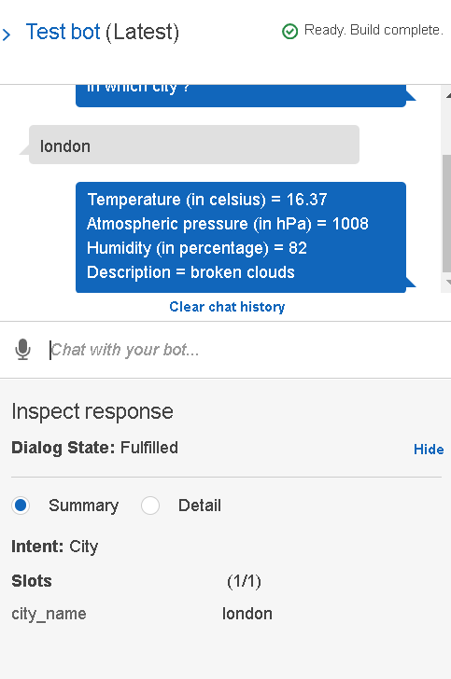The bot is built and published. Testing is done to ensure positive results.

