1.

import pandas as pd

import matplotlib.pyplot as plt

from sklearn.linear_model import LinearRegression

df = pd.DataFrame({'a':[5,6,7,10,12,15,18,20], 'b':[7.4, 9.3, 10.6, 15.4, 18.1, 22.2, 24.1, 24.8]})

scatter = df.plot.scatter(x='a', y='b', c='DarkBlue')

model = LinearRegression()

model.fit(df[['a']], df['b'])

y = model.predict(df[['a']])

print("coefficient(slope): ", model.coef_[0]) # slope

print("intercept: ", model.intercept_) # intercept

print("y = {}x + {}".format(model.coef_[0], model.intercept_))

# plot df and regression line

df.plot.scatter(x='a', y='b', c='DarkBlue')

plt.plot(df['a'], y, color='red')

plt.show()

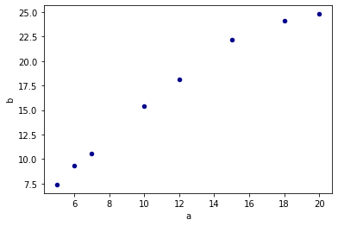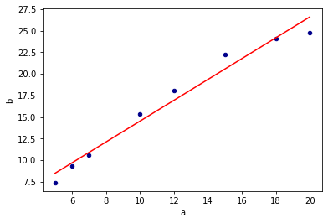

2.

df = pd.DataFrame({'ordered': [88, 112, 123, 136, 158, 172], 'price': [50, 40, 35, 30, 20, 15]})

model = LinearRegression()

model.fit(df[['price']], df['ordered'])

y = model.predict(df[['price']])

print("coefficient(slope): ", model.coef_[0]) # slope

print("intercept: ", model.intercept_) # intercept

print("y = {}x + {}".format(model.coef_[0], model.intercept_))

# 25 for price

print(model.predict([[25]]))

```output

coefficient(slope): -2.376

intercept: 206.74

y = -2.376x + 206.74

[147.34]

3.

df = pd.DataFrame({'speed':[45,50,55,60,65,70,75],'mpg':[24.2, 25.0, 23.3, 22.0, 21.5, 20.6, 19.8]})

model = LinearRegression()

model.fit(df[['speed']], df['mpg'])

y = model.predict(df[['speed']])

print("coefficient(slope): ", model.coef_[0]) # slope

print("intercept: ", model.intercept_) # intercept

print("y = {}x + {}".format(model.coef_[0], model.intercept_))

```output

coefficient(slope): -0.16999999999999998

intercept: 32.542857142857144

y = -0.16999999999999998x + 32.542857142857144

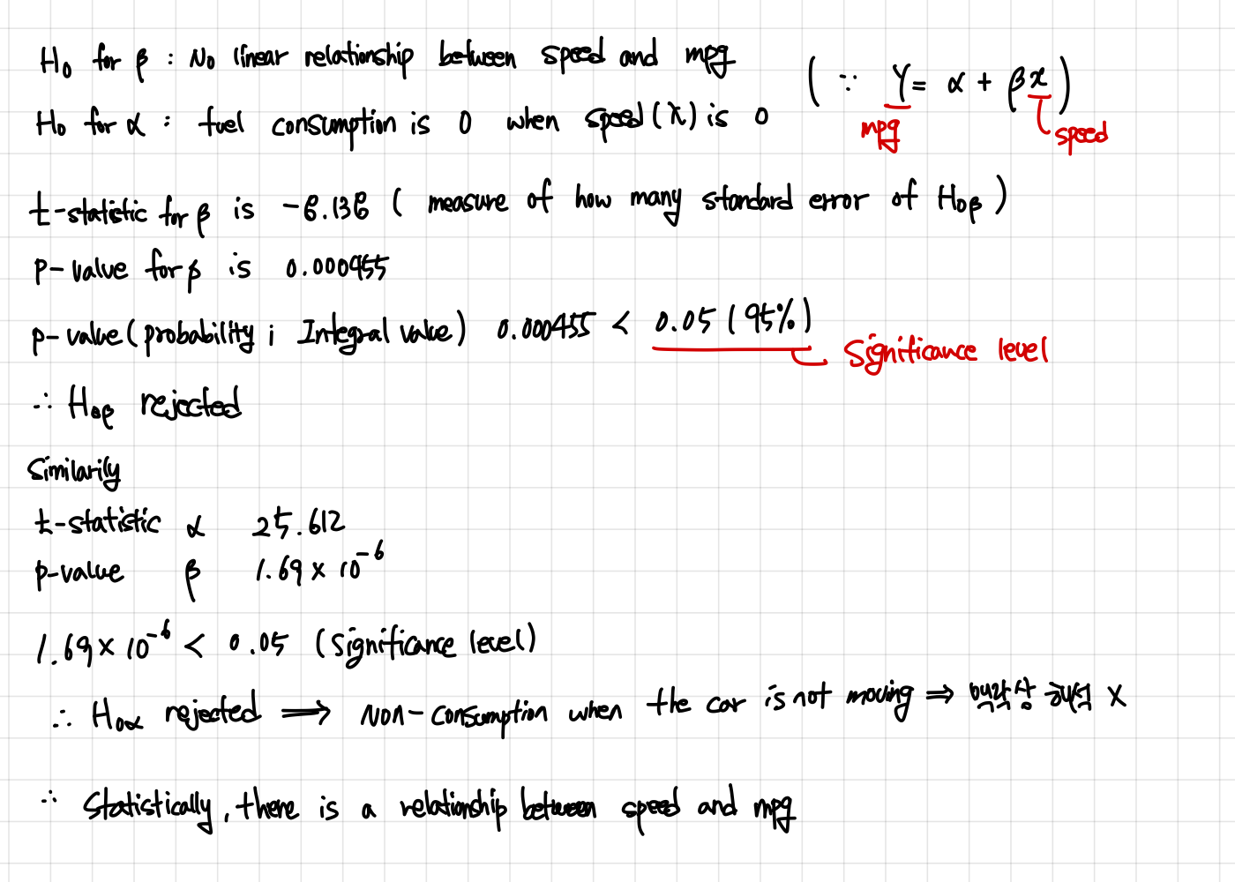

4.

