3.

import pandas as pd

import numpy as np

import matplotlib.pyplot as plt

prop_class_1 = np.arange(0, 1.001, 0.001)

prop_class_2 = 1 - prop_class_1

classification_error = 1 - np.maximum(prop_class_1, prop_class_2)

gini = prop_class_1*(1-prop_class_1) + prop_class_2*(1-prop_class_2)

entropy = -prop_class_1*np.log(prop_class_1) - prop_class_2*np.log(prop_class_2)

df = pd.DataFrame({'prop_class_1': prop_class_1,

'prop_class_2': prop_class_2,

'classification_error': classification_error,

'gini': gini,

'entropy': entropy})

df = pd.melt(df, id_vars=['prop_class_1', 'prop_class_2'],

value_vars=['classification_error', 'gini', 'entropy'],

var_name='metric', value_name='value')

plt.plot('prop_class_1', 'value', data=df[df['metric'] == 'classification_error'], label='Classification Error')

plt.plot('prop_class_1', 'value', data=df[df['metric'] == 'gini'], label='Gini')

plt.plot('prop_class_1', 'value', data=df[df['metric'] == 'entropy'], label='Entropy')

plt.xlabel('Proportion (of class \'1\')')

plt.ylabel('Value')

plt.ylim(0,1)

plt.yticks(np.arange(0,1.1,0.1))

plt.legend()

plt.show()

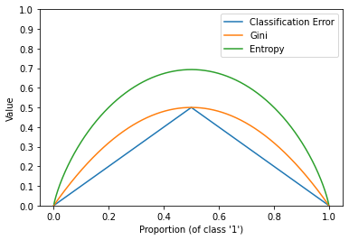

4.

