1. Using command-line arguments involves the sys module. Review the docs for this

module and using the information in there write a short program that when run

from the command-line reports what operating system platform is being used.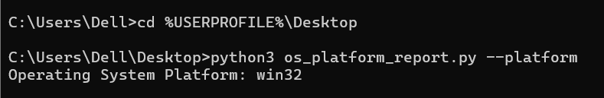

2. Write a program that, when run from the command line, reports how many

arguments were provided. (Remember that the program name itself is not an

argument).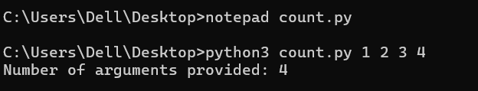 3. Write a program that takes a bunch of command-line arguments, and then prints

out the shortest. If there is more than one of the shortest length, any will do.

Hint: Don't overthink this. A good way to find the shortest is just to sort them.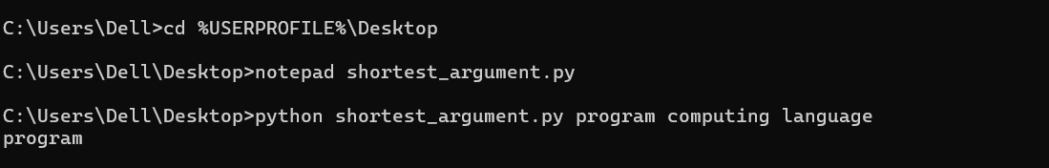4. Write a program that takes a URL as a command-line argument and reports

whether or not there is a working website at that address.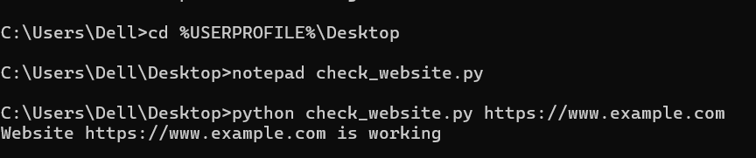

5. Last week you wrote a program that processed a collection of temperature readings

entered by the user and displayed the maximum, minimum, and mean. Create a

version of that program that takes the values from the command-line instead. Be

sure to handle the case where no arguments are provided!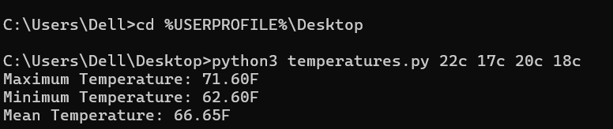

6. Write a program that takes the name of a file as a command-line argument, and

creates a backup copy of that file. The backup should contain an exact copy of the

contents of the original and should, obviously, have a different name.