1. The Unix nl command prints the lines of a text file with a line number at the start

of each line. (It can be useful when printing out programs for dry runs or white-box

testing). Write an implementation of this command. It should take the name of the

files as a command-line argument.

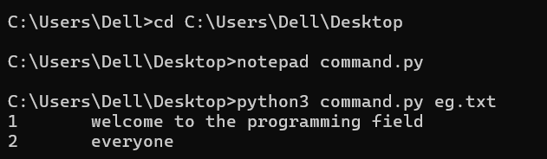

2. The Unix diff command compares two files and reports the differences, if any.

Write a simple implementation of this that takes two file names as command-line

arguments and reports whether or not the two files are the same. (Define "same" as

having the same contents.)

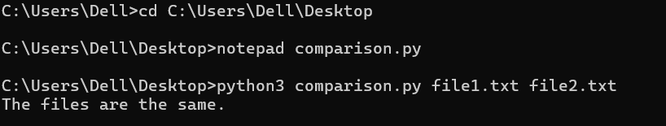

When I change the content of txt file

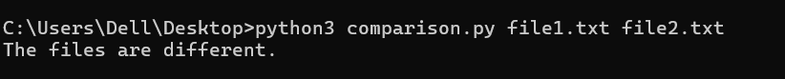

3. The Unix grep command searches a file and outputs the lines in the file that

contain a certain pattern. Write an implementation of this. It will take two

command-line arguments: the first is the string to look for, and the second is the

file name. The output should be the lines in the file that contain the string.

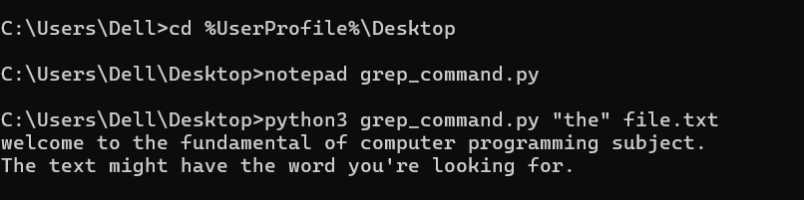

4. The Unix wc command counts the number of lines, words, and characters in a file.

Write an implementation of this that takes a file name as a command-line

argument, and then prints the number of lines and characters.

Note: Linux (and Mac) users can use the "wc" command to check the results of their

implementation.

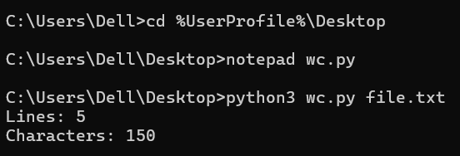

5. The Unix spell command is a simple spell-checker. It prints out all the words in a

text file that are not found in a dictionary. Write and test an implementation of this,

that takes a file name as a command-line argument.

