PhD proposal: the role of social identity in Swiss urban commons

Pedrazzini Sabina1

1 Centre for Development and Environment, University of Bern

PhD proposal: the role of social identity in Swiss urban commons

General plan:

* societal problem: social foundation vs planetary boundaries => no countries has attained both
* **commons = new social organization that could allow to attain the goals**
* **challenge in commons = cooperation**
* **More in details:**
  + **Situation in CH**
  + **Urban commons (=> same challenge as classic commons)**
* **state of research & gaps: in studies about cooperation in real-life commons, a social psychology perspective, as well as a quantitative approach is missing**
* **scope: housing initiatives in Switzerland**
  + **see document for kick-off meeting with parallel between definition and CODHA**
* **research questions:**
  + **does the social identification as a commoners impact cooperation?**
  + **is social identification impacted by the commons organization?**
  + **how could cooperation be increased?**
  + **how does social identification evolve overtime?**
  + **does housing initiatives contributes to create a social change?**

Since several years, we are facing many global crises, both on the environmental and on the social level. For instance, we recently went through a global pandemic, several natural disaster such as fires and floods, wars with consequent humanitarian emergencies, and an important rising in the cost of living. To address these problems, 17 sustainable development goals (SDGs) were created during the 2012 United Nations Conference on Sustainable Development. The aim was to “produce a set of universal goals that meet the urgent environmental, political and economic challenges facing our world” (United Nations Development Program, n.d.). Some years later, (**Steffen2015?**) proposed the Planetary Boundaries Framework, based on the biophysical processes regulating the stability of the Earth system. This framework defines nine “planetary boundaries” (the most important of which are climate change and biosphere integrity) that, if not overshot, insure a safe operating space for human activities. However, the path to attain the SDGs and to respect planetary boundaries is still long. In fact, the latest Global Sustainable Development Report (2023) highlighted that we are far from achieving most of the SDGs.[1] Moreover, according to the latest update of the Stockholm Resilience Center (2023), at a global level, six boundaries are already crossed.

In order to develop a new model for human well-being, Raworth (2017) combined the United Nations’ SDGs with the Planetary Boundaries Framework. In her approach, “well-being depends on enabling every person to lead a life of dignity and opportunity, while safeguarding the integrity of Earth’s life-supporting systems” (Raworth, 2017, p. 1). Her model (shown in Figure 1) allows to define a safe and just space for humanity. The inner boundary (social foundation) is composed by social-related SDGs; a minimum level is necessary to attain these goals. On the other side, the ecological ceiling is based on the Planetary Boundaries Framework and ideally should not be overshot.

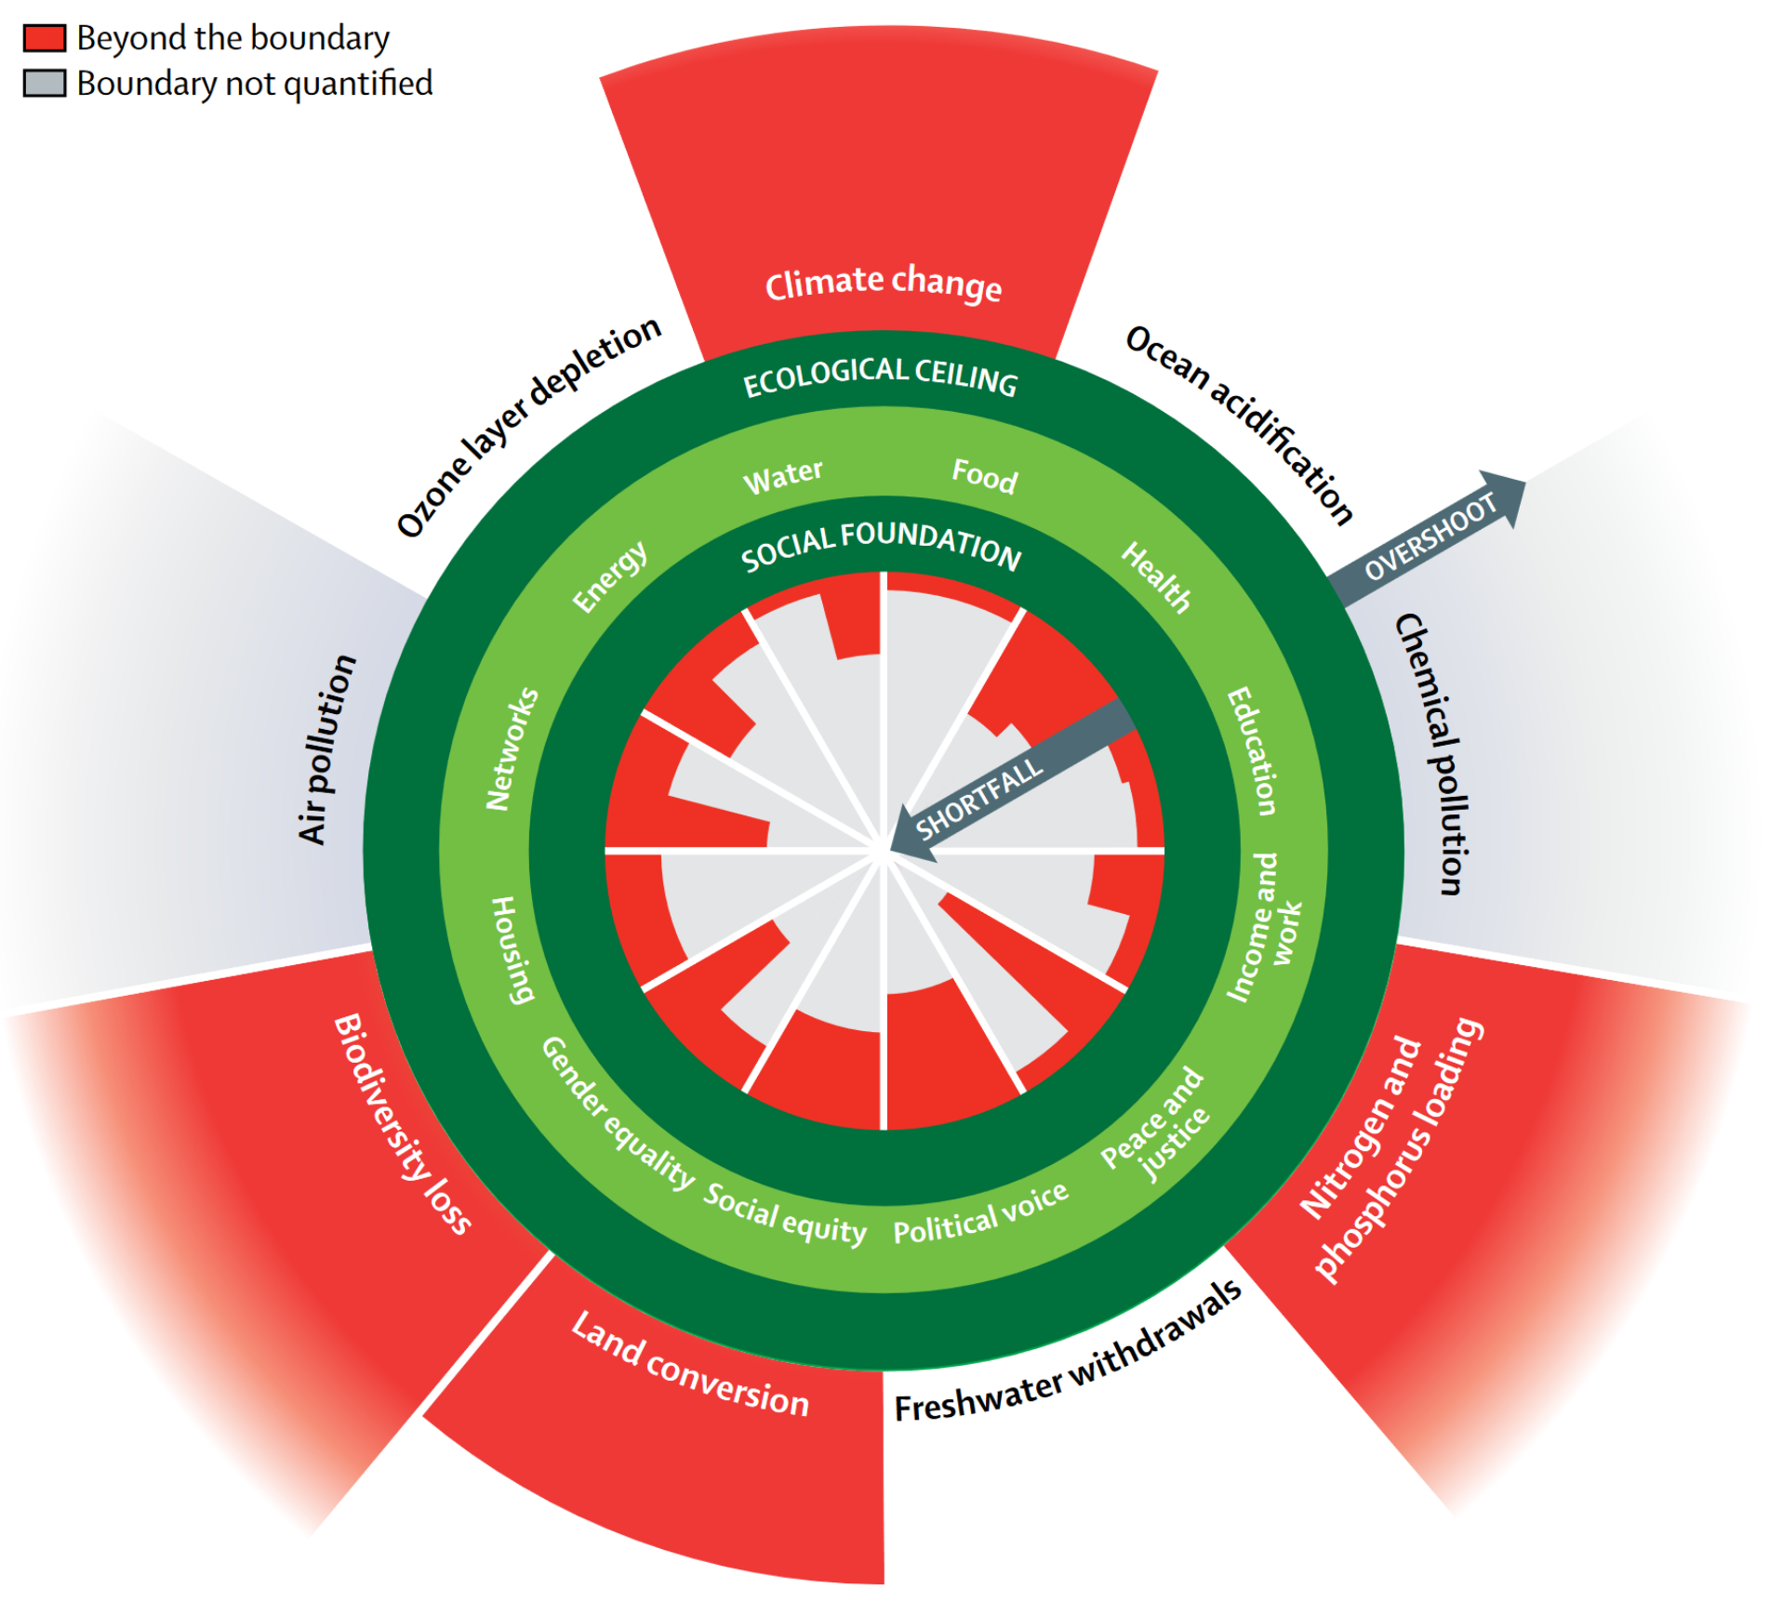

Figure 1. Doughnut with social foundations as inner boundary and ecological ceiling as outer boundary.  
Source: Raworth (2017)

As shown in Figure 1, at a global level, social foundations are not fully met and several planetary boundaries are already overshot. Therefore, a radical change is needed to attain Raworth’s definition of well-being.[2] However, the path to fully satisfy human needs within planetary boundaries is not the same for every country. In fact, countries in Global North generally ensure their population’s needs, but they also overshoot most of the planetary boundaries, while in Global South the planetary boundaries are usually respected, but people’s needs are not (fully) met (O’Neill, Fanning, Lamb, & Steinberger, 2018). The actual situation would therefore suggest that the social foundation is attained just when planetary boundaries are exceeded. To inverse this tendency, O’Neill et al. (2018) suggested that “provisioning systems must be fundamentally restructured to enable basic needs to be met at a much lower level of resource use” (p. 92).

## The commons[3] as a solution

Commons could be a solution to the current social and ecological issues because they allow people to contrast the detrimental effects of capitalism by self-organizing to directly address their problems and needs in a sustainable way (Bollier & Helfrich, 2019; **Bollier2014?**). In fact, the capitalistic organization of labor has separated the production from the consumption, and individuals are therefore lead to ignore the social and environmental cost of the products they purchase (**Federici2010?**). Moreover, commons are a possible way to attain degrowth (Euler, 2019). This term indicates a radical change on the political and economic level aimed at drastically reduce resource consumption (**Kallis2018?**). The goal is to create a socially and ecologically sustainable society, that is not based on economic, capitalistic growth, that is “structurally unsustainable, because it builds on structures of insufficiency — there is no”enough” to it” (Euler, 2019, p. 2).

Commons can assume various forms, because “they can arise whenever a community decides it wishes to manage a resource in a collective manner, with a special regard for equitable access, use and sustainability” (**Bollier2014?**). Due to their variety there are several definitions of commons, that can be resumed through three key points.

1. The commons’ goal is to manage shared resources that can be material or abstract (Meroni & Selloni, 2022; Ostrom, 1990), and to allow people to find solutions for their shared needs (Euler, 2018, 2019).

Secondly, commons are managed by a self-organized community of users, i.e the commoners (Ostrom, 1990). This community can be seen as a “social network of mutual aid, solidarity, and practices of human exchange that are not reduced to the market form” (**DeAngelis2003?**). Commoners are engaged in creating the commons and in defining rules to successfully manage it, and both these practices and the community can be seen as part of the commons itself (Meroni & Selloni, 2022; **Bollier2014?**). Moreover, the organization is usually local, egalitarian, integrative, and fair (**Gidwani2011?**). The process through which people come together to find solutions, and to create institutions to govern the commons is called “commoning” (Euler, 2018; Schmelzer, Vetter, & Vansintjan, 2022). Given the essential role of the community in defining a common, considering the characteristics of the specific group of people who is commoning is crucial to have a full understanding of the commons itself (Dove et al., 2019). Finally, commons are not organized around the generalized market competition (Euler, 2019) and do not involve the classic private and public model (Ostrom, 1990).

In fact, in degrowth literature, aspects related to commons are mentioned as potential changes toward a new social and economic organization. For example, in Fitzpatrick, Parrique, and Cosme (2022), guarantee the decommodified and universal provision of fundamental humans needs, promote shared housing, and prioritize self-sufficient communities are part of the objectives that could allow to attain degrowth. Moreover, a shift toward a more democratic economy is also needed, and to realize it commons, solidarity economy, democratic ownership and institutional support for cooperative are essential (Schmelzer et al., 2022).

conclusion: commons can improve well-bieng by X and Y, and reduce environmental impact by X and Y, so they can lead to a “good life for all within planetary boundaries”

# References

Independent Group of Scientists appointed by the Secretary-General, Global Sustainable Development Report 2023: *Times of crisis, times of change: Science for accelerating transformations to sustainable development*, (United Nations, New York, 2023)

United Nations Development Program (n.d.). *Sustainable Development Goals: Background on the Goals*. Retrieved November 9, 2023, from <https://www.undp.org/sdg-accelerator/background-goals>

University of Leeds (n.d.). *Country Comparisons*. A Good Life For All Within Planetary Boundaries. Retrieved November 9, 2023, from <https://goodlife.leeds.ac.uk/national-snapshots/countries/#Switzerland>

OECD (n.d.). *Switzerland*. OECD Better Life Index. Retrieved November 9, 2023, from <https://www.oecdbetterlifeindex.org/countries/switzerland/>

Stockholm Resilience Centre, Stockholm University (n.d.). *Planetary boundaries*. Retrieved November 20, 2023, from <https://www.stockholmresilience.org/research/planetary-boundaries.html>

Swiss Confederation (2023, June 30). *Population - facts and figures*. About Switzerland. Retrieved November 20, 2023, from <https://www.eda.admin.ch/aboutswitzerland/en/home/gesellschaft/bevoelkerung/die-bevoelkerung---fakten-und-zahlen.html>

Bollier, D., & Helfrich, S. (2019). *Free, fair and alive. The insurgent power of the commons*. Canada: New Society Publishers.

Dove, M. R., Johnson, A., Lefebvre, M., Burow, P., Zhou, W., & Kanoi, L. (2019). Who Is in the Commons: Defining Community, Commons, and Time in Long-Term Natural Resource Management. In L. R. Lozny & T. H. McGovern (Eds.), *Global Perspectives on Long Term Community Resource Management* (pp. 23–40). Cham: Springer International Publishing. <https://doi.org/10.1007/978-3-030-15800-2_3>

Euler, J. (2018). Conceptualizing the Commons: Moving Beyond the Goods-based Definition by Introducing the Social Practices of Commoning as Vital Determinant. *Ecological Economics*, *143*, 10–16. <https://doi.org/10.1016/j.ecolecon.2017.06.020>

Euler, J. (2019). The Commons: A Social Form that Allows for Degrowth and Sustainability. *Capitalism Nature Socialism*, *30*(2), 158–175. <https://doi.org/10.1080/10455752.2018.1449874>

Fitzpatrick, N., Parrique, T., & Cosme, I. (2022). Exploring degrowth policy proposals: A systematic mapping with thematic synthesis. *Journal of Cleaner Production*, *365*, 132764. <https://doi.org/10.1016/j.jclepro.2022.132764>

Meroni, A., & Selloni, D. (2022). Commons, New Commons, Urban Commons. In A. Meroni & D. Selloni, *Service Design for Urban Commons* (pp. 3–9). Cham: Springer International Publishing. <https://doi.org/10.1007/978-3-031-06035-9_1>

O’Neill, D. W., Fanning, A. L., Lamb, W. F., & Steinberger, J. K. (2018). A good life for all within planetary boundaries. *Nature Sustainability*, *1*(2), 88–95. <https://doi.org/10.1038/s41893-018-0021-4>

Ostrom, E. (1990). *Governing the Commons: The Evolution of Institutions for Collective Action* (1st ed.). Cambridge University Press. <https://doi.org/10.1017/CBO9780511807763>

Raworth, K. (2017). *Doughnut economics: seven ways to think like a 21st-century economist*. London: Random House Business Books.

Schmelzer, M., Vetter, A., & Vansintjan, A. (2022). *The future is degrowth: a guide to a world beyond capitalism*. New York: Verso.

1. More specifically, between the measurements of 2019 and 2023, a regression was observed in goals concerning air pollution, agricultural water use, relative poverty rates, food waste, greenhouse gas emissions, and biodiversity and nitrogen use. There were minimal progress on goals related to malnutrition and gender gap, while gains were observed only in few areas such as extreme poverty reduction and global income convergence.
2. In fact, if we stay on a “business-as-usual pathway”, we will not be able to achieve SDGs by 2030, or even 2050 (GSDR, 2023).
3. The term “commons” is both singular and plural (**Bollier2014?**). For the difference between the singular forms “common” and “commons”, see (**Feinberg2021?**).