

Tribhuvan University Faculty of Humanities and Social Science

A PROJECT ON

PORTFOLIO MANAGEMENT SYSTEM

Submitted to
Department of Computer Application
Nepal Mega College

In partial fulfillment of the requirements for the Bachelors in Computer Application

Submitted by
Sabinaya Khadka (Roll No: 23)
Pawan Thapa (Roll No: 17)
June 2026

Under the supervision of
(SUPERVISOR NAME)
SUPERVISOR Recommendation
LETTER OF APPROVAL
Abstract
Acknowledgement
TOC

List of abbreviation
List of Figures
List of Table

Chapter 1: Introduction

Introduction
Portfolio management involves organizing, monitoring, and evaluating investments held by an individual. As investors may maintain investments through multiple Demat accounts, keeping track of different accounts, shareholdings, purchase prices, current prices, and overall portfolio performance can become difficult when the information is maintained separately.
The Portfolio Management System (PMS) is a web-based application developed to provide a centralized platform for managing manually recorded shareholdings across multiple Demat accounts. The system allows users to create and manage up to ten Demat accounts and record the companies and quantities of shares held in each account. Users can also enter the purchase price and current price of their holdings, based on which the system calculates the invested amount, current portfolio value, and profit or loss.
The system also provides facilities for browsing and searching company information and accessing stock market and Initial Public Offering (IPO)-related news. News can be imported through RSS feeds and reviewed by an administrator before being published. Administrators can also manage users and company information.
The Portfolio Management System is designed as a portfolio organization and learning-oriented system. It does not directly connect to users' Demat accounts, execute stock transactions, handle real money, or obtain live market prices. The portfolio values displayed by the system are calculated from information manually entered by the users.
1.2 Problem Statement
- Managing multiple Demat accounts in different places makes it annoying to know how much you’ve actually invested or earned.
- Holding the same stock in different accounts gets confusing real fast without separate tracking.
- Users need one easy place to track everything and check market news without dealing with direct broker connections.

1.3 Objectives
The main objectives of the Portfolio Management System are:
- To develop a web-based system for managing multiple Demat accounts under a single user account.
- To allow users to record and manage holdings separately for each Demat account.
- To maintain company information centrally so that users can select available companies when recording holdings.
- To prevent duplicate holding records for the same company within the same Demat account.
- To calculate total invested amount, current recorded portfolio value, and profit or loss from user-provided holding information.
- To provide a dashboard for viewing relevant portfolio information and account-level summaries.
- To provide search functionality for available companies using company name or symbol.
- To provide stock market and IPO-related news through administrator-managed and RSS-imported content.
- To provide user authentication and account management features with appropriate access control.
- To provide administrators with facilities to manage users, companies, and news content.
- To maintain separation and security of users' Demat and holding information so that one user cannot access another user's portfolio data.
- To apply database management, programming, system analysis, interface design, and software testing concepts learned during the BCA program.

1.4 Scope and Limitation
The scope of the Portfolio Management System covers user account management, multiple Demat account management, portfolio holding management, company information, portfolio calculations, news management, and administrator functions.
Users can register and authenticate themselves, manage their profile, and maintain up to ten Demat accounts. Each Demat account contains its own account information and holdings. Users can add holdings by selecting companies maintained in the system and entering the quantity, purchase price per share, and current price per share. The system calculates the invested amount, current recorded value, and profit or loss based on these values. A company may be held in multiple Demat accounts, while duplicate records of the same company within one Demat account are not permitted.
Administrators can manage registered users, maintain company information, and manage stock market and IPO-related news. News can be imported from an RSS feed and stored for administrator review before publication. Administrators can also disable user accounts when necessary while retaining their stored data.
The system is intended for portfolio record keeping and learning purposes. It does not execute share purchases or sales, connect users to a stock exchange, or provide real-time market prices. Current prices are entered and updated manually by users. The system therefore does not guarantee that the recorded portfolio value represents the actual current market value of an investment.
The system also does not verify whether the Demat account holder name or broker/Depository Participant information entered by a user is officially valid. BOID format and uniqueness are checked by the system, but ownership of the BOID cannot be independently verified. The application is initially designed for a local development environment using XAMPP and MySQL/MariaDB. Integration with external financial services, live market-data providers, or trading platforms is outside the scope of the current project.

1.5 Report Organization
This report is organized into five chapters.
Chapter 1: Introduction presents the project background, problem statement, objectives, scope and limitations, and organization of the report.
Chapter 2: Background Study and Literature Review presents the project-related background, fundamental concepts, relevant terminology, and review of similar systems and related studies.
Chapter 3: System Analysis and Design presents the requirements of the system, feasibility analysis, data and process modelling, architectural design, database schema design, interface design, and physical data flow design.
Chapter 4: Implementation and Testing presents the tools and technologies used to implement the system, implementation details of the major modules, and test cases used for unit and system testing.
Chapter 5: Conclusion and Future Recommendations presents the lessons learned and outcomes of the project, conclusion of the developed system, and recommendations for possible future improvements.
Chapter 2: Background Study and Literature review
2.1 Background Study
The proposed Portfolio Management System is based on the need to maintain organized records of investments held through multiple Demat accounts. The system combines concepts related to securities holding, portfolio management, investment valuation, and web-based information management.
In Nepal, securities held in dematerialized form are maintained through a depository system. Investors use Demat accounts to hold securities electronically, and such accounts are opened through Depository Participants (DPs). According to CDS and Clearing Limited (CDSC), an investor can maintain more than one Demat account with the same or different Depository Participants. This provides the basis for allowing a user of the proposed system to maintain multiple Demat account records within a single application [1].
Each Demat account is associated with a Beneficial Owner Identification Number (BOID). CDSC describes the BOID as a unique 16-digit identification number generated when a Beneficial Owner opens a Demat account through an authorized Depository Participant. The BOID is used in securities-related transactions and cannot be duplicated between Beneficial Owners [2]. This concept is applied in the proposed system by requiring each recorded Demat account to contain a 16-digit BOID and by preventing duplicate BOIDs within the system.
Portfolio management involves maintaining and evaluating a collection of financial assets according to an investor's objectives. In the context of the proposed system, portfolio management is focused on maintaining records rather than automatically selecting or trading securities. A user's portfolio consists of holdings distributed across one or more Demat accounts. Each holding identifies the company, the quantity owned, the purchase price per share, and the currently recorded price per share.
The valuation of a holding can be obtained by multiplying the number of shares by the relevant price per share. Based on the information entered by the user, the proposed system calculates the invested amount, current recorded holding value, and profit or loss. The invested amount is calculated from the quantity and purchase price, while the current recorded value is calculated from the quantity and current recorded price. Profit or loss is then determined from the difference between the current recorded value and the invested amount. These calculations allow users to review their portfolio position without manually performing the same calculations for each holding.
A portfolio may contain the same company through different Demat accounts. For example, a user may hold shares of one company in two separate Demat accounts. These holdings represent separate account-level records even though they refer to the same company. The proposed system therefore associates each holding with both a specific company and a specific Demat account. This allows the user to view individual account holdings while also obtaining an overall portfolio summary.
The system also uses a centralized company directory. Company information is maintained by the administrator and is shared among users. Users select an available company when recording a holding rather than creating company records themselves. This provides consistency in company identification and prevents different users from creating separate records for the same company.
The proposed system is implemented as a web-based application. A web-based approach allows the different modules of the system, including authentication, Demat management, holdings management, company browsing, portfolio calculations, and news management, to be accessed through a common interface. The application uses HTML and CSS for the interface, JavaScript for client-side interaction and validation, PHP for server-side processing, and MySQL/MariaDB for persistent data storage.
The system also incorporates stock market and IPO-related news as supporting information. News can be imported from RSS sources and reviewed by an administrator before being made available to users. The news component complements the portfolio-recording functions while remaining separate from the portfolio calculations. The system does not directly provide live market prices, execute transactions, or perform automated trading. Current prices used for portfolio calculations are recorded and updated manually by users.
2.2 Literature Review
Several existing studies and systems have explored the development of portfolio management applications using different approaches. These works provide a basis for understanding how portfolio information can be managed and how additional analytical features can be incorporated into investment systems.
Kumar et al. presented a real-time portfolio management system that applies machine learning techniques to portfolio selection, optimization, and management [3]. The study uses methods including K-Means clustering and genetic algorithms and evaluates different portfolio construction approaches. The work demonstrates how portfolio management systems can be extended beyond simple record keeping to support automated analysis and optimization. However, such advanced computational techniques are outside the scope of the proposed system, which focuses on maintaining user-entered portfolio records and performing basic portfolio valuation.
A study on an adaptive stock market portfolio management and stock price prediction platform for the Colombo Stock Exchange proposed a system combining portfolio management with stock price prediction [4]. The study considered investor requirements, functional and non-functional requirements, user interface considerations, system architecture, and testing as part of the development process. The proposed platform also incorporated prediction models such as Brownian Motion and Long Short-Term Memory (LSTM). This demonstrates the potential for portfolio management applications to integrate market analysis and prediction features. In contrast, the proposed Portfolio Management System intentionally avoids prediction and automated market analysis and instead focuses on simpler portfolio record management suitable for the project's scope.
Existing research therefore shows that portfolio management systems can range from basic investment record-keeping applications to complex platforms involving real-time market data, optimization, and machine learning. The proposed system adopts a simpler approach appropriate for its intended purpose. It concentrates on managing multiple Demat accounts, maintaining account-specific holdings, calculating recorded portfolio values and profit or loss, and providing relevant company and news information. This approach allows the system to address practical portfolio-recording requirements while remaining within the technical scope of the project.

Chapter 3: System Analysis and Design
3.1: System Analysis
3.1.1: Requirement Analysis
The requirements of the proposed Portfolio Management System were identified based on the intended use of the system for managing multiple Demat accounts and their associated share holdings. The requirements focus on providing users with a centralized platform to maintain investment records, calculate portfolio values and profit or loss, and access company and stock-market-related information. Administrative requirements were also identified for managing users, companies, and news content.
i. Functional Requirements
The functional requirements of the proposed system are as follows:
- User Account Management: The system shall allow users to register, log in, log out, verify their email address, reset forgotten passwords, and change their registered email address. The system shall temporarily restrict login after repeated failed authentication attempts.
- Demat Account Management: The system shall allow users to add and manage multiple Demat accounts, up to a maximum of ten accounts per user. Each Demat account shall store an account nickname, account holder name, DP/broker name, and 16-digit BOID. The system shall validate the BOID and prevent duplicate BOIDs.
- Holding Management: The system shall allow users to record holdings under a selected Demat account. Each holding shall contain a company, quantity, purchase price per share, and current recorded price per share. Users shall be able to add, edit, and remove holdings. The system shall prevent duplicate holdings of the same company within the same Demat account.
- Portfolio Calculation: The system shall calculate the invested amount, current holding value, and profit or loss for individual holdings. It shall also calculate the total invested amount, overall portfolio value, and total profit or loss across the user's Demat accounts.
- Company Management: The system shall provide users with a company directory that can be searched by company name or symbol. Administrators shall be able to add and manage company records and maintain sector information.
- News and IPO Management: The system shall display stock-market and IPO-related news. It shall support importing news through configured RSS feeds, identifying duplicate news entries, and storing imported news for administrative review. Administrators shall be able to manage, publish, and unpublish news content.
- Administrative Management: The system shall allow authorized administrators to manage registered users, disable or re-enable user accounts, manage user roles according to authorization rules, and manage company and news records.
- Access Control: The system shall restrict users to their own Demat accounts and holdings and shall restrict administrative functions to authorized administrators. Disabled users shall not be allowed to access the system until their account is re-enabled.
ii. Non-Functional Requirements
The proposed system shall satisfy the following non-functional requirements:
- Security: The system shall protect user credentials and restrict access to user-specific information according to authentication and authorization rules.
- Usability: The system shall provide clear navigation, understandable forms, input validation, and meaningful feedback to users.
- Performance: Common operations such as authentication, company searching, data retrieval, and portfolio calculations shall be performed efficiently under normal system usage.
- Reliability: The system shall maintain the consistency and availability of stored user, Demat, holding, company, and news records during normal operation.
- Data Integrity: The system shall enforce appropriate validation and database constraints to prevent invalid quantities, prices, duplicate BOIDs, duplicate holdings, and invalid relationships between records.
- Maintainability: The system shall be organized so that individual components can be modified or maintained without unnecessarily affecting unrelated parts of the application.
- Compatibility: The system shall operate through commonly used modern web browsers.
- Responsiveness: The user interface shall adapt to desktop, tablet, and mobile screen sizes.
- Accessibility: Important information and system feedback shall not depend solely on color, animation, or other visual effects.
- Future Extensibility: The system shall be structured so that future features, such as integration with external market-data services, can be added without requiring a complete redesign of the existing system.
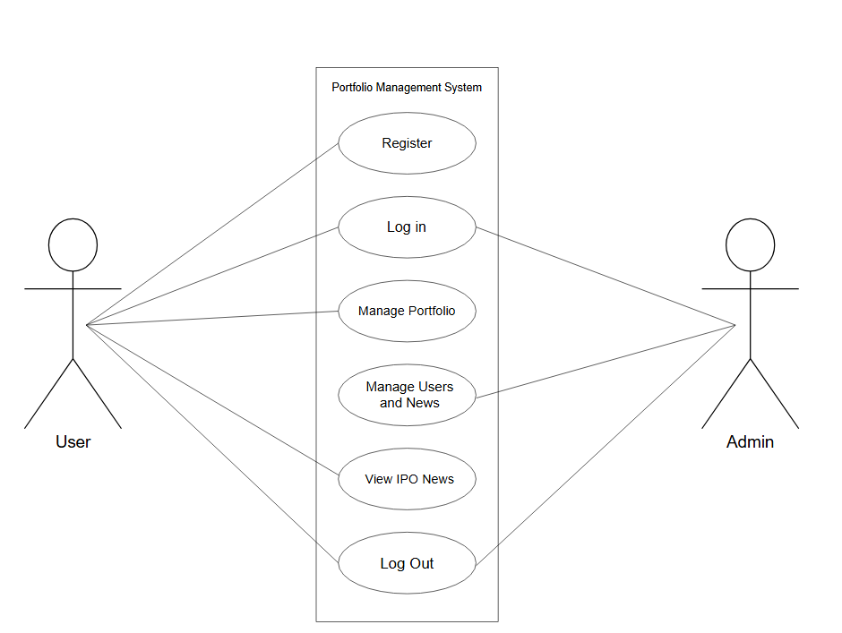
Figure 1: Use Case Diagram for Portfolio Management System
3.1.2 Feasibility Analysis
The feasibility of the proposed Portfolio Management System was evaluated from technical, operational, economic, and schedule perspectives. The analysis was conducted to determine whether the system could be developed and used effectively within the available resources, environment, and project duration.
i. Technical Feasibility
The proposed system is technically feasible because it uses technologies that are suitable for developing a web-based application and are available in the development environment. The system uses HTML, CSS, and JavaScript for the user interface, PHP for server-side processing, and MySQL/MariaDB for data storage. XAMPP provides the local web server and database environment required for development and testing.
The system does not require specialized hardware or external financial APIs. News can be imported through RSS feeds, while portfolio prices are entered and updated manually by users. The required development tools and technologies are accessible on the available hardware, making the proposed system technically feasible within the project environment.
ii. Operational Feasibility
The proposed system is operationally feasible because its functions are designed around common portfolio record-management activities. Users can maintain multiple Demat accounts, record their holdings, update recorded prices, and view calculated portfolio values and profit or loss from a centralized interface.
The system also provides administrative functions for managing users, companies, and news. The interface is designed to provide clear navigation, validation, and feedback so that users can perform the required operations without specialized technical knowledge. Therefore, the system can be operated within the intended user environment.
iii. Economic Feasibility
The proposed system is economically feasible because it can be developed using freely available or already accessible development technologies. HTML, CSS, JavaScript, PHP, MySQL/MariaDB, and XAMPP do not require additional commercial software licenses for the intended development environment.
The system also does not depend on paid financial data APIs or specialized hardware. Therefore, the main costs are limited to existing computing resources, internet access where required, and other routine development expenses. The proposed system can consequently be developed within the available project resources without significant additional financial investment.
iv. Schedule Feasibility
The proposed system is schedule-feasible because its scope is limited to portfolio record management rather than real-time market trading or automated investment analysis. The development can be completed in stages covering requirement analysis, system design, database design, implementation, testing, documentation, and final refinement.
The project follows a structured development schedule in which the major activities are planned according to the available academic project period. The selected technologies and limited system scope reduce unnecessary development complexity and make it possible to complete the required system within the planned timeframe.
3.1.3 Data Modeling (ER-Diagram)

