Contents

Task 1-Report Content 2

Introduction 2

Plan 3

Description of Problem Solving Process 3

a) Problem definition 3

b) Identifying Selection Criteria 3

c) Process of selection (evaluation of solutions) 4

d) Statement and details of solution 7

Table for final Budget plan 9

Conclusion 9

References 9

# Task 1-Report Content

# Introduction

I am Sabin Budhathoki from Everton city of Liverpool, UK. For 6 years, I have been working as an IT manager of Universal Fresh and Frozen Food Company PVT Limit. The company was officially set up in 2010 and has been operating since and expanding throughout the country. Company head office is located in Bloomsbury, London which looks over 4 regional offices, 2 big warehouses, and 20 retail units of other cities of UK.

Company management team need an IT system to link the head office, regional office, warehouses and other retail units to each other. Firstly, new equipment is necessary for all the office and the new system must deal with stock control for the retail units and warehouses, staff data such as payments, deliveries and sales. Before running the new system in the company, every staff must have the knowledge of the new system how it functions. So necessary training should be given to the staff about the new system. Likewise, the company also wants to have online transactions and order facility for the customers for a better result. Similarly, the company wants the new system to have the capacity of scaling for future.

The company management team has allocated £50 000 budget. I have faced many problems and difficulties to divide the amount to the new system. I should divide allocated budget for different types of equipment properly to afford the best IT system for the company and get a positive response from customers as well as from my company staff.

# Plan

Universal Company is using old and outdated IT system to manage the firm. So, Management team allocated a budget of £50 000 to replace the old IT system by an advanced one. I have to solve budget allocation problems according to the requirements of a new IT system at first. For that, I should do good research about new IT system which can link to the head office, regional offices, warehouses and retail units and also it has the facilities of future expansion. After that, I will make a plan to afford the best IT equipment for different offices located at different location. A new system has different features and functions, so to train company staff about the functioning of a new IT system I have to hire a capable IT professional. Likewise, management team also have asked for provision of stock control for the retail units and warehouses, so for that, I should buy a database system and server which can store staff and customer data such as payments, deliveries and sales. New IT system should have the facilities of ordering online according to customer needs, so office needs high speed of internet connection. A new e-commerce website should be developed for selling of fresh and frozen food in a different location of UK.

# Description of Problem Solving Process

## Problem definition

I had been facing problem since I started with the process. The significant and immediate we have firsthand is time and allocated budget. As being IT manager I have to solve these existing problem and other problems which i face in the future. The first issue is to find the right it company which can supply us with cheap and high grade it services without getting too heavy in our pocket.

After that the other problem we have in hand is purchasing of the essential it equipment’s. I have to be very careful with the expenses and try to get the best cheap deals on excellent quality products. Then I have to train the office workers to use the new it system which they might find hard to operate since it is a completely new system. This is the problem I have ahead of me.

## Identifying Selection Criteria

I have selected various things like computer system, server, database, trainer etc. For the selection of items, I have made following selection criteria:

* **Performance**

The system should be best on high processing speed which works without any break. Rapid processing speed helps client and product owner to interact efficiently.

* **Cost**

Cost is an amount that has to be spent to buy or something. The management team of Universal Company has passed limited amount of budget to setup new IT system. The budget has to be utilize for laptop, server, website, internet facilities and for training staff etc.

* **Brand**

Brand identification has been the single most important factor for increasing sales and ensuring growth since the dawn of capitalism.

* **User-friendly**

User friendly means easy to use, understand and operate. So, Website should be user-friendly to the customers.

* **Web reviews**

A web review is review of a website on which reviews can be posted about businesses, products, or services.

* **Security**

Security plays important role in new IT system. E-commerce website will have online transaction of money so there will be high change of website hacked by the hacker. So, we must use security for securing our Company data as well as for customer privacy.

* **Scalability**

Scalability is an attribute that describes the ability of a process, network, software or organization to grow and manage increased demand. If the system is scalable then in near future we can increase our business with the same system. (Techopedia.com, 2019)

* **Reliability**

The probability that an item will perform a required function without failure understand conditions for a stated period of time. (McLeod, 2019)

## Process of selection (evaluation of solutions)

* **Laptop:** Portable computer for office use and also have different useful features like high performance, great graphics, attached power backup etc.

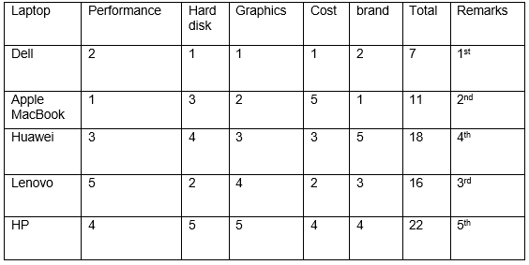

Table 1: Selection of laptop

* **Internet Service Provider**: Internet Service Provider provide SoHo internet connection for office usage so that there will be fast communication but clients and company staff.

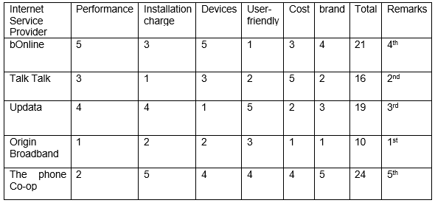

Table 2: Selection of Internet Service Provider

* **Website Developing Companies:** The web development companies developed a familiar layout of e-commerce website for selling and buying product online. And also they developed online money transaction from different payment methods like PayPal, eSewa, Maestro card etc.

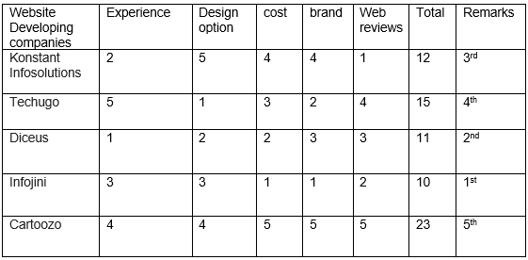

Table 3: Selection of Website Developing Companies

* **Server:** Server helps to hold staff and customer data and also provides web hosting facilities to the company.

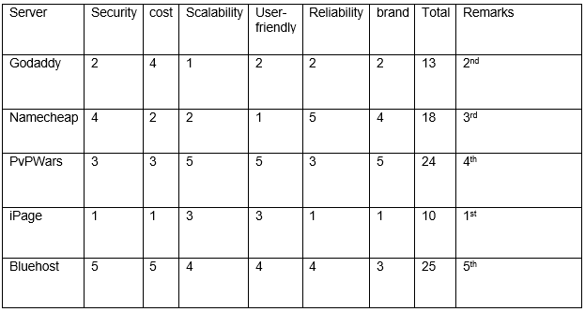

Table 4: Selection of Server

* **Training Institute:** Training Institute helps to make familiar about the information and functions of a new IT system to the company staff.

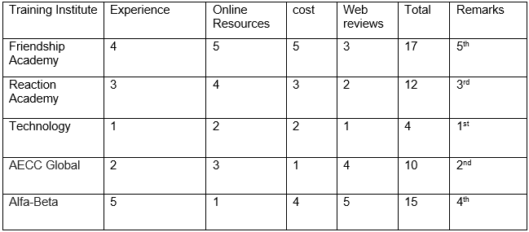

Table 5: Selection of Training Institute

**Database:** A database is an organized collection of data that is easily accessed, store and managed from computer system. (SearchSQLServer, 2019)

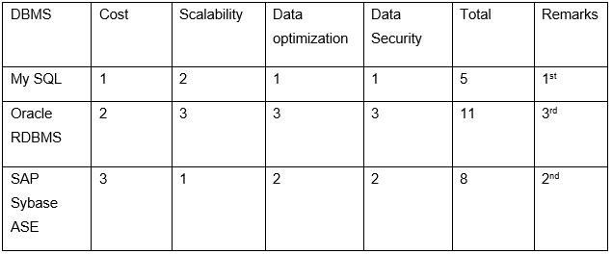

Table 6: Selection of Database

## Statement and details of solution

* **DELL:**

Dell XPS laptop is best for office use which has fast processing **CPU** of 1.8GHz Intel Core i7-8550U (quad-core, 8MB cache, up to 4.0GHz), graphics of Intel UHD Graphics 620, and storage capacity of 1TB HDD with SDD which makes computer faster. I have buy to 20 laptops to give best services to our customers with the available range of budget. (Notebookcheck, 2019)

* **Origin broadband:**

Origin is the best internet service provider in UK with affordable budget. It provide SoHo internet facilities which is very fast than home package.100 Mbps of SoHo internet is enough for our offices.

* **Infojini:**

Infojini is a Website developing company which developed website with best layout and in affordable price.

* **iPage:**

iPage is best and affordable web and database hosting service provider with high performance and it is user-friendly.

* **Technology:**

Technology institute is best in UK with experience teacher. Even they provide online resource for reference.

* **MY SQL**

MySQL is [free and open-source software](https://en.wikipedia.org/wiki/Free_and_open-source_software) which is used to store data of staff and customer, so we can use it to save the budget. Although it is free software but also we need to buy genuine software so, it cost around £2890.6 per Annual Subscription, Support & Maintenance.

(SearchOracle, 2019)

## Table for final Budget plan

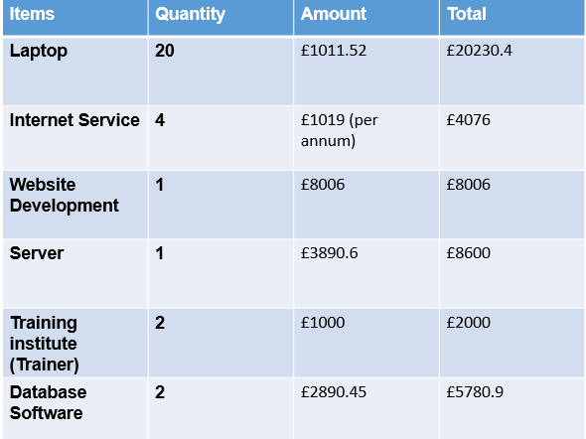

Table 7: Budget Plan

## Conclusion

I have managed all the items which are needed for better IT system of the company. I have utilized available budget very properly. Before spending the amount on buying the different item I have to make a plan and analyze the plan with coming problems. Identifying selection criteria is used to chase problems. I have recommended the possible solution for given problems. Finally, I setup Universal Fresh and Frozen Food PVT Limit with new IT system for better performance.

## References

McLeod, S. (2019). *What is Reliability? | Simply Psychology*. [online] Simplypsychology.org. Available at: https://www.simplypsychology.org/reliability.html [Accessed 18 Jan. 2019].

Notebookcheck. (2019). *Dell XPS 13 (i7-8550U, QHD) Laptop Review*. [online] Available at: https://www.notebookcheck.net/Dell-XPS-13-i7-8550U-QHD-Laptop-Review.257650.0.html [Accessed 18 Jan. 2019].

SearchOracle. (2019). *What is MySQL? - Definition from WhatIs.com*. [online] Available at: https://searchoracle.techtarget.com/definition/MySQL [Accessed 18 Jan. 2019].

SearchSQLServer. (2019). *What is database (DB)? - Definition from WhatIs.com*. [online] Available at: https://searchsqlserver.techtarget.com/definition/database [Accessed 18 Jan. 2019].

Techopedia.com. (2019). *What is Scalability? - Definition from Techopedia*. [online] Available at: https://www.techopedia.com/definition/9269/scalability [Accessed 18 Jan. 2019].