* Summary

1. ATLAS data:
_ Fullfill the “update-notes-atlas.txt”

Issues:
1/ Fig.6b, Fig.8a of HIGG-2016-22 (36 fb-1) are updated by Fig.12b, Fig.14a of ATLAS-CONF-2018-018 (80 fb-1).
2/ Fig. 5, Fig.11 of HIGG-2016-29 (36 fb-1) are updated by Fig.3, Fig.6 Aux. of HIGG-2018-04 (80 fb-1).
3/ Fig.11 of HIGG-2017-03, I still not clear what data should I take.
4/ Fig.17a,b of HIGG-2017-02 are 2D plot for VV-bb, VV-tautau, they were not mentioned in the notes, should we take them?

5/ For 2D plot such as, we have non-normalized Cross section*Br. I normalized it by simply divide all the points by (Cross section*Br)_SM.
My argument is as follows:

*with conventions:
a(x,y) = Cross section x Br,
b(x_0,y_0) = (Cross section x Br)_SM
f = a/b

For the uncertainty of signal strengths, I use the error propagation of:
df^2 = f^2 [ (da/a)^2 + (db/b)^2 - 2Cov(ab)/(ab)]
and make some assumptions:
1/ No correlation btw a and b => Cov(ab) = 0.
2/ db << b, in every 2D case, db is also neclegible compared to da (I also check with 1D results at page 11 and 13, (C.s. x Br) and Signal Strength Values 1808.09054 [hep-ex] ), even when they're comparable, they are still neclegted in calculation (Table.9 in 1712.02304 [hep-ex] for 1D case) . => db = 0

Now the df^2 = (da/b)^2. Here da and b are 2 component (x,y) vectors, these two components have no correlation relation (they're only set of different points), so the two components transform independently (we can think df^2 of a vector of two elements of a diagonal 2x2 matrix).
Notice that, the way we derive the central values is exactly the same (with the rescaling of 1/b like the 1D case).
So all the points within the contour transform exactly the same, I simply derive the contour for signal strengths it by taking (x/x_0,y/y_0) of each (x,y), of course, the continuity and the boundary is still preserved.

2. Fitting method
_ Fitting method for 2D contour and validation plots
First, I tried to keep the experimental central value and linearly fitted the 68% contour plot. The validation plot for 95%:
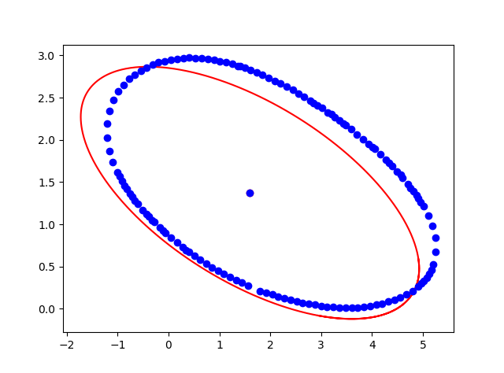
The fit was not good, so I neglected the exp. central value, and fit for 68% contour only. The validation plot for 95% (also compared with the plot from Lilith’s data in green line):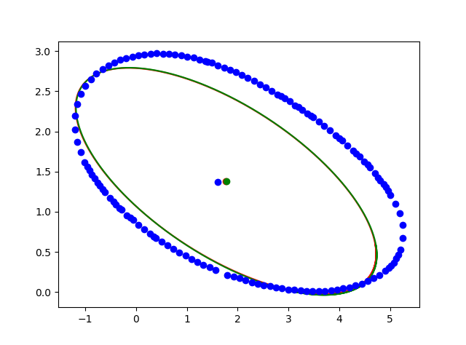
About the fit (for checking):
- Basically, we don’t fit directly for A, B, C, but the vector ‘a’ as mentioned in:
http://nicky.vanforeest.com/misc/fitEllipse/fitEllipse.html
Notes that, from these fitted 6 components, we derive theoretically the central (x0,y0) the parameters A, B, C, and the scale factor k, which follow the relations:
(A, B, C) = k*(a_xx, a_xy/2, a_yy)
k = -2 log likelihood/(a_mod - a_1), = 2.30/(a_mod - a_1) (at 68%), = 5.99/(a_mod - a_1) (at 95%)
with the modified coefficient (a_mod) defined as:
a_mod := (- a_yy * a_x^2 + a_xy * a_x * a_y - a_xx * a_y^2)/(a_xy^2 - 4 a_xx a_yy)
Central value is also given in that links (I have cross checked and agreed with them)
Issues:
1/ Every 2D plot for “update-notes-atlas.txt” fitted well, apart from the Fig. 9 of ATLAS-CONF-2018-021. I think the contour doesn’t seem to be symmetric, we should take only either upper or lower half of the contour.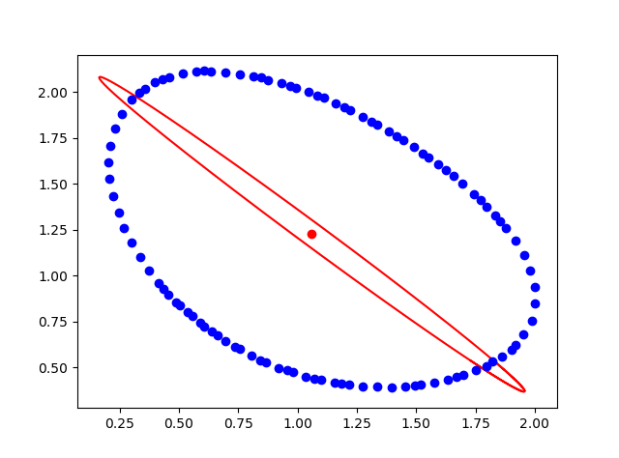
2/ (Just for cross checking) For data like Figure 8-c: CMS-HIG-16-041, which has refitted best-fit point at exactly 0.00. This additional condition makes the fit much more complex (as we have an additional parameter for the Lagrange multiplier, and have to make prediction for its range), I still working on it.

3. CMS data:
_ Collected some data, I have noted in the CMS file. Please have a check if I do it correctly, and which kind of data shall we use.
Issue:
Questions in CMS file.

