# Chapter 2

# Introduction

Analysis is the process of gathering requirement for a software. This process also defines collecting and understanding details, finding the problem and decomposition of a system into its workings. Analysis is conducted for the purpose if studying a system or its parts in order to identify its objectives. This process also helped to solve the problem occurred in the system and again help the system to works efficiently. Analysis clarify what the system should do.

Analysis is also known as requirement gathering process which means it will communicate with user so that user can get the system what they want. By communicating frequently with user, it will be easily for developer to determine the specific feature that user want and resolve of conflict in the requirement as demanded by the user and documentation of all features of the project development process from start to end. Also by performing this process, software can be testable easily.

We need to perform analysis due to following reasons.

* To gather all requirement for the software development.
* By performing brainstorming and walkthrough to understand the requirement.
* To know that, it will suitable for feasibility test to ensure that requirement is testable or not.

To complete this project I have used CATWOE Analysis. This analysis is one of many techniques that analyst uses to find what is the goal of their application and that goal was achieve or not and to find out problem area in that application.

CATWOE Stands for

* **Customer:** the receiver of the production from the system
* **Actor:** user who perform the role of system processing.
* **Transformation:** the main development that provide the outputs to the user.
* **World-Wide View:** the basic world-view for the change.
* **Owner:** the stakeholder with the complete power for the system.
* **Environment:** the rules and controls nearby the system.

Due to this reasons I have chosen CATWOE analysis for my system.

# 2.2 Feasibility Study

A feasibility study is an analysis used in measuring the ability and likelihood to complete a project successfully including all relevant factors. Feasibility study helps to take decision to cancel the project or postponed project or to take to further process. To determine the goal of the software developer use feasibility study so that developer can achieve their goal. There are different types of feasibility study which are explained below:

* **Economic feasibility**

This feasibility study will helps to find out the cost and all the benefits of the purposed software.

This study will include following reasons:

* + - * Hardware cost.
      * Application’s software costs.
      * Documentation preparation cost.

Due this reasons my project is economically feasible

* **Technical feasibility**

This process will analysis the skill and capabilities of the team member while developing the software. Also it will determine the appropriate technology will be stable or not. Ascertains that the technology chosen for software development has a large number of users so that they can be consulted when problems arise or improvements are required.

Also this project maintain all the above technical feasibility so my project is technically feasible.

* **Schedule feasibility**

In this study all time and date will be calculated to until the project complete. In the feasibility study not only requirement and cost will be gather but also time will calculate so that project can go through times and completed at given time. Sometimes client will provide deadline to complete project, that we have to set all the development according to timeline and this will help schedule feasibility study. In this analysis we calculate all time required to complete this whole project. That’s why my project is schedule feasible.

* **Operational feasibility**

This study will helps to determine that new software can adapt by the user. This study also accept the solution suggest by the developer team. Determine whether the organization is satisfied by the alternative solutions proposed by the software development team. I have provides user manual system so that user feel comfortable to use this system which means my system is operationally feasible.

* **Legal feasibility**

The process of studying to know that project conform the legal and ethical requirement is known as legal feasibility. This study helps to know that legal doable. It is important that the project or business is following the requirements needed to start a business or a project including business licenses, certificates, copyrights, business insurance, tax number, health and safety measures and many mores. This things needed to consider while performing legal feasibility study. To complete this project I have manage all the things as mentioned so that my project is legally feasible.

# 2.3 Requirement Analysis

## 2.3.1 Functional Analysis

This process will identify the function or behavior of the software. Also this process specify what system will do.

**Function for User (Front end):**

* Responsive Template, Mobile Friendly
* Registration System for blood Donor
* search engine for blood group and location
* Donor Details Information
* Inquiry form

**Function for Administration (Admin Section):**

* Manage Blood Group(add, delete)
* Add and Delete Donor Information
* Enable and Disable Donors
* Manage to Contact us Queries
* Update the contact us Info
* Admin Dashboard

|  |  |  |  |  |
| --- | --- | --- | --- | --- |
| **ID** | **Title** | **Description** | **Rational** | **Dependency** |
| FR01 | Responsive Template, Mobile Friendly | To make application attractive and to make supportive on mobile version | To make attractive interface | N/A |
| FR02 | Registration System | This will record donor detail on the system. | To know the detail of donor | N/A |
| FR03 | search engine | This will helps user to search blood donor through blood group and location | Donor information can find easily | FR02 |
| FR04 | Donor Details Information | Donor record can be found easily and can be contact through information | User can donor information | FR02 |
| FR05 | Inquiry form | User can contact us through inquiry form and can give feedback to our system | This maintain relation between user and developer | N/A |
| FR06 | Manage Blood Group(add, delete) | Admin can remove those blood group which are not required or already donated and can be added blood group which are new to the system | Blood group can be add and delete by admin | FR02 |
| FR07 | Add and Delete Donor Information | Those detail which are not necessary for the system can be removed by the admin and admin can add new donor info in the system | Admin can have authority to manage the donor detail. | FR04 |
| FR08 | Manage to Contact us Queries | Those who have bad comment can be remove by the admin. | Admin have right to manage all the inquiries form. | N/A |
| FR09 | Update the contact us Info | Those provide info in the contact us section cab be manages by admin | Contact regularly updated by admin | FR08 |
| FR10 | Admin Dashboard | Admin can watch all list detail of donor, list of inquiry forma and register user from this function. | Total number of detail of all information can be look this function. | FR02,FR05 |

## 2.3.2 Non Functional Analysis

The process specifying how the system will performed is known as non-functional analysis. This analysis will include all activities which is not performed by functional analysis. This process will specify the operational of the system, rather than behavior. Example of this analysis is modifying data in database should updated so that user can access it within 2 second. The non-functional analysis are mentioned below:

* **Performance**

In this process the speed of the software will be measure so that it can measure how much software is efficient in given task. This can be measure by the MIPS (millions of instruction per second).

* **Supportability**

This is the process of install, configure and monitor the software in the system. This process also used to find the error and debug in the software. This helps to find solution in particular problem and restore it. This process is also done within the maintainability cost.

* **Security**

This is the most important part of the analysis in where developer must see the security by seeing which framework we used. In this process also we have to see that network is secured we were using from the firewall. Also we have to application infrastructure security so that no one can hack our software. In my system I have strong security feature which avoid all above mentioned problem.

* **Maintainability**

It’s about code quality how easy for someone else to read the code and maintain application by someone else and the code quality is not good it cannot maintain by someone other so during the process must keep in mind the application must be read or maintained by someone else instead of application maker.

* **Usability**

In this function, the frequently used function should be tested for usability. Give the more prioritizes to most important function in the system so that can tested to maintain system easily.

## 2.3.3 Moscow Prioritization

MoSCoW is a prioritization technique for helping to understand and manage priorities. The letters stand for:

* **M**ust Have

In this priority software will be unsafe without it. Also without this function software cannot provide solution.

* **S**hould Have

In this priority solution will not be much important but it can play vital role in this software.

* **C**ould Have

In this priority solution will be less impact if that function is left. This might wanted or desired but less important as compared to should have

* **W**on’t Have this time

This also helps to manage expectations that some requirements will simply not make it

Into the Deployed Solution, at least not this time around.

Below mentioned table Moscow Prioritization which give priority in my functional and non-functional requirement analysis.

|  |  |  |
| --- | --- | --- |
| **ID** | **Title** | **Priority** |
| **Functional Requirement** | | |
| FR01 | Responsive Template, Mobile Friendly | Should have |
| FR02 | Registration System | Must Have |
| FR03 | search engine | Must Have |
| FR04 | Donor Details Information | Should Have |
| FR05 | Inquiry form | Could have |
| FR06 | Manage Blood Group(add, delete) | Must Have |
| FR07 | Add and Delete Donor Information | Must Have |
| FR08 | Manage to Contact us Queries | Won’t Have |
| FR09 | Update the contact us Info | Won’t Have |
| FR10 | Admin Dashboard | Should Have |
| **Non Functional requirement** | | |
| FR11 | Performance | Should Have |
| FR12 | Supportability | Could Have |
| FR13 | Security | Must Have |
| FR14 | Maintainability | Should have |
| FR15 | Usability | Could Have |

# 2.3.4 SRS

SRS is a software requirement specification of the software system to be developed with its function and non-function requirement. This is done between client and developer to make agreement on the requirement provided by the client. It will helps to provide all the required document necessary to develop a project.

**Software Requirement**

**Programming Language:** PHP version 5.6

**Database:** My SQL 2014

**UI Design:** HTML 5, AJAX, JQUERY, JAVASCRIPT

**Web Browser:** Mozilla, Google Chrome, Opera and other browser

**Software Used:** Apache Server

**Hardware Requirement**

**Memory:** 4GB RAM

**OS:** Windows 10 64 bits

# 2.4 Use Case

The process analysis system requirement to develop a project is Use Case. It is also the process of interaction between user and system in a particular environment. The characteristics of use case are:

* Manage functional requirement.
* Record the interaction between system and user.
* Record developments from initiate result to objective.
* Explain the flow of the system through diagram.

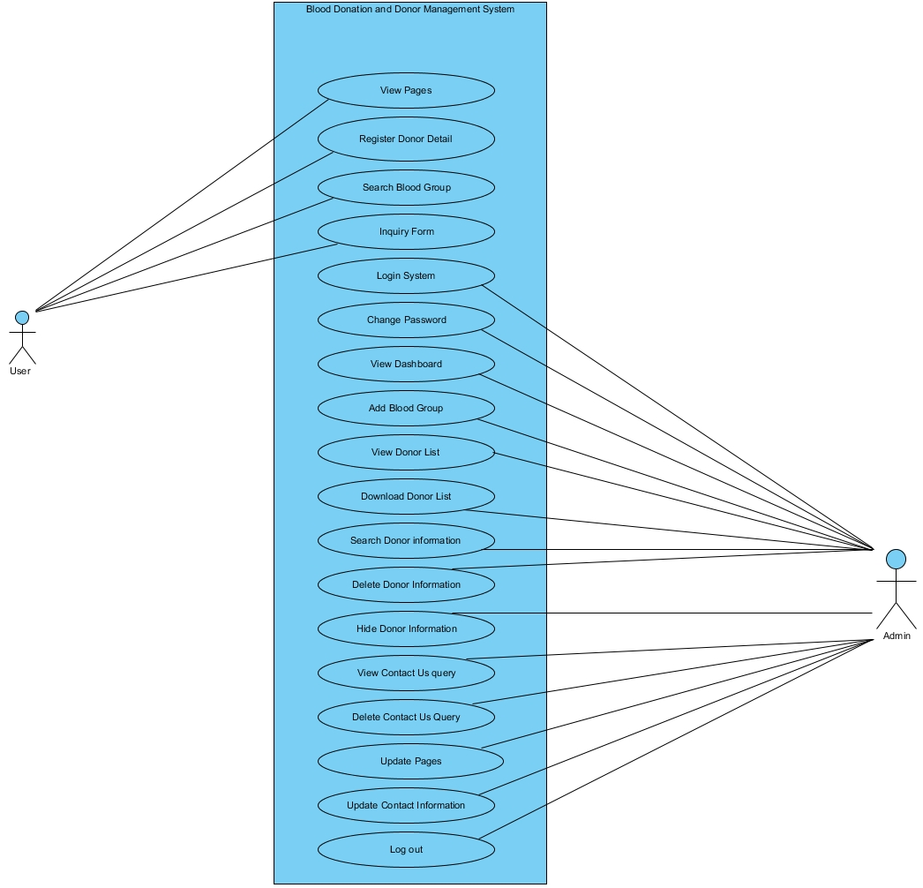

Figure 1: Use Case

|  |  |  |
| --- | --- | --- |
| **Id** | **Title** | **Description** |
| 1 | View page | User can view the pages directly without any login to the system. |
| 2 | Register Donor Detail | Donor have to register their detail to the system so that donor can identified |
| 3 | Search blood group | User who needed blood can search through the blood group and location |
| 4 | Inquiry form | User can inquiry about the required blood in emergency |
| 5 | Login system | This system is valid for only admin |
| 6 | Change password | This right is given only to the admin. |
| 7 | View dashboard | Admin can look all information through dashboard |
| 8 | Add blood group | Admin have to add blood group into system so that user can find blood group. |
| 9 | View donor list | Admin can view the donor list through admin section. |
| 10 | Download donor list | Admin have authority to download the list of donor. |
| 11 | Search donor information | There is a search engine for admin to search the donor information |
| 12 | Delete donor information | Admin can delete the donor information if they already given blood. |
| 13 | Hide donor information | Admin hide the detail of the donor from the system. |
| 14 | View contact us query | Admin can view contact us query and manage it |
| 15 | Delete contact us query | Admin can the contact us query that provide by the user. |
| 16 | Update contact information | Admin can update the information provided in the contact us form |
| 17 | Log out | Finally admin have to logout from the system so that other user cannot use admin section. |

## 2.5 Class Diagram

**Scenario**

Blood donation and donor management is software which provide a reliable platform for a user to connect local donor so that user can get any blood group from different location. This software provide detail of donor at user interface so that user may get information about blood in the interface. Also this application provide communication process to communicate with donor direct or can contact to blood bank. This application also provide search engine to search required blood group. In case of emergency user can contact to admin so that blood can be available at the time.

In this application there are function to register the donor information through form and this information can be manage by admin. And their information can be visible in the application interface so that other user can contact to them for blood. In the registration system user need to register their detail through online and they have to provide location and contact information so that our searching system used their information which are store in the system so that user can search required blood through blood group and location. This will helps a user to find the required blood group in case of emergency.

The Final NLA of this scenarios to make class diagram is mentioned below:

|  |  |  |
| --- | --- | --- |
| **Noun(Class)** | **Verb(Operation)** | **Adjectives(Attributes)** |
| Blood, User, System, Blood Bank, admin, location | Provide, connect, search, register, manage, store | Reliable, platform, communication, function, online, emergency |

From this NLA I have created from class diagram:

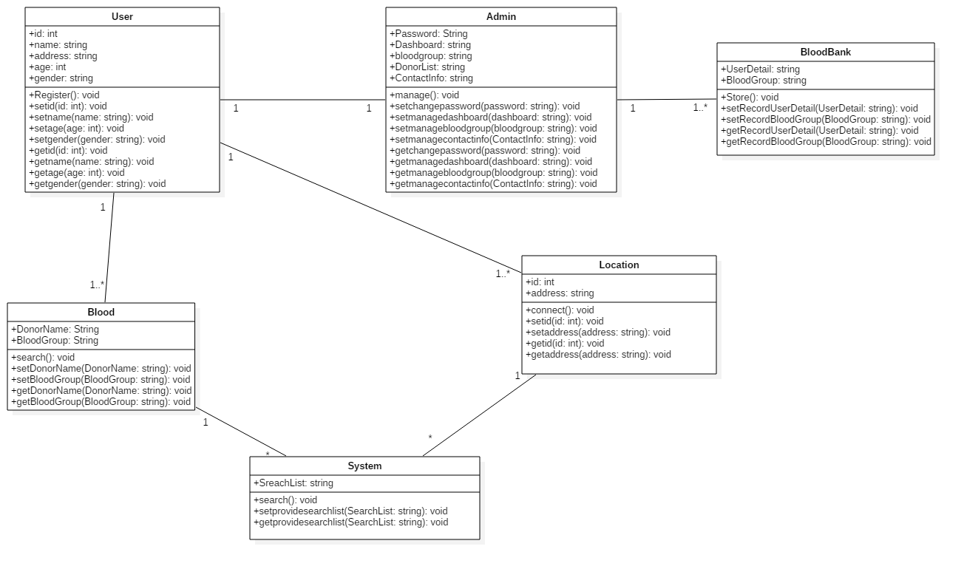

Figure 2: class diagram

# Conclusion

Finally, the analysis of blood donor and donation management system is completed. Also to analysis the system CATWOE analysis is used. In this analysis, functional and non-functional requirement for system is list out. And the listed requirement are prioritize through MoSCoW prioritization. With the help of requirement use case diagram also created and from this diagram the flow of the system is find out. In this use case the actor, system and use case are define through the different role found in the system. Also from the help of scenarios the class diagram created so that the function of the system is known.