Specification of my computer:

* The brand of CPU (Intel or AMD) Intel
* The model of CPU (e.g. Intel i7-9700K Coffee Lake) IntelCore I5
* The number of cores on CPU Two
* The clock rate of CPU in GHz 1.4GHz
* The amount of memory in GB 8GB
* The speed of memory (for example: DDR4 3200) DDR3 2133
* The capacity of hard drive
* The type of hard drive: magnetic or SSD
  + For magnetic hard drive, provide
* The RPM number
* Cache size
* Average latency
  + For SSD, provide
    - Max sequential read speed
* Max sequential write speed
* Max random read speed
* Max random write speed

Integer Operation BenchMark:



Floating Operation Benchmark:

Memory Benchmark



Harddrive benchmark

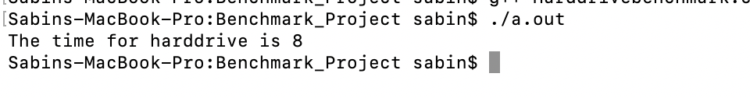

|  |  |  |  |
| --- | --- | --- | --- |
| **Description** | **Execution time(In seconds)** | **Reference Time**  **(In Seconds)** | **SPECratio** |
| Integer Operation Benchmark | 528 | 100 | 0.19 |
| Float Operation Benchmark | 553 | 500 | 0.90 |
| Memory Benchmark | 23 | 100 | 4.35 |
| Harddrive BenchMark | 8 | 1000 | 125 |
| Geometric Mean |  |  | 3.10 |

I used the formula below to calculate the Geometric mean

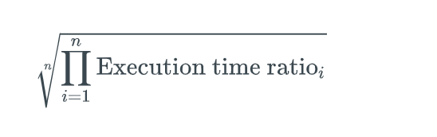

The calculation of a single number is 3.10