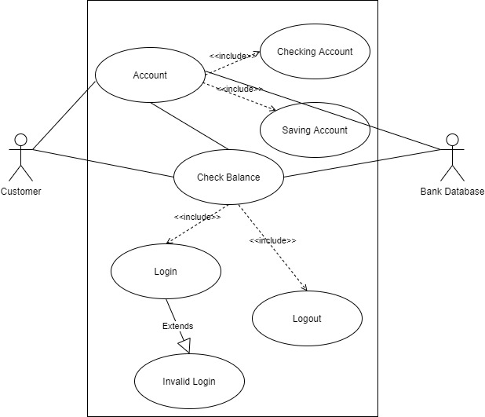

This use case will implement a check balance action of either the checking account or the saving account. The customer will choose the account of their preference to check their balance. It will include the login functionality to authenticate the user. In the case of wrong credentials, the invalid login message will appear. Once the user views the balance, they will be able to logout of their account. All the functionality interact with the bank database to obtain the necessary information.