**Omdena's Capacity Building Program with NIC Nepal**

**Assignment 1**

**Configuration – Python, Anaconda, VS Code, Git / Github**

**Sabin Bajracharya**

**Python Installation Verify**

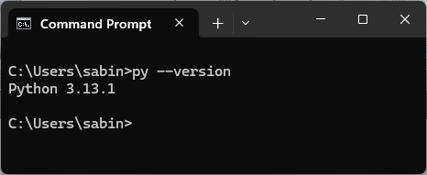

**Anaconda Installation Verify**

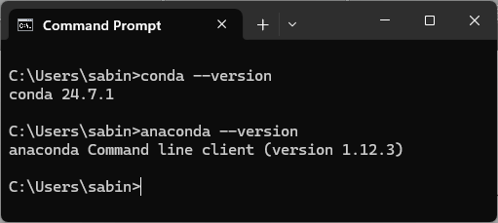

**VS Code Installation Verify**

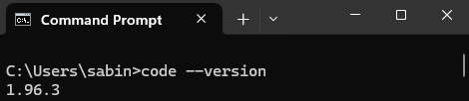

**Git Installation Verify**

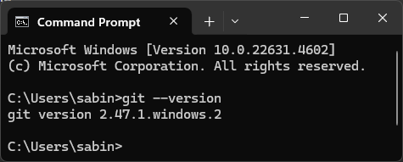

**Git username and email configured (Configure your identity)**

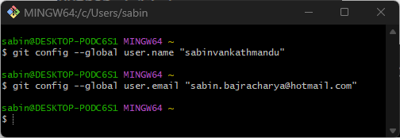

**Verify Configurations**

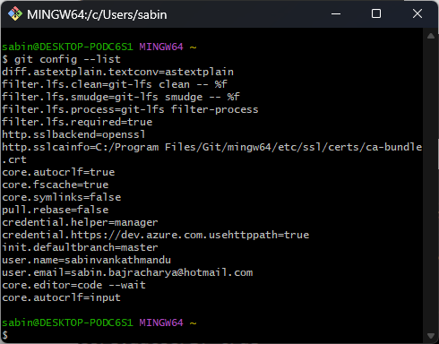

**Generate an SSH Key**



**Add SSH Key to Github**

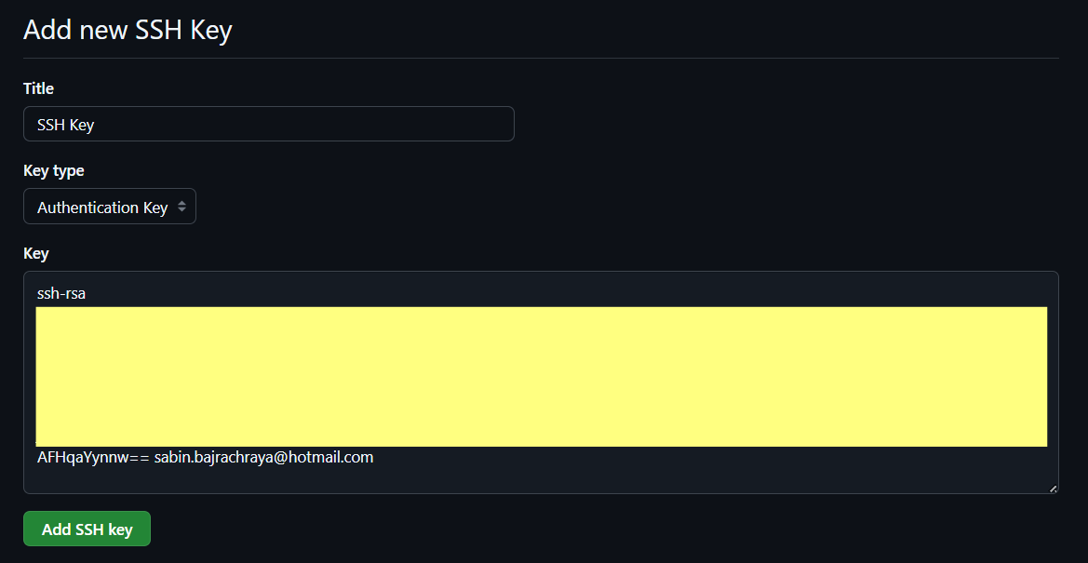

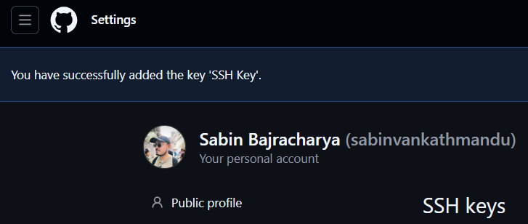

**Github Profile**

Link: <https://github.com/sabinvankathmandu>

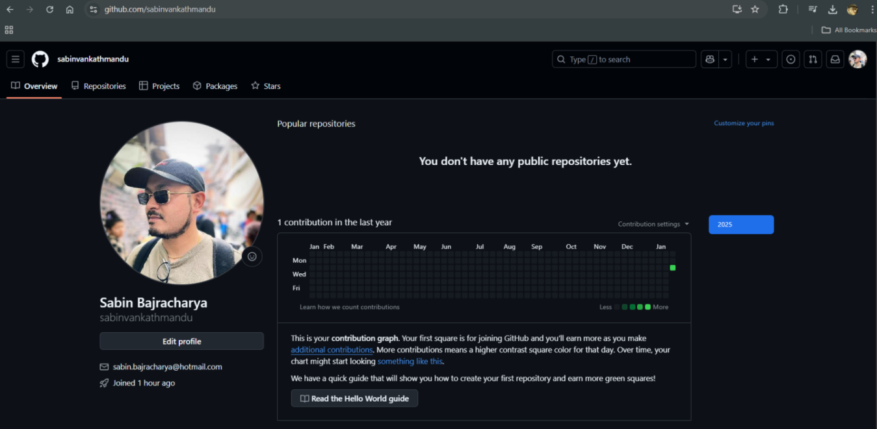

**Github Repository link**

Link: <https://github.com/sabinvankathmandu/OmdenaAI1>

**Clone the repository to local machine**

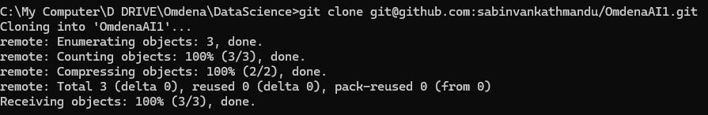

**Git add, commit and push**

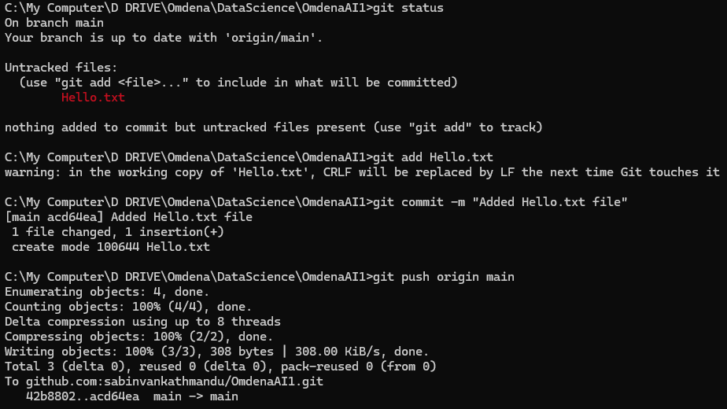

**Collaborate with others (Creating a New - Branch)**



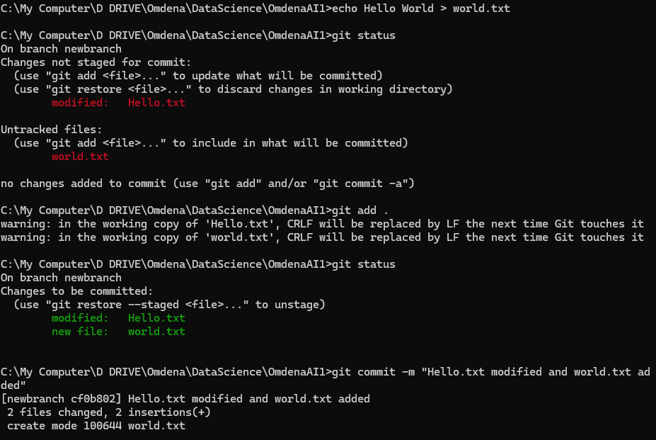

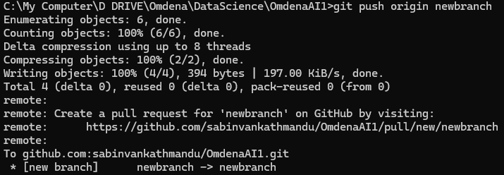

**Create a pull request**

