**Evaluation Only. Created with Aspose.Words. Copyright 2003-2023 Aspose Pty Ltd.**

**PAS-X MES**



**System Requirements**

**System manual**

**PAS-X MES System manual**

Körber Pharma Software

PAS-X MES Standard

Valid as of software version V3.3.2/00 Document version 1.3

Modification date: 25 May 2023

Company,productandservicenamesmaybetrademarksorservicemarksoftheirrespectiveowners.

**Körber Pharma Software GmbH**

Wulf-Werum-Str. 3 · 21337 Lüneburg · Germany T+49413189000·[info.pasx@koerber.com ·](mailto:info.pasx@koerber.com) [koerber-pharma.com](https://koerber-pharma.com)

**Table of contents**

1. General....................................................................................................................................................7
2. Purpose.................................................................................................................................................7
3. Target audience.....................................................................................................................................7
4. Symbols and typographical conventions...............................................................................................7
5. Miscellaneous........................................................................................................................................9
6. Abbreviations / Definition of Terms........................................................................................................10
7. Introduction to the MES Infrastructure...................................................................................................14
8. Typical PAS-X MES Infrastructure.......................................................................................................14
9. DMZ 3/4 (Interfacing Zone)...............................................................................................................14
10. Level 3 (Manufacturing Operations Management)............................................................................15
11. DMZ 2/3 (Interfacing Zone)...............................................................................................................16
12. Corporate Level.................................................................................................................................16
13. PAS-X Client Options........................................................................................................................17
14. PAS-X Optional Components..............................................................................................................17
15. PDF/A conversion..............................................................................................................................17
16. PAS-X Monitoring Service.................................................................................................................17
17. PAS-X Authentication Adapter...........................................................................................................18
18. Deployment registry ..........................................................................................................................18
19. Requirements........................................................................................................................................19
20. Container Orchestration Platform........................................................................................................19
21. Docker Swarm...................................................................................................................................19
22. Kubernetes........................................................................................................................................31
23. PAS-X System Services....................................................................................................................39
24. Client Peripherals................................................................................................................................49
25. Client Screen Size.............................................................................................................................49
26. Barcode Scanners.............................................................................................................................49
    1. Common Unix Printing System (CUPS)..............................................................................................49
27. Supported printers.............................................................................................................................49
28. Adding Printers to CUPS...................................................................................................................50
29. Configure PAS-X Printing Service to use CUPS...............................................................................51
30. Configure PAS-X Printing Service.....................................................................................................51
31. CUPS Security ..................................................................................................................................51
32. Database.............................................................................................................................................51
33. Oracle software requirements...........................................................................................................52
34. Oracle database requirements..........................................................................................................52
35. Oracle user requirements..................................................................................................................55
36. PostgreSQL software requirements..................................................................................................56
37. PostgreSQL database requirements.................................................................................................56
38. PostgreSQL database prerequisites .................................................................................................59
39. ERP Integration...................................................................................................................................61
40. XML IDoc...........................................................................................................................................61
41. SAP RFC...........................................................................................................................................61
42. Fonts ...................................................................................................................................................61
43. Operating System................................................................................................................................61
44. Password Encryption...........................................................................................................................62

4.8.1 Restricted characters for configuration property values....................................................................62

1. PAS-X Client........................................................................................................................................62
2. Java Runtime Environment (JRE).....................................................................................................63
3. Web Start (IcedTea-Web)..................................................................................................................63
4. Web Browser.....................................................................................................................................67
5. Citrix Terminal....................................................................................................................................72
6. Encrypted Client Communication......................................................................................................72
7. PDF/A conversion / Ghostscript ..........................................................................................................72
8. Time Zone ...........................................................................................................................................72
9. Appendix ...............................................................................................................................................74
10. Supporting Infrastructure Components...............................................................................................74
11. Systems Sizing Introduction................................................................................................................74
12. Availability Options..............................................................................................................................74
13. Production Network.............................................................................................................................74
14. Virtualization Statement ......................................................................................................................75
15. Recommended Monitoring Spots for PAS-X Systems........................................................................75
16. Network Communication.....................................................................................................................76
17. Network Ports for Docker Swarm......................................................................................................76
18. Network Ports for Kubernetes...........................................................................................................82
19. Citrix Ports.........................................................................................................................................84
20. PAS-X runtime configuration...............................................................................................................86
21. Client.................................................................................................................................................86
22. Server................................................................................................................................................86
23. Platform Releases.............................................................................................................................87

**Document history**

**Version Date Name Change**



1.0 19 Aug 2022 C. Dröscher Initial document for software version PAS-X MES V3.3.2/00.

1.0 19 Aug 2022 A. Kröger Updated sections "PAS-X runtime configuration / Server" and "PDF/A conversion / Ghostscript" regarding Ghostscript version.

1.0 07 Oct 2022 K. Hinz Updated section "Service users" regarding usage of ssh socket connection for traefik.

1.0 07 Oct 2022 K. Hinz Updated section 'Docker Remote API Access' regarding a secure API access over ssh.

1.0 02 Nov 2022 G. Kirck Updated section "Password encryption", refer to "System Manager" system manual.

1.0 21 Dec 2022 G. Kirck Added section "RabbitMQ node labels" and updated section "Host bound PAS-X Services" regarding RabbitMQ deployment and requirements in the Swarm configuration.

1.0 23 Jan 2023 N. Haffke Editorial changes.

1.0 09 Feb 2023 C. Friedrich Updated section "PAS-X runtime configuration": Corrected browser & XenApp version for client runtime and Helm & kubectl version for server runtime.

1.0 23 Feb 2023 T. Burlatis Updated section "PAS-X runtime configuration": Corrected browser version. Corrected PostgreSQL requirements.

1. 24 Feb 2023 B. Tiernan Editorial changes.
2. 27 Feb 2023 T. Burlatis Corrected Kubectl version.
3. 11 Apr 2023 T. Burlatis Updated section "PAS-X runtime configuration": allow applying Citrix CU packages.
4. 25 May 2023 T. Burlatis Updated section "PAS-X runtime configuration": added Bash V5 as requirement for deployment host.

**Document Creation and Review**

Creation and review of this document is typically a joint activity performed by several project team members. Thesignatureconfirmingcreationandreviewofthisdocumentindicatesthatithasbeencreatedand reviewed by the person signing.

It is confirmed that the content of this document fits the purpose described in the respective "Purpose" section in the document.

It is also confirmed that this document is created in a manner that an administrator is able to understand it.

Created and reviewed by

**_____________________________________________** Name / date / signature

**Document Review and Approval**

Reviewandapprovalsignaturesforthisdocumentactasconfirmationbythepersonsigningthatthis document has been created in the way indicated above.

Reviewed and approved by

**_____________________________________________** Name / date / signature

**1 General**

1. **Purpose**

This section describes the requirements for systems utilizing PAS-X.

The hardware structure of PAS-X systems varies:

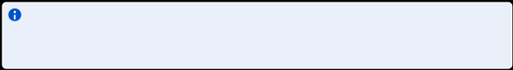

* from complete systems on a single computer, e.g. for demo systems
* to distributed system components on several computers (productive systems).

The mentioned system requirements do NOT include requirements for redundant hardware; this means that **requirements for systems employing redundancy concepts are not considered in this document**.

It is assumed that ONLY the PAS-X **productive** system runs on the hardware. **Additional loads caused by other systems**, such as testing and/or training systems running on the same hardware **are not considered** **in this document**. It is common to have the following systems installed at the customer:

* Development or sandbox system to e.g. perform testing of a prototype
* Training system to train end users, e.g. operators or supervisors
* Qualification system used for validation
* Productive system

1. **Target** **audience**

This document is aimed for administrators. Prerequisites:

* Technical knowledge relating to the system infrastructure.
* Good command of the functions of the PAS-X user interface.

1. **Symbols** **and typographical conventions**

**Symbol Description / Example**

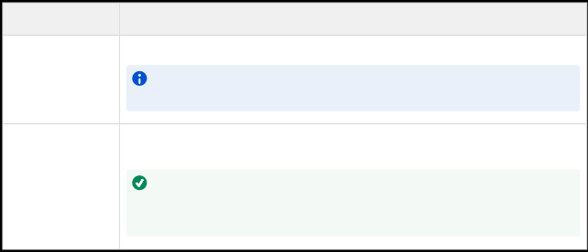

Indicates important information for the proper use of the software. Example:



All functions are protected by user rights. If you do not have the respective right, the appropriate button is disabled.

Indicates useful information designed to make working with the software easier. Example:



To display the navigator permanently, in the upper right corner of the navigator, click:



General

**Symbol Description / Example**



Indicates notes that, if not observed, can lead to a loss of data or put the software's support of the process at risk. Example:



Deleting ERP locations can cause inconsistencies in the WMS data. Hence, only administrators can delete ERP locations. Before you delete an ERP location, make sure that it is not assigned to WMS locations.

Indicates information quoted from an external source, e.g. from a website.



✓ Indicates a requirement that must be met before you can complete the corresponding tasks.

1. Indicates tasks you have to complete. The tasks must be completed in the specified
2. order. Example:
3. 1. Open the desired dialog.
4. In the menu bar, click: **File > New**.
5. In the detail view: Enter the required data.

This excludes tasks that depend on a condition. If the condition is not met, skip this task and continue with the next one. Example:

1. If the MBR is not in edit mode, in the icon bar, click: **Edit**.
2. Select the basic operation in which you want to edit a material.

–or– Indicates alternative tasks you can complete. Example:

1. Click **Ok**.

–or–

On the keyboard, press [Enter].

► Indicates the result of a task or a series of tasks. Example: ►Thefilterisdeactivated.Allentriesaredisplayed.

**Bold font** Indicates fixed terms and texts, e.g. buttons or fields in the application window.

Examples:

* Click: **Ok**.
* In the **Material no.** field: Select a value.

*Italic font* Indicates messages and information displayed in the application window or data to

be selected or entered by the user. Examples:

* The message *Failed to save your data* is displayed.
* Enter the value *HB125*.
* The equipment is set to status *Allocated*.

General

**Symbol Description / Example**

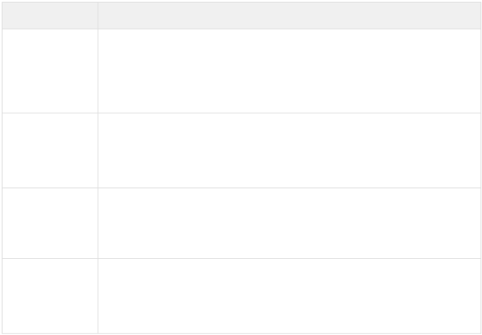

[Blue font](http://www.werum.com) Indicates cross-references which can be clicked for further information.

Example: See section: ["Dialog" title](https://www.koerber-pharma.com).

Also indicates cross-references to an external source of information, e.g. a specific web address.

Example: For further information see: [www.koerber-pharma.com](https://www.koerber-pharma.com).

**Menu >** Indicates a navigator or menu path via which you can open a dialog or execute a **Menu item > ...** function. Examples:

* In the navigator, select: **Master Data > Material Master Data > Material**.
* In the menu bar, click: **Help > About**.

"Quotation marks" Indicates emphasis, e.g. additional highlighting of terms in the application window or

specific terms used in this documentation. Example:

* This documentation uses the terms "application window", "work areas", and "dialog".

[Key] Indicates a key on the keyboard. Examples:

* On the keyboard, press [Enter].
* To open a pop-up dialog to display the shortcuts for keyboard operation, press [CTRL]+[ALT]+[L].

1. **Miscellaneous**

The dialogs and their content in your installation may differ slightly from the examples and screenshots in this document due to configuration and parameterization.

In addition, corporate design elements may look different in your application, e.g. company and product logos. Also dialog icons may look different, but are placed at the same position in the dialog.

To ensure readability, the use of gender-neutral phrasing may sometimes be omitted. However, the text is meant to always address all genders.

**2 Abbreviations / Definition of Terms**

**Abbreviation / Term Description**



**This document was truncated here because it was created in the Evaluation Mode.**