1-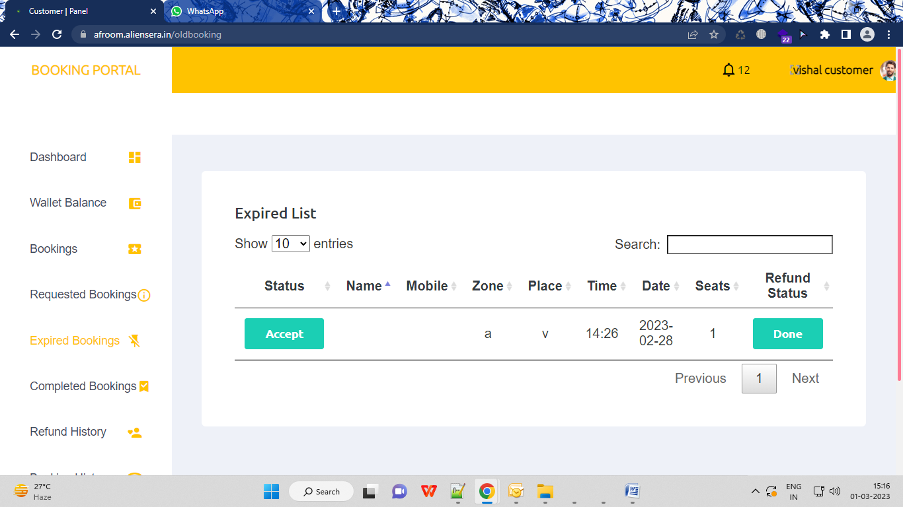

Expire booking me concept theek karo , for an example agar booking date 1 march 2023 3: 30 pm hay aur is date aur time k bad booking apne aap expire me chali jaegi aur refund b apne aap wapas chala jaega

**Note:** abhi refund ka concept galat chal rha hay bina expire hue booking pending hone ke bavjud refund ho jar ha hay wo b driver aur customer dono ko please fix it also expire booking me status , name and mobile ko hata do koi kaam nahi iska

2- Running Ride work nahi kar rahi hay today bookings kar ke apne ek banaaya hay but its not that listen carefully , suppose m doing a booking to wo customer ko uske running ride me dikhega jab tak koi driver use accept nahi kar leta aur agar accept karega toh ye running ride se pending ride me chali jaaegi

Aur agar koi accept nahi karta to ye expire me chali jaaegi

Running ride driver me nahi hogi

3- booking history me amount 0 aaa rahi hay ,and book status aur payment mode ulte ho gae hay

4- refund history not working

5- notification ekdam sahi se kaam nahi kar rahi hay agar jda problem ho rahi hay notification me to notification bar na dikha k eek popup dikha do har new notification pe aur ek ring wali bell laga do jab koi popup pe click kare to notification chali jae aur kuch nahi

6- session logout na ho ye ek bar dekh lena , aur jab guest login hoti hay to us mobile number se session login ho jaana chahie .

6 – document wala mujhe ek bar aur test karna hay