

Bursa Uludağ University
Faculty of Engineering
Computer Engineering Department

Software Testing and Automation

Performance Testing Automation Using Selenium WebDriver

Prepared by:
Sabir Süleymanlı
Student ID: 502531019

Instructor:
Prof. Dr. İbrahim Arpacı

Date: 10/03/2026

Sauce Demo Test Automation Report

Performance Comparison Using Selenium

1. Introduction
Software performance testing is an essential part of modern software development. It helps evaluate how efficiently an application responds to user interactions under different conditions. Automated testing tools such as Selenium WebDriver allow testers to simulate real user behavior and measure system performance.
In this project, an automated performance test was implemented on the demo e-commerce website SauceDemo. The goal of the test was to measure the response time of several user actions and compare the performance between two different user accounts.

2. Test Environment
The test automation environment was implemented using the following technologies:
- Programming Language: Python
- Test Automation Framework: Selenium WebDriver
- Browser: Google Chrome
- Visualization Library: Matplotlib
- Test Platform: SauceDemo
The tests were executed on a local machine using the Chrome browser and automated through Selenium scripts written in Python.

3. Test Scenario
The automated test simulates a typical user interaction with an e-commerce platform. The following steps were executed automatically by the Selenium script:
- User login
- Adding a product to the cart
- Navigating to the shopping cart
- Filling checkout information
- Completing the order
Two different user accounts provided by the platform were tested:
- standard_user
- performance_glitch_user
The second account is intentionally designed to simulate performance issues, allowing comparison between normal and degraded performance scenarios.

4. Performance Measurement
Execution time for each step was measured using Python’s time module. The time difference between the start and end of each step was recorded in seconds.
A performance rule was applied:
- If the step completes in less than 5 seconds → PASS
- If the step exceeds 5 seconds → FAIL
This threshold allows identification of performance bottlenecks during automated testing.

5. Results
The automated test execution produced the following performance results based on the defined 5-second threshold rule.
Test Step | Execution Time | Result
Login | 7.62 s | FAIL
Add to Cart | 1.09 s | PASS
Go to Cart | 2.13 s | PASS
Checkout | 4.68 s | PASS
Finish | 1.12 s | PASS
According to the test results, the login step exceeded the defined 5-second performance threshold, resulting in a FAIL status. The login operation took 7.62 seconds, which indicates a noticeable delay in system response for that step.
All other steps completed successfully within the acceptable performance limit. The Add to Cart, Go to Cart, Checkout, and Finish operations were executed in less than 5 seconds and therefore passed the performance criteria.
This result is expected because the performance_glitch_user account is intentionally designed to simulate slower system behavior in order to demonstrate performance testing scenarios.
The generated performance graph visually confirms these results, showing a clear spike in the login step compared to the other actions.
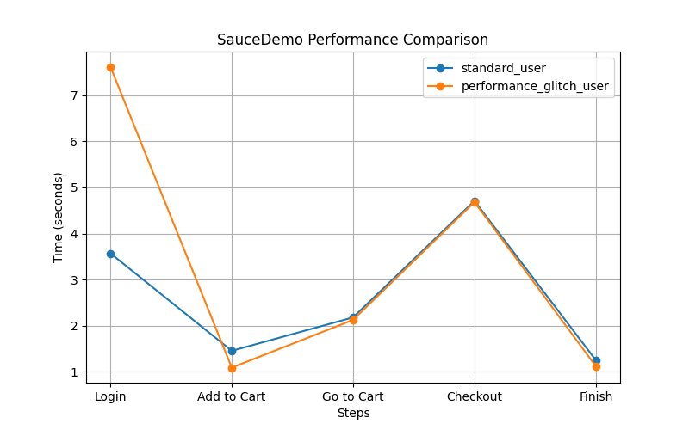
Figure 1. Performance comparison between standard_user and performance_glitch_user across different test steps on the SauceDemo platform.

6. Conclusion
This project demonstrated how automated testing tools can be used to evaluate application performance. By using Selenium WebDriver, it was possible to simulate real user actions and measure execution times across multiple steps of an e-commerce workflow.

