Eclipse RCP – Assignments

1. Create a view with table viewer as below to display the Person class having attributes name,age and Gender.

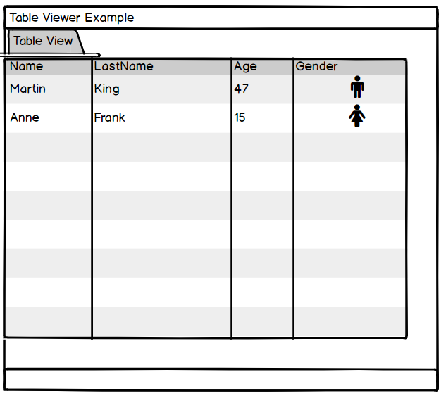

1. Create a TreeViewer as shown in the Mockup diagram. On Right click a Show Details pop up menu is shown and the details of the file is displayed appropriately

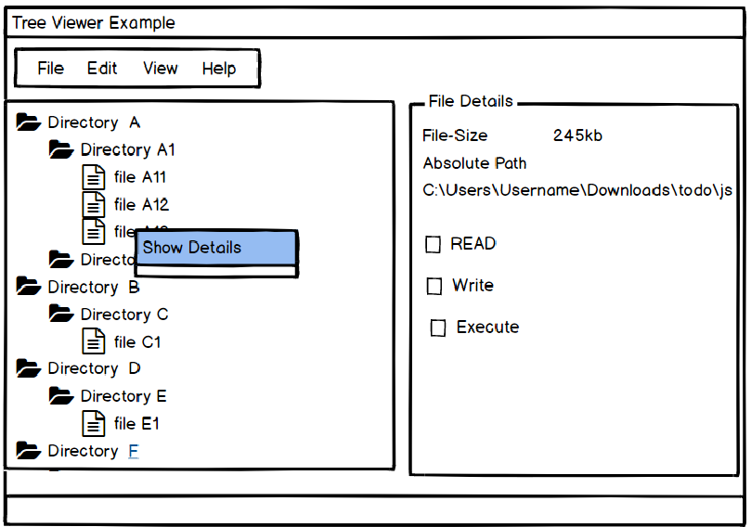

1. Create a Text Editor to detect a C Program .C file and highlight all the print and println statements in RED and the comments /\* \*/ in GREEN.
2. Update the composite view from com.sabir.training.rcp.swt.layouts.example as below.

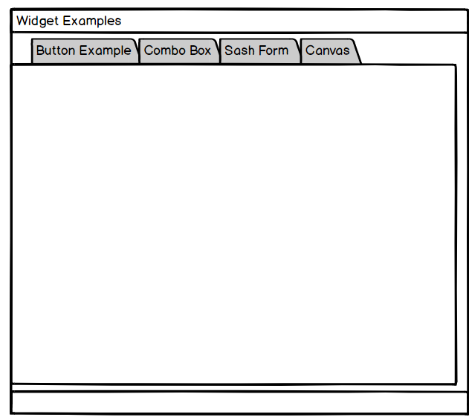

1. Create an installable feature with two plugins created from template plugins.

The feature should be updatable

1. Sample Menu Command
2. Sample View