<http://localhost:8080/createTestData>

🡪 this will calculate the reward points and create dataset information in H2 DB.

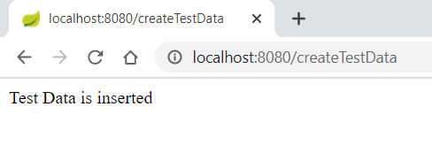

<http://localhost:8080/getRewards?name=customer1>

🡪 Get the customer total earning points and monthly wise total earning points

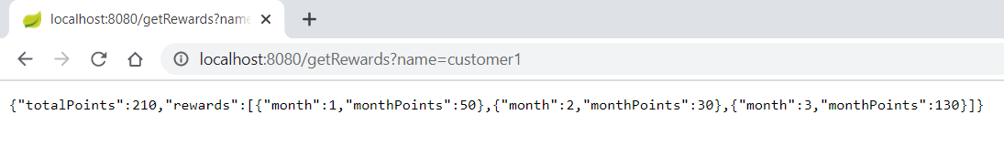

<http://localhost:8080/getRewards?name=customer2>

🡪 Get the customer total earning points and monthly wise total earning points

