A Cross-Layer Harris Hawk Optimized UAV–IRS Framework for Communication-Aware Federated Learning in 6G Vehicular Networks

1. Install Anaconda (only once)
- Go to: https://www.anaconda.com/products/distribution
- Download Anaconda for Windows (64-bit)
- Run the installer → keep clicking Next → Next → Install
- After installation, restart your system (recommended)

2. Open Spyder
- Press Windows key
- Type Anaconda Navigator
- Open it
- Find Spyder → click Launch

3. Install Required Packages
Before running your code, install dependencies.

👉 Open Anaconda Prompt
- Press Windows key
- Type: Anaconda Prompt
- Open it

👉 Run these commands one by one:
pip install numpy
pip install matplotlib
pip install torch
pip install torchvision
pip install scikit-learn
pip install pandas
Wait for each to finish before typing the next one.
For example:-
Open Anaconda Prompt and type a command
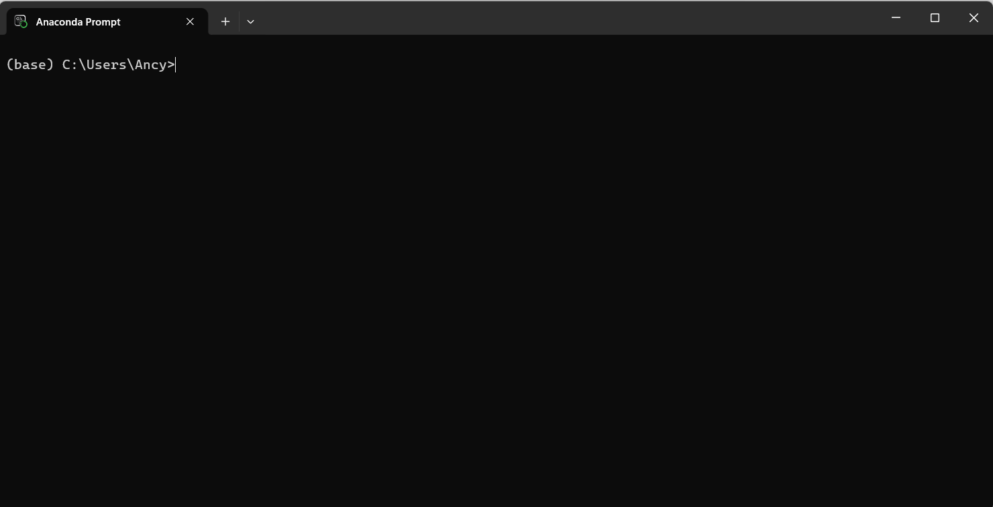
Click enter
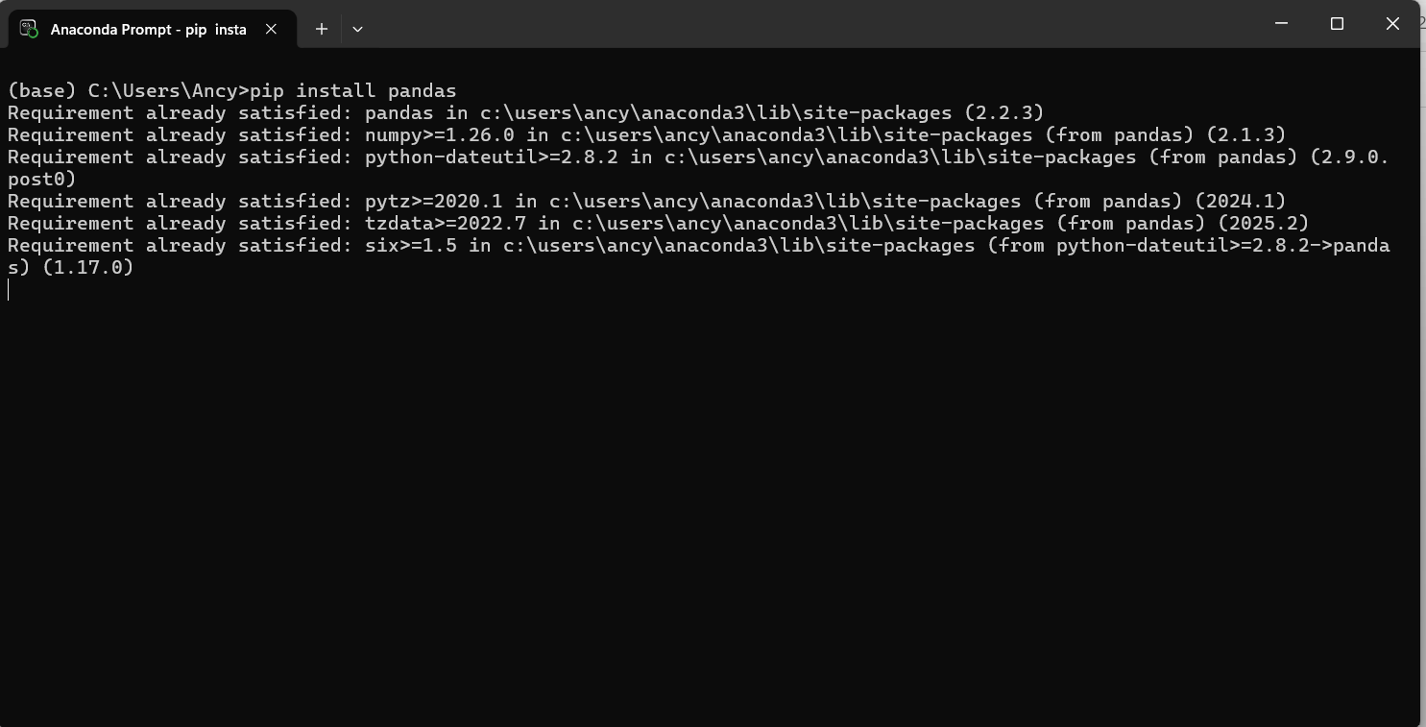

4. Extract Your Project Folder
- Right-click your .zip file
- Click Extract Here or Extract All
- Open the extracted folder
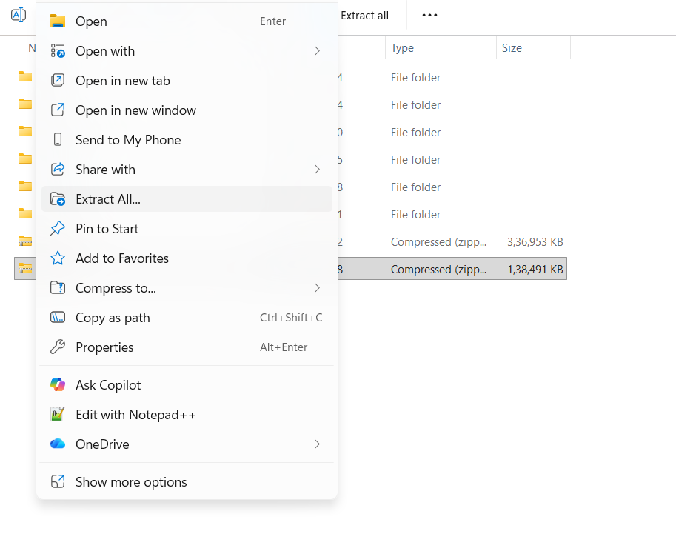
After extracting the zip file open Spyder application
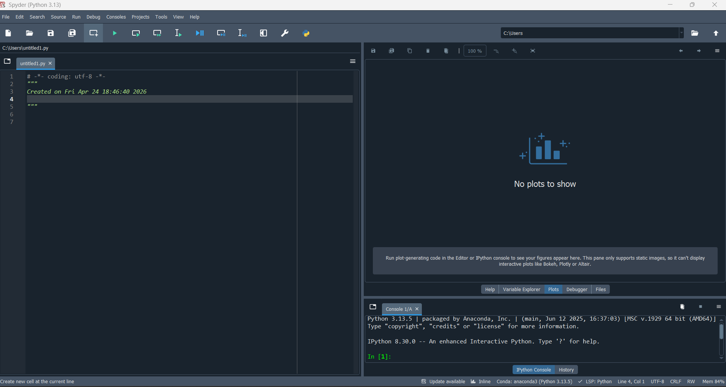

5. Open Your File in Spyder
In Spyder:
- Click File → Open
- Browse to your project folder
- Select:
run_simulation.py
- Click Open
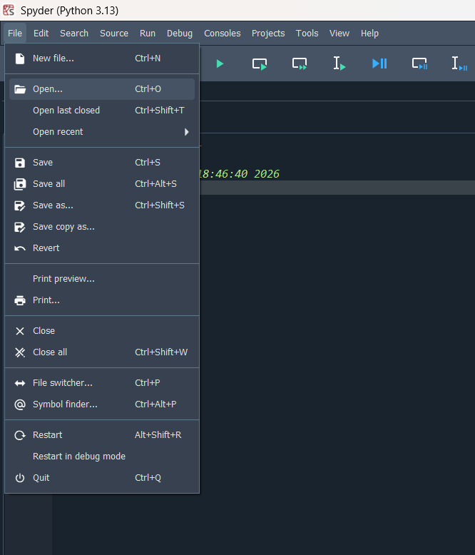
Browse and select the run_experiment.py file from the extracted folder and click Open
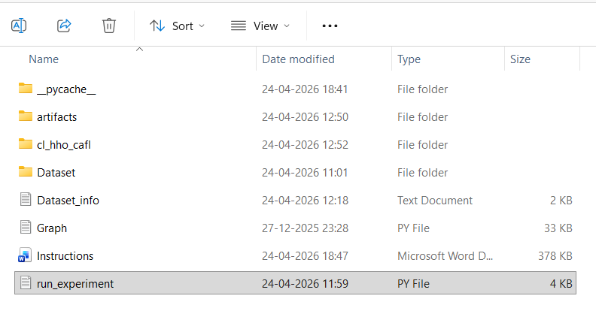
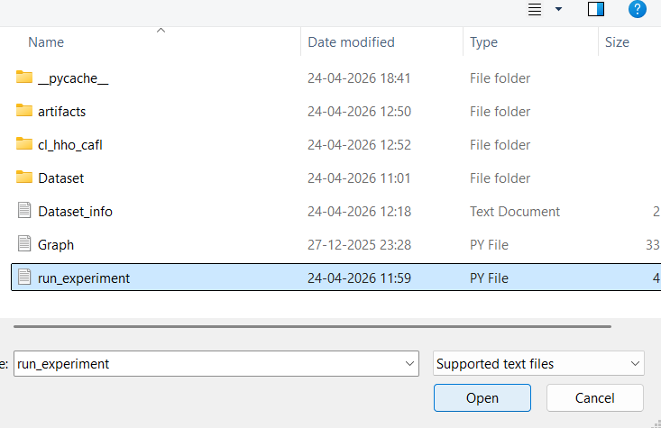
Now the run_experiment.py will be loaded like this
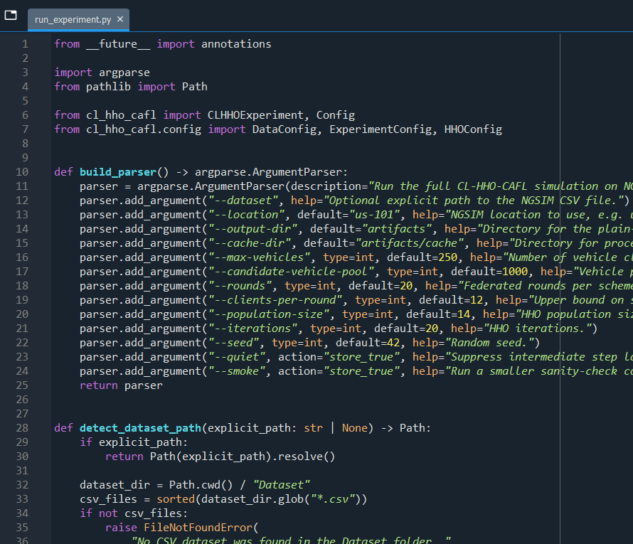

Run the Code ▶
Now simply:
- Press F5
OR
- Click Run → Run
- Or click this 

