数据集划分：取三类动作的第一阶段的trigger（11,21,31）作为start_index，向后取长度为4000（4s）的窗口

def prepare_dataset(filepaths):  
 all_segments = []  
 all_labels = []  
 triggers_list = [11, 21, 31]  
 labels = [0, 1, 2]  
  
 for filepath in filepaths:  
 data = load_data(filepath)  
 eeg_data = data['data'][:-1, :]  
 trigger_signals = data['data'][-1, :]  
 for triggers, label in zip(triggers_list, labels):  
 segments = extract_specific_segments(eeg_data, trigger_signals, triggers)  
 all_segments.append(segments)  
 all_labels.append(np.full(segments.shape[0], label))  
  
 return np.concatenate(all_segments), np.concatenate(all_labels)

def extract_specific_segments(eeg_data, trigger_signals, trigger):  
 segments = []  
 i = 0  
 while i < len(trigger_signals):  
 if trigger_signals[i] == trigger:  
 start_index = i  
 end_index = start_index + 4000  
 if end_index <= eeg_data.shape[1]: # 确保段落不会超出数据范围  
 segment = eeg_data[:, start_index:end_index]  
 segments.append(segment)  
 i += 1  
 return np.array(segments)

训练条件：官网下载训练和测试数据集，作上述处理后得到两个90*64*4000的数组

模型：DBNet，lr=0.0005（early_stop_lr=0.00001）epoch=100-300 batch_size=8

受试者：s2

实验结果：



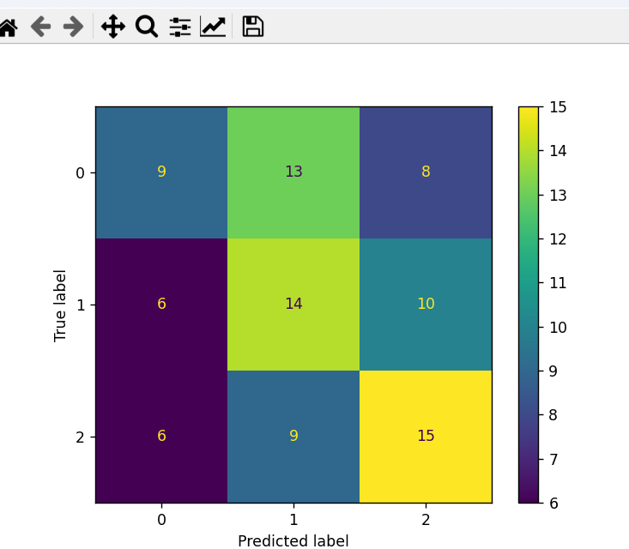

加上滤波：  
fs = 1000 / 2  
FLTNUM = scipysignal.firwin(1000 * 2 + 1, np.array([8, 30]) / fs, pass_zero='bandpass')

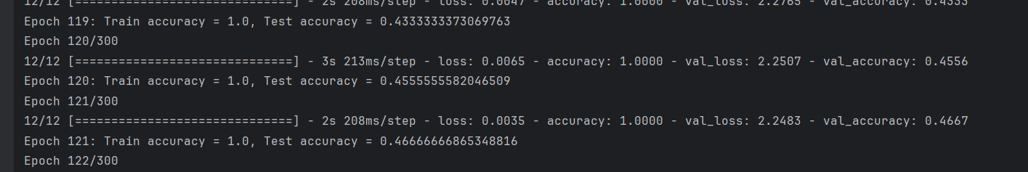

EEGNet：其他条件同上

model = EEGNet(nb_classes = 3, Chans = 64, Samples = 4000,  
 dropoutRate = 0.5, kernLength = 32, F1 = 8, D = 2, F2 = 16,  
 dropoutType = 'Dropout')

准确率最高52，平均45