**CSC 5750 – Principles of Web Technology**

**Homework 1 – Sable Morgan**

**25 points – Due January 26, 5pm**

**Late deadline is January 28, 11:59pm, but 20% off**

**a)** Save this document with your name and the homework number somewhere in the file name.

**b)** Type/paste your answers into the document.

**c)** Gather the following files into a ZIP file:

● This document

● Main page (.HTML)

● Products and services page (.HTML)

● Information request page (.HTML)

● Image files

● Any other optional files specific to your implementation

**d)** Submit the ZIP file to the Blackboard item where you downloaded this document.

You've been hired by a local businessto create a web site that has the following three web pages:

* A **Main page** that contains general information about the business including its products and services, contact information, and two or more images.
* A **Products and Services page** that shows in tabular format at least five pieces of information (including images) about each product and service sold.
* An **Information Request page** that provides a user a form that enables them to request information from your business. The form includes:

First name

Last name

Delivery format (e-mail or snail mail)

E-mail address

Mailing address

Define the form to use method **get** and action **http://www.tipjar.com/cgi-bin/test**.

**Invent your own business with its own unique information**. It could reflect a hobby or interest you have. When creating the pages, begin with the provided HTML templates (main and other). Place a header with page title(s) at the top of each page. Place a footer with business information at the bottom of each page. Include copyright text in the footer. Incorporate the following HTML elements on each page:

* Comments.
* Paragraphs.
* At least two of the six pre-defined heading styles.
* Quick styling tags <b>, <i>, and <u>.
* Links to the other two pages in a menu.
* Within the Products and Services page, links to the top and bottom of the page.
* Horizontal ruler(s).
* Within the Main page, one or more unordered lists, and an e-mail link.
* Within the Products and Services page, one or more tables.
* Within the Information Request page, a set of radio buttons (for the delivery format).

**Main page**

**<!DOCTYPE html>**

**<html>**

**<!--==================================================================**

**//**

**// Web site: It's So Pretty**

**// Web page: Home**

**// Course: CSC 5750**

**// Homework: 1**

**// Author: Sable Morgan**

**// Date: 01/25/17**

**// Description: A site to showcase my handmade and custom made products.**

**//**

**//**

**//=================================================================-->**

**<head>**

**<title>HOME :: It's So Pretty</title>**

**<meta charset="UTF-8">**

**<meta name="author" content="Sable"/>**

**<meta name="description" content="DIY"/>**

**<meta http-equiv="Expires" content="-1">**

**<link rel="apple-touch-icon" href="/favicon.ico" type="image/x-icon">**

**<link rel="shortcut icon" href="/favicon.ico" type="image/x-icon">**

**<link rel="stylesheet" href="styles.css">**

**<script type="text/javascript">**

**//==================================================**

**// SomeFunction**

**//==================================================**

**function SomeFunction()**

**{**

**}**

**</script>**

**</head>**

**<body>**

**<!-- logo/banner -->**

**<h1><img src="images/isp.png"></h1>**

**<!-- navbar -->**

**<h1><a href="home.html">Home</a> <a href="products.html">Products</a> <a href="info.html">Information</a></h1>**

**<hr>**

**<!-- content -->**

**<h1>Welcome</h1>**

**<h2>About It's So Pretty</h2>**

**<p><u>It's So Pretty</u> is a small business based out of the Metro Detroit area. The products here are made with love and passion. The team is a collective group of beautiful sistas with goals and aspirations. They take pride in making beautiful items for you to show off to the world. Thank you for checking out <u>It's So Pretty</u> and we hope you enjoy the site. Tell your friends about us. We take pride in everything we do.**

**</p>**

**<h2>Products</h2>**

**<p>I make:**

**<ul>**

**<li>Button Earrings</li>**

**<li>Tutus</li>**

**<li>Skirts</li>**

**<li>And <b>Much Much</b> More!</li>**

**</ul>**

**</p>**

**<p>Below are a couple pictures of my <u>happy clients!</u></p>**

**<!-- pics -->**

**<h2>Satisfied Customers</h2>**

**<img src="images/tutu.jpg" alt="young girl in hi-lo tutu" height="300">**

**<img src="images/tutu2.jpg" alt="young woman in tutu and custom top" height="300">**

**<!-- contact -->**

**<h2>How to Reach Me</h2>**

**<p><a href="mailto:msmorgan@wayne.edu">Click Here to Email Me</a></p>**

**<!-- footer -->**

**<br>© 2017 by Sable of It's So Pretty**

**</body>**

**</html>**

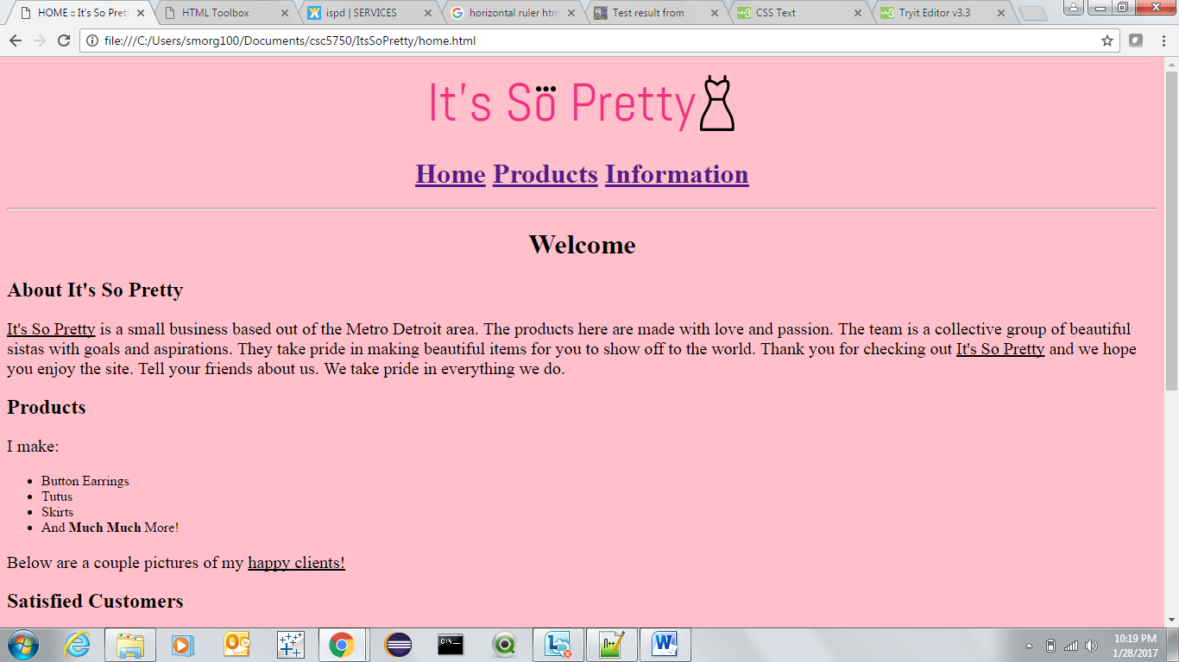

**Products and Services page**

**<!DOCTYPE html>**

**<html>**

**<!--==================================================================**

**//**

**// Web site: Its So Pretty**

**// Web page: Products**

**// Description: A page with pictures and descriptions how the item was**

**// made and how to order one.**

**//**

**//**

**//=================================================================-->**

**<head>**

**<title>Products and Services :: It's So Pretty</title>**

**<meta charset="UTF-8">**

**<meta name="author" content="Sable"/>**

**<meta name="description" content="DIY"/>**

**<meta http-equiv="Expires" content="-1">**

**<link rel="shortcut icon" href="/favicon.ico" type="image/x-icon">**

**<link rel="icon" href="/favicon.ico" type="image/x-icon">**

**<link rel="stylesheet" href="styles.css">**

**<script type="text/javascript">**

**//==================================================**

**// SomeFunction**

**//==================================================**

**function SomeFunction()**

**{**

**}**

**</script>**

**</head>**

**<body>**

**<!-- logo/banner -->**

**<h1><img src="images/isp.png"></h1>**

**<!-- navbar/topspot -->**

**<p id="TopOfPage"></p>**

**<h1><a href="home.html">Home</a> <a href="products.html">Products</a> <a href="info.html">Information</a></h1>**

**<hr>**

**<!-- content -->**

**<h2>Products/Services Price Table</h2>**

**<table style="border:2px; width:100%">**

**<!-- Caption -->**

**<caption>**

**<b>Here is a table with prices and a short description of some of the items I sell. Click the picture to enlarge.</b>**

**</caption>**

**<a href="#EndOfPage">Jump to the end of the web page</a>**

**<!-- Column specs -->**

**<colgroup>**

**<col width="10%" style="background-color:white">**

**<col width="10%" style="background-color:white">**

**<col width="40%" style="background-color:white">**

**<col width="10%" style="background-color:lightgreen">**

**</colgroup>**

**<!-- Column headers -->**

**<thead>**

**<tr>**

**<td>**

**<b>Images</b>**

**</td>**

**<td>**

**<b>Item</b>**

**</td>**

**<td>**

**<b>Description</b>**

**</td>**

**<td>**

**<b>Price</b>**

**</td>**

**</tr>**

**</thead>**

**<!-- Column footers (NOT USED) -->**

**<!-- Rows and columns -->**

**<tbody>**

**<tr>**

**<td>**

**<a href="images/earrings.jpg"><img src="images/earrings.jpg" alt="earrings" height="100" width="75"></a>**

**</td>**

**<td>**

**Button Earrings**

**</td>**

**<td>**

**Custom or ready-made earrings for any event or occasion.**

**</td>**

**<td>**

**<b>$10</b>**

**</td>**

**</tr>**

**<tr>**

**<td>**

**<a href="images/tutu3.jpg"><img src="images/tutu3.jpg" alt="tutu" height="100" width="50"></a>**

**</td>**

**<td>**

**Tutus**

**</td>**

**<td>**

**Custom made for young girls and woman. Choose one or multiple colors to fit your style.**

**</td>**

**<td>**

**<b>$25 and up</b>**

**</td>**

**</tr>**

**<tr>**

**<td>**

**<a href="images/skirt.jpg"><img src="images/skirt.jpg" alt="skirt" height="100" width="75"></a>**

**</td>**

**<td>**

**Skirts**

**</td>**

**<td>**

**Form fitting or fit and flare. Any color, any material, and style. Let your imagination run wild.**

**</td>**

**<td>**

**<b>$45 and up</b>**

**</td>**

**</tr>**

**</tbody><tbody>**

**</tbody></table>**

**<!-- more content -->**

**<h2>Other Products and Services We Offer</h2>**

**<p><h3>Hair</h3>**

**We make pretty wigs to spice up your weekend or trip. We can also teach you how to do them yourself.**

**<h3>Tech</h3>**

**We have certified nail technicians and PC techs that would be happy to service you. Broken laptop or broken nail? Call us!**

**</p>**

**<h1>Thank You</h1>**

**<p id="EndOfPage">Please come again soon.</p>**

**<a href="#TopOfPage">Jump to the top of the web page</a>**

**<!-- footer -->**

**<br>© 2017 by Sable of It's So Pretty**

**</body>**

**</html>**

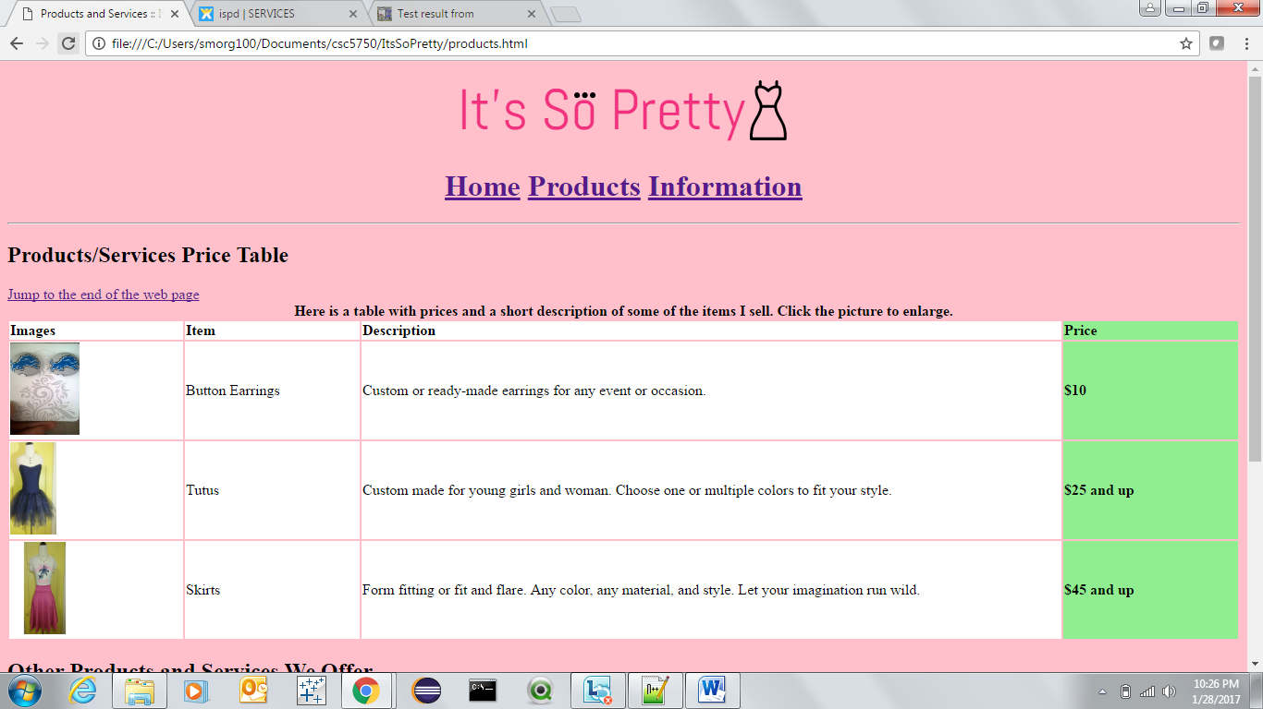

**Information Request page**

**<!DOCTYPE html>**

**<html>**

**<!--==================================================================**

**//**

**// Web site: It’s So Pretty**

**// Web page: Information**

**// Description: A page with form on how to get more information.**

**//**

**//**

**//**

**//=================================================================-->**

**<head>**

**<title>Information :: It's So Pretty</title>**

**<meta charset="UTF-8">**

**<meta name="author" content="Sable"/>**

**<meta name="description" content="DIY"/>**

**<meta http-equiv="Expires" content="-1">**

**<link rel="shortcut icon" href="/favicon.ico" type="image/x-icon">**

**<link rel="icon" href="/favicon.ico" type="image/x-icon">**

**<link rel="stylesheet" href="styles.css">**

**<script type="text/javascript">**

**//==================================================**

**// SomeFunction**

**//==================================================**

**function SomeFunction()**

**{**

**}**

**</script>**

**</head>**

**<body>**

**<!-- logo/banner -->**

**<h1><img src="images/isp.png"></h1>**

**<!-- navbar -->**

**<h1><a href="home.html">Home</a> <a href="products.html">Products</a> <a href="info.html">Information</a></h1>**

**<hr>**

**<!-- content -->**

**<h2>Information Form</h2>**

**<p>To receive more information about this company fill out the form below.</p>**

**<!-- form -->**

**<form method="get" enctype="application/x-www-form-urlencoded" action="http://www.tipjar.com/cgi-bin/test">**

**<label>First name: </label><input type="text" name="txtFirstName">**

**<br><br>**

**<label>Last name: </label><input type="text" name="txtLastName">**

**<br><br>**

**<label>Email address: </label><input type="text" name="txtEmail">**

**<br><br>**

**<label>Mailing address: </label><input type="text" name="txtSnailMail">**

**<br><br>**

**<!--radio buttons-->**

**<legend>Preferred Delivery Format</legend>**

**<input type="radio" name="format" value="Email"> Email<br>**

**<input type="radio" name="format" value="Snail"> Snail Mail<br>**

**<br>**

**<input type="submit" value="Submit">**

**<input type="reset" value="Reset">**

**</form>**

**<!-- more content -->**

**<h2>Thank You</h2>**

**<!-- footer -->**

**<br>© 2017 by Sable of It's So Pretty**

**</body>**

**</html>**

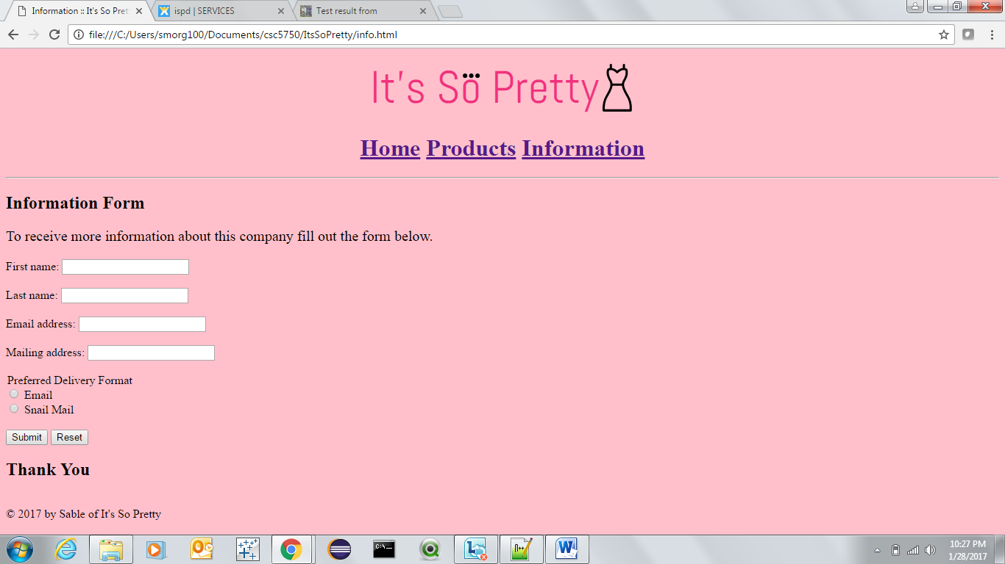

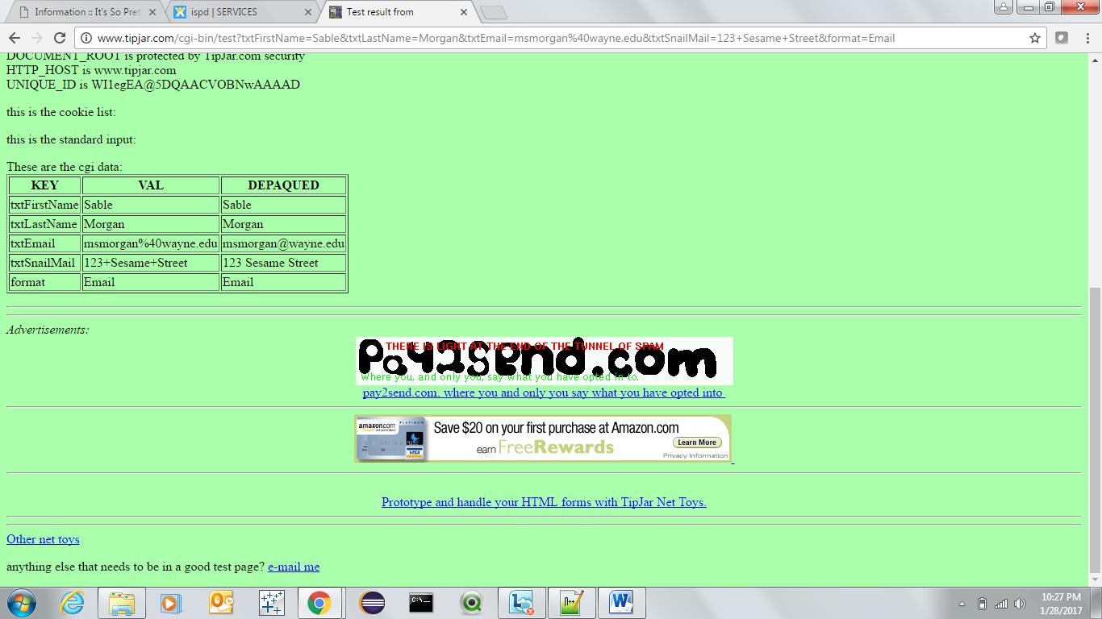

Thank you,

Sable Morgan

[msmorgan@wayne.edu](mailto:msmorgan@wayne.edu?subject=HomeWork%201-%20CSC%205750)