Contents

Introduction 1

Background 1

Purpose: 1

Significance: 1

Materials and Methods 1

Estimation of Fork Length using Cranial Measurements 1

Sample collection 1

Sampling on shore 1

Head measurements 1

2. Development of a genetic test for gender determination 1

Results 1

Estimation of Fork Length using Cranial Measurements 1

Repeatability and feasibility of each measurement type 1

Discussion 1

# Introduction

## Background

* Stock Assessment of Sablefish in British Columbia requires information on individual fish size, age, and sex in the commercial fisheries
* Biological Data is obtained from sources that are either
  + independent of the fishery (annual random stratified trap survey) that is implemented by DFO/industry (and other DFO surveys?). Random samples are collected on the survey and fish size/sex/sexual maturity/ length/weight are recorded. Otoliths are collected and these are used to estimate fish age.
  + fishery dependent sources
    - Since commercial product is landed headed and gutted (J-cut), biological data have historically been obtained from the commercial fishery through a voluntary catch sampling program.
      * In the voluntary catch sampling program, commercial fishers randomly selected fish from longline trap or hook gear and returned them whole to port, for sampling onshore. Reward incentives were offered to increase the voluntary return of whole fish to be sampled.
  + A Sablefish tagging and recovery program (implemented….add a couple of details, which provides data about….) also relied on the voluntary return of whole tagged Sablefish.
    - Sablefish are a valuable species (particularly large fish), and it is possible that fishers would prefer to sell large fish, rather than submitting them for biological sampling. If this were the case, then larger fish would not be represented in the biological samples collected from the commercial fishery.
    - Larger fish are represented in samples collected on the fishery-independent surveys and are less well represented in the voluntary catch sampling program from the commercial fishery.
      * It is not clear as to whether this is due to lack of participation, or due to gear selectivity (or….)…but making sample submission easier would likely improve participation and in turn, improve the quality of the biological data.
      * Benefits to moving to a head only catch sampling program:
        + Easier for fishers to submit samples, likely to get more participation in the program and large fish would be more likely to be returned and represented in the sample.
      * Cons:
        + Rely on fishers to determine sex, no info re: sexual maturity, estimate of fish length rather than a direct measurement

Requirements: need to be able to estimate fish length from head dimensions, fishers need to be able to sex the fish

* + - In order to improve participation in the voluntary catch sampling program, we investigated the potential for obtaining biological information using heads, rather than entire fish.
  + Some researchers have demonstrated that there are strong relationships between head dimensions and fish length (give some examples)

## Purpose:

* We are investigating the potential for obtaining biological information using only Sablefish heads.
* This requires:

1. Demonstrating that head measurements can be used to reliably predict fork length for both sexes
2. Developing an at-sea sampling program where fishermen determine sex and then separate the returned heads
3. Developing an audit program of the fisher-determined sex accuracy through genetic methods
4. Revising shore-side sampling of Sablefish to collect head measurements, and otoliths, and genetic tissue.

## Significance:

* Successful application of this research may result in increased participation in the voluntary catch sampling and tagging programs and improve the quality of biological data from all commercial gear types that intercept Sablefish

# Materials and Methods

## Estimation of Fork Length using Cranial Measurements

### Sample collection

* Sablefish were selected for sampling during biennial DFO Groundfish Synoptic Bottom Trawl surveys in 2016, following a trip-wide length stratified selection protocol. A total of 431 fish were sampled on 2 surveys - the 2016 West Coast Vancouver Island survey (212 fish), and the 2016 West Coast Haida Gwaii survey (219 fish). For each selected fish, fork length, round weight, fish sex and maturity (determined by internal examination of the gonads) were recorded at sea. The heads were removed and were bagged individually. Each head was tagged so it could be matched to the corresponding biological data, and was frozen for additional sampling on shore.

### Sampling on shore

* On shore, the heads were thawed, and cranial dimensions were measured using electronic calipers. Ageing structures (sagittal otoliths) were also collected from each head. Operculum clips were collected from the first 137 fish measured (79 male and 58 female), and were stored in vials containing 95% ethanol, to be used for DNA extraction and the development of a genetic test for fish gender.

### Head measurements

* A number of cranial dimensions were considered as possible candidates for estimating fork length, and the five most repeatable ones are described below (Table x). *Post orbital head length* (Posterior inner edge of orbit to dorsal insertion of opercle) was also measured, but this was abandoned after 130 measurements, to save time, and because it was not possible to measure this on a number of the heads for a variety of reasons (opercula had been cut off from some heads, it was awkward to take longer measurements using the electronic calipers, and the end points of the measurement were difficult to define.
* Table x –Head dimensions measured and instructions for positioning calipers when measuring

|  |  |
| --- | --- |
| Definition of head measurement and  *Instructions for positioning calipers* |  |
| Eye Diameter: anterior-posterior diameter of eye socket. *Use the outward-facing points of the calipers when measuring. Stretch them firmly against the eye socket at the vertical midpoint of the eye.* |  |
| Inter-Orbital Distance: narrowest distance between eye sockets, measured on dorsal surface. *Measure at the horizontal midpoint of the eyes on the dorsal surface.* |  |
| Snout length: tip of snout to anterior edge of eye socket. *Measure from the most forward point/centre of the snout, to the horizontal midpoint of the anterior edge of the eye socket.* |  |
| Upper jaw length: Tip of snout to the posterior edge of the maxilla. *Measure from the most forward point/centre of the snout to the back of the maxilla.* |  |
| Post orbital to preoperculum distance:  Posterior edge of obit to visual insertion point of pre-opercle on the dorsal side.  *Measure from the back of the eye socket (caliper vertically centred), to the top of the preopercle* |  |

* Each cranial measurement was compared to fork length, and correlation coefficients were calculated.
* This is what we had done initially, just to look at the data. Probably some kind of more in depth analysis should be done (Brendan?)
* Each measurement type was ranked in terms of repeatability and utility (this is maybe too much detail to include in a paper, but I’m throwing it in here).

### 2. Development of a genetic test for gender determination

* DNA multiplex PCRs were conducted using fluorescently labelled forward primers
* X-insert and Y-insert specific primers developed by Rondeau *et al*. (2013) were used, but the X-insert forward and Y-nested reverse were redesigned to produce slightly smaller PCR products (Table x).

Table x. Primers used in the development of a genetic test for determining Sablefish sex

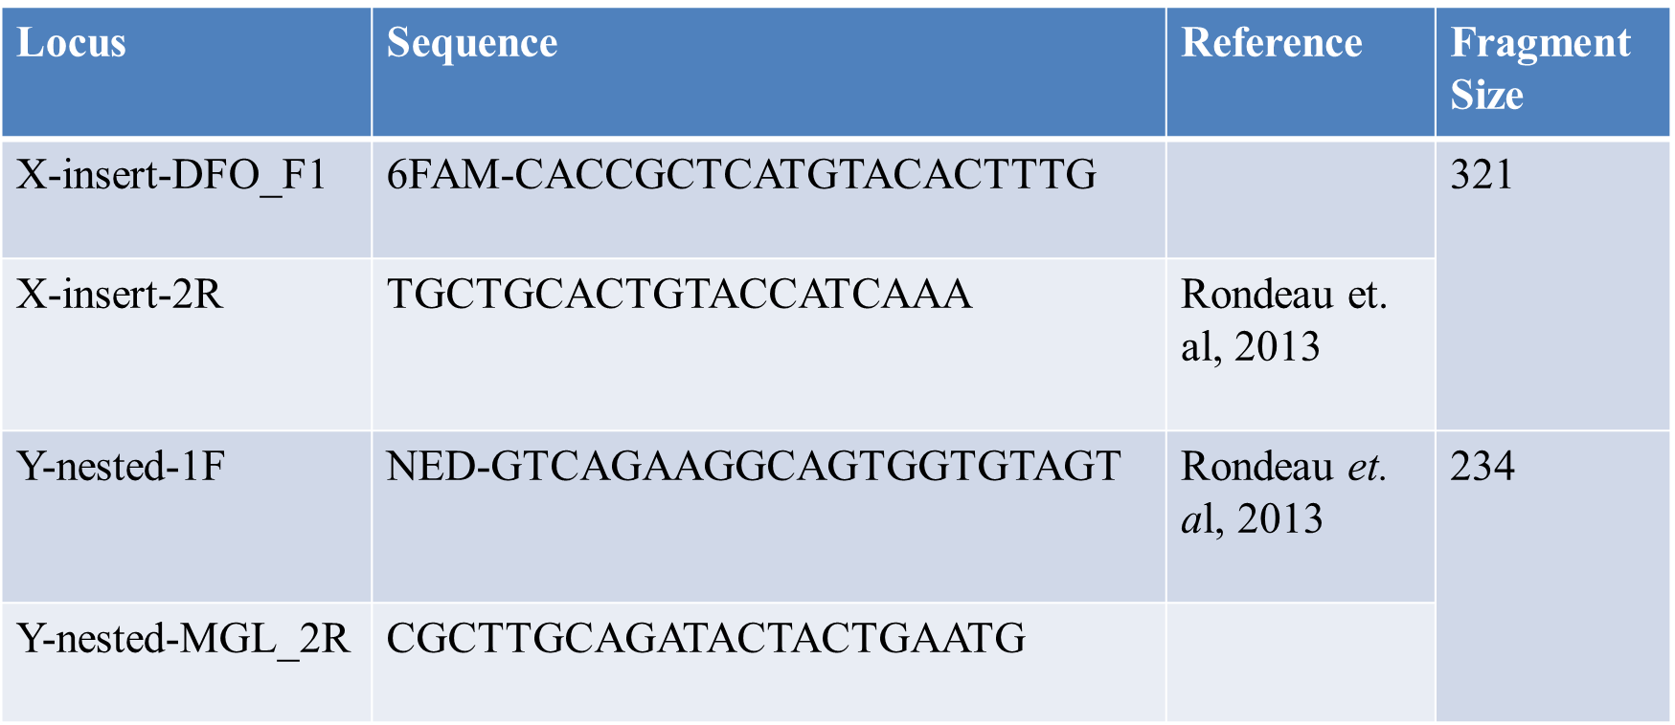

* Sex specific alleles were size fractionated in an ABI 3730 capillary DNA analyzer and were scored with ABI GeneMapper using an internal lane sizing standard (Figure 7a and 7b)

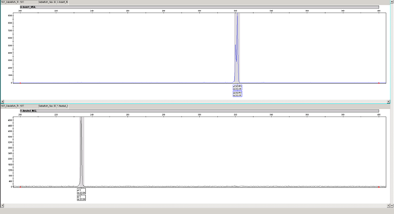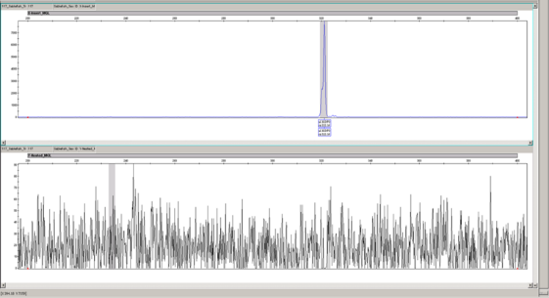

Y-DFO

X-DFO

X-DFO

Figure 7a Male Genotype Figure 7b Female Genotype

1. Pilot Collection of Sablefish Heads as a Biological Sample
2. To test the feasibility of the proposed collection methods, a commercial crew collected heads as samples from designated fishing traps. (In 2017; ~360 heads, from Bowie Seamount).
3. The crew J-cut the fish as per the usual commercial protocol, and marked each operculum using either one knife cut (male) or two knife cuts (female) to indicate sex (Figure x).

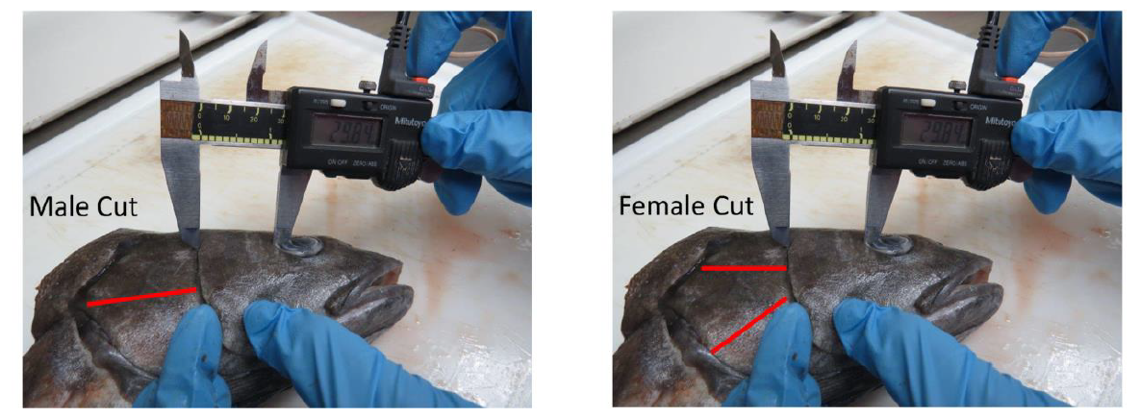

Figure x. Operculum cuts used to indicate fish sex in commercial samples

1. To determine how repeatable each cranial measurement was, the first 99 Sablefish heads (collected during the Pilot Study) were measured in triplicate, by 3 technicians.
2. NOTE: Sampling of these fish is still in progress (~70 have not yet been sampled. I have been measuring 4 dimensions (interorbital distance, snout length, upper jaw length, and post orbital to pre-operculum distance) …collecting otoliths, and operculum clips for genetics…

# Results

Brendan probably can help..

## Estimation of Fork Length using Cranial Measurements

1. Cranial dimensions were found to be highly correlated to fork length (Fig x-xxx).
2. Fork lengths of sampled fish ranged from 240mm to 1080 mm.
3. Graphs (by sex) of each cranial dimension measured, vs fork length and resulting relationships.
4. Whatever else should go in here….

*PRELIMARY GRAPHS: We have data for all of the measurements below (Note that the n and r values below are for males/females combined. We’d probably want to divide it by sex. I included all of the different head measurements in this list for completeness, but we could pare them down to the best ones if we want..)*

Snout length vs fork length (n=437; r=0.976)

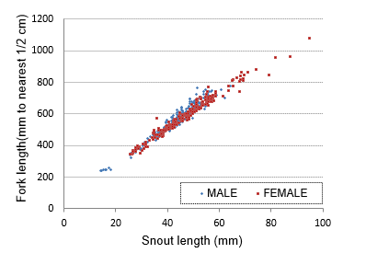

Upper jaw length vs fork length (n=437, r=0.973)

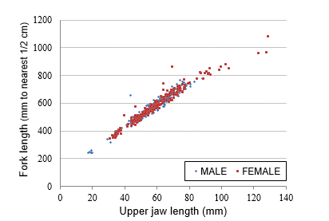

Interorbital distance vs fork length (n=437, r=0.971)

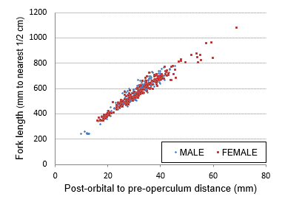

Post orbital to pre-operculum vs fork length (n=426, r=0.965)

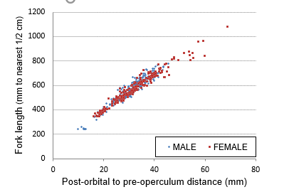

Eye diameter vs fork length (n=438, r=0.938)

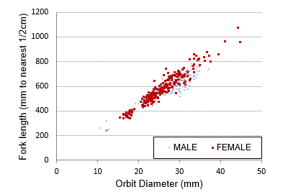

## Repeatability and feasibility of each measurement type

In order to help identify the head dimensions that would be most practical to measure, each measurement was subjectively ranked in terms of ‘Ease of Use’ and ‘Repeatability’. ‘Ease of use’ considerations included: the ability to clearly define and measure the dimension quickly, and whether our existing equipment could be used to easily measure it. In general, we found that measurement of hard parts (rather than soft, moveable tissue) was more repeatable.

Table . Each measurement was ranked in terms of ‘Ease of Use’ and ‘Repeatability’, where 5-Great; 4- Good; 3-Moderate; 2-Questionable; 1-Terrible.

|  |  |  |  |  |  |
| --- | --- | --- | --- | --- | --- |
|  | **n** | **R** | **Ease of use** | **Repeat-ability** | **Considerations** |
| **Snout length** | 437 | 0.976 | 4 | 5 | Bony part; can measure on right or left side  Must ensure caliper is in centre of snout |
| **Upper jaw length** | 437 | 0.973 | 3 | 4 | Bony part; can measure on right or left side  Electronic Calipers tended to malfunction with longer measurements; had to use manual calipers for >15cm distances; awkward to measure.  The end of the maxilla can be hard to define.  Must ensure caliper is in center of snout |
| **Interorbital distance** | 437 | 0.971 | 5 | 5 | Bony part; Easy to define where to hold calipers; so far there has been no reason (eg damage) to not include this measurement |
| **Post orbital to pre-operculum** | 426 | 0.965 | 4 | 5 | Bony part; can measure on right or left side; difficult to define measurement endpoints |
| **Post orbital head length** | 130 | 0.956 | 3 | 2 | Can measure on right or left side  Operculum was cut off on a number of fish; measurement endpoints difficult to define; Electronic Calipers tended to malfunction with longer lengths; had to use manual calipers for >15 cm distances; abandoned measurements after n=130 |
| **Eye diameter** | 438 | 0.938 | 3 | 2 | Easy to define where to hold the calipers in the eye socket, but the tissue is soft/stretchy so its difficult to know how hard to press against the flesh; can measure on right or left side  Uses the outside rather than the inside of the calipers (? slower); Soft tissue, so repeatability is questionable; somewhat awkward to measure |

Repeatability of measurements between technicians

To demonstrate the repeatability of 4 measurement types between technicians, we measured the first 99 heads from the pilot study in triplicate. We measured inter orbital distance, snout length, upper jaw length, and post orbital to pre-operculum distance. To save time, we omitted the 2 least promising dimensions from the comparison (eye diameter and post-orbital head length measurements)

Preliminary results:

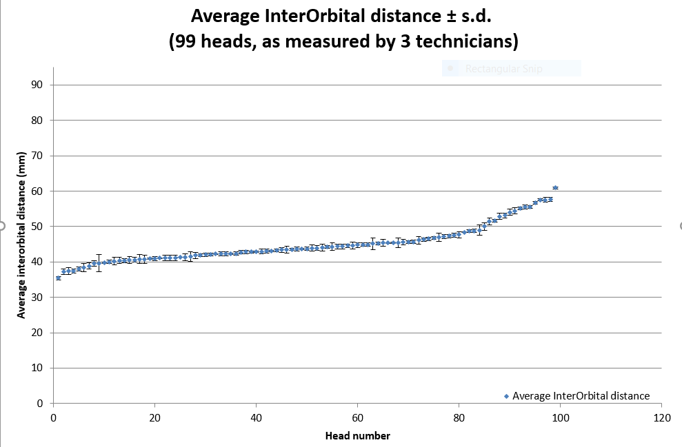

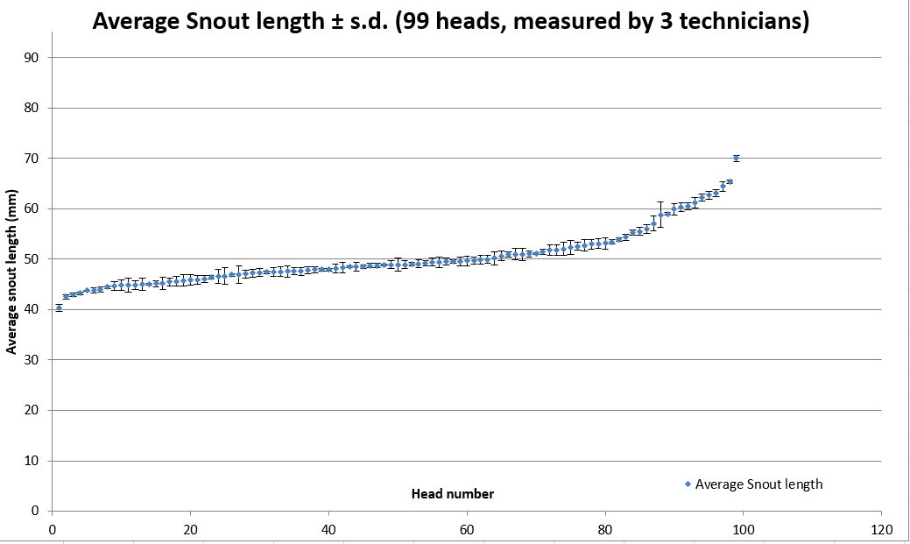

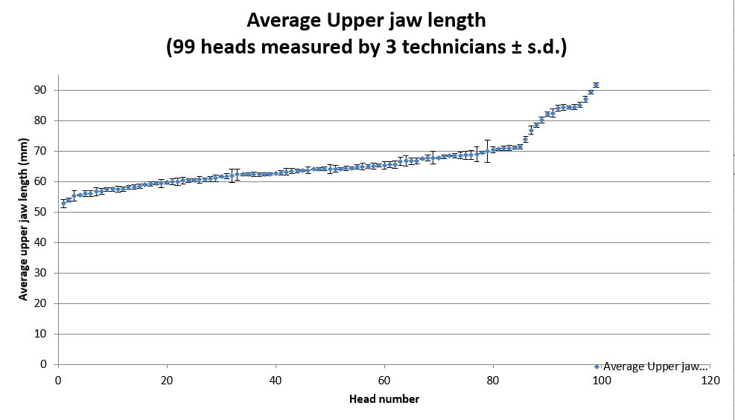

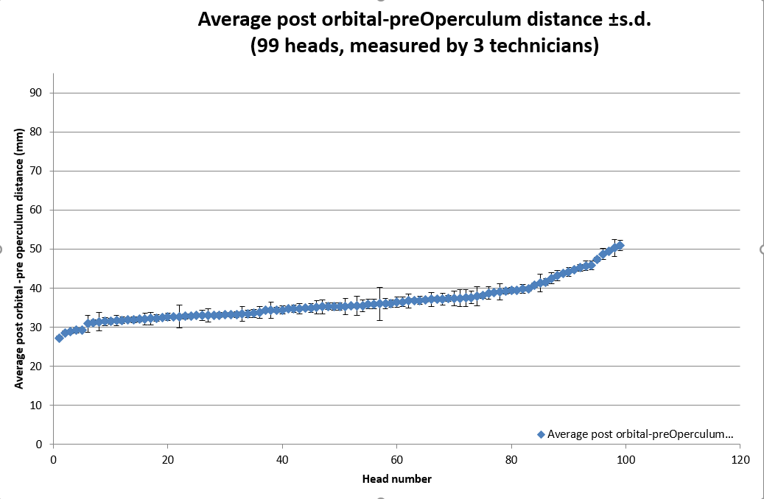

* 1. Insert reasoning for switching to a single measurement

3. Development of a genetic test for gender determination

1. 94% (130/138) of samples were successfully PCR amplified from genomic DNA (KT note: these were samples that were collected on the bottom trawl surveys
2. For these samples that were successfully PCR amplified, the accuracy of the sex call was ~91% (119/130) (Fish gender, as determined by the genetic assay matched the gender, as determined when visually assessed by technicians while at sea.
3. The cost for analysis is $14/sample

2. Pilot Collection of Sablefish Heads as a Biological Sample

a. Heads were received by DFO in good condition (intact and not deformed), segregated by set, for measuring and otolith extraction. Operculum cuts worked well to indicate sex. *Sampling is in progress (~200 of ~260 heads have been measured.) Check - Has any DNA been tested?*

# Discussion

1. Significance that head dimensions can be used to predict fish length
   1. Application: Routine biological sampling procedures have been modified so that commercial fisheries are now only returning heads, rather than entire fish (when did this happen, can we tell yet if we’re getting more data from larger fish now?)
   2. Extrapolating fish length from head dimensions may be useful in other situations (for other species):
      1. Halibut heads (without bodies) recovered on longline surveys (predation problems)
      2. Difficult to measure species (eg. Deep sea species (measure eye diameter in photos, use that to extrapolate length)
2. Limitations of extrapolating length from cranial measurements
   1. Have to extrapolate for larger/smaller fish
      1. Do we need to collect head vs length data from more (larger and smaller) Sablefish on future surveys so that we can expand the size range covered?
   2. Depends on abilities of technicians to measure accurately, repeatedly, and quickly. We feel that we have chosen a dimension (orbital distance) that is feasible to measure repeatedly by trained technicians.