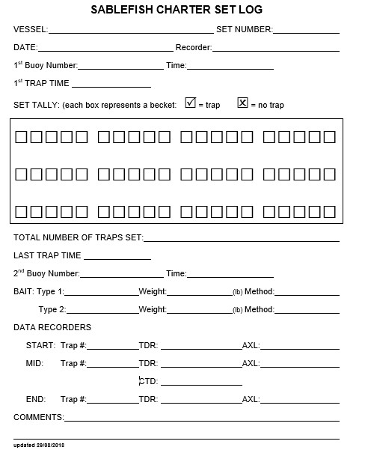

Record time when **first trap** is deployed.

Verify the buoy numbers at each end.

Record time when **last trap** is deployed.

If applicable, visually estimate bait weight.

Inspect each trap as it is deployed to ensure no damage to the web, correct baiting practices, etc. Record the trap number of any problem traps. *NOTE: survey-specific traps were purchased prior to the 2017 survey and do not have escape rings.

Mark traps as they are deployed. Each box represents a becket.  represents traps,  represents missed traps. At the end, record total.

Record the trap numbers used for data recorders. Record the serial numbers for the temperature-depth recorder (TDR), accelerometer (AXL) and camera.

Record comments about any extra anchors to secure excess buoyline, marine mammal sightings, etc.