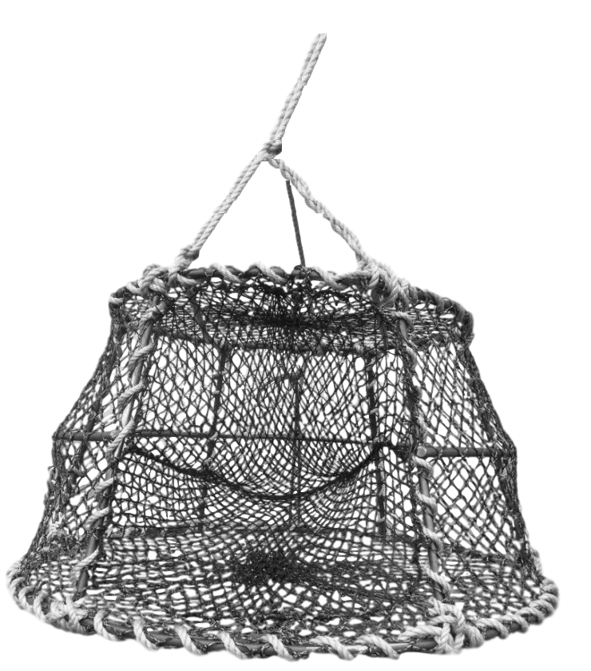

bridle

tunnel

framework

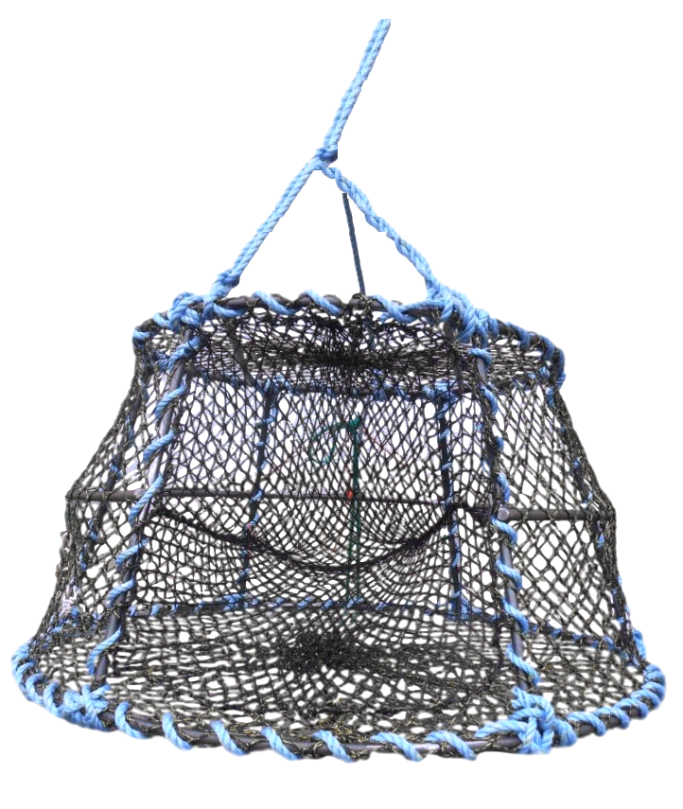
anchor
buoy
flagpole
sinkerline
anchorline
bridle
groundline
25 traps
shotline(s)
snap, ring, and becket
water surface
ocean floor

