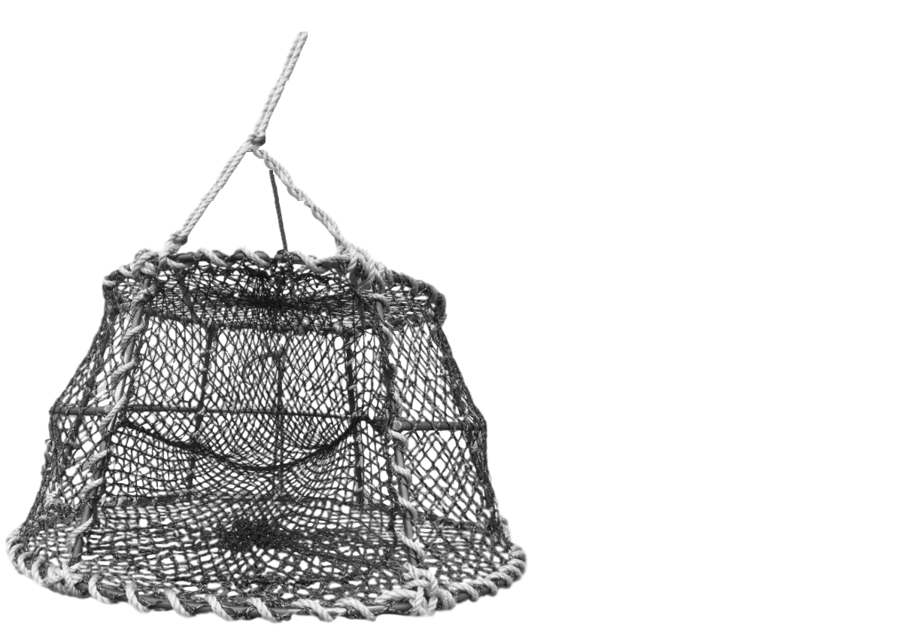

Tunnel

Bridle

Framework