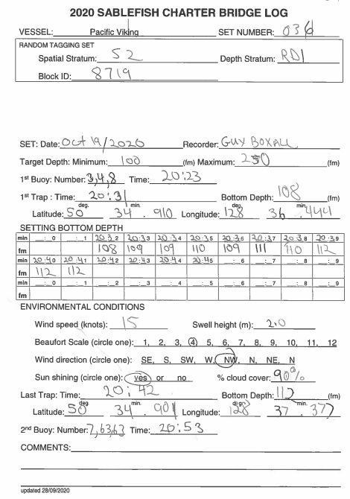

Record the time, depth and position when the first trap is deployed, not when snapped to the groundline. Traps should never be towed but vessels may tow the anchor prior to setting the string. If so, use the time of drum release and trap deployment.

Record the Block ID and the target depth and spatial strata. Refer to the chart and table of selected blocks.

Record the bottom depth from the sounder at the start of each minute. Logically, if recordings are made every minute, the 1st anchor time plus the number of depth recordings should equal the 2nd anchor time. Use the minute boxes to keep track of which minutes you record a depth for.

Record the environmental conditions while setting. There will be a guide available for the Beaufort scale

Record the time, depth and position when the last trap is deployed.

Record all positions to two decimal places.

Comments include nearby whales, vessels, weather conditions affecting depth readings, etc.

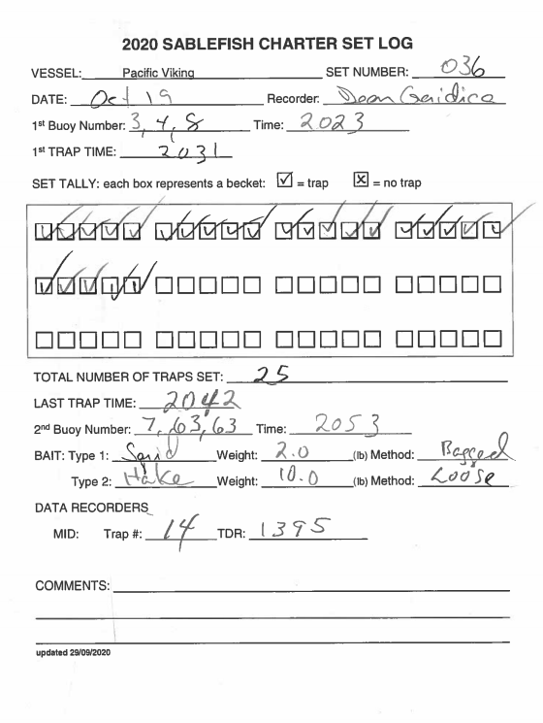

Record the trap number that is used for the data recorder. Do this when the trap is actually deployed. Record the serial number of the temperature-depth recorder (TDR).

In 2020, every trap on every set should be baited with 2 lbs of squid in bag and 10 lbs of hake loose in the trap. Visually confirm that 10lbs is being added to the traps.

Record the time when the last trap is deployed.

Mark traps as they are deployed. Each box represents a becket: checks mean traps, X means missed traps. Then record the total number deployed.

Record the time the first trap is deployed. Traps should never be towed but vessels may tow the anchor prior to actually setting the string and the first trap may be snapped to the groundline long before the set is deployed.

It is important to verify the buoy numbers on both ends.

Inspect each trap as it is deployed to ensure no damage to the web, correct baiting practices, etc. Record the trap number of any problem traps. *NOTE: survey-specific traps were purchased prior to the 2017 survey and do not have escape rings

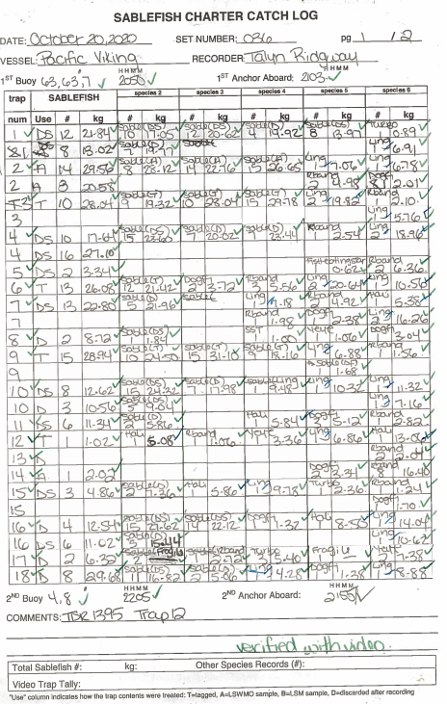•  Accurate count of traps is very important.

* Verify buoy numbers as they are retrieved.
* Record times the first trapand last trapare hauled

aboard.

* Identify specific columns for common species.
* Ensure all species abbreviations are

recorded on the worksheet.

* Label specific cells for uncommon species

in the set. Species names in cells

override the species name in a column

for that row only. Subsequent rows

revert back to the original species.

* Record species count and weight for each trap.

Each row is a single trap but one trap can be in

multiple rows.

* Indicate trace weights with a dash in the weight

field

* Put a line through the sablefish column if there are

no sablefish or record ***MT (***empty). Never leave a

row completely blank.

* Record how the catch was used:
  + Sablefish: ***T*** = tagged, ***A*** = age biosample,

***D*** = discarded, ***DS*** = discarded sublegal,

***DF*** = discarded frames,

***TRA*** = tag recovery age (USA tags),

***TRT***= tag recovery tagged (CAN tags)

* + All other species: assumed as discarded so

indicate if frames or age biosample

* Track the number of Sablefish in the biosample and

tagging in the margins

* Record the count and weight of each basket as

they occur to ensure the form matches the video.

* If a fish is lost overboard, indicate if it was before or

after weighing.

* Either in the trap row or in the comments section,

record any open traps, snarls, missed beckets, trap

damage (include estimate in inches of hole size),

gilled in mesh, gilled in tunnel, open escape panels,

etc. Ensure the crew inspects the trap and reports

any damage.

## 

## Record the date the set was hauled

* Enter records by trap
* Enter every basket. For each basket, enter:
  + the species code
  + the count (the only records without

counts should be trace amounts)

* + the weight or a dash (“**-**“) for trace weights
  + the basket use
    - ***T*** = tagged
    - ***A*** = age biosample
    - ***D*** = discarded
    - ***DS*** = discarded sublegal
    - ***DF*** = discarded frames
    - ***TRA*** = tag recovery age

(US tag recoveries)

* + - ***TRT***= tag recovery tagged

(Canadian tag recoveries)

* For the first basket in each trap, enter comments about the trap: record any open traps, snarls, missed beckets, trap damage (include the location (top, bottom, side, tunnel), as well as an estimated measure of the hole size in inches), gilled in mesh, gilled in tunnel, open escape panels, etc. If there are multiples holes of different sizes in the same area of the trap: the largest is the one that gets coded.
* If the trap is empty, enter “***MT***” in the species code field
* Count the number of baskets and compare it to the number on the original catch log.

Cross out the length of broken tags.

Ignore the Sample Type, Species and Tag Type fields but ensure to fill in the all other fields. Don’t worry about codes.

Verify all nine digits of the tag number every time a new cartridge of tags is started, for the first and last fish tagged in the set, and for tag re-releases.

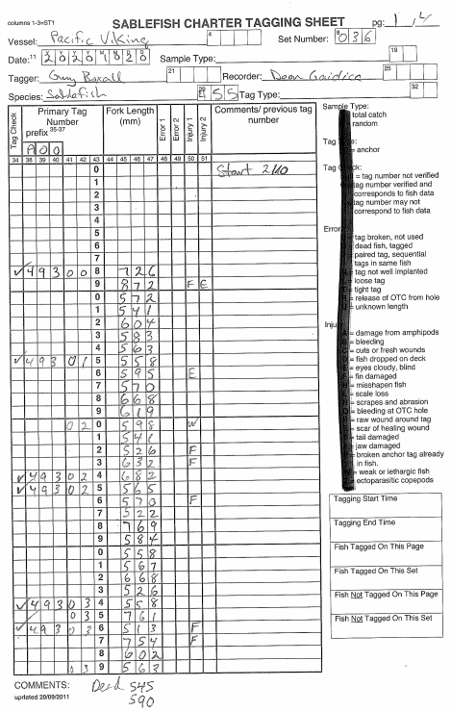

The tag check states are:

Null = Blank, the tag number was not checked

Check mark = True, the tag number was checked and correct

X = False, the recorder was not on the same record when the tag number was checked.

Verify at least the last three digits of the tag number at least every ten fish and after every tagging error. i.e., after a broken tag or a paired tag.

Ignore all the codes listed on the tagging sheets – use the codes from the code sheet instead.

For tag recoveries that will be re-released (Canadian tags), record the wound condition, the vial number, and the last three digits of the tag. Verify all nine digits of the new tag. Do not re-tag foreign tagged fish or poor condition fish, instead sacrifice them and collect LSWMO.

Record the time tagging operations start on the first page.

Record the time tagging operations end on the last page.

Record the lengths of dead fish

Ignore the 4 fields of the count of tagged/not tagged.

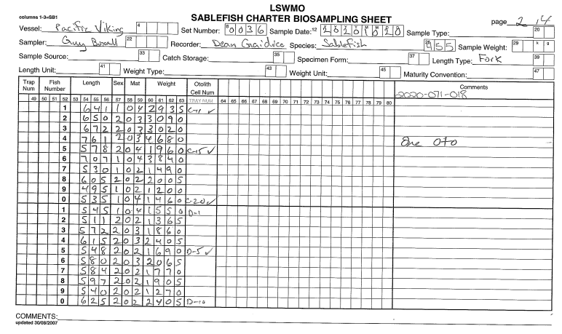

## Calibrate the scale with a basket on the platform

Always complete **Vessel**, **Set Number, Sample Date**, **Page, Sampler**, **Recorder,** and **Species** fields.

* If the sample is recovered tagged Sablefish (US tags), record ‘*Selected Tag Recoveries’* in the **Sample Source** field. Otherwise leave the field blank.

## Record the **Length Type** you are measuring (***Fork Length***)

* Leave the all other fields blank.

On the first page:

* Record the time the first fish is sampled in the **Comments**

For each fish:

* Leave the **Trap Num** and **Fish Number** columns blank.
* Record **Weight** (grams), **Length** (mm)**, Sex** (0=not looked at, 1=male, 2=female, 3=looked at but unknown), and **Maturity**.

For **otolith** age samples:

## Record the otolith Tray Number in the **Comments** header

* For each fish record the **Otolith Cell Num**. Use a checkmark next to the cell number to indicate when an otolith is verified and ensure to verify the first fish, every fifth fish, and the last fish. The check mark signifies that the otolith in the cell matches the fish.
* If large otoliths occupy two cells, make a comment and record the last cell in the **Cell No.**
* The assumption is that 2 otoliths are collected from every fish. If this is not the case, make a note as to 0 or 1 otolith.
* If you break an otolith make a note (‘BO’ is acceptable). Otolith pieces are useful if larger than half an otolith.

For **DNA** samples (Rougheye/Blackspotted Rockfish only in 2020)

* DNA will be collected using vials. Each vial has a unique number as follows: ***394-########_V***. Ignore the “***-V***” and record the “***394_”***part in the header and then verify and record the 8 digit number (***########***) for each fish. It is acceptable to use some means to indicate repeated numbers after the first fish.

For **Tag Recoveries** (US tagged Sablefish), ensure to record the vial number, last three digits of the tag number, and the wound condition in the Comments section.

On the last page: Record the time the biosample is complete in the **Comments**