Experiment 4 — VHDL Code for FIFO

1. VHDL Design Code (FIFO.vhd)
----------------------------------------------------------------
-- Module Name : FIFO - Behavioral
-- Design : 8 x 8-bit FIFO with 1 Hz clock divider
----------------------------------------------------------------
library IEEE;
use IEEE.STD_LOGIC_1164.ALL;

entity FIFO is
Port (
clk : in STD_LOGIC;
rst : in STD_LOGIC;
wren : in STD_LOGIC;
rden : in STD_LOGIC;
empty : out STD_LOGIC;
full : out STD_LOGIC;
dataout : out STD_LOGIC_VECTOR(7 downto 0)
);
end FIFO;

architecture Behavioral of FIFO is

signal clkout : STD_LOGIC;
signal counter : integer range 0 to 49999999;

signal rdptr, wrptr : integer range 0 to 7;

type fifo1 is array (0 to 7) of STD_LOGIC_VECTOR(7 downto 0);
signal memory : fifo1;

type datain1 is array (0 to 7) of STD_LOGIC_VECTOR(7 downto 0);
signal data : datain1 := (
"10101010", "10111011", "10010101", "11110000",
"00001111", "10100101", "11110101", "01100110"
);

begin

-- Clock Frequency Division (100 MHz -> 1 Hz)
process(clk, rst)
begin
if (rst = '1') then
clkout <= '0';
counter <= 0;
elsif (clk'event and clk = '1') then
if (counter = 49999999) then
clkout <= not clkout;
counter <= 0;
else
counter <= counter + 1;
end if;
end if;
end process;

-- Actual FIFO Process
process(clkout)
begin
if (clkout'event and clkout = '1') then

-- RESET
if (rst = '1') then
for i in 0 to 7 loop
memory(i) <= "00000000";
end loop;
empty <= '1';
full <= '0';
rdptr <= 0;
wrptr <= 0;
dataout <= "ZZZZZZZZ";

-- WRITE IN FIFO
elsif (wren = '1') then
memory(wrptr) <= data(wrptr);
empty <= '0';
if (wrptr = 7) then
wrptr <= 0;
full <= '1';
else
wrptr <= wrptr + 1;
end if;

-- READ FROM FIFO
elsif (rden = '1') then
dataout <= memory(rdptr);
full <= '0';
if (rdptr = 7) then
rdptr <= 0;
empty <= '1';
else
rdptr <= rdptr + 1;
end if;

else
dataout <= "ZZZZZZZZ";
end if;

end if;
end process;

end Behavioral;

2. Constraints File (FIFO.xdc / UCF)
## Constraints file (FIFO.xdc) - Basys 3 / Artix-7 (xc7a35tcpg236-1)

## Clock - 100 MHz on-board oscillator
set_property PACKAGE_PIN W5 [get_ports clk]
create_clock -period 10.000 -name sys_clk [get_ports clk]

## Control inputs (switches)
set_property PACKAGE_PIN V17 [get_ports rst]
set_property PACKAGE_PIN V16 [get_ports wren]
set_property PACKAGE_PIN W16 [get_ports rden]

## Status outputs (LEDs)
set_property PACKAGE_PIN L1 [get_ports empty]
set_property PACKAGE_PIN P1 [get_ports full]

## Data outputs (LEDs)
set_property PACKAGE_PIN U16 [get_ports {dataout[7]}]
set_property PACKAGE_PIN E19 [get_ports {dataout[6]}]
set_property PACKAGE_PIN U19 [get_ports {dataout[5]}]
set_property PACKAGE_PIN V19 [get_ports {dataout[4]}]
set_property PACKAGE_PIN W18 [get_ports {dataout[3]}]
set_property PACKAGE_PIN U15 [get_ports {dataout[2]}]
set_property PACKAGE_PIN U14 [get_ports {dataout[1]}]
set_property PACKAGE_PIN V14 [get_ports {dataout[0]}]

## I/O standard for all ports
set_property IOSTANDARD LVCMOS33 [get_ports clk]
set_property IOSTANDARD LVCMOS33 [get_ports rst]
set_property IOSTANDARD LVCMOS33 [get_ports wren]
set_property IOSTANDARD LVCMOS33 [get_ports rden]
set_property IOSTANDARD LVCMOS33 [get_ports empty]
set_property IOSTANDARD LVCMOS33 [get_ports full]
set_property IOSTANDARD LVCMOS33 [get_ports {dataout[7]}]
set_property IOSTANDARD LVCMOS33 [get_ports {dataout[6]}]
set_property IOSTANDARD LVCMOS33 [get_ports {dataout[5]}]
set_property IOSTANDARD LVCMOS33 [get_ports {dataout[4]}]
set_property IOSTANDARD LVCMOS33 [get_ports {dataout[3]}]
set_property IOSTANDARD LVCMOS33 [get_ports {dataout[2]}]
set_property IOSTANDARD LVCMOS33 [get_ports {dataout[1]}]
set_property IOSTANDARD LVCMOS33 [get_ports {dataout[0]}]

3. Simulation Waveform
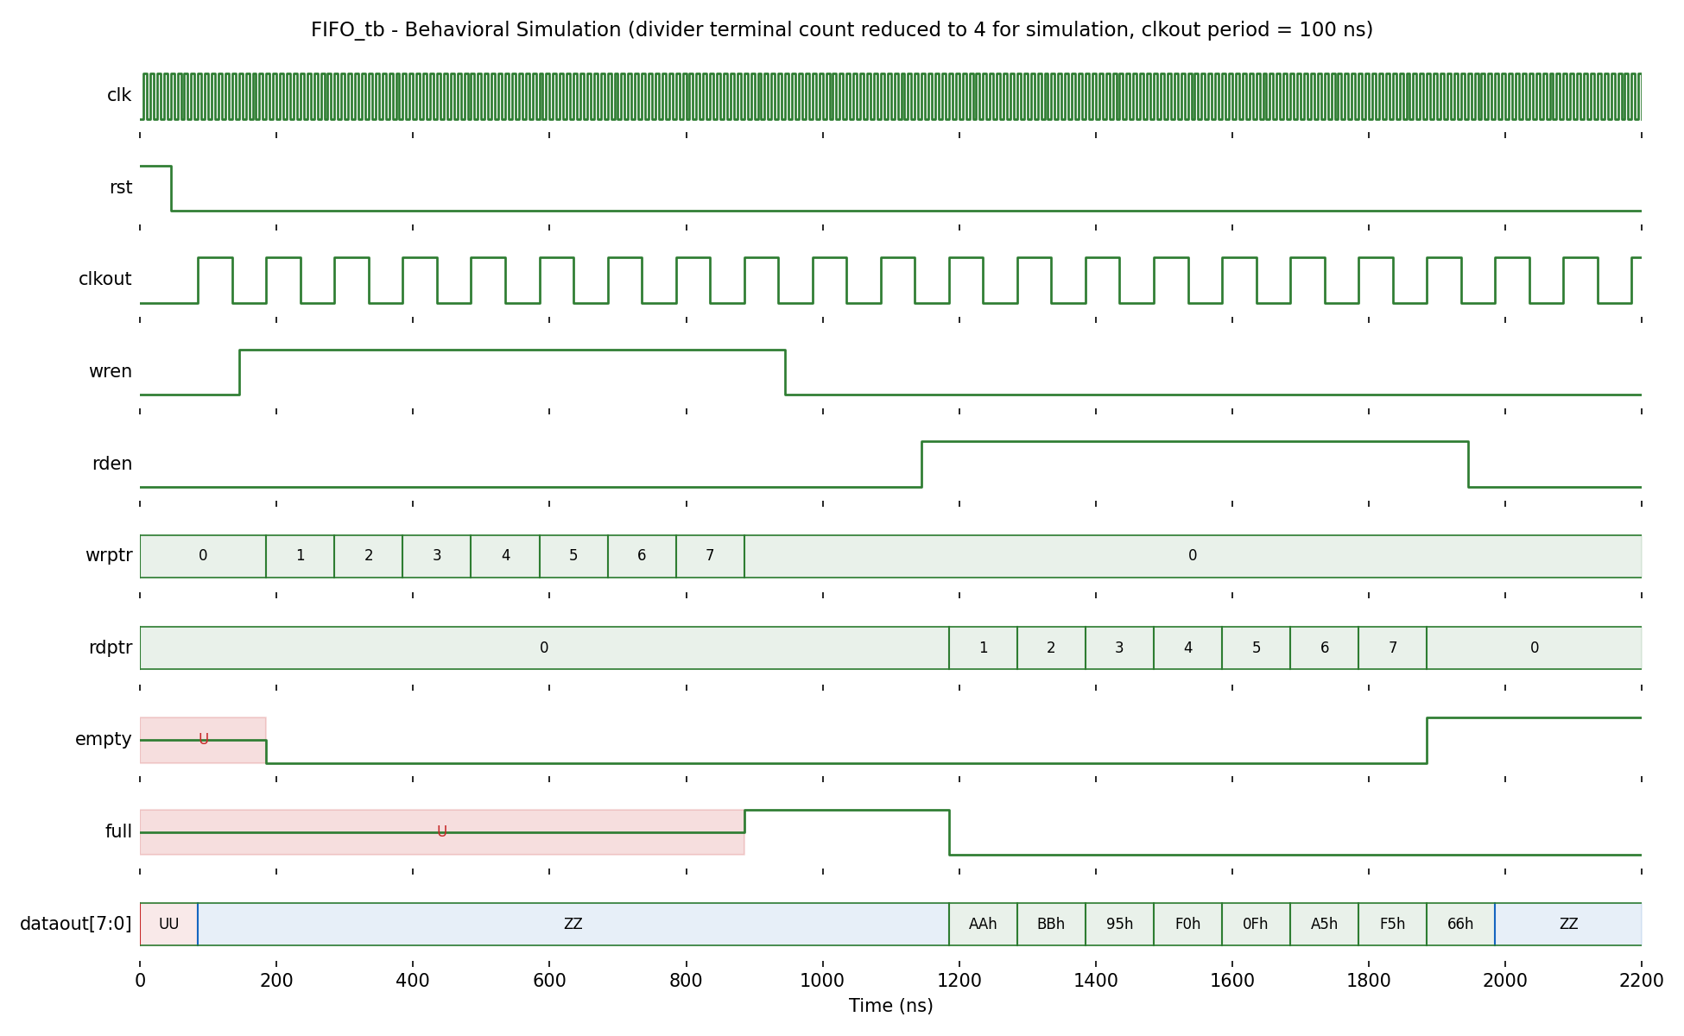
Note: for behavioural simulation the divider terminal count was reduced from 49999999 to 4 so that clkout has a 100 ns period and the full write/read sequence is visible within about 2 us. The value is restored to 49999999 (1 Hz) for synthesis.
Observations:
• Write phase (wren = 1): on each rising edge of clkout one pre-loaded data word is written to memory(wrptr) and wrptr increments 0 to 7. empty goes low on the first write. When wrptr reaches 7 the eighth word is written, wrptr wraps to 0 and full goes high.
• Idle (wren = rden = 0): dataout is driven to high impedance (ZZ).
• Read phase (rden = 1): dataout presents the stored words in order AAh, BBh, 95h, F0h, 0Fh, A5h, F5h, 66h, one per clkout edge, and rdptr increments 0 to 7. full goes low on the first read and empty goes high after the eighth word is read (rdptr wraps to 0), confirming FIFO (first in, first out) operation.
• empty and full show U (undefined) until the first write and first full condition respectively. This is because rst asynchronously holds clkout at 0, so the FIFO process (which samples rst only on a clkout edge) never sees the reset. On hardware the registers power up at 0 so this is not visible, but it can be fixed by making the FIFO reset asynchronous as well (if rst = '1' then ... elsif rising_edge(clkout) then ...).

4. VHDL Testbench Code (FIFO_tb.vhd)
library IEEE;
use IEEE.STD_LOGIC_1164.ALL;

entity FIFO_tb is
end FIFO_tb;

architecture Behavioral of FIFO_tb is
component FIFO
Port ( clk : in STD_LOGIC;
rst : in STD_LOGIC;
wren : in STD_LOGIC;
rden : in STD_LOGIC;
empty : out STD_LOGIC;
full : out STD_LOGIC;
dataout : out STD_LOGIC_VECTOR(7 downto 0));
end component;

signal clk, rst, wren, rden : STD_LOGIC := '0';
signal empty, full : STD_LOGIC;
signal dataout : STD_LOGIC_VECTOR(7 downto 0);
constant Tclk : time := 10 ns; -- 100 MHz
-- slow clock period in simulation = 2 x 5 x Tclk = 100 ns
constant Tslow : time := 100 ns;
begin
uut : FIFO port map (clk => clk, rst => rst, wren => wren, rden => rden,
empty => empty, full => full, dataout => dataout);

-- clock generation
clk_proc : process
begin
clk <= '0'; wait for Tclk/2;
clk <= '1'; wait for Tclk/2;
end process;

-- stimulus
stim_proc : process
begin
rst <= '1'; wait for 45 ns;
rst <= '0'; wait for 100 ns;

wren <= '1'; wait for 8*Tslow; -- write all 8 locations -> full
wren <= '0'; wait for 2*Tslow; -- idle, dataout = ZZ

rden <= '1'; wait for 8*Tslow; -- read all 8 locations -> empty
rden <= '0'; wait for 2*Tslow;
wait;
end process;
end Behavioral;

5. Synthesis Report (Selected Pages)
Copyright 1986-2018 Xilinx, Inc. All Rights Reserved.
--------------------------------------------------------------------------------
| Tool Version : Vivado v.2018.2 (win64) Build 2258646
| Date : Wed Sep 30 15:30:41 2026
| Host : DESKTOP-22PHA3V running 64-bit
| Command : report_utilization -file FIFO_utilization_synth.rpt
| Design : FIFO
| Device : 7a35tcpg236-1
| Design State : Synthesized
--------------------------------------------------------------------------------

Utilization Design Information

1. Slice Logic
--------------

+-------------------------+------+-------+-----------+-------+
| Site Type | Used | Fixed | Available | Util% |
+-------------------------+------+-------+-----------+-------+
| Slice LUTs* | 86 | 0 | 20800 | 0.41 |
| LUT as Logic | 86 | 0 | 20800 | 0.41 |
| LUT as Memory | 0 | 0 | 9600 | 0.00 |
| Slice Registers | 107 | 0 | 41600 | 0.26 |
| Register as Flip Flop | 107 | 0 | 41600 | 0.26 |
| Register as Latch | 0 | 0 | 41600 | 0.00 |
| F7 Muxes | 8 | 0 | 16300 | 0.05 |
| F8 Muxes | 0 | 0 | 8150 | 0.00 |
+-------------------------+------+-------+-----------+-------+

Register breakdown: counter_reg[25:0] 26, clkout_reg 1, memory_reg[0..7][7:0] 64,
rdptr_reg[2:0] 3, wrptr_reg[2:0] 3, empty_reg 1, full_reg 1,
dataout_reg[7:0] 8 (total 107)

1.1 Summary of Registers by Type
--------------------------------

+-------+--------------+-------------+--------------+
| Total | Clock Enable | Synchronous | Asynchronous |
+-------+--------------+-------------+--------------+
| 0 | _ | - | - |
| 0 | _ | - | Set |
| 27 | _ | - | Reset |
| 0 | _ | Set | - |
| 8 | _ | Reset | - |
| 72 | Yes | - | - |
+-------+--------------+-------------+--------------+

4. IO and GT Specific
---------------------

+-----------------------------+------+-------+-----------+-------+
| Site Type | Used | Fixed | Available | Util% |
+-----------------------------+------+-------+-----------+-------+
| Bonded IOB | 14 | 0 | 106 | 13.21 |
| Bonded IPADs | 0 | 0 | 10 | 0.00 |
| PHY_CONTROL | 0 | 0 | 5 | 0.00 |
| IDELAYCTRL | 0 | 0 | 5 | 0.00 |
| IBUFDS | 0 | 0 | 104 | 0.00 |
| ILOGIC | 0 | 0 | 106 | 0.00 |
| OLOGIC | 0 | 0 | 106 | 0.00 |
+-----------------------------+------+-------+-----------+-------+

5. Clocking
-----------

+------------+------+-------+-----------+-------+
| Site Type | Used | Fixed | Available | Util% |
+------------+------+-------+-----------+-------+
| BUFGCTRL | 2 | 0 | 32 | 6.25 |
| BUFIO | 0 | 0 | 20 | 0.00 |
| MMCME2_ADV | 0 | 0 | 5 | 0.00 |
| PLLE2_ADV | 0 | 0 | 5 | 0.00 |
+------------+------+-------+-----------+-------+

7. Primitives
-------------

+----------+------+---------------------+
| Ref Name | Used | Functional Category |
+----------+------+---------------------+
| FDRE | 72 | Flop & Latch |
| FDCE | 27 | Flop & Latch |
| FDSE | 8 | Flop & Latch |
| LUT6 | 28 | LUT |
| LUT3 | 18 | LUT |
| LUT2 | 14 | LUT |
| LUT1 | 12 | LUT |
| LUT4 | 8 | LUT |
| LUT5 | 6 | LUT |
| MUXF7 | 8 | MuxFx |
| CARRY4 | 7 | CarryLogic |
| OBUFT | 8 | IO |
| IBUF | 4 | IO |
| OBUF | 2 | IO |
| BUFG | 2 | Clock |
+----------+------+---------------------+

8. Black Boxes : none
9. Instantiated Netlists : none

6. Implementation — I/O Planning & Device View
Port to package pin assignment (I/O Planning view):
Name Direction Package Pin Bank I/O Std Board Resource
----------- --------- ----------- ---- -------- ---------------------------
clk IN W5 34 LVCMOS33 100 MHz oscillator
rst IN V17 14 LVCMOS33 Switch SW0
wren IN V16 14 LVCMOS33 Switch SW1
rden IN W16 14 LVCMOS33 Switch SW2
empty OUT L1 35 LVCMOS33 LED LD15
full OUT P1 35 LVCMOS33 LED LD14
dataout[7] OUT U16 14 LVCMOS33 LED LD0
dataout[6] OUT E19 14 LVCMOS33 LED LD1
dataout[5] OUT U19 14 LVCMOS33 LED LD2
dataout[4] OUT V19 14 LVCMOS33 LED LD3
dataout[3] OUT W18 14 LVCMOS33 LED LD4
dataout[2] OUT U15 14 LVCMOS33 LED LD5
dataout[1] OUT U14 14 LVCMOS33 LED LD6
dataout[0] OUT V14 14 LVCMOS33 LED LD7

Vivado I/O Planning - Package view and I/O Ports table:
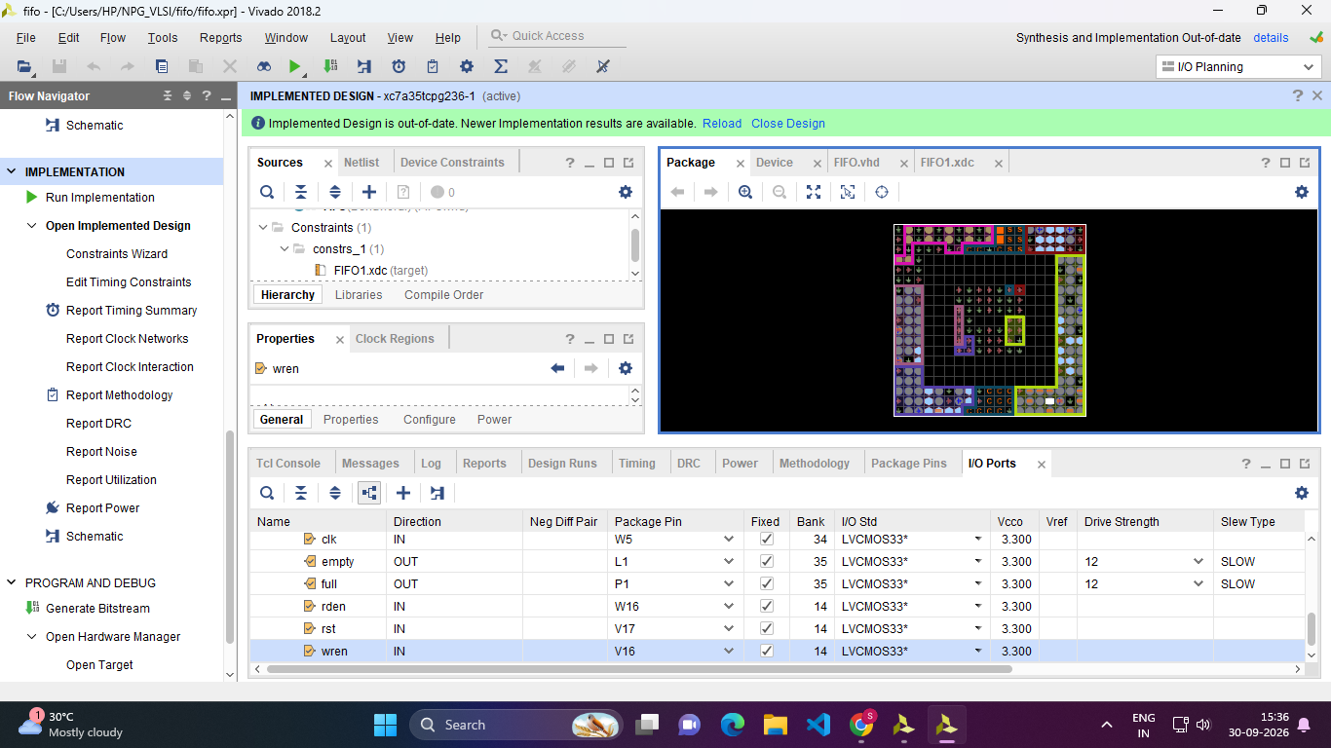
Vivado I/O Planning - Device view (clock regions X0Y0 to X1Y2):
