1. Screenshot of the web-page you created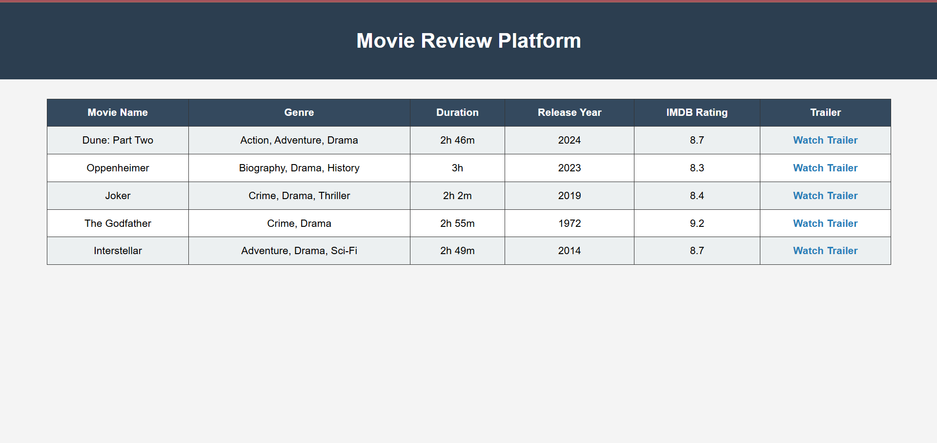

2. Analysis of the DOM structure
The webpage consists of a header element identified by an ID and a table containing movie data. Each movie is represented as a table row, with individual data points stored in table cells. Classes are used to identify each type of data, making extraction straightforward.

3. List of CSS Selectors

Data Point | CSS Selector
Movie Name | .movie-name
Genre | .movie-genre
Duration | .movie-duration
Release Year | .movie-year
IMDB Rating | .movie-rating
Trailer Link | .movie-trailer

4. Briefly explain the role of attributes
id: The purpose of the ID attribute is to identify a single element when linking (using a fragment identifier), scripting, or styling (with CSS). (https://developer.mozilla.org/en-US/docs/Web/HTML/Reference/Global_attributes/id#description)
class: Classes allow CSS and JavaScript to select and access specific elements via the class selectors or functions like the document.getElementsByClassName(). (https://developer.mozilla.org/en-US/docs/Web/HTML/Reference/Global_attributes/class)
Attributes (like href in <a> tag): Provide specific data (like URLs for trailers) that can be extracted directly by scraping tools.

