**JBA Test Specification**

**Document ID: Doc_JBA_v.1.1.0_TS_OQ**

**According to GAMP5 Appendix D5 (ISPE, pp. 198-199)**

**Document History**

|  |  |  |  |  |
| --- | --- | --- | --- | --- |
| **Version** | **What** | **Who** | **When** | **Comment/Signature** |
| 1.0 | New, issued for JBA v.1.1.0.0. | T’Challa, Test Analyst | 15-Jun-2020 | Digitally signed by Test Analyst (Author), SME (Reviewer), Process Owner (Approver) |

**Introduction**

This document is based on the approved Test Plan. It is specifically dedicated to the OQ for JBA_v.1.1.0.0. As defined in the Test Plan, this document shall be written by the Test Analyst, reviewed by the SME and approved by the Process Owner. It describes the OQ part of the JBA v.1.1.0.0 verification process.

**Purpose**

This document defines the set-up and the rules to be followed for a valid OQ execution. It guarantees a consistent embedding of the OQ in the whole verification process. The goal of the OQ is to get the formal evidence, that the pre-defined functional specifications are met.

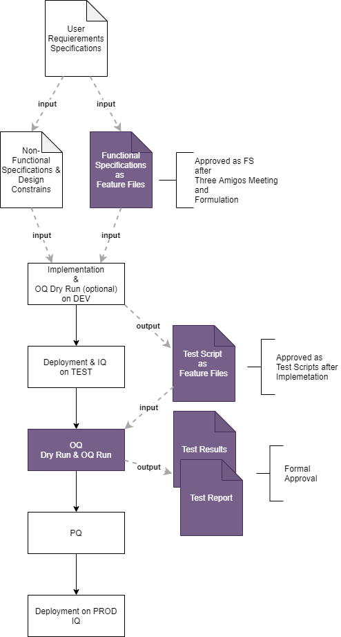

Figure 1: Overview of the whole verification process. The OQ part is highlighted in lilac.

**OQ Scope**

Version of Software to be verified in this OQ:

* JBA v.1.1.0.0: It additionally includes the implementation of the feature file 'consent management'.

OQ tests to be performed, required test review and reason:

OQ tests with a full test review to be performed on following feature files:

* Consent management, signature Version 1.0.0.0 approved by the Process Owner the 15th of June 2020 (new feature)
* Setting the baseline weight measurement, signature Version 1.0.0.0 approved by the Process Owner the 4th of June 2020 (to verify correct integration, business critical)

OQ tests with a partial test review to be performed on following feature files (regression only):

* Registration of a participant, signature Version 1.0.0.0 approved by the Process Owner the 4th of June 2020
* Participant’s overview, signature Version 1.0.0.0 approved by the Process Owner the 4th of June 2020

**Personnel/Resources**

Following roles and persons have an active role for the execution of OQs:

* Test Analyst: T’Challa, ct
* Process owner: Hank McKoy, mh
* SME: Patricia Walker, wp
* Tester: Scott Lang, ls
* Test Reviewer: Patricia Walker, wp
* Quality Unit: Hope Pym, ph

**Methods**

The OQ of the JBA application will be done by the test automation software ‘OQ Test App’. The OQ is done in an automated way based on the feature file (test scripts) and the glue code (automated tester).

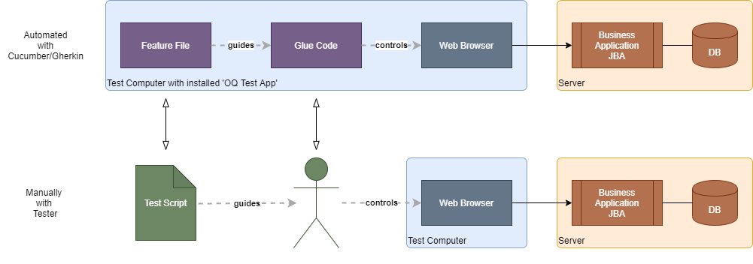

Fig. 2: Analogy between manual and automated testing.

In order to assure and confirm the correctness of the tests, a test review will be performed in a similar way as it would have been done for testing performed by a human tester.

The review is then based on the Test Results displayed in Scenarioo and documented on a report. The process shown in the Annexe will be followed.

**Prerequisites**

Before the OQ shall be performed following prerequisites needs to be fulfilled:

* IQs on JBA v.1.1.0.0 successfully performed
* OQ Test App validated
* Scenarioo validated

**Environment**

JBA Test Environment Platform.

**Tools** (including automated test tools)

Following tools have to be used:

* OQ Test App: To perform the OQ testing in an automated way
* Scenarioo: To display the test results for review and approval

**Reference to Specifications**

As the feature file is a combined functional specification and test script document, only the references to the user requirements are needed. The user requirements are identified by their unique ID, which is noted in the "Specification brief" section of the feature file.

**Required Documentation**

Following documentation are required for OQ:

* Feature Files: Written by the ThreeAmigos or a delegate, reviewed by the SME and approved by the Process Owner.
* Glue Code: Written by the supplier (incl a code review), 2nd code review by the Tester on the changed parts of the Glue Code.
* Test Result: consists of the autogenerated test results by the OQ Test App and the filled in document Doc_JBA_v.1.1.0_TER_OQ version 1.0: reviewed by the Test Reviewer, approved by the QA.
* Test Report based on Doc_JBA_v.1.1.0_TRep_OQ version 1.0: filled in by the Test Reviewer, reviewed and approved by the QA

**Test Execution**

The execution of the tests includes setting up the OQ Test App, running the automated runs (first as a dry run, then as a validation run) and filling out the form Doc_JBA_v.1.1.0_TER_OQ version 1.0. A zip file of the test results is placed in the folder \\dia\InterneProjekte\BDD4OQ\JBA\v.1.1.0.0\OQ\TestResults.

**Test Review**

The test results will be reviewed and based on that review a report will be written.

To guide that process the document „Test Report form” Doc_JBA_v.1.0.0_TRep_OQ version 1.0 has to be used, filled in and signed by the Test Reviewer.

In order to view the test results in Scenarioo, the zip file found in:

\\dia\InterneProjekte\BDD4OQ\JBA\v.1.1.0.0\OQ\TestResults is taken and checked if the signature of the tester is valid. The zip-file is unzipped and the folder with the test results is put into the location:

[\\dia\InterneProjekte\BDD4OQ\Scenarioo\Reports\JBA Version 1.1.0.0](\\\\dia\\InterneProjekte\\BDD4OQ\\Scenarioo\\Reports\\JBA Version 1.1.0.0)

Scenarioo can then be started and the results viewed in the Chrome browser with following url: <http://localhost:8080/scenarioo/>

The filled-in and signed form Doc_JBA_v.1.0.0_TRep_OQ should be placed in following folder for approval:

\\dia\InterneProjekte\BDD4OQ\JBA\v.1.1.0.0\OQ\TestReview

Two types of test reviews are foreseen:

* *Full Test Review*, for which each step with screenshot and the other available data needs to be verified: The goal is to fully verify the new functionalities and their integration. Therefore, the full test review is foreseen for all tests defined in new feature files, feature files that where subjected to changes since last OQ or for feature files that prove the correct integration of the new functionalities into the already existing JBA v.1.0.0.0. If whished by the SME or the Process Owner some additional feature files could also be subjected to the full test review (e.g. they might be of special business criticality).  
  As the full test review also checks the glue code, tests based on glue code that has changed and that allow to check the correct functioning of the changed glue code are also submitted to a full test review.
* *Partial Test Review*, for which the step by step verification can be omitted, as it concerns functionalities that did not change (regression tests) and for which it has been proven in a former OQ process, that the OQ Test App is working correctly and as expected[1].

**Test Approval**

The Doc_JBA_v.1.1.0_TRep_OQ that was filled and signed by the Test Reviewer is reviewed and approved by the QA.

**Annexe: OQ Execution Process**

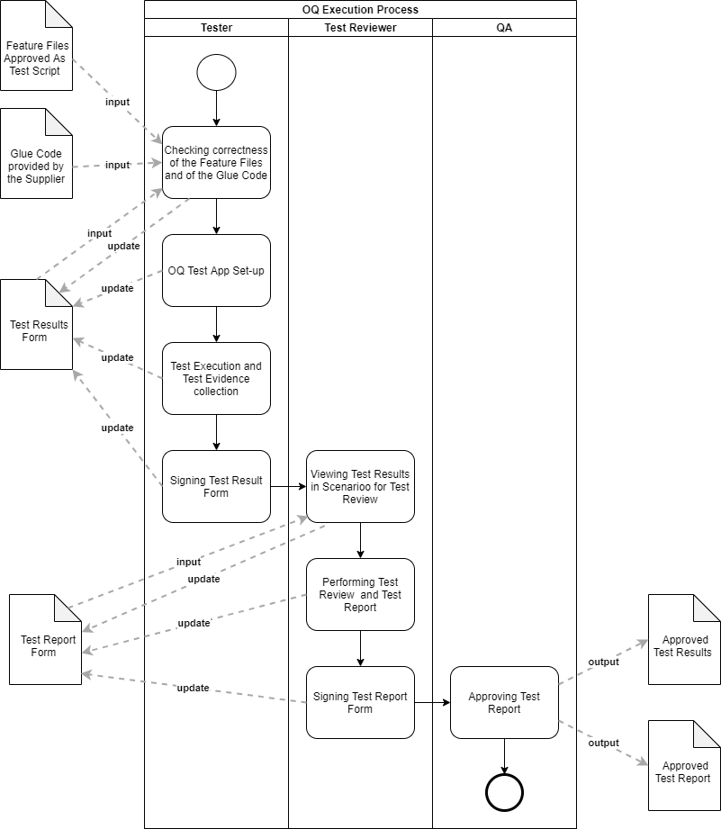

1. This allows that the complete specification suite is tested in the OQ of each new version, which would be very time consuming if performed manually.