VisionGuard
AI-generated versus real image classification and deployment
Assignment 2 report (MLOps). Tasks 1 to 3 are complete in this version; Tasks 4 to 8 will be added.
Name | [Your full name]
Roll number | 23L-0522
Project name | 23L-0522_A2_Ops
GitHub repository | [GitHub link]
DagsHub project | https://dagshub.com/saboor-sarfraz/mlops-a2
Live URL / API URL | [Add when Task 7 is deployed]
Commit hash of graded version | [Add commit hash]
AI assistant / tutorial disclosure | [State which AI assistant or tutorial was used and for what]
Date | [Date of submission]

Executive summary
The project compares a small convolutional neural network with a pretrained MobileNetV2. The model selected using validation data was transfer_finetune. The held-out test set was reserved for one final prediction pass per model; its results are shown in the evaluation section. A predicted AI probability is the sigmoid output, and label 1 denotes AI-generated artwork.

Task 1: Data Understanding and Versioning
The goal of this task is to understand the data before training anything. The dataset is the Kaggle collection AI Generated Images vs Real Images. The label of an image is the folder it sits in: RealArt holds the real images and AiArtData holds the AI-generated ones. Everything below was run from S:\MLOps\A2 with the project virtual environment active.

1.1 Environment
What I did. I used an isolated Python virtual environment at S:\MLOps\venv (Python 3.12.14) instead of the system Python, and installed TensorFlow and the supporting libraries into it with pip. I wrote two small scripts: check_tensorflow.py prints the interpreter, the operating system, the TensorFlow version and the GPU devices (Figure 1.1), and env_report.py prints the exact version of every library the project uses and saves the full package list to requirements_frozen.txt (Figure 1.2).
Why. An isolated environment keeps this project from clashing with other work, and recorded versions make every later result reproducible. That matters here because Keras 3 behaves differently from older Keras versions, so the same code can give different results on a different install.
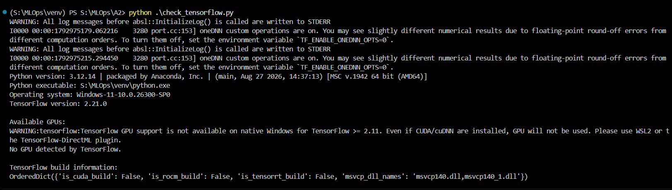
Figure 1.1: Output of check_tensorflow.py inside the venv: TensorFlow 2.21.0 and no GPU detected.
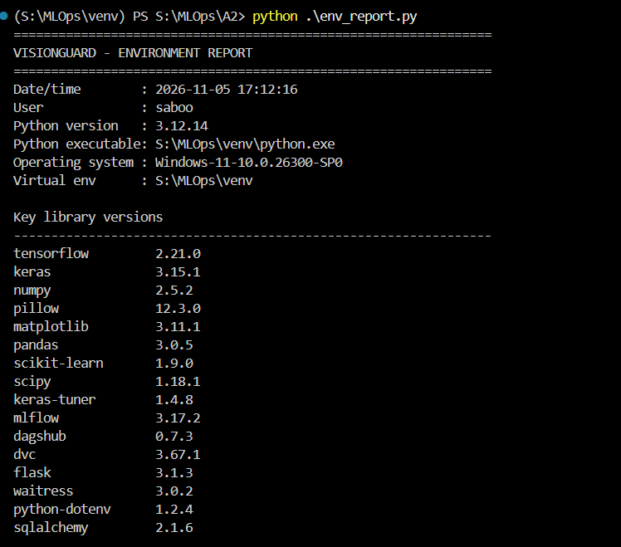
Figure 1.2: Output of env_report.py: exact version of every project library, with the full package list saved to requirements_frozen.txt.
Table 1.1 lists the versions installed in the environment, read from the installed package metadata.
Library | Version | Used for
tensorflow | 2.21.0 | Model training and tf.data input pipeline
keras | 3.15.1 | Model building API, callbacks
numpy | 2.5.2 | Array maths
pillow | 12.3.0 | Reading images in the audit script
matplotlib | 3.11.1 | EDA figures and later plots
pandas | 3.0.5 | Tables and CSV handling
scikit-learn | 1.9.0 | Metrics (precision, recall, ROC-AUC)
keras-tuner | 1.4.8 | Hyperparameter search (Task 2.7)
mlflow | 3.17.2 | Experiment tracking (Task 3)
dagshub | 0.7.3 | DagsHub integration
dvc | 3.67.1 | Data version control (Task 1.4)
flask | 3.1.3 | Web application (Task 4)
Table 1.1: Main library versions in the project environment.
GPU check. TensorFlow reports no GPU (Figure 1.1). This is expected: my computer has no supported GPU, and the warning in the screenshot also states that TensorFlow 2.11 and newer no longer use a GPU on native Windows. All training in the later tasks will therefore run on the CPU, which pushes me towards a small pretrained backbone and a modest image size so training stays practical.

1.2 Dataset audit
What I did. I wrote dataset_audit.py myself. It walks every class folder, keeps files with an image extension, and for each image records the class, file size, width, height, colour mode, format and a SHA-256 hash. To find unreadable files it opens each image with Pillow, calls verify(), then opens it again and calls load() so that the pixel data is fully decoded; a truncated file passes the first check but fails the second. The hash is computed in 1 MB chunks so large files do not fill memory. Two images with the same hash are byte-for-byte identical, which is how exact duplicates are found. The script writes image_audit.csv (one row per image), class_counts.csv, dataset_summary.csv, duplicate_files.csv and audit_report.txt. show_evidence.py prints these files for the screenshots (Figures 1.3 and 1.4).
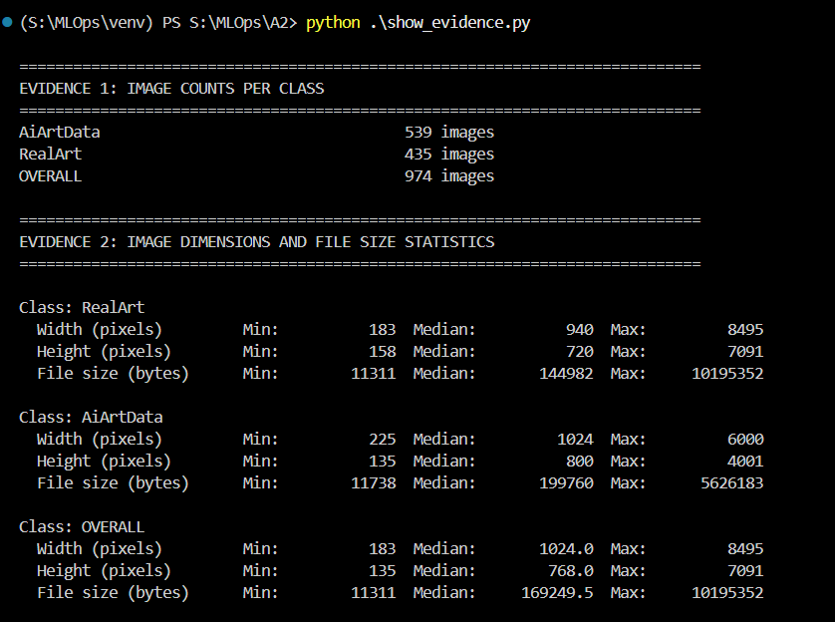
Figure 1.3: Image counts per class and min / median / max of width, height and file size (show_evidence.py).
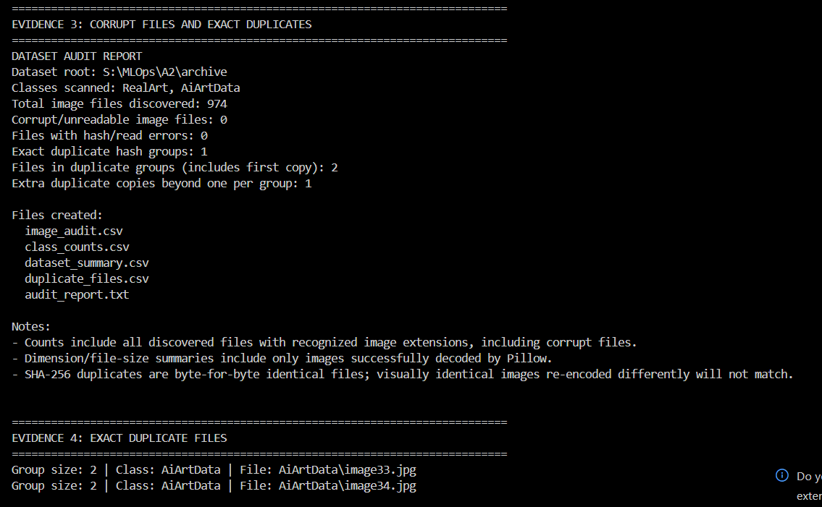
Figure 1.4: Corrupt-file and duplicate counts from the audit report, and the duplicate files found.
Table 1.2 summarises the numbers shown in Figures 1.3 and 1.4. Statistics only include images that decoded successfully, which here is all of them.
Measure | RealArt | AiArtData | Overall
Images | 435 | 539 | 974
Width min / median / max (px) | 183 / 940 / 8,495 | 225 / 1,024 / 6,000 | 183 / 1,024 / 8,495
Height min / median / max (px) | 158 / 720 / 7,091 | 135 / 800 / 4,001 | 135 / 768 / 7,091
File size min / median / max (bytes) | 11,311 / 144,982 / 10,195,352 | 11,738 / 199,760 / 5,626,183 | 11,311 / 169,250 / 10,195,352
Corrupt or unreadable files | 0 | 0 | 0
Exact duplicate pairs | 0 | 1 | 1
Table 1.2: Dataset audit summary.
What I found. The data has 974 images, 539 AI-generated (55.3%) and 435 real (44.7%). That is a mild imbalance, so I will use a stratified split and judge models with precision, recall and F1 as well as accuracy. No file is corrupt. There is one exact duplicate pair, and both files are in AiArtData (image33.jpg and image34.jpg). If one copy landed in training and the other in the test set, the test score would be inflated because the model would be tested on an image it already saw, so I will keep only one of the two before splitting. Image sizes range from 135 px to 8,495 px, so every image must be resized to one fixed shape for the network.
Limitation. A SHA-256 hash only catches byte-identical files. A copy that was resized or re-saved with different compression has a different hash and would not be found, so near-duplicates may still exist.

1.3 Visual EDA
What I did. visual_eda.py draws a grid of 12 random sample images per class (fixed random seed 42 so the grid is reproducible) and histograms of width, height and file size per class with 30 bins each. File size is plotted in kilobytes because bytes would give unreadable axis numbers. Only images that Pillow could decode are included. Each figure is explained below.
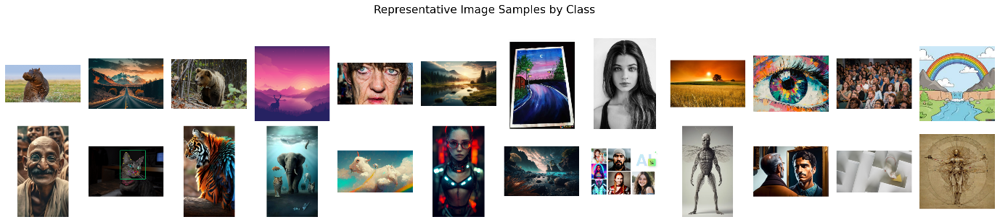
Figure 1.5: Sample images by class (OLD version without row labels - replace with the regenerated figure).
Interpretation. Each row shows 12 random images from one class, with the class name printed at the left of the row. Both classes mix portraits, animals, landscapes and illustration-like pictures, so subject matter alone does not separate them, although the AI row leans towards polished, highly stylised scenes. Image shapes vary a lot between portrait, landscape and square, so the pipeline must decide how to handle aspect ratio.
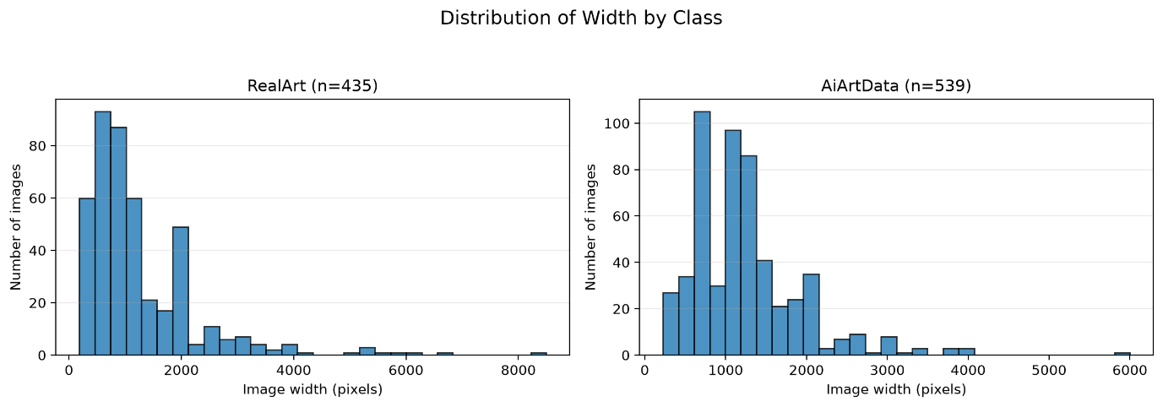
Figure 1.6: Distribution of image width by class.
Interpretation. Both classes are right-skewed. RealArt has a median width of 940 px and a long tail up to 8,495 px, while AiArtData has a median of 1,024 px, a tighter spread and a maximum of 6,000 px. Most images are under about 2,000 px wide, so resizing to a small fixed input size will almost always shrink them, and the few very wide images will not matter.
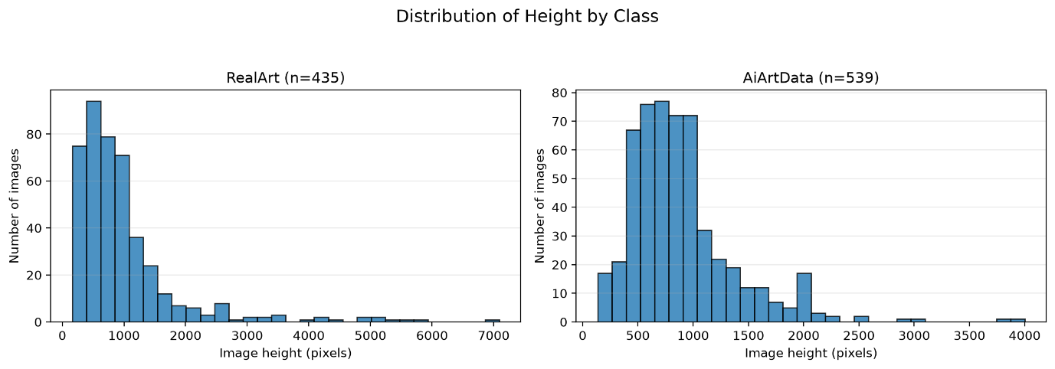
Figure 1.7: Distribution of image height by class.
Interpretation. The pattern mirrors width. RealArt peaks at lower heights (median 720 px) with outliers up to 7,091 px, whereas AiArtData is more bell-shaped around 500 to 1,000 px (median 800 px) and stops near 4,001 px. The two classes overlap heavily, which is good because image size alone should not be a strong clue to the label.
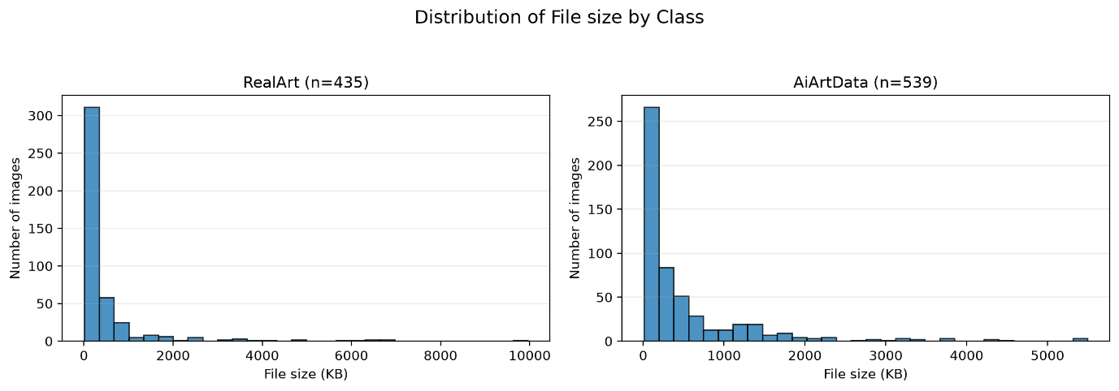
Figure 1.8: Distribution of file size by class (kilobytes).
Interpretation. Both histograms are strongly right-skewed with most files below about 500 KB. The median is about 145 KB for RealArt and 200 KB for AiArtData, and the largest files are 10.2 MB and 5.6 MB. Because file size and resolution differ slightly between the classes, a model could learn these shortcuts instead of real content, so all images are resized and re-encoded to the same shape before training.
What went wrong. In the first run the class names were missing from the rows of the sample grid. I had set them with set_ylabel, but the script turns the axes off with axis("off"), which also hides the label. I fixed it by drawing the class name as plain text next to the first image of each row.

1.4 DVC (data version control)

Toy part
Set-up. In a new empty folder dvc-toy-demo I created a small CSV (data/toy.csv, names and scores), then ran git init and dvc init. dvc init creates the .dvc folder (DVC configuration and cache) and a .dvcignore file, and these were committed as the first commit.
Tracking version 1. dvc add data/toy.csv moves the file contents into the DVC cache under a name derived from the file hash, leaves the file in place in the workspace, writes a small pointer file toy.csv.dvc, and adds data/toy.csv to data/.gitignore so Git stops watching the real file. I then committed only the pointer file and the .gitignore (Figure 1.9).
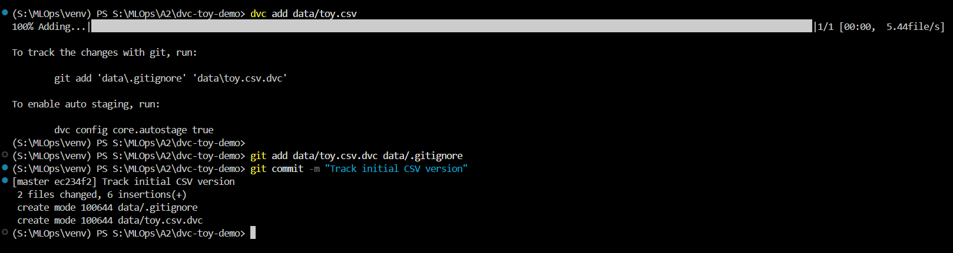
Figure 1.9: dvc add and the first Git commit of the toy CSV (version 1).
Version 2. I edited the CSV, ran dvc add again, and committed the changed pointer as a second version. Figure 1.10 shows the commit history and the new file content.
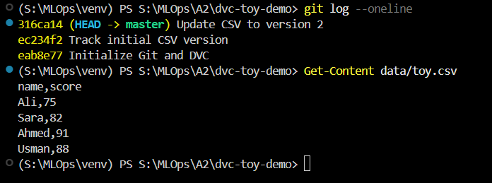
Figure 1.10: git log showing the initial commit, version 1 and version 2, and the updated CSV content.
Remote storage, push and pull. I configured a local folder (dvc-storage) as the default DVC remote. dvc push uploads the cached data to it (Figure 1.11). After deleting the local data, dvc pull fetched the file back from the remote and restored it in the workspace (Figure 1.12). Figures 1.13 and 1.14 show the remote being configured and the data being pulled back after it was deleted.
Figure 1.11: dvc push uploads the tracked data to the remote storage.
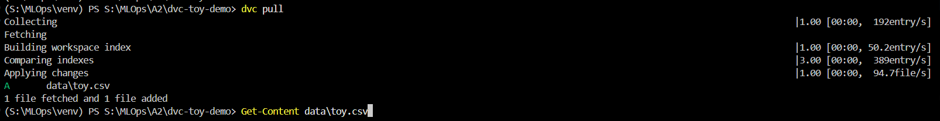
Figure 1.12: dvc pull restores the deleted data from the remote.
Returning to the older version. Git checks out the older commit, which brings back the older pointer file; dvc checkout then reads that pointer and puts the matching data back into the workspace. Going back to master and running dvc checkout again restores the newest data. So Git moves through history and DVC makes the data follow it.
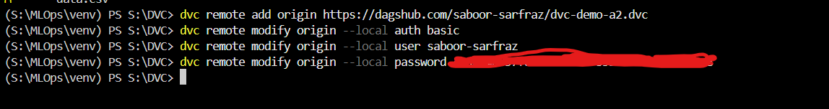
Figure 1.13: Setting up DVC remote storage for the toy project.
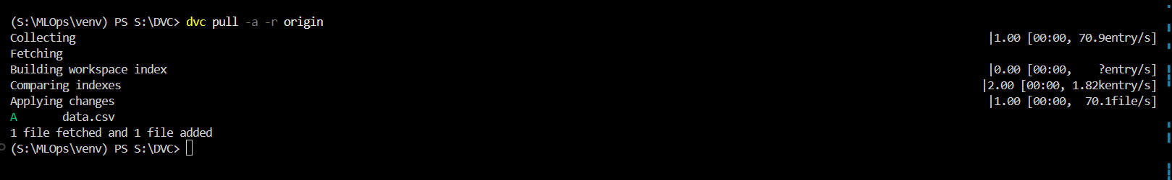
Figure 1.14: Pulling from the remote after deleting the DVC cache and the local CSV file.

Apply part: the real dataset
I tracked the dataset folder the same way. dvc add archive hashes the whole folder (974 images), stores the files in the DVC cache and creates one small pointer file, archive.dvc, which I committed. The remote is DagsHub storage, configured with dvc remote add. The access token was written with --local, which stores it in .dvc/config.local, a file DVC keeps out of Git, so no secret is committed. Figure 1.15 shows the dataset push.
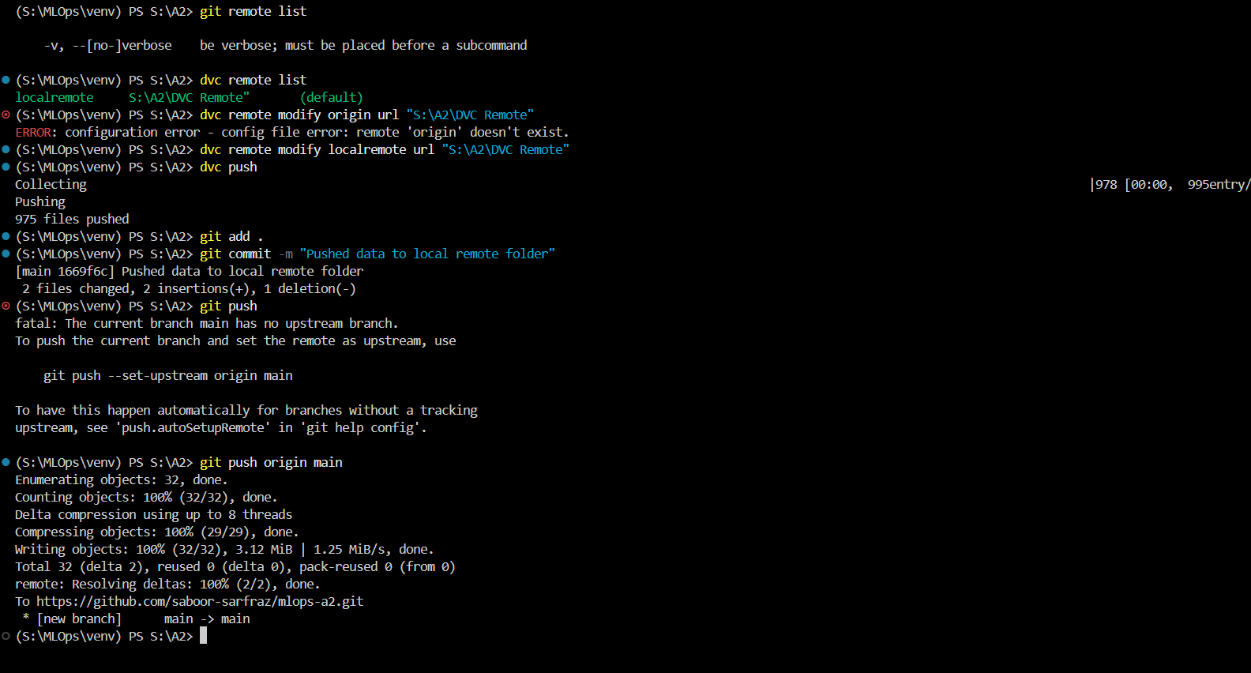
Figure 1.15: Original dataset pushed to the DVC remote (Apply part).

What the pointer file holds, and why large data does not belong in Git
The pointer file (archive.dvc or toy.csv.dvc) is a few lines of YAML. It holds the MD5 hash of the tracked file or folder, its total size, the number of files for a folder, and its path. It contains none of the actual data. The hash acts as the address of the content: DVC stores the real files in its cache and in the remote under that hash, and recreates them in the workspace whenever a checkout or pull is run for that pointer. Because the pointer changes whenever the data changes, committing it in Git records exactly which version of the data belongs to which version of the code.
Large data does not belong in Git for four reasons. Git keeps every version of every file in its history forever, so a repository holding images only ever grows. Every clone has to download that whole history. Hosting services limit file and repository sizes. And Git cannot store small differences between binary files such as images, so each changed file is stored again in full. Git is therefore used for what it does well (code, small pointers and history), and DVC moves the heavy data to separate storage.

Task 2: Model Development with TensorFlow/Keras
This task trains two models and compares them: a small CNN built from scratch and a pretrained MobileNetV2 fine-tuned on the data. Sub-tasks 2.1 to 2.7 follow the assignment order, and the optional Grad-CAM bonus is at the end. All figures and tables were generated by the project scripts and are stored in visionguard_outputs.

2.1 Input pipeline
Split | Images | Real (label 0) | AI-generated (label 1)
Train | 681 | 304 | 377
Validation | 146 | 65 | 81
Test | 146 | 66 | 80
Table 2.1: Train, validation and test split sizes.
The archive contains 974 recognized image files. 1 byte-identical duplicate was removed before splitting so identical files cannot leak across subsets. Split lists are saved as CSV files under visionguard_outputs/splits and are reused on subsequent runs. The split is stratified, reproducible (seed 42), and approximately 70%/15%/15%. Table 2.1 lists the split sizes and Figure 2.1 shows one augmented training batch.
- The CSV split list supplies a path and binary label; label 0 is RealArt and label 1 is AiArtData.
- tf.io.read_file loads each file and tf.io.decode_image decodes it into three RGB channels; GIFs use their first frame.
- tf.image.resize converts every decoded image to 160 x 160 pixels using bilinear interpolation with antialiasing. Images are stretched directly to a square: aspect ratio is not preserved, so circles/faces can be slightly distorted. No crop is used.
- Images remain float32 in [0, 255] in the input pipeline. Only training data is shuffled and receives random horizontal flips, rotations, zoom, and contrast variation. Validation and test data are not augmented or shuffled.
- The examples are grouped into batches of 32 and prefetched with tf.data.AUTOTUNE to overlap input work with model execution.
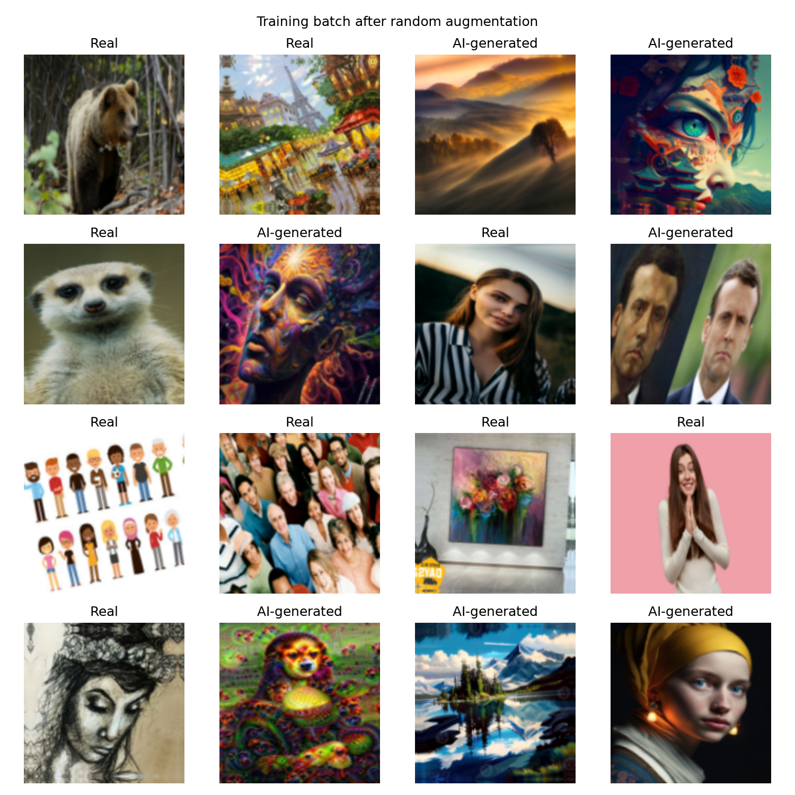
Figure 2.1: Example training batch after random augmentation (labels shown above each image).

2.2 Baseline CNN
The baseline is a compact Keras CNN trained from scratch. Binary cross-entropy is appropriate for the single sigmoid probability and binary labels. Adam starts at 1e-3 to provide adaptive updates. Accuracy is easy to interpret; precision and recall expose the two error types; ROC-AUC measures ranking over thresholds. Figure 2.2 and Table 2.2 show the resulting architecture.
- Rescaling maps RGB pixels from [0, 255] to [0, 1], making optimization numerically stable.
- Three 3 x 3 convolutions (32, 64, 128 filters) learn increasingly complex local patterns; batch normalization stabilizes activations and ReLU adds non-linearity.
- Max pooling reduces spatial resolution and computation. Dropout after the second block and after the dense layer reduce overfitting on this small dataset.
- Global average pooling replaces a large flatten layer with a compact feature vector, reducing parameters; a 128-unit dense layer combines learned features.
- A final one-unit sigmoid returns P(AI-generated), the only output required for binary classification.
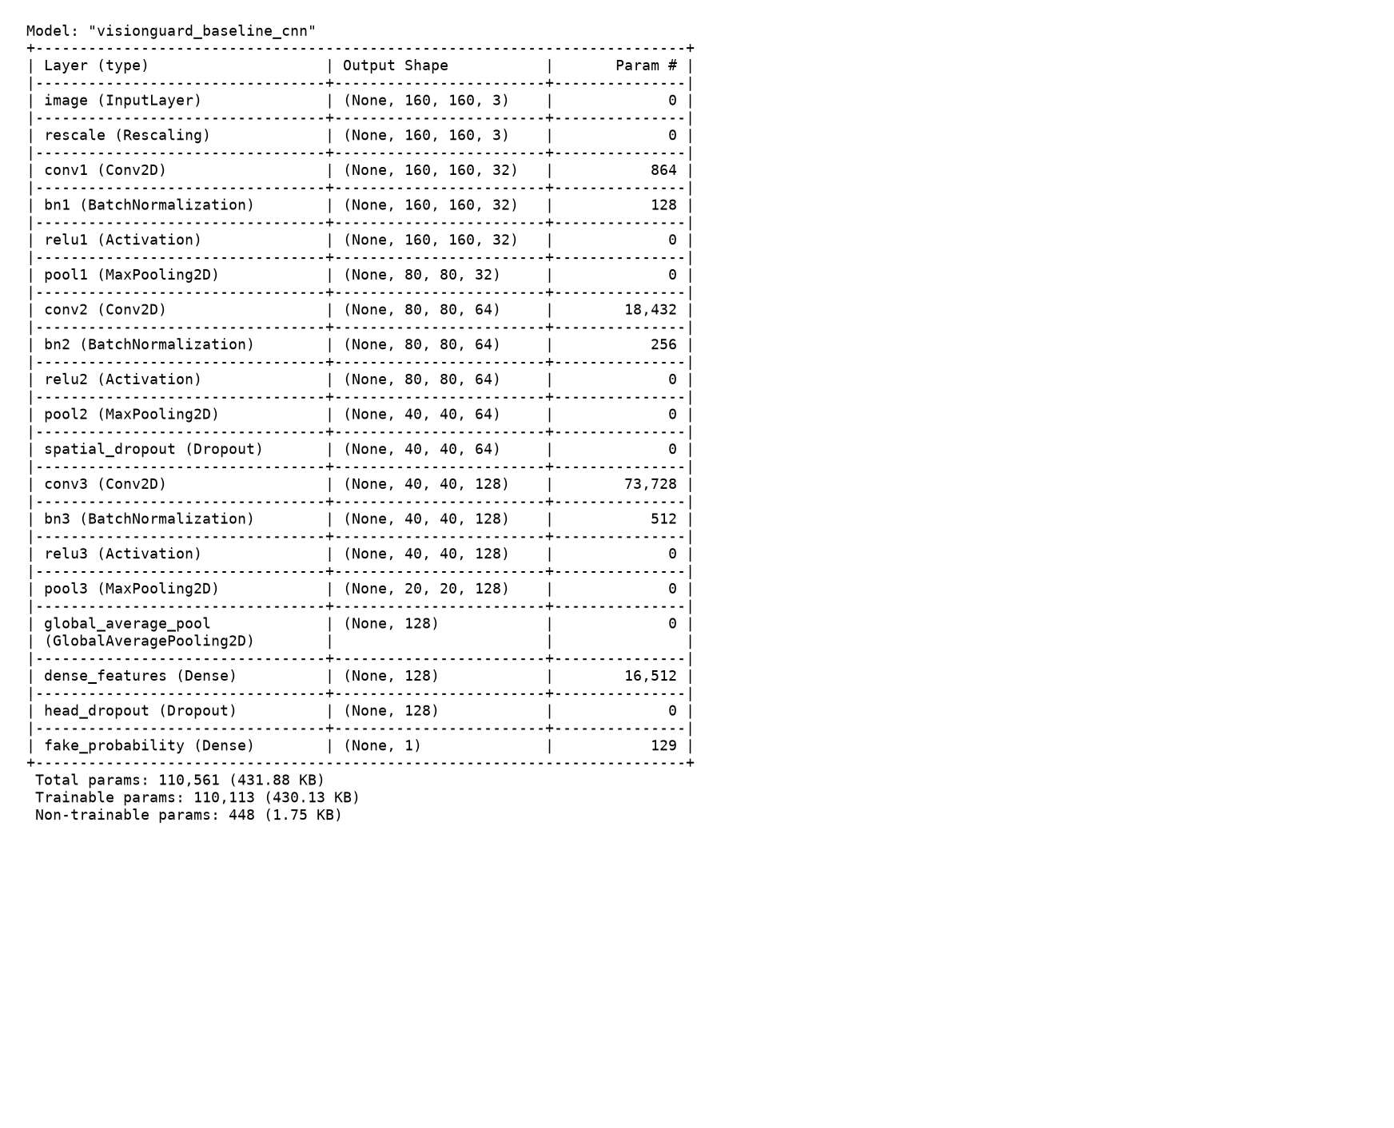
Figure 2.2: Keras baseline model.summary() rendered as an image for quick inspection.
Layer | Output shape | Parameters
image | (None, 160, 160, 3) | 0
rescale | (None, 160, 160, 3) | 0
conv1 | (None, 160, 160, 32) | 864
bn1 | (None, 160, 160, 32) | 128
relu1 | (None, 160, 160, 32) | 0
pool1 | (None, 80, 80, 32) | 0
conv2 | (None, 80, 80, 64) | 18432
bn2 | (None, 80, 80, 64) | 256
relu2 | (None, 80, 80, 64) | 0
pool2 | (None, 40, 40, 64) | 0
spatial_dropout | (None, 40, 40, 64) | 0
conv3 | (None, 40, 40, 128) | 73728
bn3 | (None, 40, 40, 128) | 512
relu3 | (None, 40, 40, 128) | 0
pool3 | (None, 20, 20, 128) | 0
global_average_pool | (None, 128) | 0
dense_features | (None, 128) | 16512
head_dropout | (None, 128) | 0
fake_probability | (None, 1) | 129
Table 2.2: Baseline CNN output shape and parameter count per layer.

2.3 Transfer learning
MobileNetV2 is loaded from keras.applications with include_top=False and ImageNet weights. Its expected input transform maps RGB pixels to [-1, 1], implemented as Rescaling(scale=1/127.5, offset=-1) inside the model. This keeps preprocessing consistent with the pretrained feature extractor. Table 2.3 lists the trainable layers in each stage, and Figures 2.3 and 2.4 show the two sets of training curves.
- Stage 1: freeze the complete pretrained backbone and train a new global-average-pooling, 128-unit ReLU, 0.30-dropout, sigmoid head.
- Stage 2: unfreeze only MobileNetV2 block_16 (the last inverted-residual block), keep its batch-normalization layers frozen, and continue with Adam at 1e-5.
Training stage | Trainable backbone layers | Trainable head layers
Frozen backbone | None | dense_features, fake_probability
Fine-tuning | block_16_expand, block_16_depthwise, block_16_project | dense_features, fake_probability
Table 2.3: Trainable layers in each transfer-learning stage.
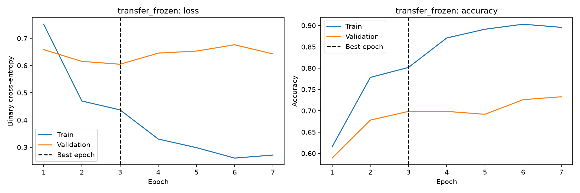
Figure 2.3: Transfer-learning stage 1 (frozen backbone); best validation-loss epoch: 3.
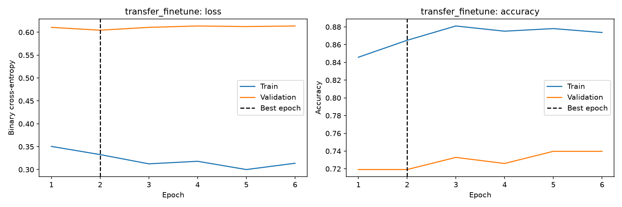
Figure 2.4: Transfer-learning fine-tuning stage; best validation-loss epoch: 2.

2.4 Training discipline
Python, NumPy, and TensorFlow/Keras seeds are fixed at 42; TensorFlow deterministic operations are enabled. All models monitor validation binary cross-entropy. ModelCheckpoint saves the lowest-validation-loss model, EarlyStopping stops after four non-improving epochs and restores best weights, and ReduceLROnPlateau reduces the learning rate by a factor of 0.2 after two stagnant epochs. Best epochs are defined as the epoch with minimum validation loss. Training ran on the CPU because TensorFlow reported no usable GPU in the native Windows environment. Figures 2.5 to 2.7 show the loss and accuracy curves for each run, with the best epoch.
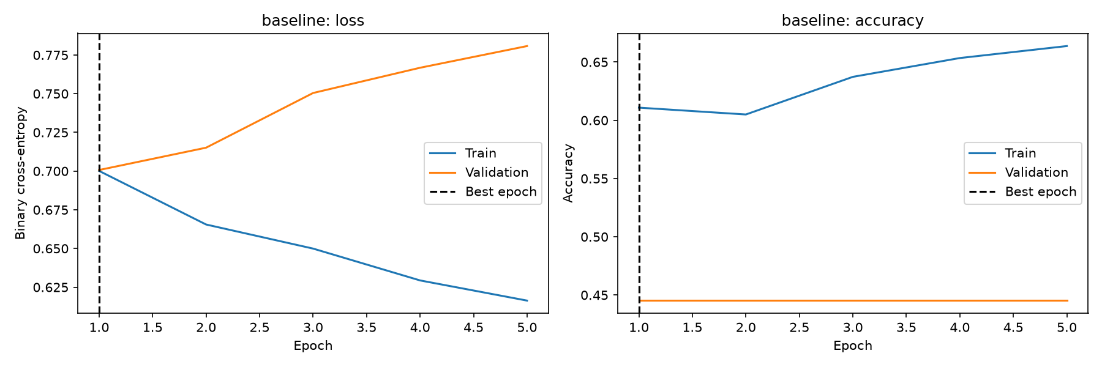
Figure 2.5: Baseline CNN loss and accuracy curves; best epoch 1 of 5 epochs.
Figure 2.6: Transfer stage 1 curves (same plot as Figure 2.3); best epoch 3 of 7 epochs.
Figure 2.7: Transfer fine-tuning curves (same plot as Figure 2.4); best epoch 2 of 6 epochs.

2.5 Evaluation
For each model, the decision threshold is chosen using validation predictions only by minimizing 2 x false positives + false negatives; ties choose the higher threshold. A false positive here means calling a real image AI-generated. For a tool that may label an authentic photograph as fake, that accusation is the worse product error, so it receives twice the cost of allowing an AI image through. Test data is not used to choose thresholds or select a model. Each model is run once on the test dataset, and all thresholded metrics, ROC values, and error examples reuse that pass.
The optional Grad-CAM figure is generated from validation examples in this report. It uses additional forward/gradient passes only for up to eight selected examples and does not alter the threshold, model selection, or test metrics.
Model | Accuracy | Precision | Recall | F1 | ROC-AUC | Threshold | FP | FN
Baseline CNN | 0.4521 | 0.0000 | 0.0000 | 0.0000 | 0.6112 | 0.4795 | 0 | 80
MobileNetV2 fine-tuned | 0.7534 | 0.8793 | 0.6375 | 0.7391 | 0.8498 | 0.7717 | 7 | 29
Table 2.4: Test-set metrics for both models (each model evaluated once on the test set).
In this run the baseline's validation-selected threshold produced zero AI detections on the test set (F1 = 0). MobileNetV2 was selected using validation cost (51 versus 80 for the baseline), but it still missed 29 AI images and falsely flagged 7 real images on test. Treat these numbers as evidence from this small dataset, not a deployment guarantee. Table 2.4 lists the test metrics and Figures 2.8 to 2.11 show the confusion matrices and ROC curves.
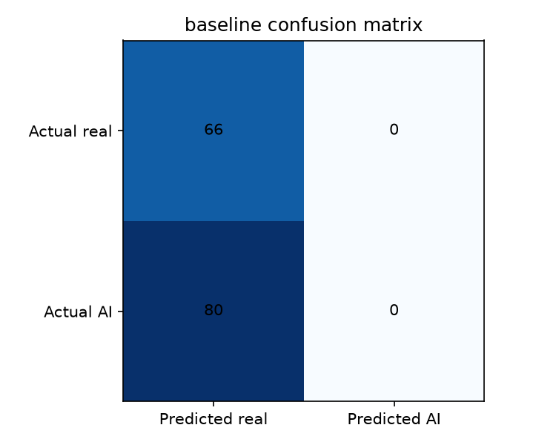
Figure 2.8: Baseline confusion matrix at its validation-selected threshold.
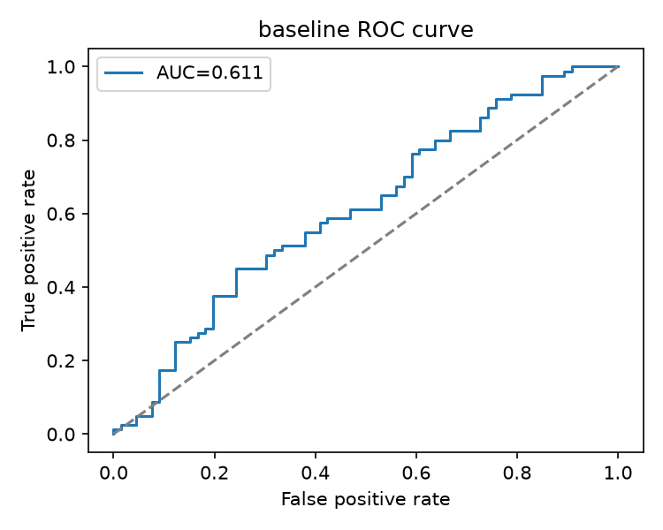
Figure 2.9: Baseline ROC curve; AUC is threshold-independent.
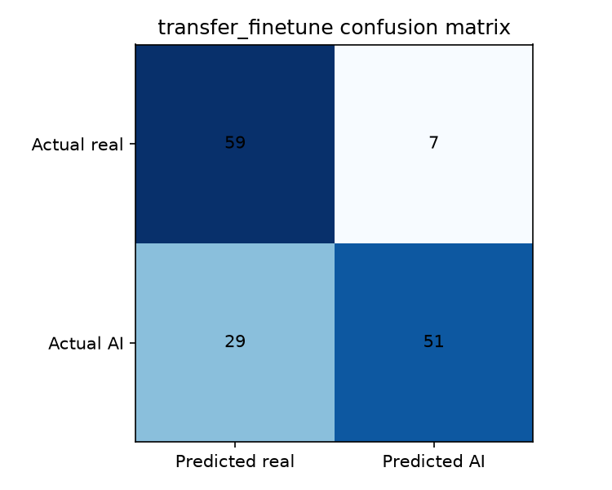
Figure 2.10: MobileNetV2 confusion matrix at its validation-selected threshold.
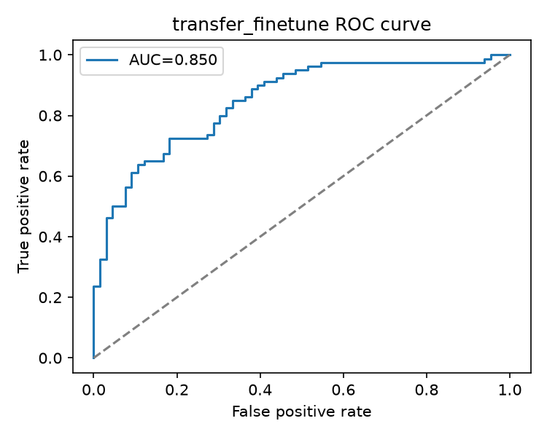
Figure 2.11: MobileNetV2 ROC curve; AUC is threshold-independent.

2.6 Error analysis
The validation-cost-selected model (transfer_finetune) supplies the displayed error examples. The image-specific explanations below are hypotheses to verify visually, not proven causes.
The reviewed grid contains photo-like AI portraits/animals that were called real, and a genuine waterfall and historical painting collage called AI. This suggests substantial style overlap: the classifier may use visual style rather than reliable generation provenance, so it should not be treated as an authenticity detector. The grid is Figure 2.12 and the hypothesis for each image is in Table 2.5.
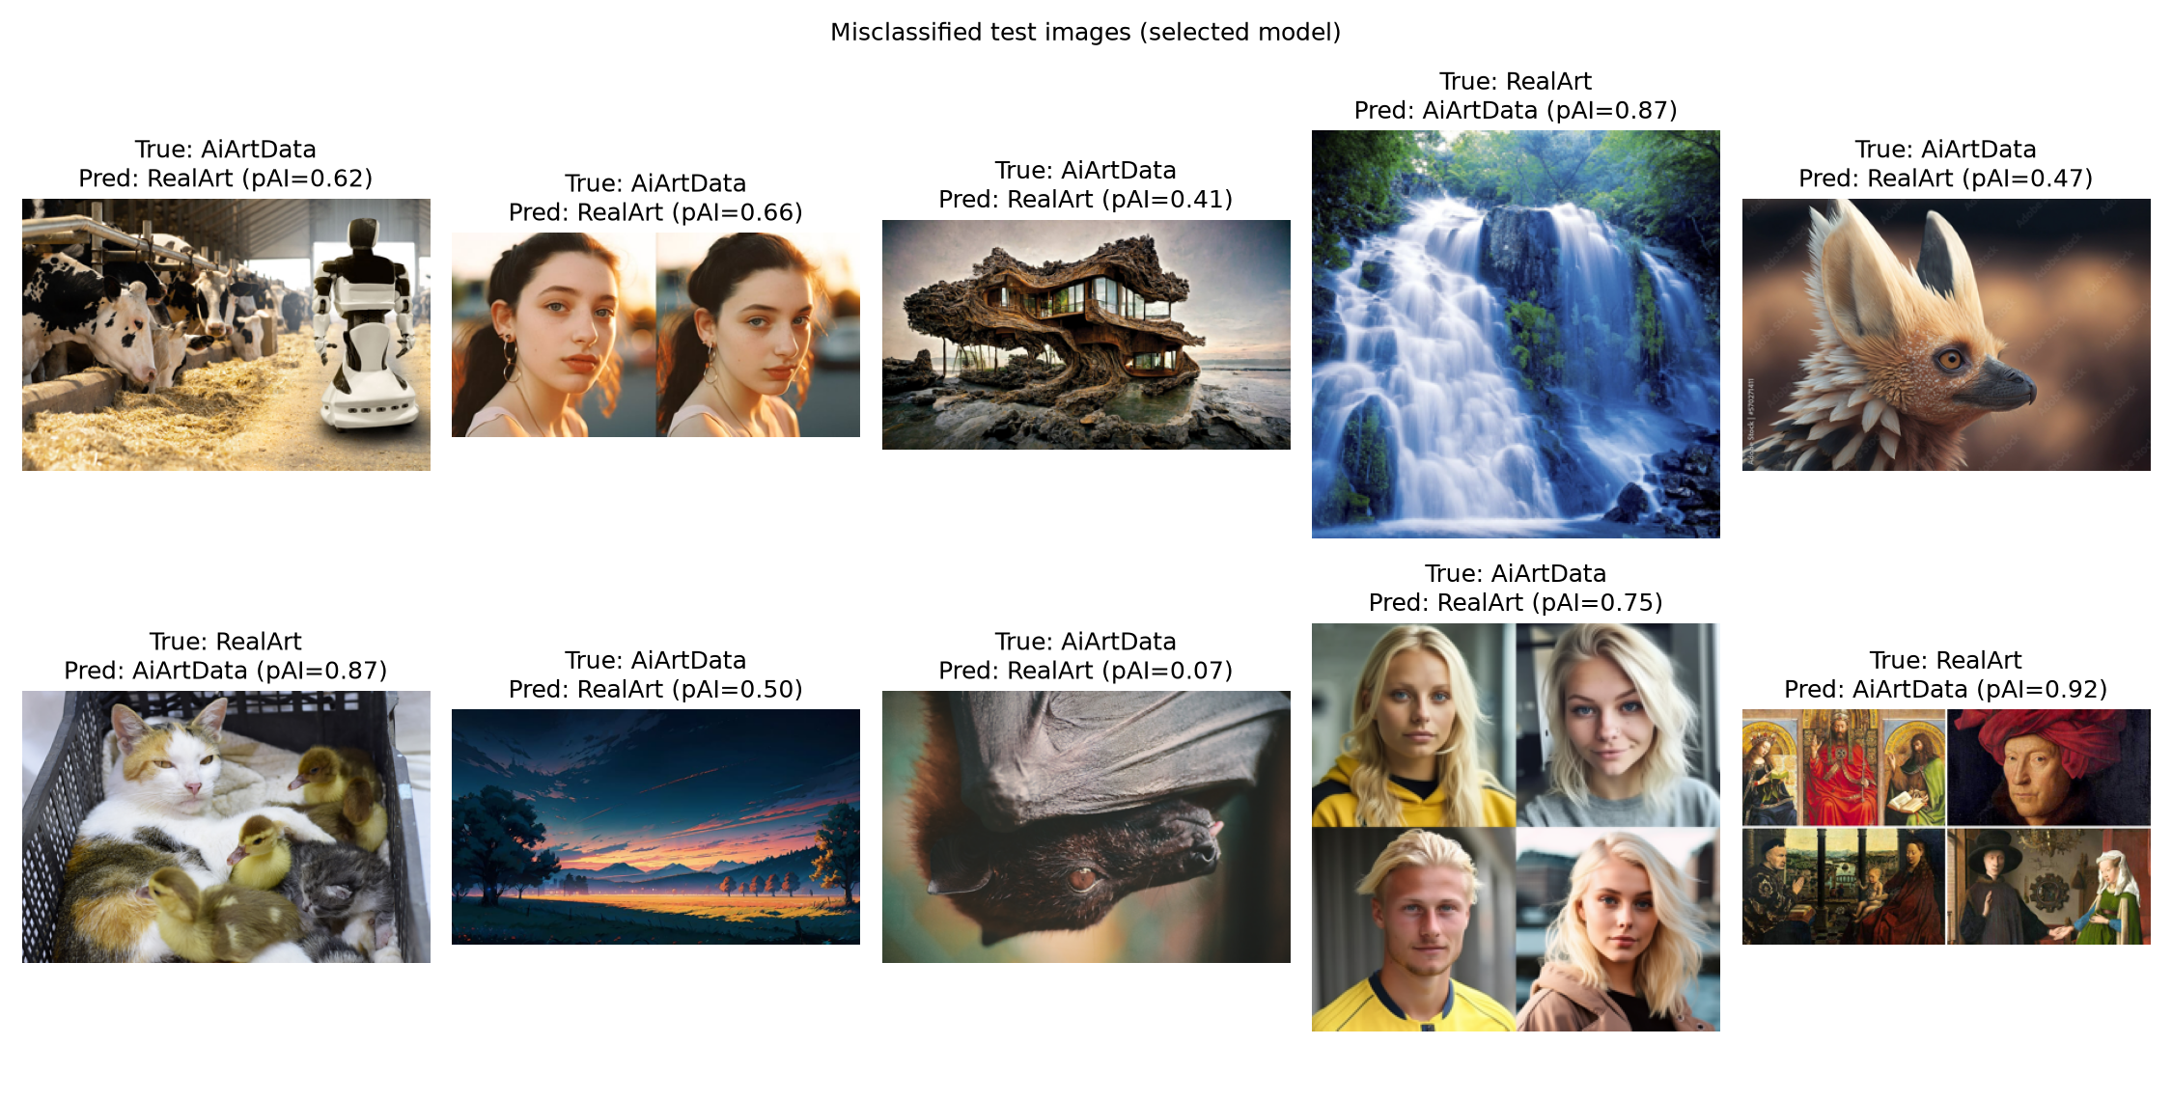
Figure 2.12: Up to 10 test-set misclassifications from the selected model.
# | Image | Actual -> predicted | P(AI) | Hypothesis
1 | robot-monitoring-dairy-farm-1200x800-1.jpg | AiArtData -> RealArt | 0.624477 | The detailed farm scene, plausible lighting, and robot/cow context may have made this AI image look like a documentary photograph.
2 | midjourney-v5-drafts-Artboard-4-800x400.jpg | AiArtData -> RealArt | 0.660369 | The realistic skin, portrait lighting, and side-by-side photo layout may have obscured generation cues.
3 | ures-created-on-midjourney-midjourney-curated-feature-stirworld-220930050044.jpg | AiArtData -> RealArt | 0.411007 | Natural-looking bark, architecture, and sunset lighting may have made this AI concept image resemble a real location photograph.
4 | nature-scenery.jpg | RealArt -> AiArtData | 0.867439 | The smooth long-exposure waterfall and saturated foliage may resemble synthetic landscape rendering.
5 | 1000_F_570271411_Tqbdg5z0mL3qV3eaDS0XGrjMMwk6aNTf.jpg | AiArtData -> RealArt | 0.473746 | Detailed fur, shallow depth of field, and a stock-style watermark may make this AI animal portrait look photographic.
6 | cat-with-ducklings.jpg | RealArt -> AiArtData | 0.867418 | The unusual animal grouping may look compositionally improbable, even though the image is labeled real.
7 | HD-wallpaper-ai-landscape-2023-digital-art.jpg | AiArtData -> RealArt | 0.504672 | The smooth sunset gradient and silhouette may imitate a conventional landscape photograph and hide painterly cues.
8 | Earth-Species-project-generative-ai-unders.max-2100x2100.jpg | AiArtData -> RealArt | 0.067660 | Dark exposure, close cropping, and dense fur-like texture may resemble a real wildlife close-up.
9 | Dottemannen_photo_of_a_blonde_swede_5d222c23-1088-4336-93c6-0fbd355e8150.png | AiArtData -> RealArt | 0.748049 | Photorealistic faces and skin detail in the portrait collage may have hidden synthetic inconsistencies.
10 | most-famous-paintings-by-jan-van-eyck.jpg | RealArt -> AiArtData | 0.920853 | Painterly texture and the collage of historical portraits may have triggered style cues associated with generated artwork.
Table 2.5: The ten misclassified test images with a hypothesis for each.

2.7 Tool lab: Keras Tuner
The toy search uses RandomSearch on Fashion-MNIST with 8 trials, tuning the hidden-unit count and Adam learning rate. It selected {'units': 256, 'learning_rate': 0.001715074355925934} and achieved test accuracy 0.8636. Table 2.6 shows the toy search results.
Trial | Units | Learning rate | Best validation accuracy
5 | 256 | 0.00171507 | 0.8713
2 | 256 | 0.000505467 | 0.8658
1 | 128 | 0.000349744 | 0.8598
4 | 128 | 0.000306927 | 0.8563
6 | 256 | 0.000151593 | 0.8482
7 | 256 | 0.000121655 | 0.8450
0 | 192 | 0.000119427 | 0.8445
3 | 160 | 0.000136072 | 0.8420
Table 2.6: Toy Keras Tuner search on Fashion-MNIST (8 trials).
The applied search uses 8 RandomSearch trials on VisionGuard, with MobileNetV2, tuning learning rate, dropout, and the number of final backbone layers opened for fine-tuning (batch-normalization layers stay frozen). Its best validation-loss setting was {'learning_rate': 4.126800832382481e-05, 'dropout': 0.30000000000000004, 'unfrozen_layers': 15} (validation loss 0.5388). Table 2.7 lists the trials.
trial_id | learning_rate | dropout | unfrozen_layers | objective
6 | 4.126800832382481e-05 | 0.30000000000000004 | 15 | 0.5387737154960632
0 | 0.00019004375238737127 | 0.2 | 5 | 0.5761297941207886
7 | 7.767449713530702e-05 | 0.30000000000000004 | 5 | 0.586186945438385
2 | 0.00012482904754698164 | 0.2 | 5 | 0.5906672477722168
3 | 3.069273045576998e-05 | 0.4 | 10 | 0.6406668424606323
1 | 3.497444477863496e-05 | 0.4 | 5 | 0.6512525677680969
4 | 0.0006718710759425462 | 0.2 | 15 | 0.6578418016433716
5 | 1.2165541012624622e-05 | 0.30000000000000004 | 0 | 0.7412360906600952
Table 2.7: Keras Tuner trials for VisionGuard (MobileNetV2), best first.
Within these trials, learning_rate had the largest observed grouped mean validation-loss spread (largest sampled difference in mean validation loss: 0.2025 (0.5388 to 0.7412)). It may matter most because it directly changes update size, so values that are too large can destabilize fine-tuning while values that are too small adapt slowly. This is an exploratory signal, not a controlled causal comparison: random trials can confound hyperparameters and training noise.
Selecting the best result after many trials can overfit the validation set because each trial indirectly adapts choices to that same validation data. The test set remains untouched until the final evaluation, and a larger study should use nested validation or a separate tuning holdout.

Bonus: Grad-CAM
Grad-CAM highlights feature-map regions that locally contribute to the AI score. In these examples attention often falls on central subjects or bright, high-contrast textures (including portrait clothing/neck areas and landscape terrain), rather than one consistent generation artifact. This may indicate reliance on content or style cues; the maps are qualitative and do not establish causal evidence. The maps are shown in Figure 2.13.
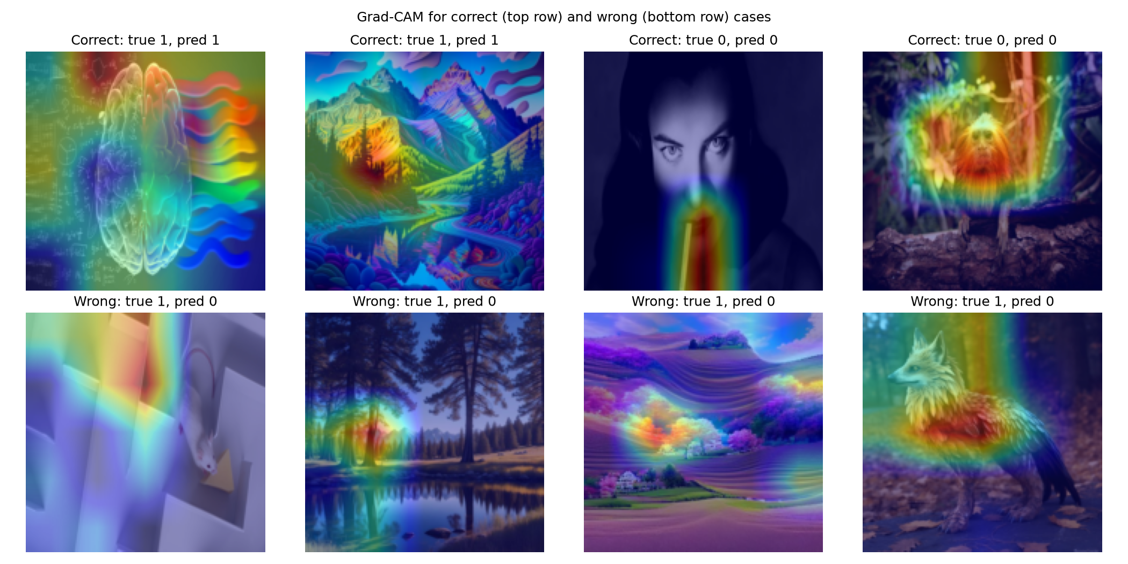
Figure 2.13: Up to four correct and four incorrect predictions with Grad-CAM overlays.

Reproducing the Task 2 results
From the repository root, activate the project virtual environment and run:
S:\MLOps\venv\python.exe visionguard.py
S:\MLOps\venv\python.exe keras_tuner_lab.py --mode all --trials 8
S:\MLOps\venv\python.exe generate_gradcam.py
S:\MLOps\venv\python.exe build_report.py
Use --prepare-only to create split lists and the augmented-batch figure without training. Run generate_gradcam.py after training to produce Grad-CAM from validation examples without re-running test evaluation. Outputs are stored in visionguard_outputs/.

Task 3: Experiment Tracking with MLflow and DagsHub
MLflow was configured with a local SQLite tracking database at mlflow_local.db and its local artifact store. Runs were verified through MLflow's tracking client and the local interface at http://127.0.0.1:5050.

3.1 Local toy runs and terminology
- Experiment: a named group of related training runs.
- Run: one recorded execution, with its own parameters, metrics, tags, and artifacts.
- Parameter: an input setting such as learning rate or batch size.
- Metric: a measured number such as validation loss at a particular epoch.
- Artifact: a file produced or saved by a run, such as a chart or model.
- Tag: searchable descriptive metadata, for example logging method or data version.
Two Fashion-MNIST runs that differ only in learning rate were logged locally (Table 3.1). Figures 3.1 and 3.2 show the per-epoch metrics of each run, Figure 3.3 shows the comparison view of the two runs, and Figure 3.4 shows the local run list.
Run | Learning rate | Test accuracy | Test loss
fashion_lr_0.0001 | 0.0001 | 0.8198 | 0.5312
fashion_lr_0.001 | 0.001 | 0.8624 | 0.3869
Table 3.1: Local Fashion-MNIST toy runs with different learning rates.
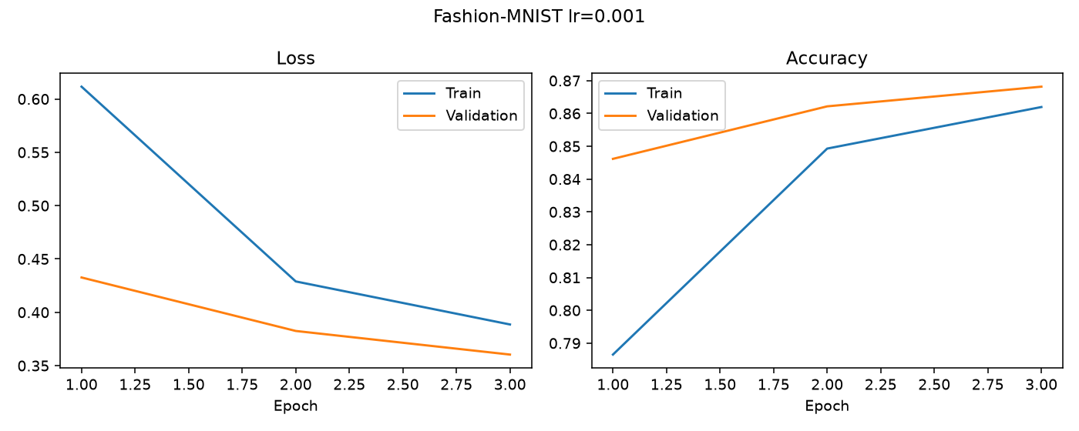
Figure 3.1: Fashion-MNIST training and validation metrics for toy run 1 (learning rate 0.0001).
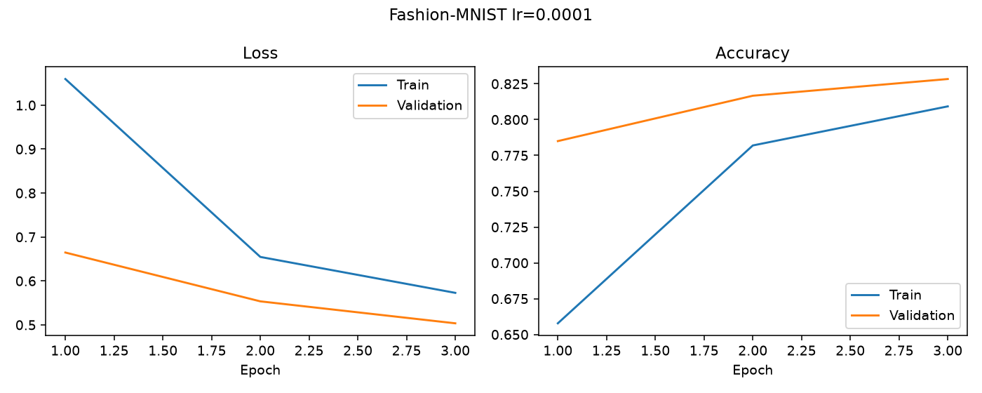
Figure 3.2: Fashion-MNIST training and validation metrics for toy run 2 (learning rate 0.001).
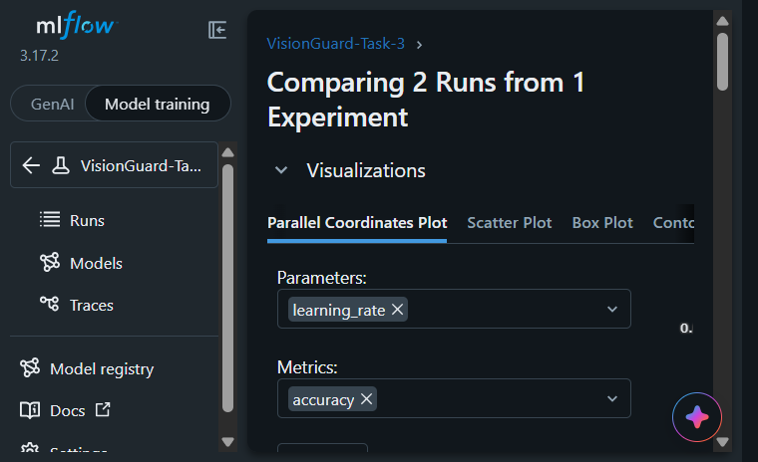
Figure 3.3: Local MLflow comparison view configured for the two Fashion-MNIST runs.
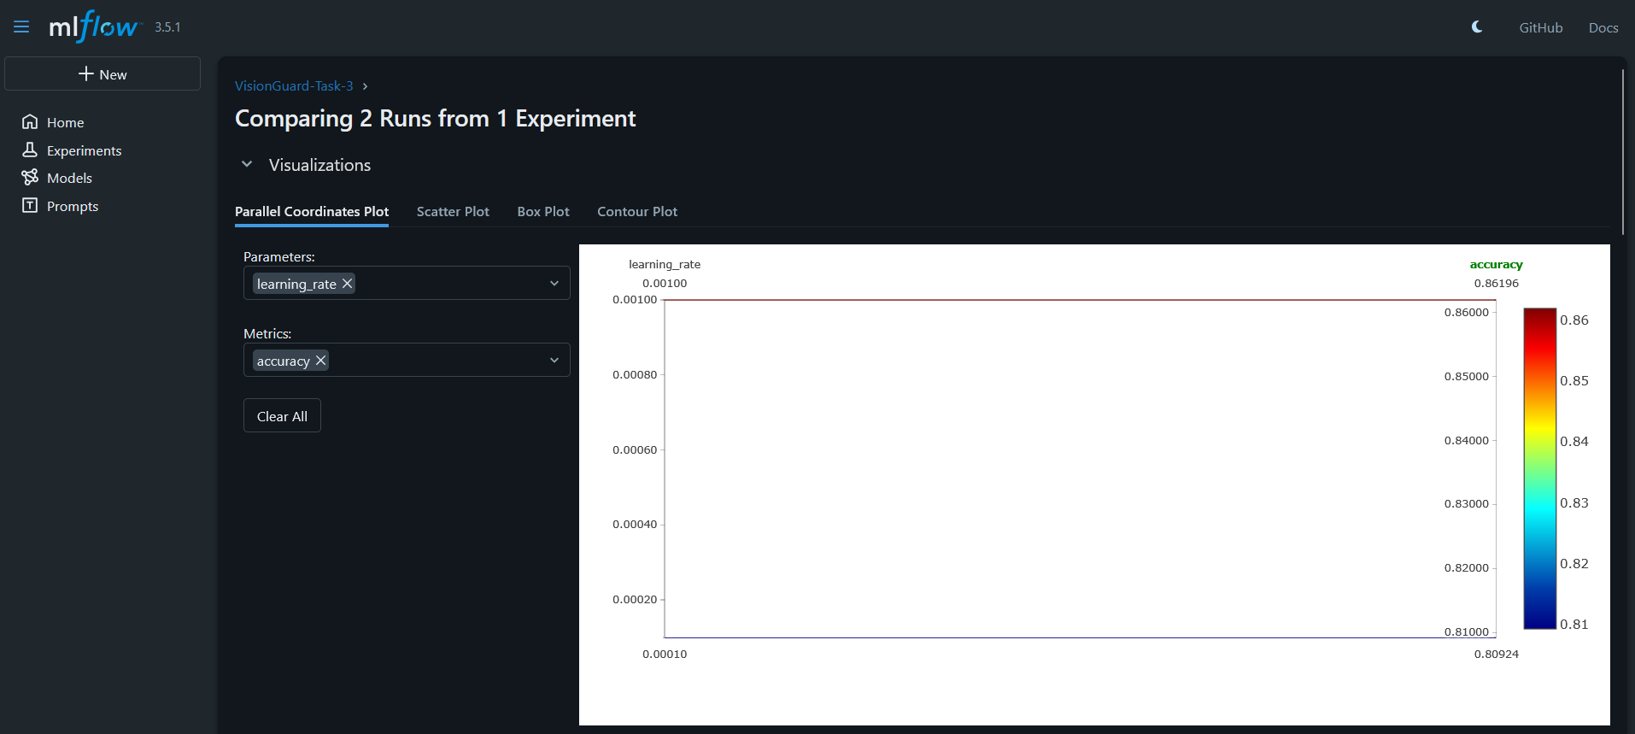
Figure 3.4: Local MLflow run list with comparison runsthe toy runs.

3.2 DagsHub configuration
The DagsHub project tracking URI supplied for this project is https://dagshub.com/saboor-sarfraz/mlops-a2.mlflow. Credentials are configured locally in the ignored .env file. The two-run Fashion-MNIST toy experiment completed successfully on DagsHub. The command output reported test accuracy 0.8624 at learning rate 0.001 and 0.8198 at learning rate 0.0001. The DagsHub MLflow run links are: Table 3.2 lists the two runs.
Learning rate | Test accuracy | DagsHub run
0.001 | 0.8624 | ae3749b59a3e4d889ad9b14c250698cf
0.0001 | 0.8198 | eddc8a1a27aa41968fcec8b4be052e7f
Table 3.2: DagsHub toy runs (same Fashion-MNIST experiment, logged remotely).
https://dagshub.com/saboor-sarfraz/mlops-a2.mlflow/#/experiments/0/runs/ae3749b59a3e4d889ad9b14c250698cf
https://dagshub.com/saboor-sarfraz/mlops-a2.mlflow/#/experiments/0/runs/eddc8a1a27aa41968fcec8b4be052e7f
The training completed in three epochs for each run. TensorFlow oneDNN and dataset NodeDef messages in the console were informational compatibility notices; both training runs finished and returned their DagsHub run links. Figures 3.5 and 3.6 show the DagsHub project and its experiments table, Figures 3.7 and 3.8 show the two run pages, and Figure 3.9 shows that .env is git-ignored, so the access token is never committed.
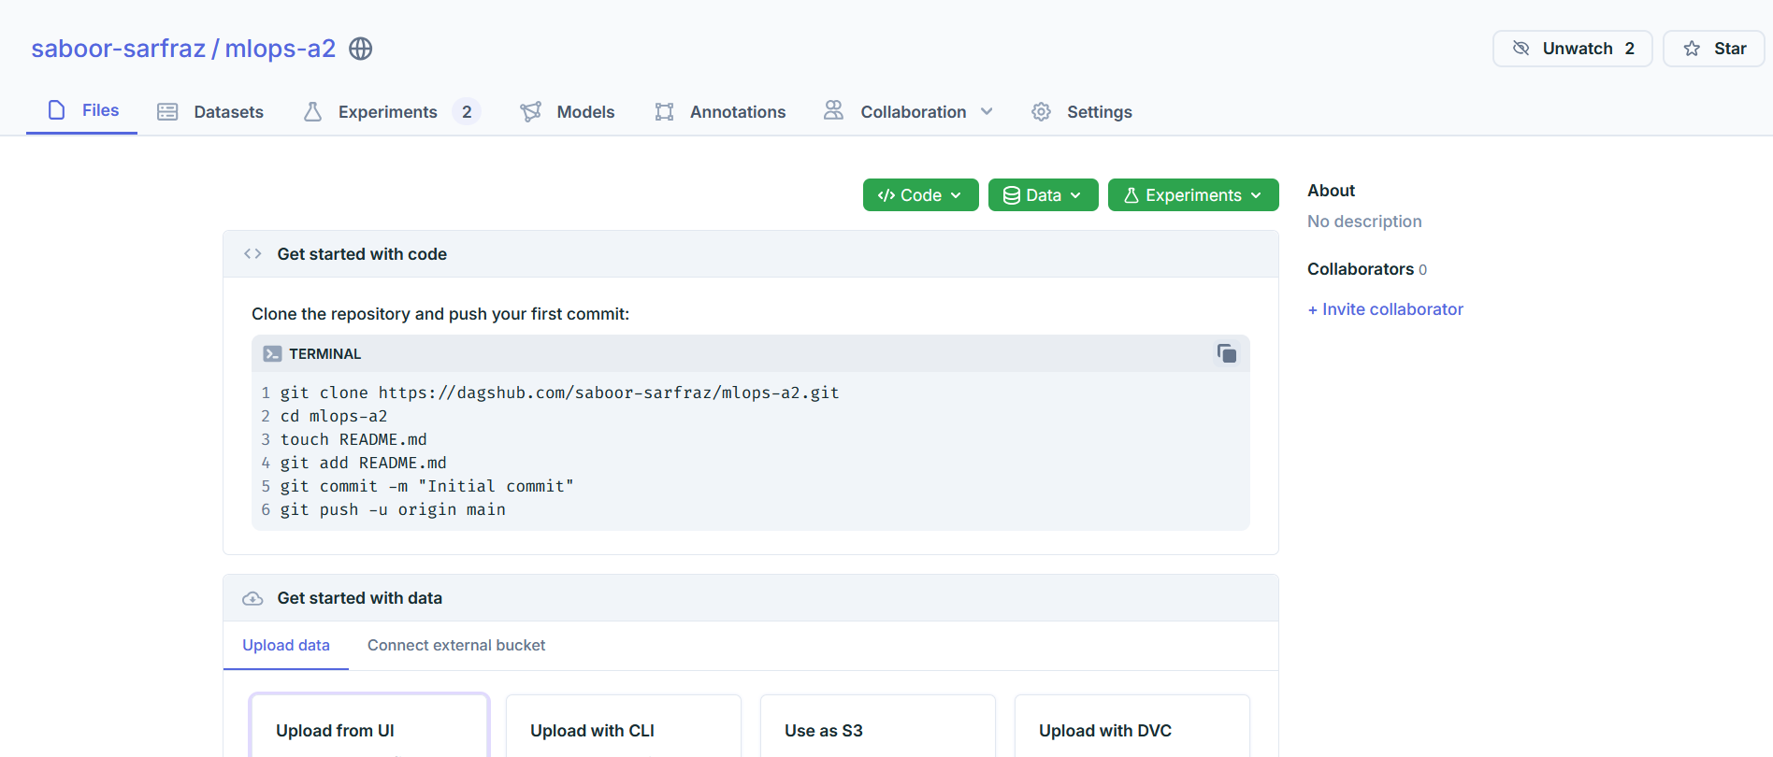
Figure 3.5: DagsHub project saboor-sarfraz/mlops-a2 with the Files, Experiments (2) and Models tabs.
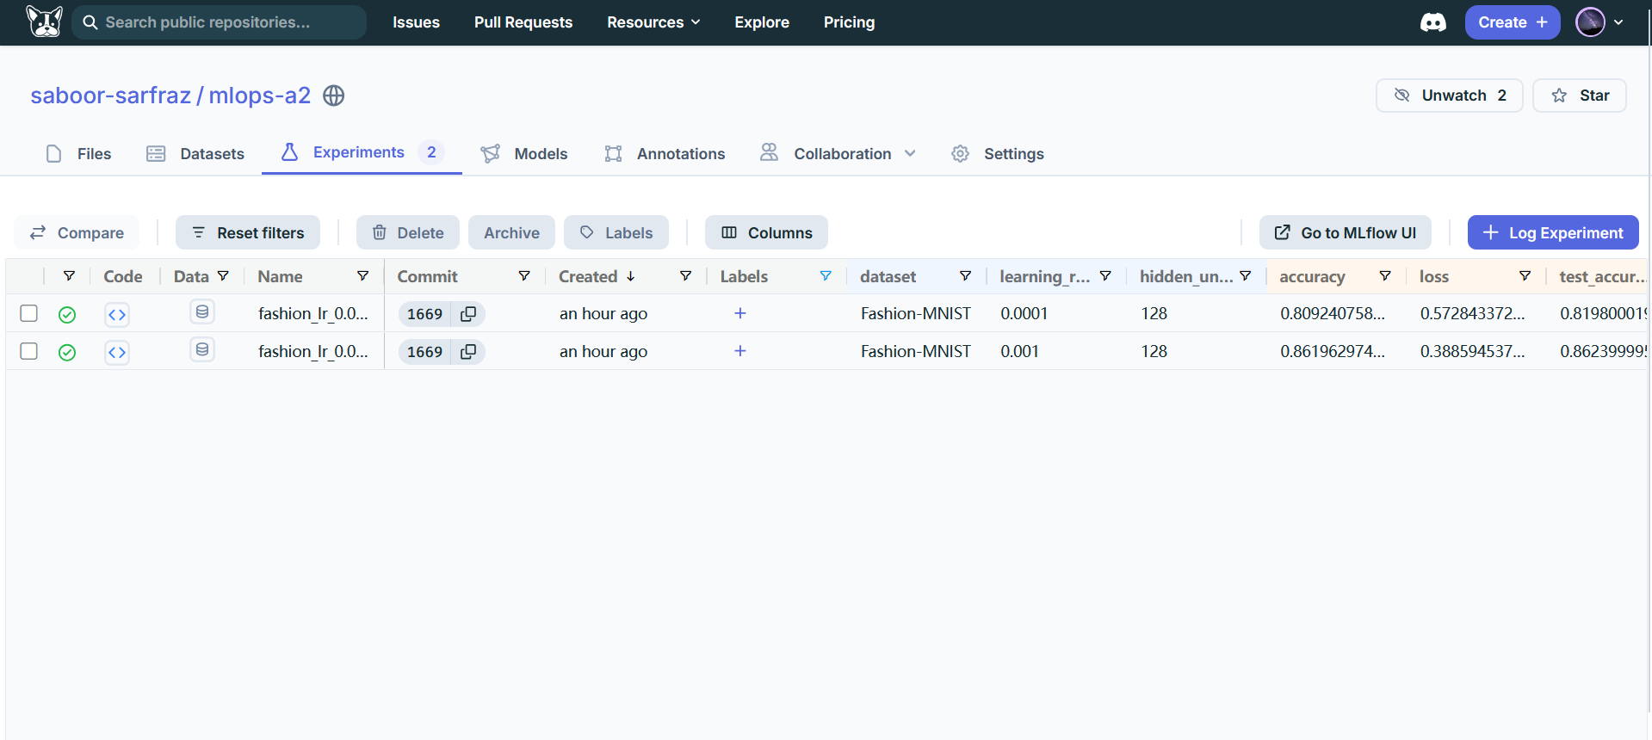
Figure 3.6: DagsHub Experiments tab listing the two Fashion-MNIST toy runs (learning rate 0.0001 and 0.001).
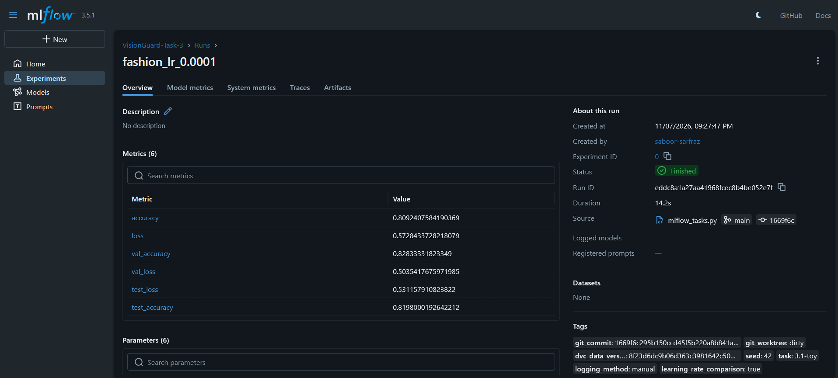
Figure 3.7: DagsHub MLflow page for run fashion_lr_0.0001: metrics, run ID, source commit and tags.
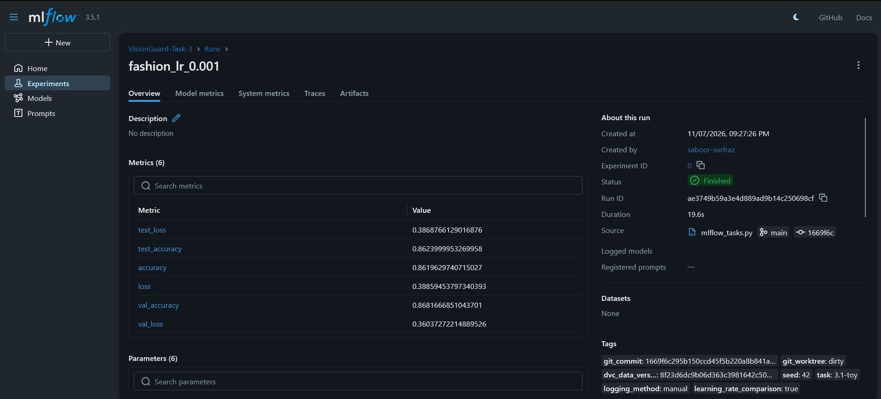.
Figure 3.8: DagsHub MLflow page for run fashion_lr_0.001: metrics, run ID, source commit and tags.
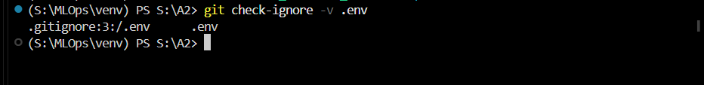
Figure 3.9: git check-ignore -v .env shows that .env is ignored through .gitignore.

3.3 Manual and autolog VisionGuard runs
Logging method | Run | Trainable LR | Validation loss | Test accuracy | Test F1
autolog | visionguard_autolog_lr_0.0001 | 0.0001 | 0.6722350716590881 | 0.5616438356164384 | 0.49206349206349204
manual | visionguard_manual_lr_0.0001 | 0.0001 | 0.6722350716590881 | 0.5616438356164384 | 0.49206349206349204
Table 3.3: VisionGuard runs logged manually and with MLflow TensorFlow autologging.
The manual callback logs every training and validation metric at each epoch; explicit code logs the final validation threshold, test metrics, tags, model, plot, confusion matrix, ROC curve, split CSVs, and package list. TensorFlow autolog captures the Keras fit history and a training model automatically, while explicit logging is still used for final test metrics, tags, the full image-input model, and assignment artifacts. Both runs train the same frozen-MobileNetV2 feature-extractor/head setup. The two runs are compared in Table 3.3.

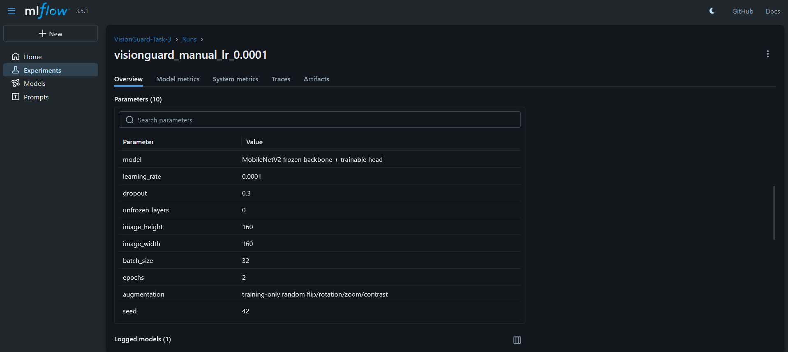

Mlflow manual log run
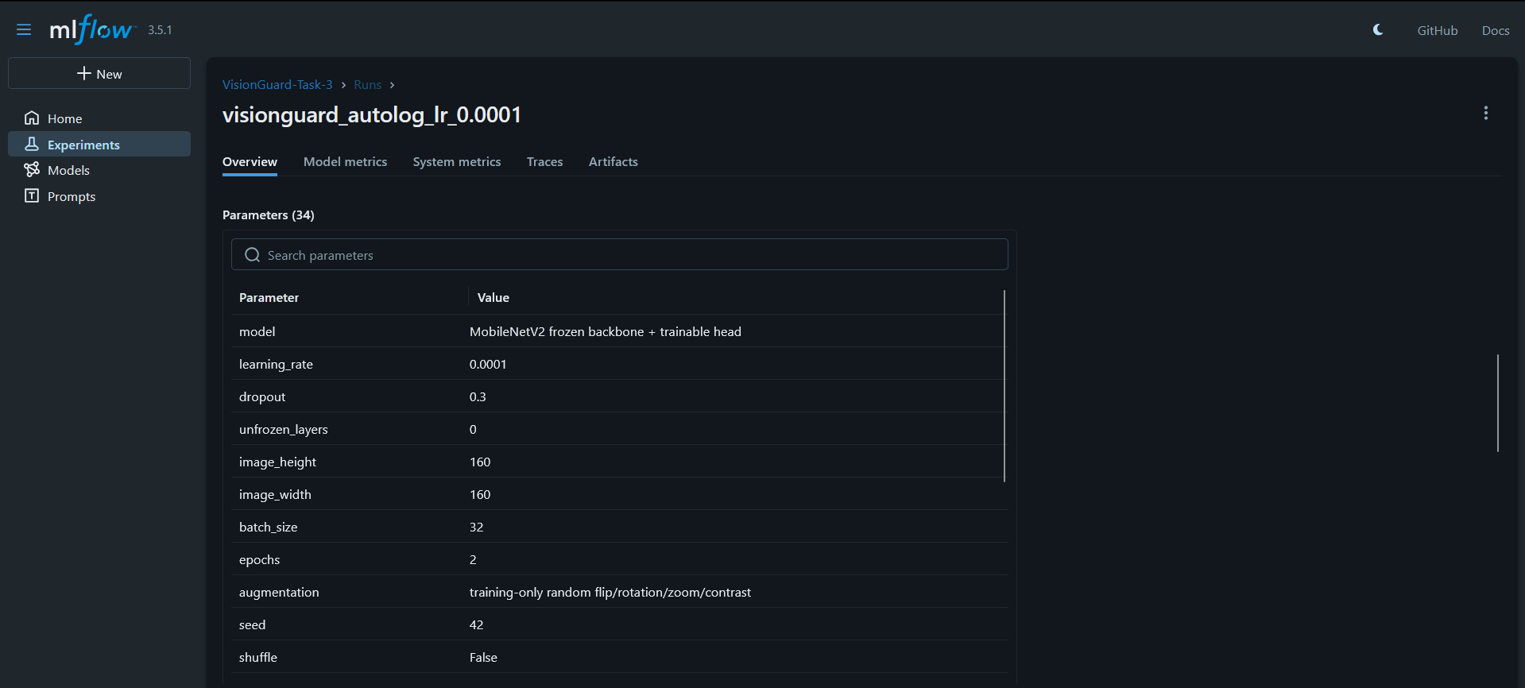

Mlflow autolog run

3.4 Logged artifacts
- The VisionGuard run's assignment_artifacts folder contains confusion matrix, ROC curve, three split CSVs, and requirements_frozen.txt.
- The models folder contains the full image-input Keras model; plots and training history are logged separately.

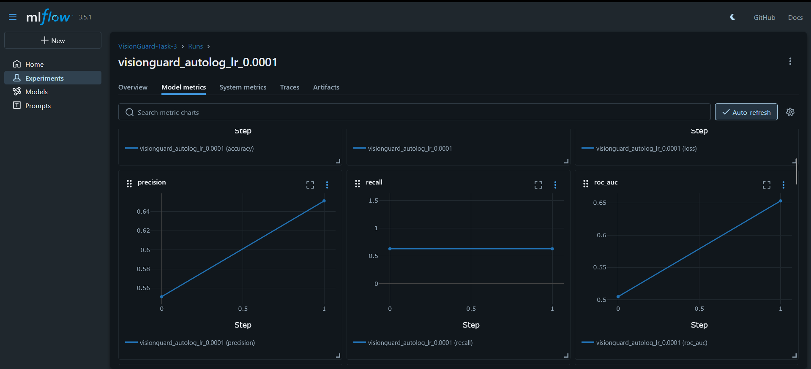

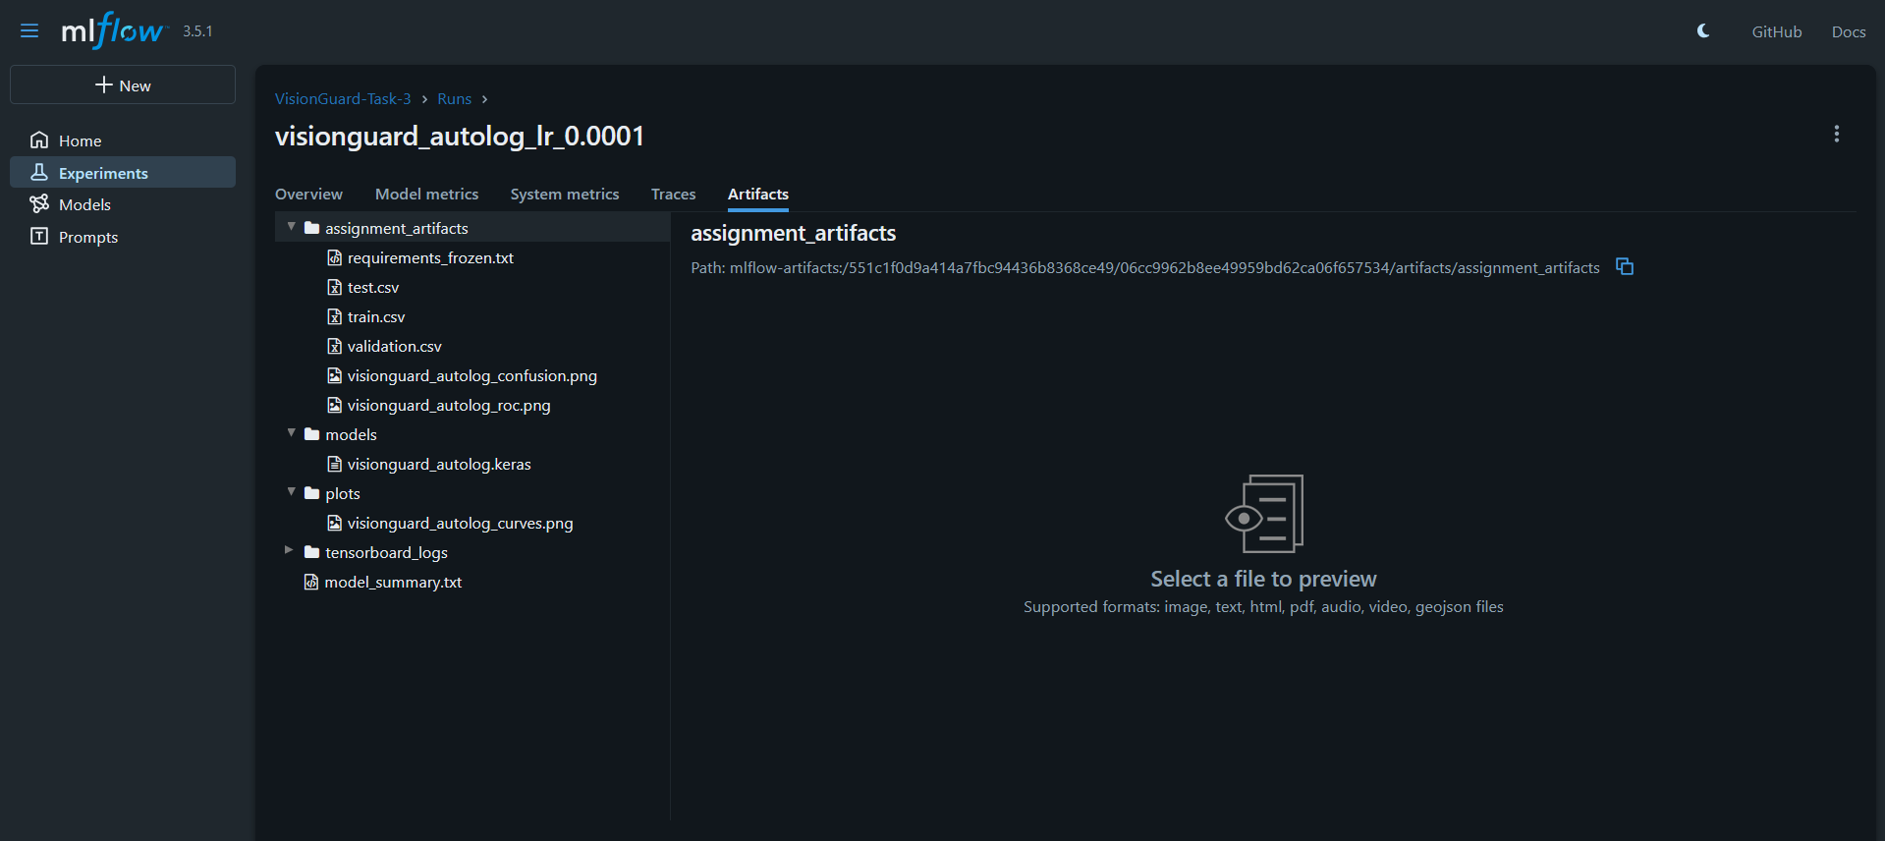

3.5 Six-run experiment comparison
Learning rate | Val cost | Val accuracy | Val F1 | Val ROC-AUC | Val loss
1e-05 | 81 | 0.445 | 0.000 | 0.520 | 0.738
3e-05 | 74 | 0.534 | 0.358 | 0.567 | 0.708
0.0001 | 68 | 0.623 | 0.586 | 0.666 | 0.658
0.0003 | 56 | 0.705 | 0.703 | 0.739 | 0.660
0.001 | 55 | 0.671 | 0.625 | 0.747 | 0.629
0.003 | 59 | 0.658 | 0.615 | 0.736 | 0.671
Table 3.4: Six runs that differ only in learning rate (validation metrics).
Only learning rate varied; backbone, image size, augmentation, batch size, seed, and three-epoch budget were held fixed. The validation-cost winner was lr_1e-3 (weighted cost 55). On its final test pass it achieved accuracy 0.712, F1 0.682, and ROC-AUC 0.828. The cost penalizes a real image incorrectly flagged as AI twice as much as an AI image missed. Table 3.4 and Figure 3.10 show the comparison.
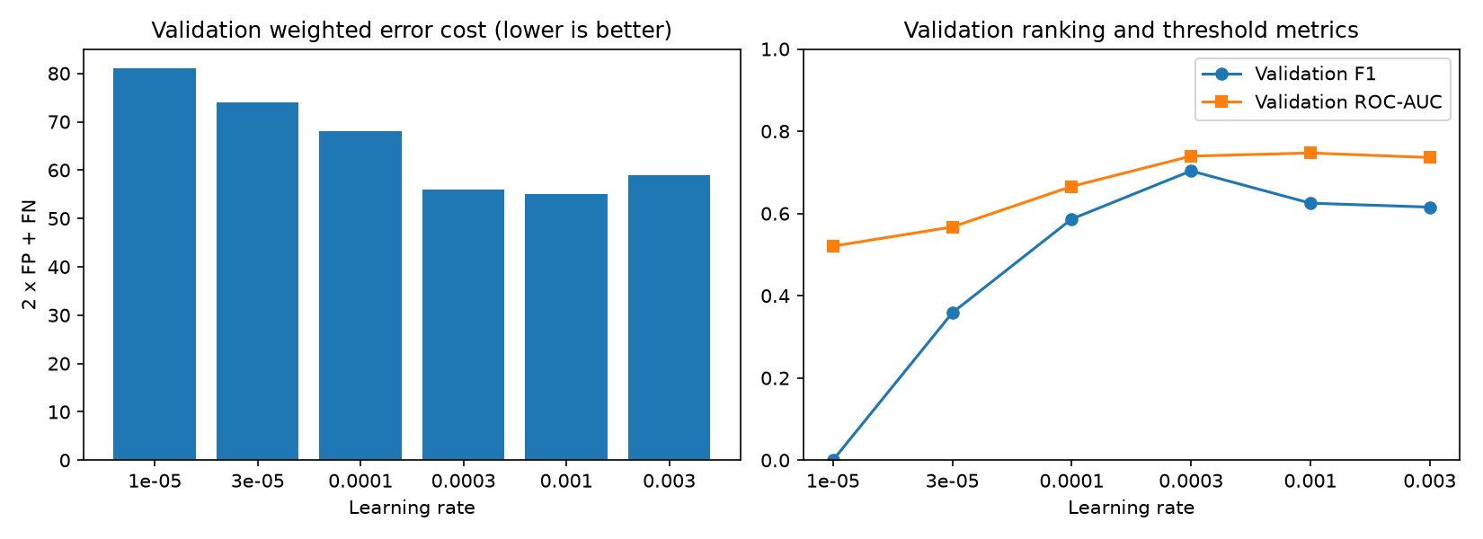
Figure 3.10: Six-run validation comparison from the local MLflow experiment.

3.6 Model registry and alias prediction
Registered model | Version | Source run | Alias
VisionGuard | 1 | 4d2944b8c9784cba8b0f618a32c53654 | champion
VisionGuard | 2 | a8a02f4888b0419bb6cff1cd6ffcb495
Table 3.5: Registered versions of the VisionGuard model and the champion alias.
The separate mlflow_predict.py script loaded models:/VisionGuard@champion and successfully classified an archive image. The test image produced AI probability 0.175510 and was labeled Real at the validation-selected threshold 0.856983. The model signature expects a float RGB image tensor with shape 160 x 160 x 3. Table 3.5 lists the registered versions and Figure 3.11 shows the registry page.
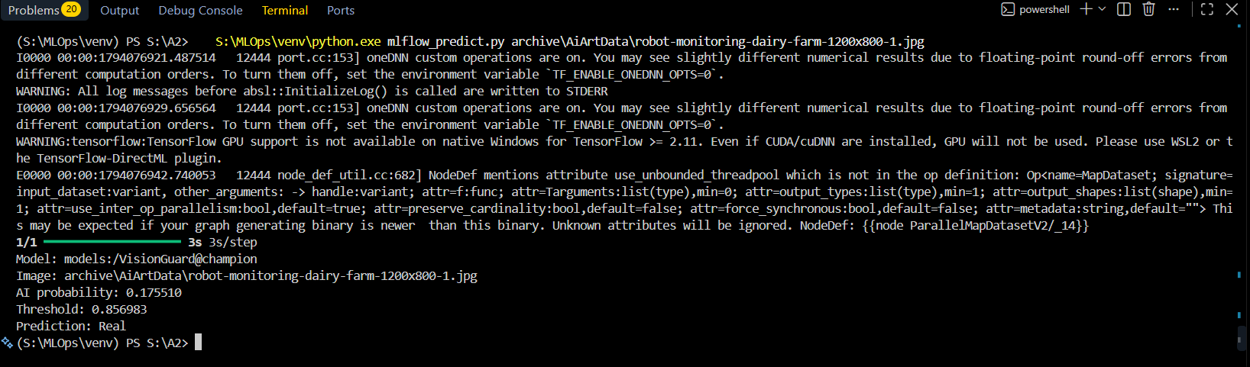
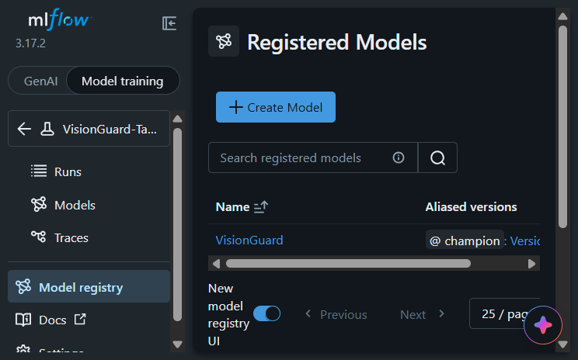
Figure 3.11: Local MLflow registry showing the VisionGuard champion alias.

Reproducing the Task 3 results
From the repository root, with the project virtual environment active, the Task 3 runs were produced with:
S:\MLOps\venv\python.exe -m mlflow ui --backend-store-uri sqlite:///S:/A2/mlflow_local.db --host 127.0.0.1 --port 5050
S:\MLOps\venv\python.exe mlflow_tasks.py --task toy-local
S:\MLOps\venv\python.exe mlflow_tasks.py --task visionguard-local --epochs 2
S:\MLOps\venv\python.exe mlflow_tasks.py --task compare-local --epochs 3
S:\MLOps\venv\python.exe mlflow_tasks.py --task register-local
S:\MLOps\venv\python.exe mlflow_tasks.py --task toy-dagshub
S:\MLOps\venv\python.exe mlflow_tasks.py --task visionguard-dagshub --epochs 2
S:\MLOps\venv\python.exe mlflow_tasks.py --task compare-dagshub --epochs 3
S:\MLOps\venv\python.exe mlflow_predict.py archive\AiArtData\robot-monitoring-dairy-farm-1200x800-1.jpg

4. Flask Web Application
VisionGuard is served as a small Flask application. A user selects one image in a browser, receives a Real or AI-generated verdict and confidence, and can review prediction metadata in the history page. Every result includes a caveat: this probabilistic classifier can make mistakes and is not proof of an image's origin.

4.1 Inference module
The separate inference.py module loads the .keras champion model once when the Flask application starts and keeps it in app.extensions for subsequent requests. Loading model weights on every request repeats expensive disk I/O, model construction, and TensorFlow initialization, adding latency and avoidable resource use. It also makes concurrent requests compete to initialize duplicate models.
For each request, uploaded bytes are decoded as three-channel RGB with TensorFlow's decode_image (the first GIF frame is used), resized to 160 x 160 with bilinear interpolation and antialiasing, and cast to float32 in [0,255]. This matches visionguard.py's training input pipeline; the saved MobileNetV2 model itself performs the expected [-1,1] rescaling. Keeping decoding, size, interpolation, channels, and numeric range consistent is necessary because a preprocessing mismatch changes the distribution the trained weights receive and can make scores unreliable.
The validation-selected threshold is 0.856983. Scores at or above it are labeled AI-generated; lower scores are labeled Real. Displayed confidence is the model score for the returned label (AI probability for AI, one minus AI probability for Real). This score is not a calibrated guarantee.
Known test-image inference output (one image from each class):
AI test image (64efd48f24bacac40feae0b4_qFcGNfN66Fp4nrvBHhQp89Kg425rczlCMKCbW2cNCCs.jpeg): prediction=AI-generated, confidence=0.977487, AI probability=0.977487, threshold=0.856983
Real test image (lemuranimaheader3.jpg): prediction=Real, confidence=0.770438, AI probability=0.229562, threshold=0.856983
[PASTE SCREENSHOT HERE]
Console output for two known images
Run `.\run_demo.ps1` from S:\A2 and replace this box with the terminal screenshot.

4.2 Routes, validation, and privacy
Route | Purpose
/ | Image-upload page
/predict (POST) | Validate and predict without saving the uploaded image
/result/<id> | Display a stored prediction result
/history | Browse paginated prediction metadata from SQLite
/health | Return model and database health as JSON
Only JPG/JPEG, PNG, BMP, and GIF filename extensions are accepted, and TensorFlow must successfully decode the content. The maximum request size is 8 MiB. Filenames are normalized with Werkzeug secure_filename. A memory-only request stream prevents Werkzeug from spooling uploaded files to disk; image bytes are processed in memory and are not stored. History keeps only the sanitized filename, timestamp, verdict, confidence, AI probability, and configured model identity.
Automated Flask tests passed for a valid prediction, upload/history flow, the health endpoint, unsupported extension, corrupt image bytes, and an over-limit upload.
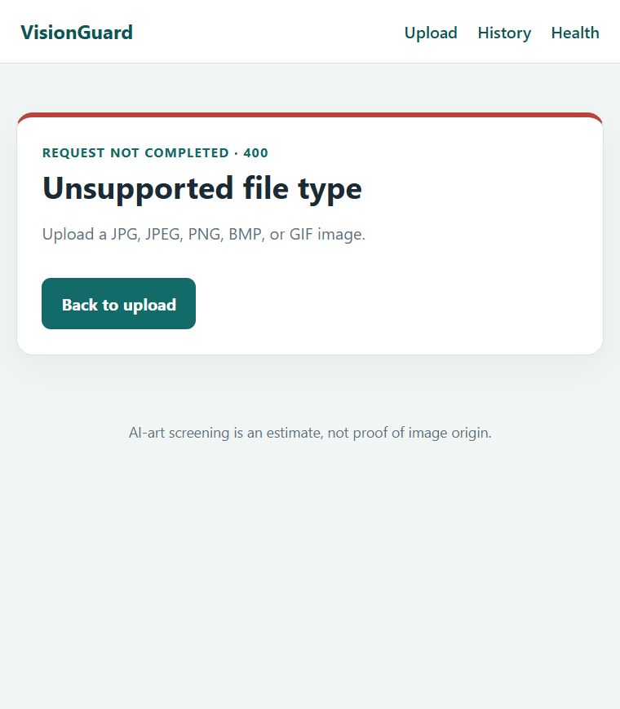
Wrong file type (HTTP 400). Friendly browser error page demonstrating that the app rejects the upload. Submit a .txt file from the upload form.
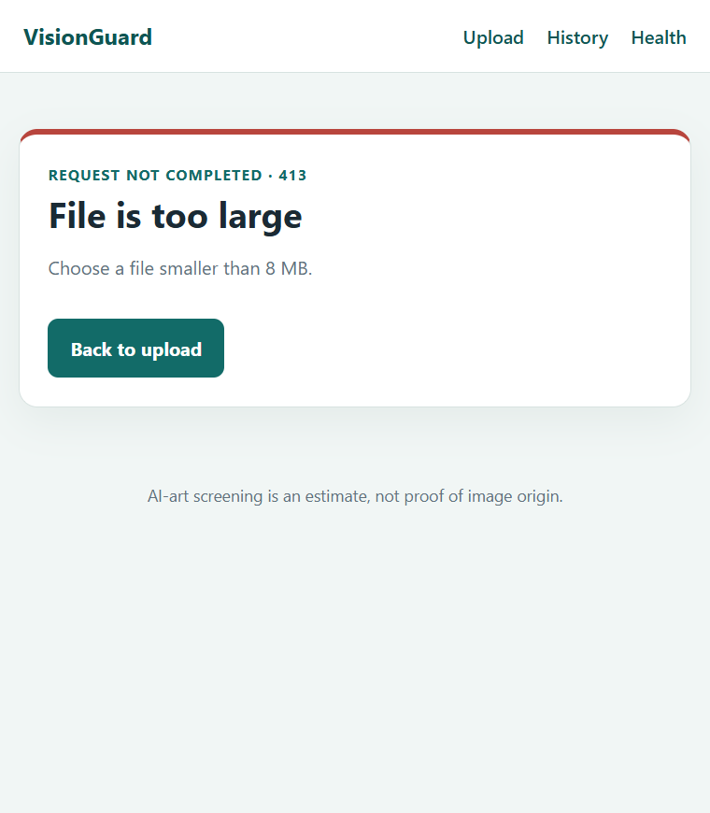
Oversized file (HTTP 413). Friendly browser error page demonstrating that the app rejects the upload. Submit an image larger than the configured 8 MiB limit.

Undecodable image (HTTP 400). Friendly browser error page demonstrating that the app rejects the upload. Rename non-image bytes to .png and submit them.

4.3 HTML and CSS
Jinja templates and a responsive stylesheet provide the upload form, result page, navigation, and history page. Results display the verdict, label confidence, raw AI probability, threshold, and an uncertainty caveat. The history page reads only metadata from the SQLite database; uploaded pictures are not retained.
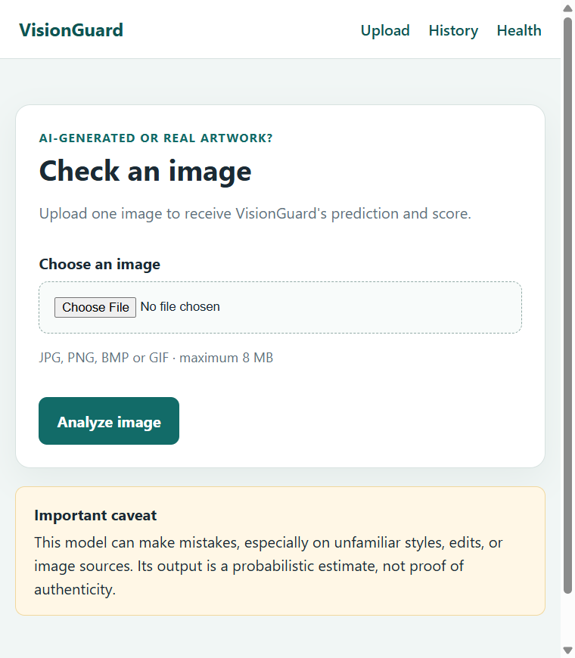
Upload page. VisionGuard upload form and model caveat.
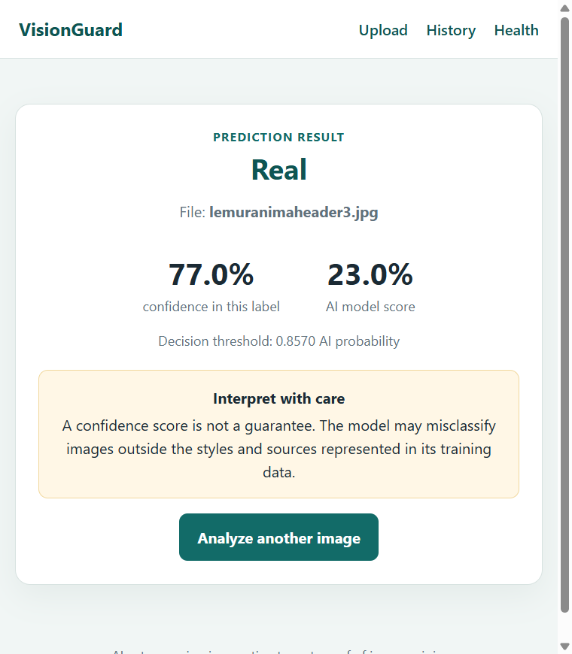
Result page. Real verdict, confidence, AI score, threshold, and caveat.
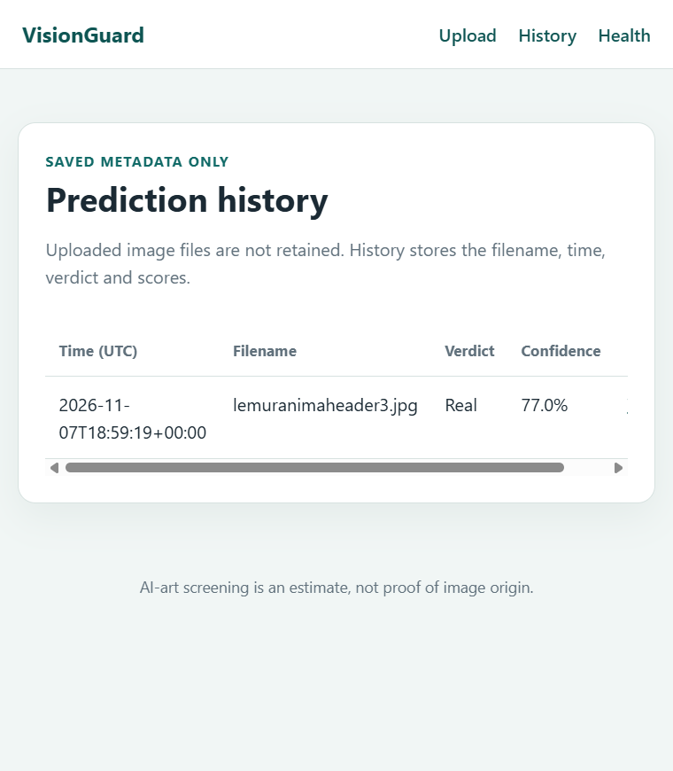
Prediction history. Stored prediction metadata displayed from SQLite.

4.4 Configuration and server
Environment variable | Example value / purpose
MODEL_PATH | S:/A2/visionguard_outputs/visionguard_comparison_champion.keras
THRESHOLD | 0.8569827079772949 (chosen on validation data)
MODEL_NAME | Human-readable model identity stored with each prediction
DATABASE_URL | sqlite:///S:/A2/visionguard_outputs/prediction_history.db
MAX_UPLOAD_BYTES | 8388608
HOST / PORT | 127.0.0.1 / 5000
The application reads model location, threshold, and database URL from environment variables (python-dotenv loads the ignored local .env when present). run_flask.ps1 supplies safe local defaults if a variable is absent. Flask starts with debug=False and use_reloader=False: debug mode can expose an interactive debugger and sensitive process details, while the development reloader can initialize the model more than once. Flask's built-in server is for this assignment/local demonstration; a public production deployment should use a production WSGI server behind HTTPS.
From S:\A2 in PowerShell:
.\run_flask.ps1
Open http://127.0.0.1:5000 in a browser. Keep the terminal open; press Ctrl+C to stop the server.
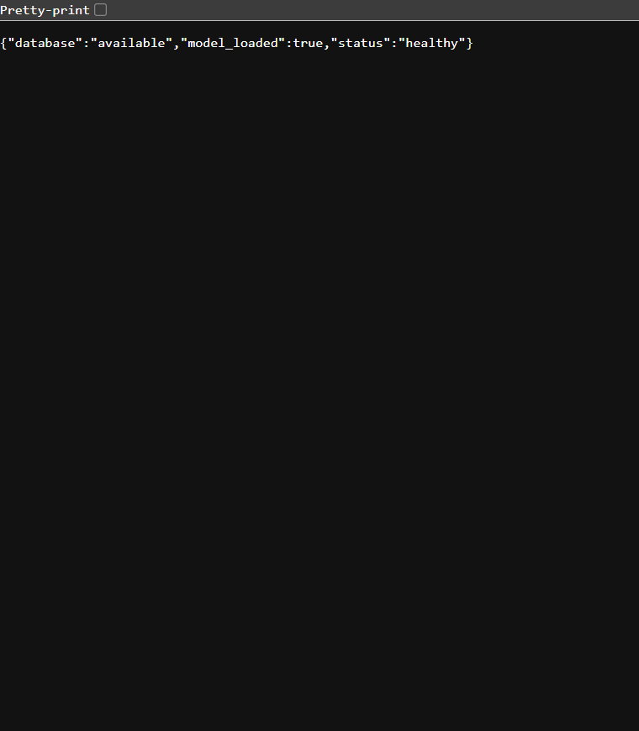
Health-check response. JSON response confirms the model is loaded and the database is available.

Task 4 reproduction and tests
S:\MLOps\venv\python.exe -m unittest discover -s tests -v
From PowerShell: .\run_demo.ps1
From PowerShell: .\run_flask.ps1

5. Database Trail
Each successful inference creates a durable SQLite row before the browser is redirected to its result page. This audit trail records the decision, UTC time, sanitized original filename, confidence, raw AI probability, and configured model identity. Image contents are deliberately not persisted. Failed uploads or inference requests do not create prediction rows.

5.1 Schema and persistence
Field | Meaning
id | Unique prediction identifier used by the result page
created_at | UTC timestamp captured after successful inference
filename | Sanitized client filename; no image bytes are stored
label | Decision: Real or AI-generated
confidence | Model score for the selected label
ai_probability | Raw probability used with the decision threshold
model_name | MODEL_NAME identity, defaulting to the model filename
The table is initialized on application startup. Existing Task 4 databases are migrated in place: if model_name is missing, SQLite ALTER TABLE adds it without dropping previous predictions. Legacy rows remain queryable and are shown as "Unknown (older record)" because their original model identity was not recorded. A descending created_at index supports the newest-first history view. Results are paginated 50 rows at a time, so older records remain accessible instead of being silently hidden by a fixed recent-record limit.
SELECT id, created_at, filename, label, confidence, ai_probability, model_name
FROM predictions ORDER BY created_at DESC;

5.2 History menu and evidence
The History navigation link opens the SQLite-backed /history page. Each row shows UTC time, filename, decision, label confidence, AI probability, and model identity; the View link opens the stored result. Navigation links allow users to browse all pages. The upload page continues to retain no image files.
[PASTE SCREENSHOT HERE]
Prediction history backed by SQLite
Paste a browser screenshot showing a prediction row with timestamp, verdict, confidence, and model.

5.3 Reproduction and tests
S:\MLOps\venv\python.exe -m unittest discover -s tests -v
From PowerShell: .\run_flask.ps1
Open http://127.0.0.1:5000, submit an image, then select History.
Automated tests verify successful inference creates a permanent row with the decision, timestamp, confidence, raw probability, and model name; the result and history pages display that record; older Task 4 database schemas migrate without losing existing rows; and unsupported, corrupt, and oversized uploads are rejected.

6. Containerization and CI
VisionGuard is packaged as a CPU-only Flask image and a PostgreSQL-backed Compose stack. The app connects to the database through the Compose service name `db`; PostgreSQL is not published to the host. Compose waits for the database health check before starting the web service. The model file is copied into the image so every container uses the same fixed champion artifact without relying on a host mount.

6.1 Docker warm-up
docker pull nginx:alpine
docker volume create vg-warmup-data-task6-20261108
docker run -d --name vg-warmup-task6-20261108 -p 127.0.0.1:18081:80 -v vg-warmup-data-task6-20261108:/usr/share/nginx/html nginx:alpine
docker ps -a
docker logs vg-warmup-task6-20261108
docker exec vg-warmup-task6-20261108 sh -c 'id; ls -la /usr/share/nginx/html'
docker stop vg-warmup-task6-20261108
docker rm vg-warmup-task6-20261108
docker image ls
docker image rm nginx:alpine
docker volume rm vg-warmup-data-task6-20261108
Term | Definition
Image | Packaged filesystem and metadata used as a template for containers.
Container | An isolated running instance of an image.
Layer | A cached, read-only filesystem change that later image steps build upon.
Volume | Docker-managed persistent storage that outlives a container.
Port mapping | A host-to-container forwarding rule that exposes a service.
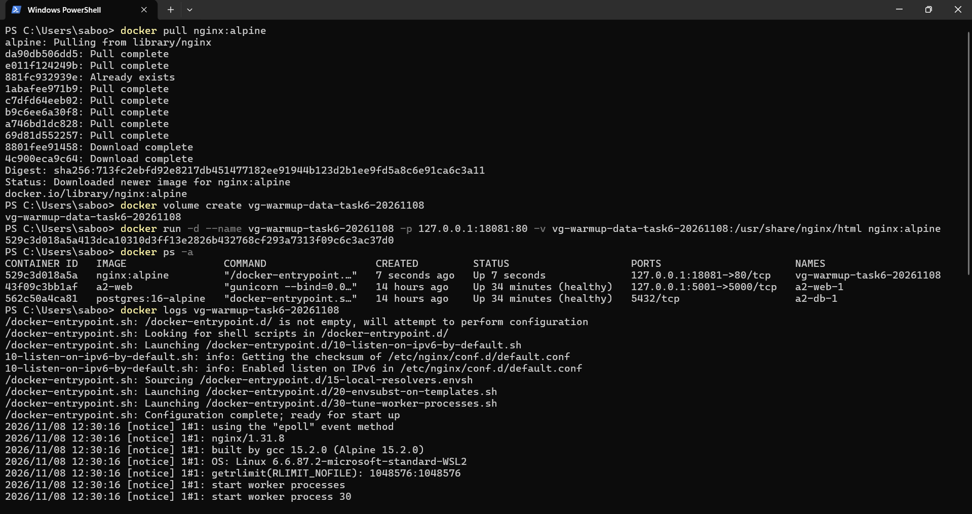
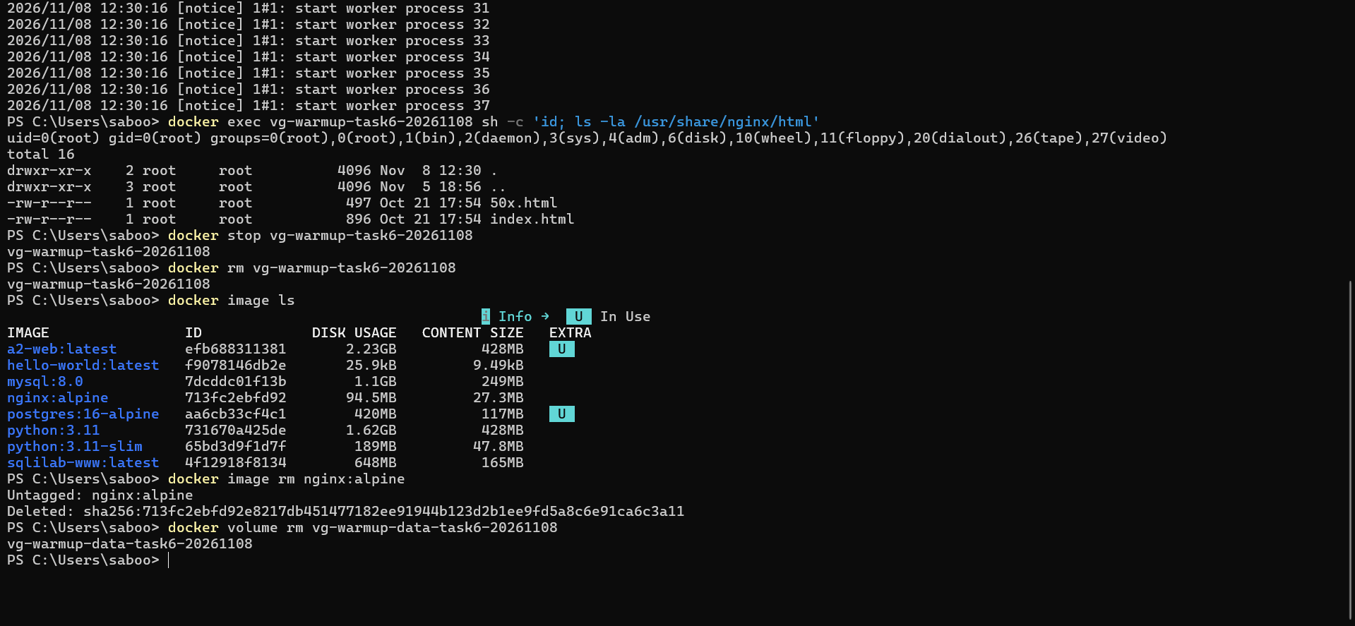

6.2 Dockerfile and image security
Dockerfile starts with the slim Python 3.11 image and installs only the inference runtime: tensorflow-cpu 2.21.0 (matching the model's training runtime), Flask, Gunicorn, Pillow, python-dotenv, and the PostgreSQL driver. CPU TensorFlow is deliberate: this inference service does not require a GPU, and using the CPU wheel avoids a CUDA runtime and its additional image size. The training libraries and tracking clients are not installed into the serving image.
The requirements file is copied and installed before application code. Docker can reuse that expensive dependency layer when only source or templates change. `.dockerignore` omits datasets, DVC/MLflow data, local databases, reports, and secrets from the build context. The model is the one intentional training output copied into the image. No `.env` file or password is copied. The process runs as UID 10001, with a read-only root filesystem in Compose, a bounded temporary filesystem, and a health check.
docker build -t visionguard:latest .
docker run --rm --entrypoint id visionguard:latest
docker image inspect visionguard:latest --format '{{.Size}}'
docker history visionguard:latest
[PASTE SCREENSHOT HERE]
Dockerfile and non-root identity
Paste the Dockerfile and `docker compose exec web id` output showing uid=10001.

6.3 Compose services, secrets, and model
The `web` and `db` services share Compose's private network and the web process connects to host `db`. Postgres uses the persistent named volume `prediction-data` and its `pg_isready` health check; `depends_on: condition: service_healthy` gates app startup. Only the Flask service publishes a loopback host port (5001 by default); Postgres has no `ports` mapping. Set credentials in the ignored `.env` file (create it from `.env.example` if it does not exist); environment interpolation supplies the password to both services without baking it into the image or repository. The champion model is copied into the image for repeatable inference.
# Create .env from .env.example if needed; otherwise add its POSTGRES_* values.
# Replace POSTGRES_PASSWORD with a strong random alphanumeric value.
docker compose up --build -d
docker compose ps
docker inspect a2-db-1 --format '{{json .NetworkSettings.Ports}}'
Test-NetConnection 127.0.0.1 -Port 5432

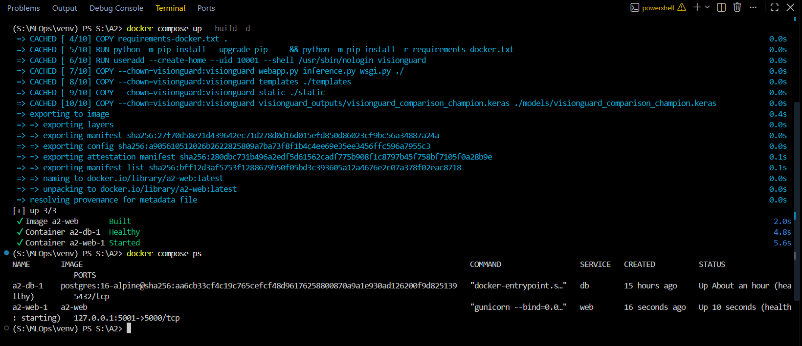

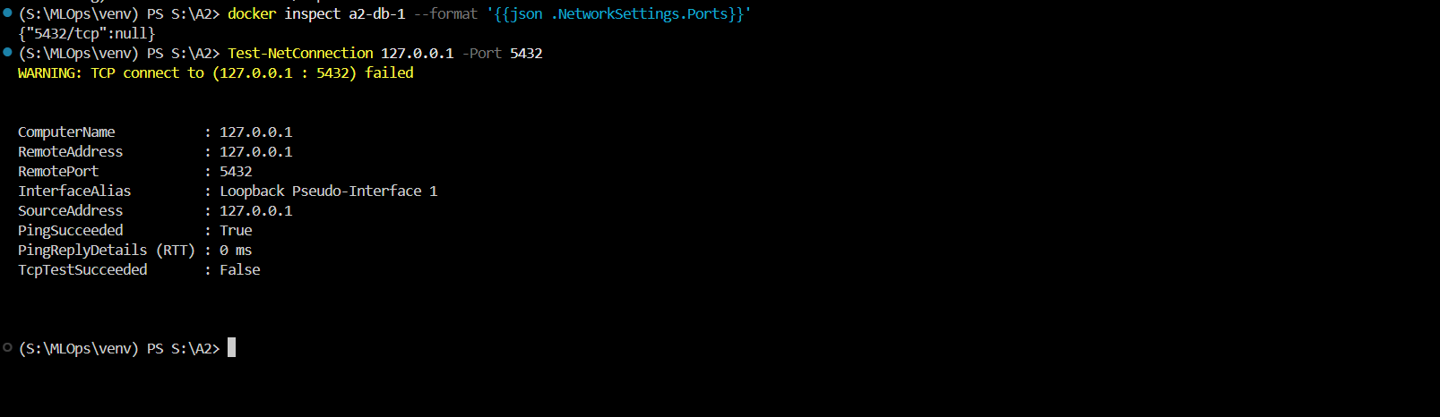
[PASTE SCREENSHOT HERE]
Healthy Compose services and closed database port
Paste `docker compose ps` showing web/db healthy, `5432/tcp: null` from inspect, and a failed host connection test.

6.4 Image size optimization
The optimization is using python:3.11-slim instead of the full python:3.11 base while installing only the CPU inference dependencies. The build also disables pip cache and excludes the archive, model-training outputs, and tracking artifacts from the context. The base image dropped from 1,598,274,424 bytes to 187,094,560 bytes (88.3% smaller). The complete optimized app image is 2,228,923,654 bytes. `docker history` reports the dependency-install layer at 1.65 GB, the largest layer; the copied champion model is 10.3 MB.
Build | Image size | Notes
Before: python:3.11 base | 1,598,274,424 bytes (1.60 GB) | Full Python runtime base
After: python:3.11-slim base | 187,094,560 bytes (187 MB) | 88.3% smaller base; app uses this pinned slim base
Complete optimized VisionGuard image | 2,228,923,654 bytes (2.23 GB) | Includes CPU TensorFlow, app, and 10.3 MB model
[PASTE SCREENSHOT HERE]
Before and after image sizes
Paste `docker image inspect` output for python:3.11 and python:3.11-slim plus `docker history a2-web`.

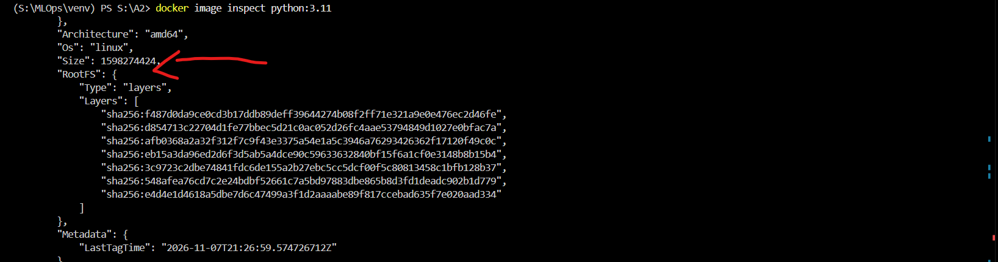
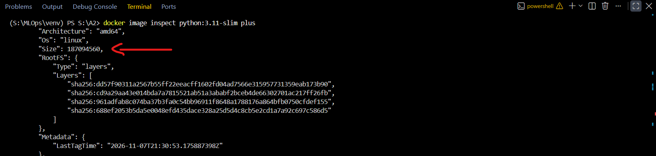

6.5 Operations and troubleshooting
docker compose up --build -d
docker compose stop
docker compose start
docker compose restart web
docker compose logs --tail=100 web
docker compose logs --tail=100 db
docker compose exec web sh
docker compose exec db sh
Troubleshooting demonstration: temporarily provide a wrong DB_PASSWORD to the web service while leaving the initialized Postgres volume unchanged. The web startup log should show PostgreSQL password authentication failure; the database log should show the rejected connection. Restore the matching `.env` password and recreate the web service. Capture the actual error and recovered healthy status rather than presenting a simulated log.
[PASTE SCREENSHOT HERE]
Failure diagnosis and recovery
Paste real web/database log excerpts showing the authentication failure, diagnosis, corrected environment, and healthy recovery.

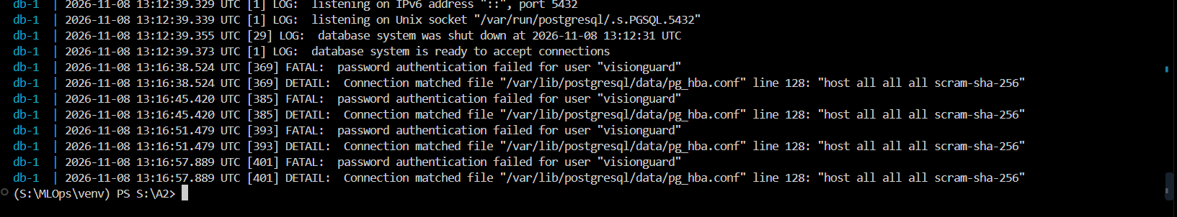

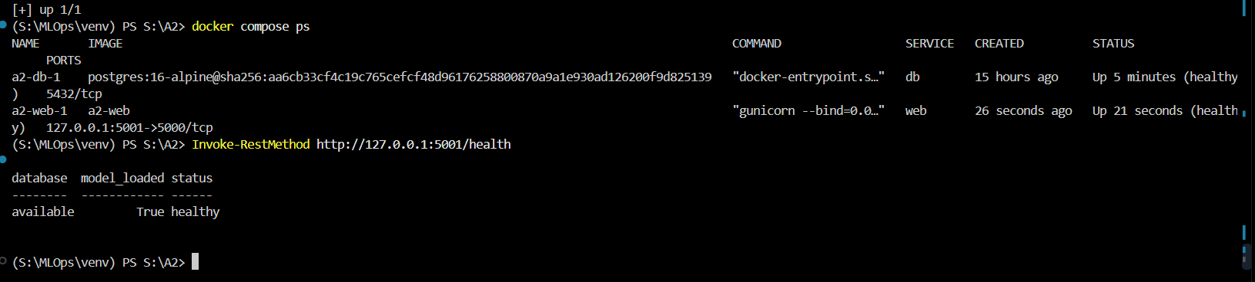

6.6 GitHub Actions
The VisionGuard CI workflow triggers on every push and pull request. A Python 3.11 and 3.12 matrix installs the serving requirements, runs Ruff, and executes the Flask unit tests. A dependent job builds the Docker image without pushing it. The repository README includes the workflow status badge. A copyable toy workflow and unit test are in `toy-ci/`; copy those files to a throwaway GitHub repository, push to see both matrix jobs, change the expected sum to produce a failing run, then restore it and push to get a green run.
Workflow secrets are stored in GitHub repository Settings → Secrets and variables → Actions. They are injected at runtime as `${{ secrets.NAME }}` only for steps that need them (for example, a future registry push). Never place credentials in workflow YAML, source, image layers, logs, or committed `.env` files: those locations are versioned or visible to users who can read the repository/build.
[PASTE SCREENSHOT HERE]
GitHub Actions evidence
Paste the toy workflow red then green matrix runs, VisionGuard CI green matrix, Docker build job, and README badge.

